Attention Accumulation in Defense Spending and Counterspace Capability A Cliometric Test of Whether Budget Growth, Alliance-Burden Sharing, and SSA Discourse Are Consolidating into a Security Literature: A Learning-Curve Analysis of Citation Growth by Article Age

1. Introduction
Citation accumulation is one way to test whether a security literature is maturing into a recognizable field. If the candidate corpus has a stable attention structure, article age should help explain how citations accumulate across the retrieved records $$1$$, $$2$$, $$3$$.

2. Theory and Hypotheses
Older articles have had more time to circulate, but attention growth is rarely linear. A learning-curve specification asks whether citation accumulation follows a regular age-based elasticity. If the security corpus is cumulative, age should matter in a measurable way. If it is fragmented, citation accumulation may be erratic rather than patterned.
H1 states that citation accumulation follows a measurable age-based curve. H0 states that article age is unrelated to citation accumulation.

3. Data
The paper uses the same 30-record candidate corpus as Paper 1. The dependent variable is cites_plus1, which equals the reported citation count plus one so the logarithm is defined for uncited records. The explanatory variable is age_index, computed as 2026 minus publication year plus one.

4. Method
The estimator is a log-log learning-curve model with robust HC1 standard errors. The coefficient on log age is interpreted as the elasticity of citation accumulation with respect to article age.

5. Findings
The model uses 30 observations. R-squared equals 0.0055. The elasticity on _ln_x is -0.1556 with a standard error of 0.3128 and a p-value of 0.6189. The intercept is 0.9864 with a standard error of 0.5542 and a p-value of 0.0751. The reported progress ratio, 2^b, is 0.8978.
This is a null result. Within the bounded candidate corpus, article age does not strongly explain citation accumulation. Older records are not automatically the attention center of the retrieved literature, but neither is there a statistically clear counter-pattern.

6. Discussion
The null result complements Paper 1. The security discourse in this corpus shows thematic concentration by venue, yet its citation accumulation does not follow a strong age-based curve. That combination suggests a literature with institutional clustering but a weaker cumulative attention structure than a mature field might display.

References
1. T. Harrison, “International Perspectives on Space Weapons,” AMOS, 2020.
2. M. Young, “Space Situational Awareness Capabilities and National Security Among Growing Space Actors: Japan Case Study,” AMOS, 2023, doi: 10.64861/TCOA6256
3. D. Porras and L. Zarkan Cesari, “Safety Norms for Space Security: How the Development of STM Norms Can Strengthen Security in Space,” AMOS, 2021.

Specification
$$ln({\text{CitesPlus1}}_{i})=α+β_{1}ln({\text{AgeIndex}}_{i})+ε_{i}$$

Results
Term | Coef. | Std. err. | t | p | 95% CI
const | 0.9864 | 0.5542 | 1.7801 | 0.0751 | [-0.0997, 2.0726]
_ln_x | -0.1556 | 0.3128 | -0.4974 | 0.6189 | [-0.7687, 0.4576]
Fit: N = 30 R2 = 0.0055 elasticity_b = -0.1556 progress_ratio_2^b = 0.8978
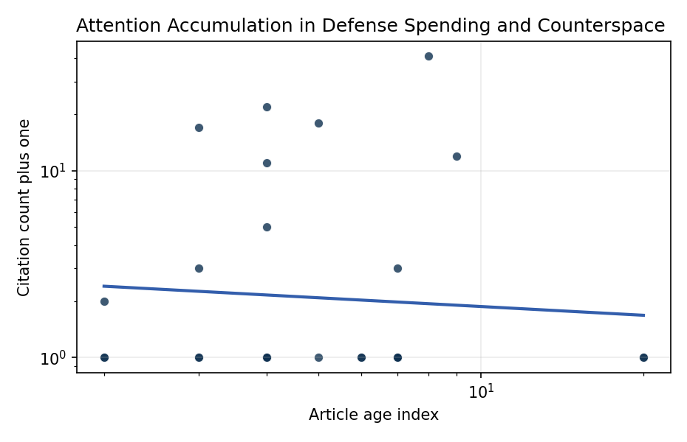
Figure 1. Citation accumulation against article age in the retrieved topic literature.

Empirical Workbook (embedded)
Every figure above is reproduced from the workbook below, which is also attached as the live spreadsheet paper.xlsx. Each observation carries its source.

Data (real observations)
doc_id | year_num | age_index | cites_num | cites_plus1 | signal_score | source
1 | 2023 | 4 | 0 | 1 | 8 | 10.64861/TCOA6256
2 | 2020 | 7 | 0 | 1 | 9 | https://amostech.space/year/2020/australias-emerging-space-policy-defense-burden-sharing-in-orbit-and-space-situational-awareness/
3 | 2024 | 3 | 0 | 1 | 2 | 10.64861/EIBC5616
4 | 2020 | 7 | 0 | 1 | 3 | https://amostech.space/year/2020/international-perspectives-on-space-weapons/
5 | 2021 | 6 | 0 | 1 | 9 | https://amostech.space/year/2021/safety-norms-for-space-security-how-the-development-of-stm-norms-can-strengthen-security-in-space/
6 | 2022 | 5 | 0 | 1 | 11 | https://amostech.space/year/2022/buying-space-trends-in-u-s-sda-acquisition/
7 | 2007 | 20 | 0 | 1 | 3 | https://amostech.space/year/2007/atmospheric-support-for-space-situational-awareness-and-space-control-the-us-naval-observatory/
8 | 2021 | 6 | 0 | 1 | 3 | https://amostech.space/year/2021/transformation-of-the-space-surveillance-telescope-into-a-dedicated-sensor-in-the-space-surveillance-network/
9 | 2024 | 3 | 0 | 1 | 5 | 10.64861/QBNC8763
10 | 2023 | 4 | 0 | 1 | 3 | 10.64861/CZGF7141
11 | 2007 | 20 | 0 | 1 | 6 | https://amostech.space/year/2007/assessing-space-and-satellite-environment-and-system-security/
12 | 2023 | 4 | 0 | 1 | 8 | 10.64861/KYFU6858
13 | 2023 | 4 | 21 | 22 | 6 | 10.1016/j.actaastro.2023.02.043
14 | 2025 | 2 | 0 | 1 | 3 | 10.1016/j.actaastro.2025.01.061
15 | 2024 | 3 | 2 | 3 | 12 | 10.1016/j.actaastro.2024.09.003
16 | 2025 | 2 | 0 | 1 | 6 | 10.1016/j.actaastro.2025.08.048
17 | 2022 | 5 | 17 | 18 | 3 | 10.1016/j.actaastro.2022.06.005
18 | 2024 | 3 | 16 | 17 | 3 | 10.1016/j.actaastro.2024.04.001
19 | 2023 | 4 | 10 | 11 | 3 | 10.1016/j.actaastro.2023.05.023
20 | 2025 | 2 | 1 | 2 | 3 | 10.1016/j.actaastro.2025.07.055
21 | 2018 | 9 | 11 | 12 | 4 | 10.1016/j.actaastro.2018.06.037
22 | 2023 | 4 | 4 | 5 | 3 | 10.1016/j.actaastro.2023.11.020
23 | 2020 | 7 | 2 | 3 | 5 | 10.1016/j.actaastro.2020.06.032
24 | 2019 | 8 | 40 | 41 | 3 | 10.1016/j.actaastro.2019.10.026
25 | 2020 | 7 | 0 | 1 | 1 | Roadmap: Australia Economic-Technological Renaissance in Space
26 | 2020 | 7 | 0 | 1 | 1 | OCEA Forecasting the Space Economy
27 | 2020 | 7 | 0 | 1 | 1 | Leveraging Circular Economy for Space Sustainability
28 | 2020 | 7 | 0 | 1 | 3 | The Role of Space in Driving Sustainability, Security, and Development
29 | 2020 | 7 | 0 | 1 | 1 | The Space Imperative (Whole-of-Nation)
30 | 2020 | 7 | 0 | 1 | 1 | Architectural Socio-Technological Transformative Change of Space-Use Norms

Variable construction
Variable | Definition | Construction / source
cites_plus1 | Citation count plus one | Computed as the reported citation count from the local brain index plus one so the log transformation is defined for uncited records
age_index | Document age index | Computed as 2026 minus publication year plus one

Estimator output
Term | Coef. | Std. err. | t | p | 95% CI
const | 0.9864 | 0.5542 | 1.7801 | 0.0751 | [-0.0997, 2.0726]
_ln_x | -0.1556 | 0.3128 | -0.4974 | 0.6189 | [-0.7687, 0.4576]
Fit: N = 30 R2 = 0.0055 elasticity_b = -0.1556 progress_ratio_2^b = 0.8978

