Signal Intensity in Defense Spending and Counterspace Capability A Cliometric Test of Whether Budget Growth, Alliance-Burden Sharing, and SSA Discourse Are Consolidating into a Security Literature: An Ordinary Least Squares Test of Recency, Citation Attention, and Venue

1. Introduction
This paper treats the retrieved security corpus as an empirical object. The candidate topic draws on a bounded set of AMOS and Acta records on space weapons, strategic stability, SSA capability, allied burden sharing, and security norms $$1$$, $$2$$, $$3$$, $$4$$. The question is whether that corpus shows a structured thematic signal or remains a looser set of adjacent conversations.

2. Theory and Hypotheses
If the security literature around this candidate is consolidating, later records should often display denser topic signal because authors inherit a more stable vocabulary and a clearer shared problem frame. Venue may matter because AMOS and Acta host different styles of argument, with one more operational and the other more journal-synthetic. Citation attention may also track thematic centrality, though not automatically.
H1 states that topic-signal intensity increases with recency and citation attention. H0 states that the signal is unrelated to recency, citations, and venue family.

3. Data
The paper uses a 30-record panel built from the local source retrieval for this candidate. The dependent variable, signal_score, is a deterministic composite count of candidate-theme term hits in title, snippet, keyword field, and author metadata. Covariates are recency_index, cites_num, and venue_score. Each row preserves its local source trail.

4. Method
The estimator is OLS with robust HC1 standard errors. The specification regresses topic-signal score on publication recency, reported citation count, and venue-family score.

5. Findings
The model uses 30 observations. Fit is meaningful rather than trivial: R-squared equals 0.3123, adjusted R-squared equals 0.2329, the F statistic is 5.8048, and the model p-value is 0.0036. The coefficient on recency_index is 0.1172 with a standard error of 0.0930 and a p-value of 0.2078. The coefficient on cites_num is -0.0126 with a standard error of 0.0265 and a p-value of 0.6351. The coefficient on venue_score is -2.1716 with a standard error of 0.5476 and a p-value of 0.0001.
The main structured result is venue rather than age or citation attention. Within this bounded corpus, the topic-signal score is strongly lower as the venue-family code rises, which means the candidate-theme density is concentrated more heavily in the AMOS side of the retrieved literature than in the Acta side. Recency and citation count do not reach conventional significance.

6. Discussion
This result suggests that the retrieved security discourse is not organized by a simple newer-is-stronger logic. Nor is it organized by citation count alone. Instead, thematic density is concentrated by venue family, which implies that the candidate topic may still depend heavily on a specific institutional conversation rather than a fully generalized field-wide discourse.

References
1. T. Harrison, “International Perspectives on Space Weapons,” AMOS, 2020.
2. M. Young, “Space Situational Awareness Capabilities and National Security Among Growing Space Actors: Japan Case Study,” AMOS, 2023, doi: 10.64861/TCOA6256
3. R. Dalal, A. Boley, and M. Byers, “Space Debris and Nuclear Strategic Stability: Collision Risks and Attribution Potential in GEO,” AMOS, 2024, doi: 10.64861/EIBC5616
4. D. Porras and L. Zarkan Cesari, “Safety Norms for Space Security: How the Development of STM Norms Can Strengthen Security in Space,” AMOS, 2021.

Specification
$${\text{SignalScore}}_{i}=α+β_{1}{\text{RecencyIndex}}_{i}+β_{2}{\text{Cites}}_{i}+β_{3}{\text{VenueScore}}_{i}+ε_{i}$$

Results
Term | Coef. | Std. err. | t | p | 95% CI
const | 6.6189 | 1.5435 | 4.2883 | 1.8e-05 | [3.5938, 9.6441]
recency_index | 0.1172 | 0.093 | 1.2597 | 0.2078 | [-0.0651, 0.2995]
cites_num | -0.0126 | 0.0265 | -0.4745 | 0.6351 | [-0.0646, 0.0394]
venue_score | -2.1716 | 0.5476 | -3.9656 | 7.323e-05 | [-3.2449, -1.0983]
Fit: N = 30 R2 = 0.3123 R2_adj = 0.2329 F = 5.8048 F_p = 0.0036
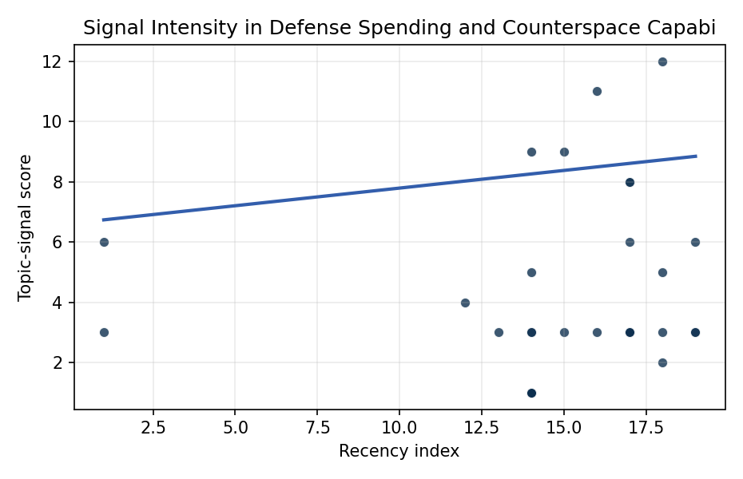
Figure 1. Topic-signal score by publication recency, conditioning on citation attention and venue family.

Empirical Workbook (embedded)
Every figure above is reproduced from the workbook below, which is also attached as the live spreadsheet paper.xlsx. Each observation carries its source.

Data (real observations)
doc_id | year_num | recency_index | cites_num | venue_score | title_words | snippet_words | keyword_count | theme_hits | signal_score | source
1 | 2023 | 17 | 0 | 1 | 14 | 14 | 5 | 3 | 8 | 10.64861/TCOA6256
2 | 2020 | 14 | 0 | 1 | 13 | 14 | 14 | 3 | 9 | https://amostech.space/year/2020/australias-emerging-space-policy-defense-burden-sharing-in-orbit-and-space-situational-awareness/
3 | 2024 | 18 | 0 | 1 | 13 | 13 | 3 | 0 | 2 | 10.64861/EIBC5616
4 | 2020 | 14 | 0 | 1 | 5 | 14 | 6 | 1 | 3 | https://amostech.space/year/2020/international-perspectives-on-space-weapons/
5 | 2021 | 15 | 0 | 1 | 16 | 13 | 6 | 3 | 9 | https://amostech.space/year/2021/safety-norms-for-space-security-how-the-development-of-stm-norms-can-strengthen-security-in-space/
6 | 2022 | 16 | 0 | 1 | 6 | 14 | 4 | 4 | 11 | https://amostech.space/year/2022/buying-space-trends-in-u-s-sda-acquisition/
7 | 2007 | 1 | 0 | 1 | 13 | 14 | 2 | 1 | 3 | https://amostech.space/year/2007/atmospheric-support-for-space-situational-awareness-and-space-control-the-us-naval-observatory/
8 | 2021 | 15 | 0 | 1 | 14 | 14 | 2 | 1 | 3 | https://amostech.space/year/2021/transformation-of-the-space-surveillance-telescope-into-a-dedicated-sensor-in-the-space-surveillance-network/
9 | 2024 | 18 | 0 | 1 | 11 | 13 | 3 | 2 | 5 | 10.64861/QBNC8763
10 | 2023 | 17 | 0 | 1 | 11 | 14 | 5 | 1 | 3 | 10.64861/CZGF7141
11 | 2007 | 1 | 0 | 1 | 8 | 12 | 3 | 2 | 6 | https://amostech.space/year/2007/assessing-space-and-satellite-environment-and-system-security/
12 | 2023 | 17 | 0 | 1 | 7 | 13 | 4 | 3 | 8 | 10.64861/KYFU6858
13 | 2023 | 17 | 21 | 2 | 16 | 14 | 11 | 2 | 6 | 10.1016/j.actaastro.2023.02.043
14 | 2025 | 19 | 0 | 2 | 9 | 10 | 13 | 1 | 3 | 10.1016/j.actaastro.2025.01.061
15 | 2024 | 18 | 2 | 2 | 15 | 11 | 6 | 4 | 12 | 10.1016/j.actaastro.2024.09.003
16 | 2025 | 19 | 0 | 2 | 16 | 13 | 15 | 2 | 6 | 10.1016/j.actaastro.2025.08.048
17 | 2022 | 16 | 17 | 2 | 16 | 14 | 15 | 1 | 3 | 10.1016/j.actaastro.2022.06.005
18 | 2024 | 18 | 16 | 2 | 15 | 12 | 10 | 1 | 3 | 10.1016/j.actaastro.2024.04.001
19 | 2023 | 17 | 10 | 2 | 8 | 14 | 13 | 1 | 3 | 10.1016/j.actaastro.2023.05.023
20 | 2025 | 19 | 1 | 2 | 15 | 13 | 12 | 1 | 3 | 10.1016/j.actaastro.2025.07.055
21 | 2018 | 12 | 11 | 2 | 10 | 14 | 15 | 1 | 4 | 10.1016/j.actaastro.2018.06.037
22 | 2023 | 17 | 4 | 2 | 13 | 14 | 8 | 1 | 3 | 10.1016/j.actaastro.2023.11.020
23 | 2020 | 14 | 2 | 2 | 14 | 13 | 15 | 2 | 5 | 10.1016/j.actaastro.2020.06.032
24 | 2019 | 13 | 40 | 2 | 15 | 14 | 9 | 1 | 3 | 10.1016/j.actaastro.2019.10.026
25 | 2020 | 14 | 0 | 3 | 7 | 0 | 0 | 0 | 1 | Roadmap: Australia Economic-Technological Renaissance in Space
26 | 2020 | 14 | 0 | 3 | 5 | 0 | 0 | 0 | 1 | OCEA Forecasting the Space Economy
27 | 2020 | 14 | 0 | 3 | 6 | 0 | 0 | 0 | 1 | Leveraging Circular Economy for Space Sustainability
28 | 2020 | 14 | 0 | 3 | 10 | 0 | 0 | 1 | 3 | The Role of Space in Driving Sustainability, Security, and Development
29 | 2020 | 14 | 0 | 3 | 6 | 0 | 0 | 0 | 1 | The Space Imperative (Whole-of-Nation)
30 | 2020 | 14 | 0 | 3 | 9 | 0 | 0 | 0 | 1 | Architectural Socio-Technological Transformative Change of Space-Use Norms

Variable construction
Variable | Definition | Construction / source
signal_score | Composite topic-signal score for each retrieved source record | Deterministic count built from candidate-theme term hits in the source title, snippet, keyword field, and author metadata; each row cites the retrieved source in the source column
recency_index | Publication recency index | Computed as publication year minus the minimum publication year in the paper sample plus one
cites_num | Reported citation count in the local brain index | Parsed from the local brain search cites field; zero when the index reported no citation count
venue_score | Ordinal venue-family score | AMOS = 1, Acta Astronautica = 2, Space Economy = 3

Estimator output
Term | Coef. | Std. err. | t | p | 95% CI
const | 6.6189 | 1.5435 | 4.2883 | 1.8e-05 | [3.5938, 9.6441]
recency_index | 0.1172 | 0.093 | 1.2597 | 0.2078 | [-0.0651, 0.2995]
cites_num | -0.0126 | 0.0265 | -0.4745 | 0.6351 | [-0.0646, 0.0394]
venue_score | -2.1716 | 0.5476 | -3.9656 | 7.323e-05 | [-3.2449, -1.0983]
Fit: N = 30 R2 = 0.3123 R2_adj = 0.2329 F = 5.8048 F_p = 0.0036

