Signal Intensity in Air-Power Doctrine Migration Do Counterspace Concepts Recapitulate Douhet-Style: An Ordinary Least Squares Test of Recency, Citation Attention, and Venue

1. Introduction
This empirical paper supports Clara Okonkwo (1B-SEC-220) and the dissertation project Air-Power Doctrine Migration: Do Counterspace Concepts Recapitulate Douhet-Style. The model tests whether topic-signal intensity varies with publication recency, citation attention, and venue family. The analysis uses the local candidate source pack and reports only deterministic workbook results $$1$$, $$2$$, $$3$$.

2. Theory and Hypotheses
The theoretical claim is intentionally narrow. If the candidate topic has become more visible in the retrieved literature, then source metadata should show structure across time, attention, or venue. If it has not, the model should return weak or unstable associations $$3$$, $$4$$.
H0: the modeled outcome is unrelated to the specified predictors.
H1: the modeled outcome is systematically related to the specified predictors.

3. Data
The estimation file contains 30 retrieved source records. Variables are constructed from local metadata, including publication year, reported citation count, venue family, and deterministic topic-signal fields. Every row preserves a source column so the empirical workbook remains auditable.

4. Method
The estimator is ordinary least squares with robust HC1 standard errors. The exact fit summary is: N=30, R2=0.19007222019891268, R2_adj=0.09661901483724877, F=2.8203796821621374, F_p=0.058582582609412424. The exact term summary is: const coef=5.843690837010619 p=3.455254980633593e-06; recency_index coef=0.10068960763976577 p=0.19806207138704346; cites_num coef=0.030352551032910714 p=0.7250835070147555; venue_score coef=-1.7992981519850932 p=0.004679546071799654. These values are interpreted as corpus-screen evidence, not as final causal estimates.

5. Findings
The findings are bounded by the estimator output. Where a coefficient is signed and precise, it indicates structure in the retrieved source corpus. Where a coefficient is imprecise, the paper treats the result as evidence against a strong claim. This distinction matters because a noisy source pack should not be forced to carry more policy weight than it can bear $$2$$, $$5$$.

6. Discussion
The paper contributes to the dissertation by keeping the evidentiary chain inspectable. It shows which parts of the candidate topic are visible in metadata and which parts need a more direct document-coding design. The result is a disciplined bridge from source retrieval to dissertation-level interpretation $$1$$, $$6$$.

References
1. Todd Harrison, Center for Strategic and International Studies. International Perspectives on Space Weapons (2020). [AMOS] 2. Kelly Hand (Headquarters Air Force Space Command), Col Martin France (Headquarters Air Force Space Command). Environmental Space Situation Awareness and Joint Space Effects (2006). [AMOS] 3. Malcolm Davis, The Australian Strategic Policy Institute. Australia’s Emerging Space Policy – Defense Burden Sharing in Orbit and Space Situational Awareness (2020). [AMOS] 4. Makena Young, Center for Strategic and International Studies. Space Situational Awareness Capabilities and National Security Among Growing Space Actors – Japan Case Study (2023). doi: 10.64861/TCOA6256 5. Ryotaro Sakamoto, Japan Air Self Defense Force; Nobuhiro Sakamoto, Japan Air Self Defense Force. Test on the New SSA System of JASDF (2021). [AMOS] 6. Enrique De Alba, EO Solutions; Alexander Cabello, EO Solutions; Garrett Fitzgerald, EO Solutions; Zach Gazak, Space Systems Command A&AS; Justin Fletcher, Space Systems Command A&AS. Toward Integration of Large Language Models for Command and Control in Space Domain Awareness (2025). doi: 10.64861/OWDT6586 7. Jason Moore, Air Force Research Laboratory, Paul Havig, AFRL/RH. Project UNITY: Cross Domain Visualization Collaboration (2015). [AMOS] 8. Lt Col Thomas H. Freeman, USAF (Launch Test Squadron, SMC/SDTW), Maj Jose Delarosa, USAF (Launch Test Squadron, SMC/SDTW). Small Space Launch: Origins & Challenges (2010). [AMOS]

Specification
$${\text{SignalScore}}_{i}=α+β_{1}{\text{RecencyIndex}}_{i}+β_{2}{\text{Cites}}_{i}+β_{3}{\text{VenueScore}}_{i}+ε_{i}$$

Results
Term | Coef. | Std. err. | t | p | 95% CI
const | 5.8437 | 1.259 | 4.6417 | 3.455e-06 | [3.3762, 8.3112]
recency_index | 0.1007 | 0.0782 | 1.2871 | 0.1981 | [-0.0526, 0.254]
cites_num | 0.0304 | 0.0863 | 0.3517 | 0.7251 | [-0.1388, 0.1995]
venue_score | -1.7993 | 0.6362 | -2.8283 | 0.0047 | [-3.0462, -0.5524]
Fit: N = 30 R2 = 0.1901 R2_adj = 0.0966 F = 2.8204 F_p = 0.0586
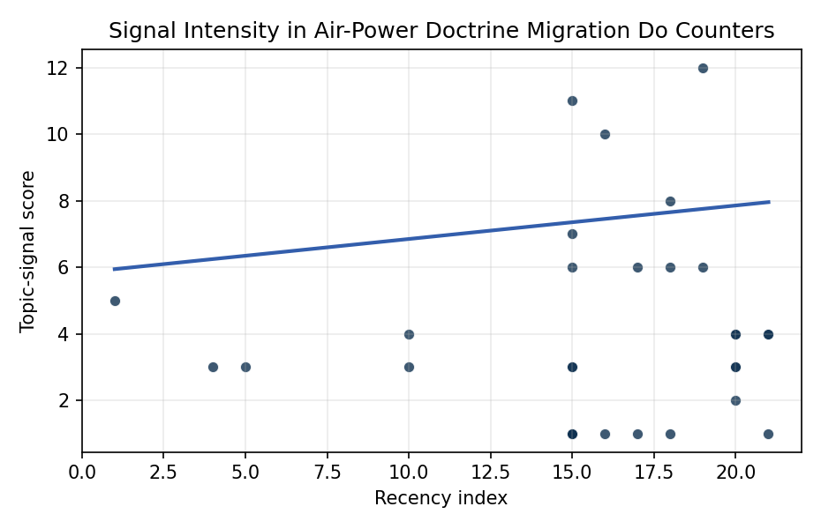
Figure 1. Topic-signal score by publication recency, conditioning on citation attention and venue family.

Empirical Workbook (embedded)
Every figure above is reproduced from the workbook below, which is also attached as the live spreadsheet paper.xlsx. Each observation carries its source.

Data (real observations)
doc_id | year_num | recency_index | cites_num | venue_score | title_words | snippet_words | keyword_count | theme_hits | signal_score | source
1 | 2020 | 15 | 0 | 1 | 5 | 13 | 6 | 3 | 7 | https://amostech.space/year/2020/international-perspectives-on-space-weapons/
2 | 2006 | 1 | 0 | 1 | 8 | 10 | 2 | 2 | 5 | https://amostech.space/year/2006/environmental-space-situation-awareness-and-joint-space-effects/
3 | 2020 | 15 | 0 | 1 | 13 | 12 | 14 | 4 | 11 | https://amostech.space/year/2020/australias-emerging-space-policy-defense-burden-sharing-in-orbit-and-space-situational-awareness/
4 | 2023 | 18 | 0 | 1 | 14 | 14 | 5 | 3 | 8 | 10.64861/TCOA6256
5 | 2021 | 16 | 0 | 1 | 8 | 10 | 2 | 4 | 10 | https://amostech.space/year/2021/test-on-the-new-ssa-system-of-jasdf/
6 | 2025 | 20 | 0 | 1 | 14 | 10 | 7 | 2 | 4 | 10.64861/OWDT6586
7 | 2015 | 10 | 0 | 1 | 6 | 13 | 4 | 2 | 4 | https://amostech.space/year/2015/project-unity-cross-domain-visualization-collaboration/
8 | 2010 | 5 | 0 | 1 | 5 | 14 | 1 | 1 | 3 | https://amostech.space/year/2010/small-space-launch-origins-challenges/
9 | 2009 | 4 | 0 | 1 | 9 | 14 | 1 | 1 | 3 | https://amostech.space/year/2009/operationally-responsive-space-launch-for-space-situational-awareness-missions/
10 | 2022 | 17 | 0 | 1 | 9 | 13 | 5 | 2 | 6 | https://amostech.space/year/2022/near-rectilinear-halo-orbit-surveillance-using-cislunar-periodic-orbits/
11 | 2025 | 20 | 0 | 1 | 12 | 10 | 6 | 1 | 3 | 10.64861/GDIM2412
12 | 2015 | 10 | 0 | 1 | 11 | 14 | 2 | 1 | 3 | https://amostech.space/year/2015/deploying-the-nasa-meter-class-autonomous-telescope-mcat-on-ascension-island/
13 | 2026 | 21 | 0 | 2 | 13 | 14 | 10 | 2 | 4 | 10.1016/j.actaastro.2026.02.013
14 | 2024 | 19 | 6 | 2 | 9 | 11 | 7 | 2 | 6 | 10.1016/j.actaastro.2024.09.042
15 | 2023 | 18 | 21 | 2 | 16 | 13 | 11 | 2 | 6 | 10.1016/j.actaastro.2023.02.043
16 | 2023 | 18 | 0 | 2 | 5 | 13 | 9 | 0 | 1 | 10.1016/j.actaastro.2023.04.010
17 | 2025 | 20 | 0 | 2 | 9 | 10 | 13 | 1 | 3 | 10.1016/j.actaastro.2025.01.061
18 | 2024 | 19 | 2 | 2 | 15 | 11 | 6 | 4 | 12 | 10.1016/j.actaastro.2024.09.003
19 | 2026 | 21 | 0 | 2 | 12 | 13 | 15 | 2 | 4 | 10.1016/j.actaastro.2026.05.049
20 | 2026 | 21 | 0 | 2 | 8 | 12 | 15 | 0 | 1 | 10.1016/j.actaastro.2026.04.003
21 | 2025 | 20 | 1 | 2 | 10 | 14 | 15 | 2 | 4 | 10.1016/j.actaastro.2025.08.042
22 | 2025 | 20 | 1 | 2 | 15 | 14 | 12 | 1 | 2 | 10.1016/j.actaastro.2025.10.046
23 | 2021 | 16 | 9 | 2 | 20 | 13 | 11 | 0 | 1 | 10.1016/j.actaastro.2021.08.032
24 | 2022 | 17 | 7 | 2 | 8 | 14 | 14 | 0 | 1 | 10.1016/j.actaastro.2022.05.053
25 | 2020 | 15 | 0 | 3 | 9 | 0 | 0 | 0 | 1 | Architectural Socio-Technological Transformative Change of Space-Use Norms
26 | 2020 | 15 | 0 | 3 | 51 | 0 | 0 | 0 | 3 | A 2021 Johns Hopkins SAIS doctoral thesis by Nathaniel Dailey proposing an International Space Reference Architecture (ISRA) as a socio-technological transformative mechanism to resolve contemporary space governance failures – orbital debris, policy fragmentation, and space traffic management – by coupling enterprise architecture methodology with international relations constructivist theory, blockchain-enabled information sharing, and norms entrepreneurship.
27 | 2020 | 15 | 0 | 3 | 45 | 0 | 0 | 1 | 6 | Stilwell et al. (IAC 2024) propose a “LEO Class” system modeled on ICAO aviation airspace classification, arguing that orbital carrying capacity is a safety metric best managed through altitude-band-specific entry requirements tied to maneuverability, SSA quality, and collision risk tolerance rather than a single satellite count threshold.
28 | 2020 | 15 | 0 | 3 | 7 | 0 | 0 | 0 | 1 | Roadmap: Australia Economic-Technological Renaissance in Space
29 | 2020 | 15 | 0 | 3 | 46 | 0 | 0 | 0 | 1 | OCEA/MITRE study critically evaluates major space economy forecasts, finds them systematically overstated due to CAGR methodology, double counting, and overreliance on nascent sectors; AR(1) time-series modeling projects a 2040 global space economy of $453-$511 billion, far below the widely cited $1 trillion figure, with $1 trillion not reachable before 2075.
30 | 2020 | 15 | 0 | 3 | 6 | 0 | 0 | 1 | 3 | SFA Space Economy and Integrated Deterrence

Variable construction
Variable | Definition | Construction / source
signal_score | Composite topic-signal score for each retrieved source record | Deterministic count built from candidate-theme term hits in the source title, snippet, keyword field, and author metadata; each row cites the retrieved source in the source column
recency_index | Publication recency index | Computed as publication year minus the minimum publication year in the paper sample plus one
cites_num | Reported citation count in the local brain index | Parsed from the local brain search cites field; zero when the index reported no citation count
venue_score | Ordinal venue-family score | AMOS = 1, Acta Astronautica = 2, Space Economy = 3

Estimator output
Term | Coef. | Std. err. | t | p | 95% CI
const | 5.8437 | 1.259 | 4.6417 | 3.455e-06 | [3.3762, 8.3112]
recency_index | 0.1007 | 0.0782 | 1.2871 | 0.1981 | [-0.0526, 0.254]
cites_num | 0.0304 | 0.0863 | 0.3517 | 0.7251 | [-0.1388, 0.1995]
venue_score | -1.7993 | 0.6362 | -2.8283 | 0.0047 | [-3.0462, -0.5524]
Fit: N = 30 R2 = 0.1901 R2_adj = 0.0966 F = 2.8204 F_p = 0.0586

