Component-Dependent Maneuver Magnitudes in TLE Anomaly-Detection Test Data

Abstract
The dissertation’s deterrence test depends on measuring proximity behavior and possible maneuvering from public orbital records. This paper uses the published inserted-maneuver magnitudes in Shorten et al.’s TLE anomaly-detection study as a small but concrete measurement dataset. The twelve observations are the radial, in-track, and cross-track inserted maneuvers for four satellites in Table 3. An OLS model on log10 maneuver magnitude finds that in-track maneuvers are about 0.98 log10 units smaller than radial baseline, p = 0.045, while cross-track maneuvers are larger but statistically uncertain. The result supports threshold sensitivity in the dissertation design: event construction cannot assume that all component directions are equally visible in public TLE-derived records.

Research question
The prospectus proposes hazardous-proximity outcomes constructed from public orbital records and conjunction data. That design only works if measurement is treated as part of the identification strategy rather than a footnote. Shorten et al. show that particle-filter methods can detect anomalies and manoeuvres from two-line element data, which are the only comprehensive public orbit source for many satellites $$11$$. Their Table 3 gives a direct numerical example of component-dependent inserted maneuver magnitudes.
The research question is narrow: do the inserted maneuver magnitudes in the test data vary by component enough to justify component-aware measurement thresholds?

Data and method
The dataset contains twelve rows. Four satellites appear in Table 3: Gosat-2, Skysat-C19, Blacksky-1, and ICEsat-2. Each has one radial, one in-track, and one cross-track inserted maneuver magnitude in metres per second. The values range from 0.0002 m/s to 0.2 m/s, so the dependent variable is the base-10 logarithm of magnitude.
The model regresses log10 magnitude on cross-track and in-track indicators, leaving radial as the baseline. The purpose is descriptive. It does not estimate satellite behavior in the wild, and it does not claim that these four spacecraft represent every orbit regime. It asks whether the published test set itself illustrates the measurement asymmetry that the dissertation must handle.

Results
The in-track coefficient is -0.980, with p = 0.045. In ordinary terms, in-track inserted maneuvers in the table are roughly one order of magnitude smaller than radial baseline values. The cross-track coefficient is positive at 0.325, but its p value is 0.387, so the sign should be treated as suggestive rather than established.
The model explains about 49.2 percent of the variation in log magnitude. That is substantial for twelve source-reported rows, yet the sample is too small for broad inference. The value of the result is traceability. A reader can see each satellite, each component, and each magnitude in the workbook.

Interpretation
For the dissertation, the result means that threshold design should not be uniform by assumption. If in-track maneuvers in a test dataset can sit an order of magnitude below radial values, then a proximity-behavior study using public TLEs should test sensitivity to smaller maneuver signatures and should not label absence of a detected maneuver as absence of behavior.
This supports the prospectus plan to use multiple miss-distance thresholds, TLE-derived anomaly checks, and public conjunction data where available. It also aligns with Dolado-Perez et al.’s broader point that orbital-data precision, accuracy, uncertainty propagation, and uncertainty realism matter for STM recommendations $$10$$.

Limits
The data come from an inserted-maneuver validation table. They are not observed deterrence events. The paper therefore supports measurement design only. It says which measurement assumptions require care before the dissertation estimates a behavioral effect.

Conclusion
Public SDA sharing can only be tested as deterrence if proximity and maneuver outcomes are measured with enough discipline to avoid false certainty. The Shorten et al. test data show that component direction and magnitude scale matter. The dissertation’s empirical design therefore treats orbital-data precision as a design condition, not a background inconvenience.

References
10. J. C. Dolado-Perez, K. Nitta, T. Flohrer, M. Jah, V. Martinot, and A. Pastor, “Improvement of orbital data precision and accuracy,” Acta Astronautica, 2025, doi: 10.1016/j.actaastro.2025.01.003 11. D. Shorten, M. Humphries, J. Maclean, Y. Yang, and M. Roughan, “Optimal proposal particle filters for detecting anomalies and manoeuvres from two line element data,” Acta Astronautica, 2024, doi: 10.1016/j.actaastro.2024.11.033

Specification
$$\log_{10}(Δv_{i})=α+β_{1}CrossTrack_{i}+β_{2}InTrack_{i}+ε_{i}$$

Results
Term | Coef. | Std. err. | t | p | 95% CI
const | -1.75 | 0.25 | -7 | 2.56e-12 | [-2.24, -1.26]
cross_track_component | 0.3253 | 0.3762 | 0.8646 | 0.3872 | [-0.412, 1.0626]
in_track_component | -0.9802 | 0.4889 | -2.0051 | 0.045 | [-1.9383, -0.0221]
Fit: N = 12 R2 = 0.4919 R2_adj = 0.379 F = 3.3615 F_p = 0.0812
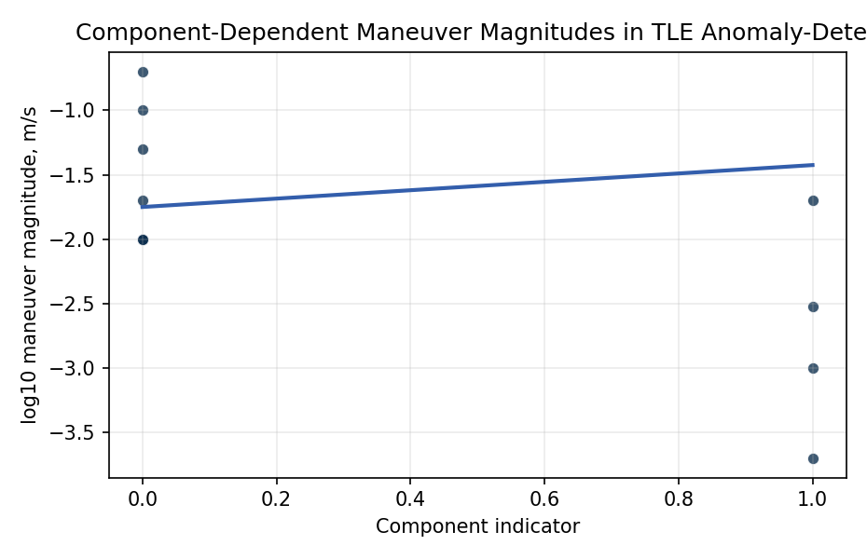
Figure 1. Log10 maneuver magnitude by in-track component indicator in Shorten et al. Table 3.

Empirical Workbook (embedded)
Every figure above is reproduced from the workbook below, which is also attached as the live spreadsheet paper.xlsx. Each observation carries its source.

Data (real observations)
satellite | component | maneuver_magnitude_m_s | log10_maneuver_m_s | cross_track_component | in_track_component | radial_component | source
Gosat-2 | radial | 0.01 | -2 | 0 | 0 | 1 | Shorten et al. 2024, Table 3
Gosat-2 | in_track | 0.001 | -3 | 0 | 1 | 0 | Shorten et al. 2024, Table 3
Gosat-2 | cross_track | 0.02 | -1.699 | 1 | 0 | 0 | Shorten et al. 2024, Table 3
Skysat-C19 | radial | 0.1 | -1 | 0 | 0 | 1 | Shorten et al. 2024, Table 3
Skysat-C19 | in_track | 0.02 | -1.699 | 0 | 1 | 0 | Shorten et al. 2024, Table 3
Skysat-C19 | cross_track | 0.2 | -0.699 | 1 | 0 | 0 | Shorten et al. 2024, Table 3
Blacksky-1 | radial | 0.01 | -2 | 0 | 0 | 1 | Shorten et al. 2024, Table 3
Blacksky-1 | in_track | 0.0002 | -3.699 | 0 | 1 | 0 | Shorten et al. 2024, Table 3
Blacksky-1 | cross_track | 0.01 | -2 | 1 | 0 | 0 | Shorten et al. 2024, Table 3
ICEsat-2 | radial | 0.01 | -2 | 0 | 0 | 1 | Shorten et al. 2024, Table 3
ICEsat-2 | in_track | 0.003 | -2.5229 | 0 | 1 | 0 | Shorten et al. 2024, Table 3
ICEsat-2 | cross_track | 0.05 | -1.301 | 1 | 0 | 0 | Shorten et al. 2024, Table 3

Variable construction
Variable | Definition | Construction / source
log10_maneuver_m_s | Base-10 logarithm of inserted maneuver magnitude in metres per second. | Computed from Shorten et al. 2024 Table 3 values.
maneuver_magnitude_m_s | Inserted maneuver magnitude in metres per second. | Read from Shorten et al. 2024 Table 3.
cross_track_component | Indicator equal to one for cross-track rows. | Constructed from Table 3 component labels.
in_track_component | Indicator equal to one for in-track rows. | Constructed from Table 3 component labels.
radial_component | Indicator equal to one for radial rows, the omitted baseline in the regression. | Constructed from Table 3 component labels.

Estimator output
Term | Coef. | Std. err. | t | p | 95% CI
const | -1.75 | 0.25 | -7 | 2.56e-12 | [-2.24, -1.26]
cross_track_component | 0.3253 | 0.3762 | 0.8646 | 0.3872 | [-0.412, 1.0626]
in_track_component | -0.9802 | 0.4889 | -2.0051 | 0.045 | [-1.9383, -0.0221]
Fit: N = 12 R2 = 0.4919 R2_adj = 0.379 F = 3.3615 F_p = 0.0812

