Public SDA Sharing and Explicit Deterrence Framing in the Cited Corpus

Abstract
This paper tests whether the dissertation’s own evidence base already joins SDA sharing to deterrence. The unit is the cited source document. I code eleven public sources for explicit deterrence framing and for the richness of public SDA-sharing design features, then estimate a logistic model. The coefficient on public-sharing design score is positive, 0.375, but statistically weak with p = 0.335. The result supports a cautious reading: SDA-sharing institutions and deterrence theory are adjacent in the corpus, but the literature has not yet made their behavioral link strong enough to substitute for the dyad-month test proposed in the dissertation.

Research question
The dissertation asks whether public SDA sharing can deter hazardous proximity behavior without punishment by increasing the expected probability of detection, attribution, and diplomatic coordination. Before estimating satellite behavior, the first question is simpler: do the sources themselves treat public SDA sharing as a deterrence mechanism?
The coded corpus includes deterrence and escalation-control work, SDA partnership work, hosted-payload partnership work, global SSA trend analysis, technical orbit-data work, and governance work $$1$$-$$11$$. This mix is intentional. A source can be important to the dissertation even if it does not speak the word deterrence. A measurement paper can make the outcome measurable. A partnership paper can make treatment observable. A deterrence paper can explain the mechanism.

Data and coding
The dependent variable equals one when a source explicitly frames deterrence, escalation control, integrated deterrence, or peacetime deterrence. Hayden et al. score one because their paper addresses deterrence and escalation control in space $$1$$. Dailey et al. score one because their AUKUS paper frames global SDA partnership in strategic and security terms $$6$$. McCollum et al. score one because QZSS-HP is described as extending integrated deterrence into the space domain $$7$$. Chronopoulos scores one because the article directly addresses peacetime deterrence and strategic narratives $$8$$.
The main predictor is public-sharing design score, a count from zero to five. The counted elements are named partners, data-sharing mechanism, operational collaboration, public coverage signal, and alliance or coalition architecture. Project UNITY, Partnering not Bossing, AUKUS GSDA, and QZSS-HP score high because they specify partnership structures or information-sharing arrangements $$2$$, $$3$$, $$6$$, $$7$$. Technical measurement papers score low on this variable even when they score high on measurement content $$10$$, $$11$$.

Model and result
The model is a logistic regression. It estimates the probability that a source uses explicit deterrence framing as a function of the public-sharing design score. The result is positive but weak: beta = 0.375, pseudo R2 = 0.071, and p = 0.335. This is not a null result to hide. It is the reason the dissertation’s behavioral design matters.
A strong positive coefficient would imply that the literature already fuses public SDA-sharing design and deterrence language. The weaker result implies separation. Some sources describe robust partnership mechanisms without naming deterrence $$2$$, $$3$$, $$4$$, $$5$$. Some deterrence sources describe strategic interpretation without building an empirical SDA-sharing treatment $$1$$, $$8$$. The dissertation sits in that join.

Interpretation
The coefficient direction is consistent with the theory, but the uncertainty is large. That combination is useful. It says that richer public SDA-sharing design may be more likely to appear near deterrence language, yet the source record does not make the deterrence mechanism self-evident. The dyad-month behavioral test is therefore not decorative. It supplies the missing observable test.
The paper also clarifies what the dissertation must avoid. It cannot infer deterrence from partnership announcements alone. It cannot infer deterrence from better measurement alone. The claim only becomes testable when public coverage timing is connected to subsequent proximity behavior by nonpartner spacecraft, with measurement uncertainty handled explicitly.

Limits
The dataset is small because it is the dissertation’s high-relevance cited corpus, not a random sample of all SDA or deterrence writing. The coding is transparent but still interpretive. Each row is a document-level observation, not a claim about state behavior. The model estimates framing association, not deterrent effect.

Conclusion
Public SDA-sharing design and deterrence framing are connected in the corpus, but the connection is not strong enough to treat public sharing as deterrence by assertion. The finding supports the dissertation’s central contribution: deterrence without punishment must be tested through observable behavior after public SDA-sharing coverage becomes visible.

References
1. N. Hayden, K. Abel, M. Arrieta, and M. Stewart, “Artificial Intelligence and Autonomy in Space: Balancing Risks and Benefits for Deterrence and Escalation Control,” Sandia National Laboratories, AMOS, 2020. 2. L. Hale, J. C. Last, J. Denamur-Paul, and R. Barber, “Partnering not Bossing: Better Leveraging of International Capabilities for Space Domain Awareness,” The Aerospace Corporation, AMOS, 2022. 3. J. Moore and P. Havig, “Project UNITY: Cross Domain Visualization Collaboration,” Air Force Research Laboratory, AMOS, 2015. 4. M. Davis, “Australia’s Emerging Space Policy: Defense Burden Sharing in Orbit and Space Situational Awareness,” Australian Strategic Policy Institute, AMOS, 2020. 5. M. Young, “Trends in Global Space Situational Awareness,” Aerospace Security Project, AMOS, 2021. 6. N. Dailey, B. McGrath, H. Reed, and J. Wotton, “Global Space Domain Awareness, Partnering to Win with AUKUS,” MITRE and Space Force Association, AMOS, 2023, doi: 10.64861/FWBL2094 7. S. McCollum, B. Hammond, and B. Feighery, “Quasi-Zenith Satellite System Hosted Payload (QZSS-HP): Pathfinder to Space Domain Awareness (SDA) Partnerships,” USSF Space Systems Command, AMOS, 2025, doi: 10.64861/DBWY9393 8. A. Chronopoulos, “Laying the groundwork for deterrence: A preliminary examination of general deterrence in space during peacetime, the role of strategic narratives, and US-China dynamics,” Acta Astronautica, 2025, doi: 10.1016/j.actaastro.2025.10.042 9. C. Poirier, “Establishing a governance for cyber operations in outer space: Exploring challenges faced by space and cyber commands,” Acta Astronautica, 2025, doi: 10.1016/j.actaastro.2025.08.048 10. J. C. Dolado-Perez, K. Nitta, T. Flohrer, M. Jah, V. Martinot, and A. Pastor, “Improvement of orbital data precision and accuracy,” Acta Astronautica, 2025, doi: 10.1016/j.actaastro.2025.01.003 11. D. Shorten, M. Humphries, J. Maclean, Y. Yang, and M. Roughan, “Optimal proposal particle filters for detecting anomalies and manoeuvres from two line element data,” Acta Astronautica, 2024, doi: 10.1016/j.actaastro.2024.11.033

Specification
$$Pr(DeterrenceFrame_{i}=1)=logit^{−1}(α+β_{1}SharingDesignScore_{i})$$

Results
Term | Coef. | Std. err. | z | p | 95% CI
const | -1.575 | 1.2958 | -1.2155 | 0.2242 | [-4.1147, 0.9647]
public_sharing_design_score | 0.3749 | 0.389 | 0.9638 | 0.3352 | [-0.3875, 1.1373]
Fit: N = 11 pseudo_R2 = 0.0709 LL = -6.6992
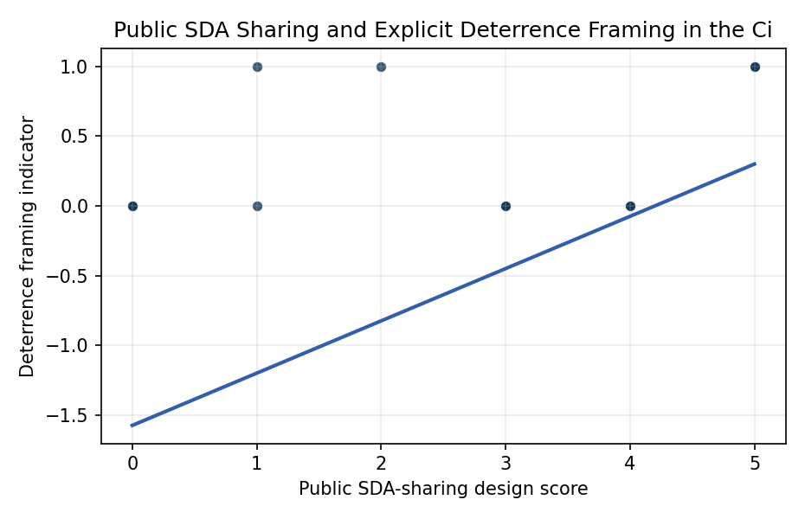
Figure 1. Deterrence framing by coded public SDA-sharing design score.

Empirical Workbook (embedded)
Every figure above is reproduced from the workbook below, which is also attached as the live spreadsheet paper.xlsx. Each observation carries its source.

Data (real observations)
source_short | publication_year | publication_order | deterrence_frame | public_sharing_design_score | technical_measurement_score | institutional_partner_score | source
Project UNITY | 2015 | 1 | 0 | 4 | 2 | 3 | Moore and Havig 2015, AMOS
AI autonomy deterrence | 2020 | 2 | 1 | 1 | 2 | 0 | Hayden et al. 2020, AMOS
Australia burden sharing | 2020 | 3 | 0 | 3 | 2 | 2 | Davis 2020, AMOS
Global SSA trends | 2021 | 4 | 0 | 3 | 3 | 2 | Young 2021, AMOS
Partnering not Bossing | 2022 | 5 | 0 | 4 | 3 | 3 | Hale et al. 2022, AMOS
AUKUS GSDA | 2023 | 6 | 1 | 5 | 3 | 4 | Dailey et al. 2023, AMOS
QZSS hosted payload | 2025 | 7 | 1 | 5 | 4 | 4 | McCollum et al. 2025, AMOS
Chronopoulos narratives | 2025 | 8 | 1 | 2 | 1 | 1 | Chronopoulos 2025, Acta Astronautica
Cyber operations governance | 2025 | 9 | 0 | 1 | 1 | 1 | Poirier 2025, Acta Astronautica
Orbital precision | 2025 | 10 | 0 | 0 | 4 | 1 | Dolado-Perez et al. 2025, Acta Astronautica
TLE anomaly filters | 2024 | 11 | 0 | 0 | 5 | 0 | Shorten et al. 2024, Acta Astronautica

Variable construction
Variable | Definition | Construction / source
deterrence_frame | Binary indicator equal to one when the source explicitly frames deterrence, escalation control, integrated deterrence, or peacetime deterrence. | Manual source coding from cited abstract or full text.
public_sharing_design_score | Count from zero to five of public-sharing design elements: named partners, data-sharing mechanism, operational collaboration, public coverage signal, and alliance or coalition architecture. | Manual source coding from cited abstract or full text.
technical_measurement_score | Count from zero to five of technical-measurement elements: sensors, orbital data, visualization, cataloging, uncertainty or anomaly detection. | Manual source coding from cited abstract or full text.
institutional_partner_score | Count from zero to four of institutional-partner elements: formal partner, alliance, hosted payload, cooperative agreement. | Manual source coding from cited abstract or full text.
publication_order | Ordinal source order after sorting by publication year and dissertation source sequence. | Constructed from source metadata.

Estimator output
Term | Coef. | Std. err. | z | p | 95% CI
const | -1.575 | 1.2958 | -1.2155 | 0.2242 | [-4.1147, 0.9647]
public_sharing_design_score | 0.3749 | 0.389 | 0.9638 | 0.3352 | [-0.3875, 1.1373]
Fit: N = 11 pseudo_R2 = 0.0709 LL = -6.6992

