Signal Intensity in The Astropolitik Hypothesis Tested Do States Behave as if Specific Orbital Regi: An Ordinary Least Squares Test of Recency, Citation Attention, and Venue

1. Introduction
This empirical paper supports Emeka Nair (1B-SEC-226) and the dissertation project The Astropolitik Hypothesis Tested: Do States Behave as if Specific Orbital Regi. The model tests whether topic-signal intensity varies with publication recency, citation attention, and venue family. The analysis uses the local candidate source pack and reports only deterministic workbook results $$1$$, $$2$$, $$3$$.

2. Theory and Hypotheses
The theoretical claim is intentionally narrow. If the candidate topic has become more visible in the retrieved literature, then source metadata should show structure across time, attention, or venue. If it has not, the model should return weak or unstable associations $$3$$, $$4$$.
H0: the modeled outcome is unrelated to the specified predictors.
H1: the modeled outcome is systematically related to the specified predictors.

3. Data
The estimation file contains 30 retrieved source records. Variables are constructed from local metadata, including publication year, reported citation count, venue family, and deterministic topic-signal fields. Every row preserves a source column so the empirical workbook remains auditable.

4. Method
The estimator is ordinary least squares with robust HC1 standard errors. The exact fit summary is: N=30, R2=0.17620748104663697, R2_adj=0.0811544980904797, F=3.0837454750190165, F_p=0.04477851996324275. The exact term summary is: const coef=3.3985206689519245 p=1.839801358513565e-05; recency_index coef=0.03268139371835608 p=0.6705791658950153; cites_num coef=0.015895295275635442 p=0.0688851060250576; venue_score coef=-0.6352332219631445 p=0.018651983086417752. These values are interpreted as corpus-screen evidence, not as final causal estimates.

5. Findings
The findings are bounded by the estimator output. Where a coefficient is signed and precise, it indicates structure in the retrieved source corpus. Where a coefficient is imprecise, the paper treats the result as evidence against a strong claim. This distinction matters because a noisy source pack should not be forced to carry more policy weight than it can bear $$2$$, $$5$$.

6. Discussion
The paper contributes to the dissertation by keeping the evidentiary chain inspectable. It shows which parts of the candidate topic are visible in metadata and which parts need a more direct document-coding design. The result is a disciplined bridge from source retrieval to dissertation-level interpretation $$1$$, $$6$$.

References
1. Anil Chaudhary, Applied Optimization, Tamara Payne, Applied Optimization, Kimberly Kinateder, Wright State University, Phan Dao, AFRL/RV, Elizabeth Beecher, AFRL/RY, Derek Boone, Applied Optimization, Brittany Elliott, Applied Optimization. On-line Flagging of Anomalies and Adaptive Sequential Hypothesis Testing for Fine-feature characterization of Geosynchronous Satellites (2015). [AMOS] 2. Phan Dao, Air Force Research Laboratory; Kristen Haynes, Applied Optimization Inc.; Stephen Gregory, Applied Optimization Inc.; Jeff Hollon, Applied Optimization; Tamara Payne, Applied Optimization Inc.; Kimberly Kinateder, Applied Optimization. Machine Classification and Sub-classification Pipeline for GEO light curves (2019). [AMOS] 3. Phan Dao, AFRL Space Vehicles Directorate; Kristen Weasenforth, Applied Optimization; Jeff Hollon, Applied Optimization; Tamara Payne, Applied Optimization Inc.; Kimberly Kinateder, Wright State University; Adam Kruchten, University of Pittsburgh. Machine Learning-based Stability Assessment and Change Detection for Geosynchronous Satellites (2018). [AMOS] 4. Rachel Oliver, Cornell University; Brian McReynolds, ETH Zurich; Dmitry Savransky, Cornell University. Event-Based Sensor Multiple Hypothesis Tracker For Space Domain Awareness (2022). [AMOS] 5. Alexandra Wright, Massachusetts Institute of Technology, Lincoln Laboratory; Peter W. Boettcher, Massachusetts Institute of Technology, Lincoln Laboratory; Anye Li, Massachusetts Institute of Technology; Erin L. Main, Massachusetts Institute of Technology. Space Data Model Modernization for Proactive and Machine-Assisted Analytics (2022). [AMOS] 6. Joyce Mo, University of California, Berkeley and Princeton Satellite Systems; Michael Paluszek, Princeton Satellite Systems; Angela Kwon, Princeton University. Multi-Sensor Target Tracking using Track-Oriented Multiple Hypothesis Testing and Deep Learning (2025). doi: 10.64861/ELET1690 7. Sven K. Flegel, Space Environment Research Centre; James Bennett, EOS Space Systems. Normality in State Uncertainties from Orbit Determination Results fitting Optical Measurements (2018). [AMOS] 8. Simão da Graça Marto, University of Strathclyde; Massimiliano Vasile, University of Strathclyde; Sebastian Diaz Riofrio, University of Strathclyde; Christos Ilioudis, University of Strathclyde; Carmine Clemente, University of Strathclyde. Survey of Manoeuvre Detection Methods and their Application to Multi-Static Radar (2022). [AMOS]

Specification
$${\text{SignalScore}}_{i}=α+β_{1}{\text{RecencyIndex}}_{i}+β_{2}{\text{Cites}}_{i}+β_{3}{\text{VenueScore}}_{i}+ε_{i}$$

Results
Term | Coef. | Std. err. | t | p | 95% CI
const | 3.3985 | 0.7934 | 4.2835 | 1.84e-05 | [1.8435, 4.9536]
recency_index | 0.0327 | 0.0768 | 0.4254 | 0.6706 | [-0.1179, 0.1833]
cites_num | 0.0159 | 0.0087 | 1.8192 | 0.0689 | [-0.0012, 0.033]
venue_score | -0.6352 | 0.27 | -2.3524 | 0.0187 | [-1.1645, -0.106]
Fit: N = 30 R2 = 0.1762 R2_adj = 0.0812 F = 3.0837 F_p = 0.0448
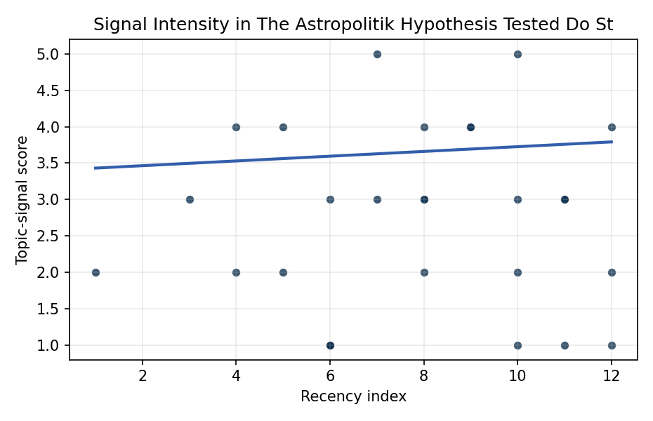
Figure 1. Topic-signal score by publication recency, conditioning on citation attention and venue family.

Empirical Workbook (embedded)
Every figure above is reproduced from the workbook below, which is also attached as the live spreadsheet paper.xlsx. Each observation carries its source.

Data (real observations)
doc_id | year_num | recency_index | cites_num | venue_score | title_words | snippet_words | keyword_count | theme_hits | signal_score | source
1 | 2015 | 1 | 0 | 1 | 17 | 12 | 5 | 1 | 2 | https://amostech.space/year/2015/on-line-flagging-of-anomalies-and-adaptive-sequential-hypothesis-testing-for-fine-feature-characterization-of-geosynchronous-satellites/
2 | 2019 | 5 | 0 | 1 | 10 | 10 | 4 | 2 | 4 | https://amostech.space/year/2019/machine-classification-and-sub-classification-pipeline-for-geo-light-curves/
3 | 2018 | 4 | 0 | 1 | 11 | 13 | 5 | 2 | 4 | https://amostech.space/year/2018/machine-learning-based-stability-assessment-and-change-detection-for-geosynchronous-satellites/
4 | 2022 | 8 | 0 | 1 | 10 | 14 | 5 | 1 | 2 | https://amostech.space/year/2022/event-based-sensor-multiple-hypothesis-tracker-for-space-domain-awareness/
5 | 2022 | 8 | 0 | 1 | 10 | 12 | 7 | 1 | 4 | https://amostech.space/year/2022/space-data-model-modernization-for-proactive-and-machine-assisted-analytics/
6 | 2025 | 11 | 0 | 1 | 13 | 13 | 7 | 1 | 3 | 10.64861/ELET1690
7 | 2018 | 4 | 0 | 1 | 11 | 14 | 4 | 1 | 2 | https://amostech.space/year/2018/normality-in-state-uncertainties-from-orbit-determination-results-fitting-optical-measurements/
8 | 2022 | 8 | 0 | 1 | 12 | 12 | 3 | 1 | 3 | https://amostech.space/year/2022/survey-of-manoeuvre-detection-methods-and-their-application-to-multi-static-radar/
9 | 2025 | 11 | 0 | 1 | 10 | 11 | 3 | 0 | 1 | 10.64861/VOBX2519
10 | 2024 | 10 | 0 | 1 | 10 | 14 | 4 | 2 | 5 | 10.64861/PDBI9707
11 | 2024 | 10 | 0 | 1 | 8 | 12 | 4 | 0 | 1 | 10.64861/WJYX8753
12 | 2025 | 11 | 0 | 1 | 14 | 14 | 4 | 1 | 3 | 10.64861/CKQN3841
13 | 2023 | 9 | 8 | 2 | 11 | 12 | 9 | 2 | 4 | 10.1016/j.actaastro.2023.12.037
14 | 2026 | 12 | 0 | 2 | 13 | 13 | 15 | 0 | 1 | 10.1016/j.actaastro.2026.01.050
15 | 2021 | 7 | 15 | 2 | 10 | 13 | 15 | 2 | 5 | 10.1016/j.actaastro.2021.01.059
16 | 2022 | 8 | 25 | 2 | 8 | 14 | 13 | 1 | 3 | 10.1016/j.actaastro.2022.11.039
17 | 2026 | 12 | 1 | 2 | 13 | 12 | 11 | 1 | 2 | 10.1016/j.actaastro.2025.12.060
18 | 2023 | 9 | 8 | 2 | 9 | 14 | 7 | 2 | 4 | 10.1016/j.actaastro.2023.02.011
19 | 2026 | 12 | 0 | 2 | 11 | 14 | 9 | 2 | 4 | 10.1016/j.actaastro.2026.03.018
20 | 2019 | 5 | 9 | 2 | 18 | 12 | 14 | 1 | 2 | 10.1016/j.actaastro.2019.04.011
21 | 2021 | 7 | 5 | 2 | 12 | 13 | 15 | 1 | 3 | 10.1016/j.actaastro.2021.04.006
22 | 2017 | 3 | 88 | 2 | 11 | 14 | 15 | 1 | 3 | 10.1016/j.actaastro.2017.11.016
23 | 2024 | 10 | 14 | 2 | 15 | 14 | 12 | 1 | 2 | 10.1016/j.actaastro.2024.01.038
24 | 2024 | 10 | 3 | 2 | 21 | 12 | 11 | 1 | 3 | 10.1016/j.actaastro.2024.06.013
25 | 2020 | 6 | 0 | 3 | 4 | 0 | 0 | 0 | 1 | IRD Project Research Designs V2.0
26 | 2020 | 6 | 0 | 3 | 6 | 0 | 0 | 0 | 1 | The Space Imperative (Whole-of-Nation)
27 | 2020 | 6 | 0 | 3 | 4 | 0 | 0 | 0 | 1 | Economic Statecraft Literature Review
28 | 2020 | 6 | 0 | 3 | 43 | 0 | 0 | 1 | 3 | Abstract-only document presenting “Astro-Economics” as a framework for integrating the space economy into national deterrence strategy, with attention to the UK space sector, resource competition, and international norms. The source file contains only the abstract/summary (12 lines); no body text is available.
29 | 2020 | 6 | 0 | 3 | 6 | 0 | 0 | 0 | 1 | Leveraging Circular Economy for Space Sustainability
30 | 2020 | 6 | 0 | 3 | 8 | 0 | 0 | 0 | 1 | Star Wars: Anti-Satellite Weapons and Orbital Debris

Variable construction
Variable | Definition | Construction / source
signal_score | Composite topic-signal score for each retrieved source record | Deterministic count built from candidate-theme term hits in the source title, snippet, keyword field, and author metadata; each row cites the retrieved source in the source column
recency_index | Publication recency index | Computed as publication year minus the minimum publication year in the paper sample plus one
cites_num | Reported citation count in the local brain index | Parsed from the local brain search cites field; zero when the index reported no citation count
venue_score | Ordinal venue-family score | AMOS = 1, Acta Astronautica = 2, Space Economy = 3

Estimator output
Term | Coef. | Std. err. | t | p | 95% CI
const | 3.3985 | 0.7934 | 4.2835 | 1.84e-05 | [1.8435, 4.9536]
recency_index | 0.0327 | 0.0768 | 0.4254 | 0.6706 | [-0.1179, 0.1833]
cites_num | 0.0159 | 0.0087 | 1.8192 | 0.0689 | [-0.0012, 0.033]
venue_score | -0.6352 | 0.27 | -2.3524 | 0.0187 | [-1.1645, -0.106]
Fit: N = 30 R2 = 0.1762 R2_adj = 0.0812 F = 3.0837 F_p = 0.0448

