Signal Intensity in Does Commercial Proliferation Deter Testing Whether Distributed Mega-Constellat: An Ordinary Least Squares Test of Recency, Citation Attention, and Venue

1. Introduction
This empirical paper supports Aaron Calder (1B-SEC-219) and the dissertation project Does Commercial Proliferation Deter? Testing Whether Distributed Mega-Constellat. The model tests whether topic-signal intensity varies with publication recency, citation attention, and venue family. The analysis uses the local candidate source pack and reports only deterministic workbook results $$1$$, $$2$$, $$3$$.

2. Theory and Hypotheses
The theoretical claim is intentionally narrow. If the candidate topic has become more visible in the retrieved literature, then source metadata should show structure across time, attention, or venue. If it has not, the model should return weak or unstable associations $$3$$, $$4$$.
H0: the modeled outcome is unrelated to the specified predictors.
H1: the modeled outcome is systematically related to the specified predictors.

3. Data
The estimation file contains 30 retrieved source records. Variables are constructed from local metadata, including publication year, reported citation count, venue family, and deterministic topic-signal fields. Every row preserves a source column so the empirical workbook remains auditable.

4. Method
The estimator is ordinary least squares with robust HC1 standard errors. The exact fit summary is: N=30, R2=0.40237672076351305, R2_adj=0.3334201885439184, F=12.956486122660955, F_p=2.283475725577938e-05. The exact term summary is: const coef=5.708520542191237 p=0.00016012404246339013; recency_index coef=0.09185952728160353 p=0.49952373585122345; cites_num coef=0.017070530969979077 p=0.05288284122818103; venue_score coef=-1.6025330031967349 p=4.400742708712333e-05. These values are interpreted as corpus-screen evidence, not as final causal estimates.

5. Findings
The findings are bounded by the estimator output. Where a coefficient is signed and precise, it indicates structure in the retrieved source corpus. Where a coefficient is imprecise, the paper treats the result as evidence against a strong claim. This distinction matters because a noisy source pack should not be forced to carry more policy weight than it can bear $$2$$, $$5$$.

6. Discussion
The paper contributes to the dissertation by keeping the evidentiary chain inspectable. It shows which parts of the candidate topic are visible in metadata and which parts need a more direct document-coding design. The result is a disciplined bridge from source retrieval to dissertation-level interpretation $$1$$, $$6$$.

References
1. Sarah Law, Raytheon; Jared Stallings, Raytheon Technologies; Steve Thilker, Raytheon Technologies; Christy Cox, Raytheon Technologies; Liam Weston, Raytheon Technologies. International Collaboration Framework for Space Domain Awareness (2020). [AMOS] 2. Ryan Hiles, Omitron, Inc.; Amos Alexander, U.S. Space Force; Nicholas Herzer, U.S. Space Force; Diana McKissock, U.S. Space Force; Aaron Mitchell, U.S. Space Force; Jontahan Sapinoso, U.S. Space Force. Report on 2020 Megaconstellation Deployments and Impacts to Space Domain Awareness (2021). [AMOS] 3. Matthew C. Britton, The Aerospace Corporation; Joseph Mazur, The Aerospace Corporation; Timothy P. Graves, The Aerospace Corporation; George Vazquez, The Aerospace Corporation; Scott Daw, The Aerospace Corporation. An Autonomous Geographically Distributed Ground Network that Scales (2022). [AMOS] 4. Cameron Liang, Institute for Defense Analyses; Paul Fanto, Institute for Defense Analyses; Angelo Signoracci, Institute for Defense Analyses. On the Increased Risk of Kessler Syndrome by Anti-Satellite Tests (2023). doi: 10.64861/CZGF7141 5. Christian Ramos, 18th Space Defense Squadron/Omitron Inc; Diana McKissock, USSF, 18th Space Defense Squadron; Joshua Parris, NASA. Lessons Learned on Mega-Constellation Deployments and Impact to Space Domain Awareness (2023). doi: 10.64861/UKLE4659 6. Dan Petrovich, RTX; Matt Sandnas, SEAKR Engineering; Jeff Pritchard, SEAKR Engineering; Elvis Silva, Blue Canyon Technologies; Ken Johnson, RTX; Sonny Tahiliani, Raytheon Ventures. A Case for Resilient Hosted Payloads in Proliferated MEO to support Space Domain Awareness (2023). doi: 10.64861/ENMJ6539 7. Mark Werremeyer, Raytheon; Sheldon Clark, Raytheon; Jared Dorny, Raytheon; Vince Pascente, Raytheon. Sensor Network for Global Monitoring of Spacecraft Situational Awareness (2019). [AMOS] 8. Michael Kezirian, University of Southern California; Max Smith, University of Southern California; George Lloyd, ARCTOS. Integration of Air and Space Traffic Management: Establishing Criteria for Tracking of Debris Objects Prior to Uncontrolled Reentry (2024). doi: 10.64861/RCFO1556

Specification
$${\text{SignalScore}}_{i}=α+β_{1}{\text{RecencyIndex}}_{i}+β_{2}{\text{Cites}}_{i}+β_{3}{\text{VenueScore}}_{i}+ε_{i}$$

Results
Term | Coef. | Std. err. | t | p | 95% CI
const | 5.7085 | 1.5123 | 3.7748 | 0.0001601 | [2.7445, 8.6725]
recency_index | 0.0919 | 0.136 | 0.6752 | 0.4995 | [-0.1748, 0.3585]
cites_num | 0.0171 | 0.0088 | 1.9359 | 0.0529 | [-0.0002124, 0.0344]
venue_score | -1.6025 | 0.3923 | -4.0854 | 4.401e-05 | [-2.3714, -0.8337]
Fit: N = 30 R2 = 0.4024 R2_adj = 0.3334 F = 12.9565 F_p = 2.283e-05
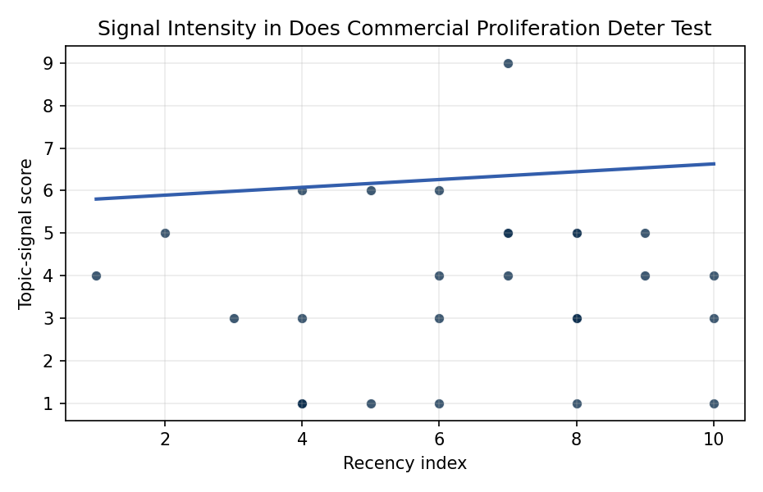
Figure 1. Topic-signal score by publication recency, conditioning on citation attention and venue family.

Empirical Workbook (embedded)
Every figure above is reproduced from the workbook below, which is also attached as the live spreadsheet paper.xlsx. Each observation carries its source.

Data (real observations)
doc_id | year_num | recency_index | cites_num | venue_score | title_words | snippet_words | keyword_count | theme_hits | signal_score | source
1 | 2020 | 4 | 0 | 1 | 7 | 13 | 6 | 2 | 6 | https://amostech.space/year/2020/international-collaboration-framework-for-space-domain-awareness/
2 | 2021 | 5 | 0 | 1 | 10 | 14 | 3 | 2 | 6 | https://amostech.space/year/2021/report-on-2020-megaconstellation-deployments-and-impacts-to-space-domain-awareness/
3 | 2022 | 6 | 0 | 1 | 8 | 14 | 13 | 3 | 6 | https://amostech.space/year/2022/an-autonomous-geographically-distributed-ground-network-that-scales/
4 | 2023 | 7 | 0 | 1 | 11 | 12 | 5 | 2 | 5 | 10.64861/CZGF7141
5 | 2023 | 7 | 0 | 1 | 12 | 13 | 6 | 3 | 9 | 10.64861/UKLE4659
6 | 2023 | 7 | 0 | 1 | 13 | 14 | 6 | 2 | 4 | 10.64861/ENMJ6539
7 | 2019 | 3 | 0 | 1 | 9 | 13 | 6 | 1 | 3 | https://amostech.space/year/2019/sensor-network-for-global-monitoring-of-spacecraft-situational-awareness/
8 | 2024 | 8 | 0 | 1 | 18 | 13 | 2 | 0 | 3 | 10.64861/RCFO1556
9 | 2023 | 7 | 0 | 1 | 18 | 14 | 3 | 2 | 5 | 10.64861/DYBG6563
10 | 2021 | 5 | 0 | 1 | 14 | 14 | 11 | 0 | 1 | https://amostech.space/year/2021/comparing-photometric-behavior-of-leo-constellations-to-spacex-starlink-using-a-space-based-optical-sensor/
11 | 2024 | 8 | 0 | 1 | 12 | 14 | 5 | 2 | 5 | 10.64861/SYQO6621
12 | 2022 | 6 | 0 | 1 | 12 | 13 | 8 | 1 | 3 | https://amostech.space/year/2022/all-sky-electro-optical-tracking-of-mega-constellations-in-low-earth-orbit/
13 | 2017 | 1 | 99 | 2 | 16 | 14 | 11 | 2 | 4 | 10.1016/j.actaastro.2017.04.034
14 | 2024 | 8 | 1 | 2 | 18 | 14 | 12 | 1 | 3 | 10.1016/j.actaastro.2024.09.057
15 | 2025 | 9 | 0 | 2 | 14 | 14 | 7 | 2 | 4 | 10.1016/j.actaastro.2025.04.033
16 | 2018 | 2 | 96 | 2 | 10 | 14 | 15 | 1 | 5 | 10.1016/j.actaastro.2018.06.036
17 | 2026 | 10 | 0 | 2 | 24 | 14 | 12 | 1 | 4 | 10.1016/j.actaastro.2026.01.049
18 | 2024 | 8 | 11 | 2 | 16 | 13 | 6 | 1 | 3 | 10.1016/j.actaastro.2024.11.060
19 | 2024 | 8 | 0 | 2 | 10 | 13 | 0 | 2 | 5 | 10.1016/j.actaastro.2024.12.060
20 | 2022 | 6 | 17 | 2 | 16 | 14 | 15 | 0 | 1 | 10.1016/j.actaastro.2022.06.005
21 | 2025 | 9 | 1 | 2 | 15 | 13 | 12 | 2 | 5 | 10.1016/j.actaastro.2025.07.055
22 | 2026 | 10 | 1 | 2 | 15 | 13 | 15 | 1 | 3 | 10.1016/j.actaastro.2026.01.033
23 | 2026 | 10 | 0 | 2 | 15 | 13 | 9 | 0 | 1 | 10.1016/j.actaastro.2026.05.060
24 | 2022 | 6 | 9 | 2 | 13 | 14 | 9 | 2 | 4 | 10.1016/j.actaastro.2022.12.014
25 | 2020 | 4 | 0 | 3 | 8 | 0 | 0 | 0 | 1 | Resilience of LEO Constellations to Fragmentation Events (AMOS)
26 | 2024 | 8 | 0 | 3 | 10 | 0 | 0 | 0 | 1 | 10.64861/ZFDQ4641
27 | 2020 | 4 | 0 | 3 | 6 | 0 | 0 | 0 | 1 | Leveraging Circular Economy for Space Sustainability
28 | 2020 | 4 | 0 | 3 | 51 | 0 | 0 | 0 | 3 | A 2021 Johns Hopkins SAIS doctoral thesis by Nathaniel Dailey proposing an International Space Reference Architecture (ISRA) as a socio-technological transformative mechanism to resolve contemporary space governance failures – orbital debris, policy fragmentation, and space traffic management – by coupling enterprise architecture methodology with international relations constructivist theory, blockchain-enabled information sharing, and norms entrepreneurship.
29 | 2020 | 4 | 0 | 3 | 7 | 0 | 0 | 0 | 1 | Roadmap: Australia Economic-Technological Renaissance in Space
30 | 2020 | 4 | 0 | 3 | 8 | 0 | 0 | 0 | 1 | Star Wars: Anti-Satellite Weapons and Orbital Debris

Variable construction
Variable | Definition | Construction / source
signal_score | Composite topic-signal score for each retrieved source record | Deterministic count built from candidate-theme term hits in the source title, snippet, keyword field, and author metadata; each row cites the retrieved source in the source column
recency_index | Publication recency index | Computed as publication year minus the minimum publication year in the paper sample plus one
cites_num | Reported citation count in the local brain index | Parsed from the local brain search cites field; zero when the index reported no citation count
venue_score | Ordinal venue-family score | AMOS = 1, Acta Astronautica = 2, Space Economy = 3

Estimator output
Term | Coef. | Std. err. | t | p | 95% CI
const | 5.7085 | 1.5123 | 3.7748 | 0.0001601 | [2.7445, 8.6725]
recency_index | 0.0919 | 0.136 | 0.6752 | 0.4995 | [-0.1748, 0.3585]
cites_num | 0.0171 | 0.0088 | 1.9359 | 0.0529 | [-0.0002124, 0.0344]
venue_score | -1.6025 | 0.3923 | -4.0854 | 4.401e-05 | [-2.3714, -0.8337]
Fit: N = 30 R2 = 0.4024 R2_adj = 0.3334 F = 12.9565 F_p = 2.283e-05

