Signal Intensity in Norm Entrepreneurship and the UNOOSA Record Which States Drive Space-Security N: An Ordinary Least Squares Test of Recency, Citation Attention, and Venue

1. Introduction
This empirical paper supports Dimitri Mbeki (1B-SEC-212) and the dissertation project Norm Entrepreneurship and the UNOOSA Record: Which States Drive Space-Security N. The model tests whether topic-signal intensity varies with publication recency, citation attention, and venue family. The analysis uses the local candidate source pack and reports only deterministic workbook results $$1$$, $$2$$, $$3$$.

2. Theory and Hypotheses
The theoretical claim is intentionally narrow. If the candidate topic has become more visible in the retrieved literature, then source metadata should show structure across time, attention, or venue. If it has not, the model should return weak or unstable associations $$3$$, $$4$$.
H0: the modeled outcome is unrelated to the specified predictors.
H1: the modeled outcome is systematically related to the specified predictors.

3. Data
The estimation file contains 30 retrieved source records. Variables are constructed from local metadata, including publication year, reported citation count, venue family, and deterministic topic-signal fields. Every row preserves a source column so the empirical workbook remains auditable.

4. Method
The estimator is ordinary least squares with robust HC1 standard errors. The exact fit summary is: N=30, R2=0.3067431057858272, R2_adj=0.2267519256841919, F=3.259013681877248, F_p=0.037532618194668736. The exact term summary is: const coef=2.5286864799356663 p=0.011758196740133968; recency_index coef=0.4332903975796549 p=0.010698715552124096; cites_num coef=0.030426212530881933 p=0.5446116916165807; venue_score coef=-0.7104099317626675 p=0.15852753897667848. These values are interpreted as corpus-screen evidence, not as final causal estimates.

5. Findings
The findings are bounded by the estimator output. Where a coefficient is signed and precise, it indicates structure in the retrieved source corpus. Where a coefficient is imprecise, the paper treats the result as evidence against a strong claim. This distinction matters because a noisy source pack should not be forced to carry more policy weight than it can bear $$2$$, $$5$$.

6. Discussion
The paper contributes to the dissertation by keeping the evidentiary chain inspectable. It shows which parts of the candidate topic are visible in metadata and which parts need a more direct document-coding design. The result is a disciplined bridge from source retrieval to dissertation-level interpretation $$1$$, $$6$$.

References
1. Harvey Reed, The MITRE Corporation; Ruth Stilwell, Aerospace Policy Solutions, LLC; Brian Weeden, Secure World Foundation; Nathaniel Dailey, The MITRE Corporation; Nick Tsamis, The MITRE Corporation. Sharing Operational Risk Information in the Space Domain to Facilitate Norms Development and Compliance Monitoring (2022). [AMOS] 2. Daniel Porras, Secure World Foundation; Laetitia Zarkan Cesari, University of Luxembourg. Safety Norms for Space Security: How the Development of STM Norms Can Strengthen Security in Space (2021). [AMOS] 3. John Goehring, National Geospatial-Intelligence Agency. U.S. Commercial Space Regulation: The Rule of Three (2022). [AMOS] 4. Todd Harrison, Center for Strategic and International Studies. International Perspectives on Space Weapons (2020). [AMOS] 5. Maciej Konacki, Nicolaus Copernicus Astronomical Center, Polish Academy of Sciences; Adrian Malacz, Polish Space Agency; Arkadiusz Chimicz, Polish Space Agency; Pawe? Lejba, Space Research Center, Polish Academy of Sciences, Borowiec Astrogeodynamic Observatory; Piotr Sybilski, Sybilla Technologies; Rafa? Paw?aszek, Sybilla Technologies; Stanis?aw Koz?owski, Cillium Engineering; Tomasz Suchodolski, Space Research Center, Polish Academy of Sciences, Borowiec Astrogeodynamic Observatory; Krzysztof Koz?owski, Institute of Automation and Robotics; Agnieszka Sybilska, Baltic Institute of Technology; Beata Rogowska, Nicolaus Copernicus Astronomical Center, Polish Academy of Sciences; Dariusz Pazderski, Institute of Automation and Robotics; Micha? ?o?nowski, 6Roads Ltd; Andy Shearer, National University of Ireland Galway; Agnieszka S?owikowska, Centre for Astronomy, Faculty of Physics, Astronomy and Informatics, Nicolaus Copernicus; Maciej Pilichowski, Sybilla Technologies; Marek Malawski, Polish Space Agency; Marcin G?dek, 6Roads Ltd. Optical, Laser and Processing Capabilities of the New Polish Space Situational Awareness Centre (2019). [AMOS] 6. Harvey Reed, MITRE; Nathaniel Dailey, MITRE; Ruth Stilwell, Aerospace Policy Solutions, LLC; Brian Weeden, Secure World Foundation. Decentralized Space Information Sharing as a Key Enabler of Trust and the Preservation of Space (2021). [AMOS] 7. Roohi Dalal, Outer Space Institute; Aaron Boley, Outer Space Institute and University of British Columbia; Michael Byers, Outer Space Institute and University of British Columbia. Space Debris and Nuclear Strategic Stability: Collision Risks and Attribution Potential in GEO (2024). doi: 10.64861/EIBC5616 8. Scott Steele, The Open University. Can International Law Provide a Basis for Actively Removing Space Debris? (2020). [AMOS]

Specification
$${\text{SignalScore}}_{i}=α+β_{1}{\text{RecencyIndex}}_{i}+β_{2}{\text{Cites}}_{i}+β_{3}{\text{VenueScore}}_{i}+ε_{i}$$

Results
Term | Coef. | Std. err. | t | p | 95% CI
const | 2.5287 | 1.0037 | 2.5193 | 0.0118 | [0.5614, 4.4959]
recency_index | 0.4333 | 0.1698 | 2.5524 | 0.0107 | [0.1006, 0.766]
cites_num | 0.0304 | 0.0502 | 0.6059 | 0.5446 | [-0.068, 0.1289]
venue_score | -0.7104 | 0.5038 | -1.41 | 0.1585 | [-1.6979, 0.2771]
Fit: N = 30 R2 = 0.3067 R2_adj = 0.2268 F = 3.259 F_p = 0.0375
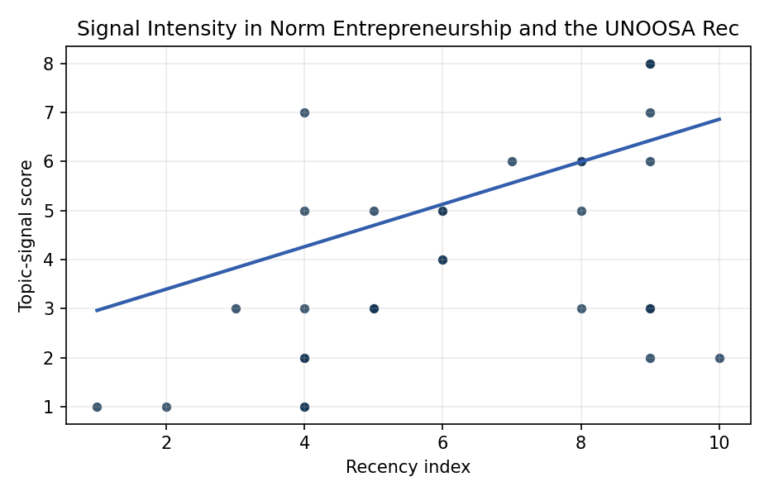
Figure 1. Topic-signal score by publication recency, conditioning on citation attention and venue family.

Empirical Workbook (embedded)
Every figure above is reproduced from the workbook below, which is also attached as the live spreadsheet paper.xlsx. Each observation carries its source.

Data (real observations)
doc_id | year_num | recency_index | cites_num | venue_score | title_words | snippet_words | keyword_count | theme_hits | signal_score | source
1 | 2022 | 6 | 0 | 1 | 15 | 14 | 3 | 2 | 5 | https://amostech.space/year/2022/sharing-operational-risk-information-in-the-space-domain-to-facilitate-norms-development-and-compliance-monitoring/
2 | 2021 | 5 | 0 | 1 | 16 | 14 | 6 | 2 | 5 | https://amostech.space/year/2021/safety-norms-for-space-security-how-the-development-of-stm-norms-can-strengthen-security-in-space/
3 | 2022 | 6 | 0 | 1 | 7 | 13 | 3 | 2 | 5 | https://amostech.space/year/2022/u-s-commercial-space-regulation-the-rule-of-three/
4 | 2020 | 4 | 0 | 1 | 5 | 14 | 6 | 1 | 3 | https://amostech.space/year/2020/international-perspectives-on-space-weapons/
5 | 2019 | 3 | 0 | 1 | 13 | 14 | 4 | 1 | 3 | https://amostech.space/year/2019/optical-laser-and-processing-capabilities-of-the-new-polish-space-situational-awareness-centre/
6 | 2021 | 5 | 0 | 1 | 14 | 14 | 7 | 1 | 3 | https://amostech.space/year/2021/decentralized-space-information-sharing-as-a-key-enabler-of-trust-and-the-preservation-of-space/
7 | 2024 | 8 | 0 | 1 | 13 | 11 | 3 | 2 | 6 | 10.64861/EIBC5616
8 | 2020 | 4 | 0 | 1 | 10 | 14 | 10 | 2 | 5 | https://amostech.space/year/2020/can-international-law-provide-a-basis-for-actively-removing-space-debris/
9 | 2021 | 5 | 0 | 1 | 8 | 12 | 8 | 1 | 3 | https://amostech.space/year/2021/geosynchronous-satellite-maneuver-classification-via-supervised-machine-learning/
10 | 2017 | 1 | 0 | 1 | 7 | 14 | 5 | 0 | 1 | https://amostech.space/year/2017/attaining-situational-understanding-in-the-space-domain/
11 | 2022 | 6 | 0 | 1 | 9 | 13 | 4 | 2 | 4 | https://amostech.space/year/2022/low-orbit-high-stakes-winning-the-leo-broadband-competition/
12 | 2022 | 6 | 0 | 1 | 14 | 14 | 3 | 1 | 4 | https://amostech.space/year/2022/employing-a-shared-space-information-sharing-ecosystem-as-a-mechanism-for-promoting-constructive-u-s-china-space-relations/
13 | 2025 | 9 | 2 | 2 | 12 | 13 | 12 | 3 | 7 | 10.1016/j.actaastro.2025.04.063
14 | 2025 | 9 | 0 | 2 | 9 | 13 | 13 | 0 | 2 | 10.1016/j.actaastro.2025.01.061
15 | 2024 | 8 | 22 | 2 | 11 | 14 | 15 | 2 | 5 | 10.1016/j.actaastro.2024.05.046
16 | 2025 | 9 | 0 | 2 | 23 | 14 | 12 | 3 | 8 | 10.1016/j.actaastro.2025.10.042
17 | 2023 | 7 | 21 | 2 | 13 | 13 | 15 | 2 | 6 | 10.1016/j.actaastro.2023.01.016
18 | 2024 | 8 | 6 | 2 | 13 | 14 | 10 | 2 | 6 | 10.1016/j.actaastro.2024.06.052
19 | 2025 | 9 | 1 | 2 | 10 | 14 | 7 | 3 | 8 | 10.1016/j.actaastro.2025.01.054
20 | 2025 | 9 | 0 | 2 | 14 | 14 | 13 | 1 | 3 | 10.1016/j.actaastro.2025.11.069
21 | 2018 | 2 | 3 | 2 | 15 | 12 | 9 | 0 | 1 | 10.1016/j.actaastro.2018.02.029
22 | 2025 | 9 | 5 | 2 | 11 | 14 | 7 | 2 | 6 | 10.1016/j.actaastro.2025.04.041
23 | 2024 | 8 | 17 | 2 | 12 | 12 | 15 | 1 | 3 | 10.1016/j.actaastro.2024.01.039
24 | 2025 | 9 | 0 | 2 | 12 | 14 | 9 | 1 | 3 | 10.1016/j.actaastro.2025.05.036
25 | 2020 | 4 | 0 | 3 | 6 | 0 | 0 | 0 | 1 | The Space Imperative (Whole-of-Nation)
26 | 2020 | 4 | 0 | 3 | 51 | 0 | 0 | 2 | 7 | A 2021 Johns Hopkins SAIS doctoral thesis by Nathaniel Dailey proposing an International Space Reference Architecture (ISRA) as a socio-technological transformative mechanism to resolve contemporary space governance failures – orbital debris, policy fragmentation, and space traffic management – by coupling enterprise architecture methodology with international relations constructivist theory, blockchain-enabled information sharing, and norms entrepreneurship.
27 | 2020 | 4 | 0 | 3 | 7 | 0 | 0 | 0 | 1 | Roadmap: Australia Economic-Technological Renaissance in Space
28 | 2020 | 4 | 0 | 3 | 9 | 0 | 0 | 1 | 2 | Architectural Socio-Technological Transformative Change of Space-Use Norms
29 | 2020 | 4 | 0 | 3 | 4 | 0 | 0 | 1 | 2 | Mapping Outer Space Norms
30 | 2026 | 10 | 0 | 3 | 11 | 0 | 0 | 1 | 2 | 10.1177/00471178261418898

Variable construction
Variable | Definition | Construction / source
signal_score | Composite topic-signal score for each retrieved source record | Deterministic count built from candidate-theme term hits in the source title, snippet, keyword field, and author metadata; each row cites the retrieved source in the source column
recency_index | Publication recency index | Computed as publication year minus the minimum publication year in the paper sample plus one
cites_num | Reported citation count in the local brain index | Parsed from the local brain search cites field; zero when the index reported no citation count
venue_score | Ordinal venue-family score | AMOS = 1, Acta Astronautica = 2, Space Economy = 3

Estimator output
Term | Coef. | Std. err. | t | p | 95% CI
const | 2.5287 | 1.0037 | 2.5193 | 0.0118 | [0.5614, 4.4959]
recency_index | 0.4333 | 0.1698 | 2.5524 | 0.0107 | [0.1006, 0.766]
cites_num | 0.0304 | 0.0502 | 0.6059 | 0.5446 | [-0.068, 0.1289]
venue_score | -0.7104 | 0.5038 | -1.41 | 0.1585 | [-1.6979, 0.2771]
Fit: N = 30 R2 = 0.3067 R2_adj = 0.2268 F = 3.259 F_p = 0.0375

