Signal Intensity in Verifiability as the Binding Constraint on Space Arms Control A Comparative Aud: An Ordinary Least Squares Test of Recency, Citation Attention, and Venue

1. Introduction
This empirical paper supports Mira Romano (1B-SEC-211) and the dissertation project Verifiability as the Binding Constraint on Space Arms Control: A Comparative Aud. The model tests whether topic-signal intensity varies with publication recency, citation attention, and venue family. The analysis uses the local candidate source pack and reports only deterministic workbook results $$1$$, $$2$$, $$3$$.

2. Theory and Hypotheses
The theoretical claim is intentionally narrow. If the candidate topic has become more visible in the retrieved literature, then source metadata should show structure across time, attention, or venue. If it has not, the model should return weak or unstable associations $$3$$, $$4$$.
H0: the modeled outcome is unrelated to the specified predictors.
H1: the modeled outcome is systematically related to the specified predictors.

3. Data
The estimation file contains 30 retrieved source records. Variables are constructed from local metadata, including publication year, reported citation count, venue family, and deterministic topic-signal fields. Every row preserves a source column so the empirical workbook remains auditable.

4. Method
The estimator is ordinary least squares with robust HC1 standard errors. The exact fit summary is: N=30, R2=0.5402985073139535, R2_adj=0.4872560273886404, F=14.673675870764065, F_p=8.638521153673204e-06. The exact term summary is: const coef=2.868231091659493 p=0.0038526729964795054; recency_index coef=0.2844607989680376 p=0.00014137891465885953; cites_num coef=-0.016632309620796825 p=0.10919475872648758; venue_score coef=-1.718239320724083 p=4.0171619928633545e-09. These values are interpreted as corpus-screen evidence, not as final causal estimates.

5. Findings
The findings are bounded by the estimator output. Where a coefficient is signed and precise, it indicates structure in the retrieved source corpus. Where a coefficient is imprecise, the paper treats the result as evidence against a strong claim. This distinction matters because a noisy source pack should not be forced to carry more policy weight than it can bear $$2$$, $$5$$.

6. Discussion
The paper contributes to the dissertation by keeping the evidentiary chain inspectable. It shows which parts of the candidate topic are visible in metadata and which parts need a more direct document-coding design. The result is a disciplined bridge from source retrieval to dissertation-level interpretation $$1$$, $$6$$.

References
1. Daniel Porras, Secure World Foundation; Laetitia Zarkan Cesari, University of Luxembourg. Safety Norms for Space Security: How the Development of STM Norms Can Strengthen Security in Space (2021). [AMOS] 2. Melrose Brown, UNSW Canberra Space; Brenton Smith, UNSW Canberra Space; Christopher Capon, UNSW Canberra Space; Rasit Abay, UNSW Canberra; Manuel Cegarra Polo, UNSW Canberra; Steve Gehly, UNSW Canberra; George Bowden, UNSW Canberra Space; Courtney Bright, UNSW Canberra; Andrew Lambert, UNSW Canberra; Russell Boyce, UNSW Canberra. SSA Experiments for the Australian M2 Formation Flying CubeSat Mission (2020). [AMOS] 3. Nathaniel Dailey, The MITRE Corporation; Kevin Toner, The MITRE Corporation; Dennis Murphy, Georgia Institute of Technology, Sam Nunn School of International Affairs. Employing a Shared Space Information Sharing Ecosystem as a Mechanism for Promoting Constructive U.S. China Space Relations (2022). [AMOS] 4. Andrea D’Ambrosio, Massachusetts Institute of Technology; Miles Lifson, Massachusetts Institute of Technology; Daniel Jang, Massachusetts Institute of Technology; Celina Pasiecznik, Massachusetts Institute of Technology; Richard Linares, Massachusetts Institute of Technology. Projected Orbital Demand and LEO Environmental Capacity (2022). [AMOS] 5. Harvey Reed, MITRE; Nathaniel Dailey, MITRE; Ruth Stilwell, Aerospace Policy Solutions, LLC; Brian Weeden, Secure World Foundation. Decentralized Space Information Sharing as a Key Enabler of Trust and the Preservation of Space (2021). [AMOS] 6. Dan Shen, Intelligent Fusion Technology, Inc; Khanh Pham, AFRL/RVSWS; Genshe Chen, Intelligent Fusion Technology, Inc.. A Numerical Solution to Orbital Pursuit-Evasion Games (2018). [AMOS] 7. Ray Deiotte (The Boeing Company), Dr. Mike Guyote (The Boeing Company), Dr. Thomas Kelecy (Boeing – LTS), Dr. Doyle Hall (Boeing – LTS), John Africano (Boeing – LTS), Paul Kervin (AMOS (AFRL/Det15). Maui Space Surveillance System Satellite Categorization Laboratory (2006). [AMOS] 8. Andrew Nicholas, Ted Finne, Ivan Galysh, Anthony Mai, Jim Yen, (Naval Research Laboratory, Washington, DC), Wayne Sawka, Jeff Ransdell, Shae Williams, (Digital Solid State Propulsion, Reno, NV). SpinSat Mission Overview (2013). [AMOS]

Specification
$${\text{SignalScore}}_{i}=α+β_{1}{\text{RecencyIndex}}_{i}+β_{2}{\text{Cites}}_{i}+β_{3}{\text{VenueScore}}_{i}+ε_{i}$$

Results
Term | Coef. | Std. err. | t | p | 95% CI
const | 2.8682 | 0.9925 | 2.89 | 0.0039 | [0.923, 4.8134]
recency_index | 0.2845 | 0.0747 | 3.8057 | 0.0001414 | [0.138, 0.431]
cites_num | -0.0166 | 0.0104 | -1.6018 | 0.1092 | [-0.037, 0.0037]
venue_score | -1.7182 | 0.292 | -5.8835 | 4.017e-09 | [-2.2906, -1.1458]
Fit: N = 30 R2 = 0.5403 R2_adj = 0.4873 F = 14.6737 F_p = 8.639e-06
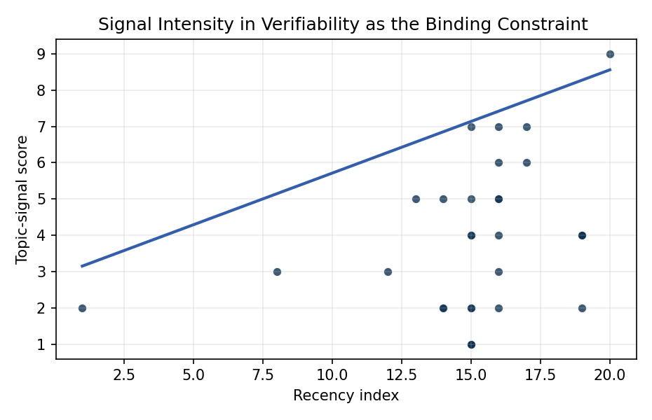
Figure 1. Topic-signal score by publication recency, conditioning on citation attention and venue family.

Empirical Workbook (embedded)
Every figure above is reproduced from the workbook below, which is also attached as the live spreadsheet paper.xlsx. Each observation carries its source.

Data (real observations)
doc_id | year_num | recency_index | cites_num | venue_score | title_words | snippet_words | keyword_count | theme_hits | signal_score | source
1 | 2021 | 16 | 0 | 1 | 16 | 14 | 6 | 3 | 7 | https://amostech.space/year/2021/safety-norms-for-space-security-how-the-development-of-stm-norms-can-strengthen-security-in-space/
2 | 2020 | 15 | 0 | 1 | 9 | 14 | 6 | 2 | 5 | https://amostech.space/year/2020/ssa-experiments-for-the-australian-m2-formation-flying-cubesat-mission/
3 | 2022 | 17 | 0 | 1 | 14 | 14 | 3 | 2 | 6 | https://amostech.space/year/2022/employing-a-shared-space-information-sharing-ecosystem-as-a-mechanism-for-promoting-constructive-u-s-china-space-relations/
4 | 2022 | 17 | 0 | 1 | 7 | 14 | 5 | 3 | 7 | https://amostech.space/year/2022/projected-orbital-demand-and-leo-environmental-capacity/
5 | 2021 | 16 | 0 | 1 | 14 | 13 | 7 | 2 | 5 | https://amostech.space/year/2021/decentralized-space-information-sharing-as-a-key-enabler-of-trust-and-the-preservation-of-space/
6 | 2018 | 13 | 0 | 1 | 7 | 10 | 7 | 2 | 5 | https://amostech.space/year/2018/a-numerical-solution-to-orbital-pursuit-evasion-games/
7 | 2006 | 1 | 0 | 1 | 7 | 13 | 2 | 1 | 2 | https://amostech.space/year/2006/maui-space-surveillance-system-satellite-categorization-laboratory/
8 | 2013 | 8 | 0 | 1 | 3 | 14 | 5 | 1 | 3 | https://amostech.space/year/2013/spinsat-mission-overview/
9 | 2017 | 12 | 0 | 1 | 8 | 14 | 6 | 1 | 3 | https://amostech.space/year/2017/non-traditional-sensor-tasking-for-ssa-a-case-study/
10 | 2020 | 15 | 0 | 1 | 5 | 14 | 6 | 3 | 7 | https://amostech.space/year/2020/international-perspectives-on-space-weapons/
11 | 2021 | 16 | 0 | 1 | 14 | 13 | 6 | 2 | 5 | https://amostech.space/year/2021/electric-propulsion-intelligent-control-epic-toolbox-for-proximity-operations-in-low-earth-orbit-leo/
12 | 2021 | 16 | 0 | 1 | 7 | 14 | 4 | 1 | 4 | https://amostech.space/year/2021/swedish-national-interests-in-space-situational-awareness/
13 | 2024 | 19 | 5 | 2 | 9 | 13 | 15 | 2 | 4 | 10.1016/j.actaastro.2024.07.036
14 | 2025 | 20 | 0 | 2 | 15 | 14 | 15 | 4 | 9 | 10.1016/j.actaastro.2025.09.031
15 | 2019 | 14 | 31 | 2 | 14 | 14 | 15 | 1 | 2 | 10.1016/j.actaastro.2019.03.008
16 | 2024 | 19 | 13 | 2 | 15 | 13 | 12 | 1 | 2 | 10.1016/j.actaastro.2024.12.036
17 | 2019 | 14 | 29 | 2 | 13 | 14 | 15 | 2 | 5 | 10.1016/j.actaastro.2019.08.004
18 | 2024 | 19 | 4 | 2 | 12 | 14 | 14 | 2 | 4 | 10.1016/j.actaastro.2024.03.023
19 | 2021 | 16 | 17 | 2 | 7 | 14 | 15 | 2 | 6 | 10.1016/j.actaastro.2021.04.009
20 | 2020 | 15 | 46 | 2 | 12 | 14 | 15 | 2 | 4 | 10.1016/j.actaastro.2020.08.006
21 | 2019 | 14 | 77 | 2 | 12 | 14 | 15 | 1 | 2 | 10.1016/j.actaastro.2019.11.002
22 | 2021 | 16 | 30 | 2 | 14 | 13 | 13 | 1 | 2 | 10.1016/j.actaastro.2021.03.021
23 | 2021 | 16 | 34 | 2 | 18 | 14 | 15 | 1 | 3 | 10.1016/j.actaastro.2021.01.034
24 | 2024 | 19 | 22 | 2 | 11 | 14 | 12 | 1 | 4 | 10.1016/j.actaastro.2024.12.017
25 | 2020 | 15 | 0 | 3 | 9 | 0 | 0 | 1 | 2 | International Relations and Economic Dimensions of Trusted Space Data
26 | 2020 | 15 | 0 | 3 | 8 | 0 | 0 | 0 | 1 | Projected Orbital Demand and LEO Environmental Capacity (AMOS)
27 | 2020 | 15 | 0 | 3 | 41 | 0 | 0 | 1 | 4 | Stilwell et al. (ASCEND 2025) propose a policy-based orbital classification framework for LEO that draws on aviation airspace classification to establish performance-based entry requirements tied to congestion and collision risk, supported by econometric analysis of satellite-dependent Fortune 500/100 company financial impacts.
28 | 2020 | 15 | 0 | 3 | 4 | 0 | 0 | 0 | 1 | Economic Statecraft Literature Review
29 | 2020 | 15 | 0 | 3 | 32 | 0 | 0 | 1 | 2 | MITRE econometric study on satellite reliance among Fortune 500/100 companies (1994-2024) demonstrating material financial dependence on space infrastructure, framed alongside digital traceability as a confidence-building measure and instrument of economic statecraft in international relations.
30 | 2020 | 15 | 0 | 3 | 6 | 0 | 0 | 0 | 1 | pyssem: Python Port of MOCAT-SSEM

Variable construction
Variable | Definition | Construction / source
signal_score | Composite topic-signal score for each retrieved source record | Deterministic count built from candidate-theme term hits in the source title, snippet, keyword field, and author metadata; each row cites the retrieved source in the source column
recency_index | Publication recency index | Computed as publication year minus the minimum publication year in the paper sample plus one
cites_num | Reported citation count in the local brain index | Parsed from the local brain search cites field; zero when the index reported no citation count
venue_score | Ordinal venue-family score | AMOS = 1, Acta Astronautica = 2, Space Economy = 3

Estimator output
Term | Coef. | Std. err. | t | p | 95% CI
const | 2.8682 | 0.9925 | 2.89 | 0.0039 | [0.923, 4.8134]
recency_index | 0.2845 | 0.0747 | 3.8057 | 0.0001414 | [0.138, 0.431]
cites_num | -0.0166 | 0.0104 | -1.6018 | 0.1092 | [-0.037, 0.0037]
venue_score | -1.7182 | 0.292 | -5.8835 | 4.017e-09 | [-2.2906, -1.1458]
Fit: N = 30 R2 = 0.5403 R2_adj = 0.4873 F = 14.6737 F_p = 8.639e-06

