Attention Accumulation in Entanglement and Inadvertent Escalation Mapping Dual-Use Space Assets That Coup: A Learning-Curve Analysis of Citation Growth by Article Age

1. Introduction
This empirical paper supports Lorenzo Cohen (1B-SEC-218) and the dissertation project Entanglement and Inadvertent Escalation: Mapping Dual-Use Space Assets That Coup. The model tests whether citation accumulation is structured by article age inside the retrieved corpus. The analysis uses the local candidate source pack and reports only deterministic workbook results $$1$$, $$2$$, $$3$$.

2. Theory and Hypotheses
The theoretical claim is intentionally narrow. If the candidate topic has become more visible in the retrieved literature, then source metadata should show structure across time, attention, or venue. If it has not, the model should return weak or unstable associations $$3$$, $$4$$.
H0: the modeled outcome is unrelated to the specified predictors.
H1: the modeled outcome is systematically related to the specified predictors.

3. Data
The estimation file contains 30 retrieved source records. Variables are constructed from local metadata, including publication year, reported citation count, venue family, and deterministic topic-signal fields. Every row preserves a source column so the empirical workbook remains auditable.

4. Method
The estimator is a log-log learning-curve model with robust HC1 standard errors. The exact fit summary is: N=30, R2=0.0005015871517498605, elasticity_b=0.02541687120304334, progress_ratio_2^b=1.017773738493698. The exact term summary is: const coef=0.2979084624246928 p=0.08538254432310016; _ln_x coef=0.02541687120304334 p=0.8673991317801459. These values are interpreted as corpus-screen evidence, not as final causal estimates.

5. Findings
The findings are bounded by the estimator output. Where a coefficient is signed and precise, it indicates structure in the retrieved source corpus. Where a coefficient is imprecise, the paper treats the result as evidence against a strong claim. This distinction matters because a noisy source pack should not be forced to carry more policy weight than it can bear $$2$$, $$5$$.

6. Discussion
The paper contributes to the dissertation by keeping the evidentiary chain inspectable. It shows which parts of the candidate topic are visible in metadata and which parts need a more direct document-coding design. The result is a disciplined bridge from source retrieval to dissertation-level interpretation $$1$$, $$6$$.

References
1. Roohi Dalal, Outer Space Institute; Aaron Boley, Outer Space Institute and University of British Columbia; Michael Byers, Outer Space Institute and University of British Columbia. Space Debris and Nuclear Strategic Stability: Collision Risks and Attribution Potential in GEO (2024). doi: 10.64861/EIBC5616 2. Nancy Hayden, Sandia National Laboratories; Kelsey Abel, Sandia National Laboratories; Marie Arrieta, Sandia National Laboratories; Mallory Stewart, Sandia National Laboratories. Artificial Intelligence and Autonomy in Space: Balancing Risks and Benefits for Deterrence and Escalation Control (2020). [AMOS] 3. Darin Koblick, Raytheon intelligence and space; Steven Wilkinson, Raytheon Space and Airborne Systems. Space-Based Spooky Radar Orbit Determination at the Earth-Moon Lagrange Points (2020). [AMOS] 4. Miguel Nunes, Hawaii Space Flight Laboratory; Piper Kline, Hawaii Space Flight Laboratory; Peter Englert, University of Hawaii at Manoa; Craig Hardgrove, Arizona State University; William Edmonson, University of Hawaii at Manoa; Scott Ginoza, Hawaii Space Flight Laboratory. Neutron-2: Advancing Space Weather Monitoring and Anomaly Detection with a Dual CubeSat System (2025). doi: 10.64861/TFPO6156 5. Panna Felsen, The Aerospace Corporation; Ronald Scrofano, The Aerospace Corporation; Ruben Rosales, The Aerospace Corporation; John Subasavage, The Aerospace Corporation; Nehal Desai, The Aerospace Corporation; Timothy Smith, The Aerospace Corporation; Michael Dearborn, The Aerospace Corporation. Detecting Space Objects in Event Camera Data through 3D Point Cloud Processing (2022). [AMOS] 6. Harvey Reed, MITRE; Nathaniel Dailey, MITRE; Ruth Stilwell, Aerospace Policy Solutions, LLC; Brian Weeden, Secure World Foundation. Decentralized Space Information Sharing as a Key Enabler of Trust and the Preservation of Space (2021). [AMOS] 7. Daniel Kline, Johns Hopkins University. Cybersecurity for Responsible AI/ML Usage in SDA Applications (2025). doi: 10.64861/VEWW9997 8. Adam Archuleta, DigitalGlobe, Inc.; Michael Nicolls, LeoLabs. Space Debris Mapping Services for use by LEO Satellite Operators (2018). [AMOS]

Specification
$$ln({\text{CitesPlus1}}_{i})=α+β_{1}ln({\text{AgeIndex}}_{i})+ε_{i}$$

Results
Term | Coef. | Std. err. | t | p | 95% CI
const | 0.2979 | 0.1732 | 1.7203 | 0.0854 | [-0.0415, 0.6373]
_ln_x | 0.0254 | 0.1522 | 0.167 | 0.8674 | [-0.2729, 0.3238]
Fit: N = 30 R2 = 0.0005016 elasticity_b = 0.0254 progress_ratio_2^b = 1.0178
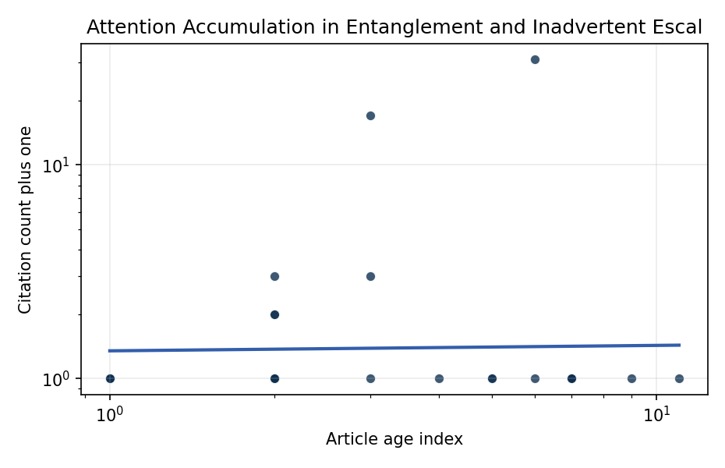
Figure 1. Citation accumulation against article age in the retrieved topic literature.

Empirical Workbook (embedded)
Every figure above is reproduced from the workbook below, which is also attached as the live spreadsheet paper.xlsx. Each observation carries its source.

Data (real observations)
doc_id | year_num | age_index | cites_num | cites_plus1 | signal_score | source
1 | 2024 | 3 | 0 | 1 | 8 | 10.64861/EIBC5616
2 | 2020 | 7 | 0 | 1 | 7 | https://amostech.space/year/2020/artificial-intelligence-and-autonomy-in-space-balancing-risks-and-benefits-for-deterrence-and-escalation-control/
3 | 2020 | 7 | 0 | 1 | 1 | https://amostech.space/year/2020/space-based-spooky-radar-orbit-determination-at-the-earth-moon-lagrange-points/
4 | 2025 | 2 | 0 | 1 | 4 | 10.64861/TFPO6156
5 | 2022 | 5 | 0 | 1 | 1 | https://amostech.space/year/2022/detecting-space-objects-in-event-camera-data-through-3d-point-cloud-processing/
6 | 2021 | 6 | 0 | 1 | 3 | https://amostech.space/year/2021/decentralized-space-information-sharing-as-a-key-enabler-of-trust-and-the-preservation-of-space/
7 | 2025 | 2 | 0 | 1 | 3 | 10.64861/VEWW9997
8 | 2018 | 9 | 0 | 1 | 4 | https://amostech.space/year/2018/space-debris-mapping-services-for-use-by-leo-satellite-operators/
9 | 2023 | 4 | 0 | 1 | 1 | 10.64861/TPIM7458
10 | 2016 | 11 | 0 | 1 | 3 | https://amostech.space/year/2016/satellite-based-emi-detection-identification-and-mitigation/
11 | 2025 | 2 | 0 | 1 | 5 | 10.64861/AZUD8556
12 | 2022 | 5 | 0 | 1 | 1 | https://amostech.space/year/2022/formation-flying-and-change-detection-for-the-unsw-canberra-space-m2-low-earth-orbit-formation-flying-cubesat-mission/
13 | 2026 | 1 | 0 | 1 | 3 | 10.1016/j.actaastro.2026.05.023
14 | 2024 | 3 | 2 | 3 | 9 | 10.1016/j.actaastro.2024.09.003
15 | 2025 | 2 | 0 | 1 | 3 | 10.1016/j.actaastro.2025.01.061
16 | 2021 | 6 | 30 | 31 | 5 | 10.1016/j.actaastro.2021.03.021
17 | 2026 | 1 | 0 | 1 | 2 | 10.1016/j.actaastro.2026.01.060
18 | 2025 | 2 | 0 | 1 | 5 | 10.1016/j.actaastro.2025.09.031
19 | 2025 | 2 | 0 | 1 | 9 | 10.1016/j.actaastro.2025.08.048
20 | 2025 | 2 | 2 | 3 | 5 | 10.1016/j.actaastro.2025.04.063
21 | 2024 | 3 | 16 | 17 | 1 | 10.1016/j.actaastro.2024.05.009
22 | 2026 | 1 | 0 | 1 | 1 | 10.1016/j.actaastro.2026.05.054
23 | 2025 | 2 | 1 | 2 | 1 | 10.1016/j.actaastro.2025.08.050
24 | 2025 | 2 | 1 | 2 | 3 | 10.1016/j.actaastro.2025.06.067
25 | 2020 | 7 | 0 | 1 | 3 | SFA Space Economy and Integrated Deterrence
26 | 2020 | 7 | 0 | 1 | 3 | SFA working paper arguing the space economy serves as both instrument and beneficiary of integrated deterrence, with UK-anchored investment data illustrating the sector’s strategic and economic weight.
27 | 2020 | 7 | 0 | 1 | 1 | Leveraging Circular Economy for Space Sustainability
28 | 2026 | 1 | 0 | 1 | 2 | 10.1177/00471178261418898
29 | 2020 | 7 | 0 | 1 | 3 | Abstract-only document presenting “Astro-Economics” as a framework for integrating the space economy into national deterrence strategy, with attention to the UK space sector, resource competition, and international norms. The source file contains only the abstract/summary (12 lines); no body text is available.
30 | 2020 | 7 | 0 | 1 | 2 | Stilwell et al. (ASCEND 2025) propose a policy-based orbital classification framework for LEO that draws on aviation airspace classification to establish performance-based entry requirements tied to congestion and collision risk, supported by econometric analysis of satellite-dependent Fortune 500/100 company financial impacts.

Variable construction
Variable | Definition | Construction / source
cites_plus1 | Citation count plus one | Computed as the reported citation count from the local brain index plus one so the log transformation is defined for uncited records
age_index | Document age index | Computed as 2026 minus publication year plus one

Estimator output
Term | Coef. | Std. err. | t | p | 95% CI
const | 0.2979 | 0.1732 | 1.7203 | 0.0854 | [-0.0415, 0.6373]
_ln_x | 0.0254 | 0.1522 | 0.167 | 0.8674 | [-0.2729, 0.3238]
Fit: N = 30 R2 = 0.0005016 elasticity_b = 0.0254 progress_ratio_2^b = 1.0178

