Signal Intensity in Entanglement and Inadvertent Escalation Mapping Dual-Use Space Assets That Coup: An Ordinary Least Squares Test of Recency, Citation Attention, and Venue

1. Introduction
This empirical paper supports Lorenzo Cohen (1B-SEC-218) and the dissertation project Entanglement and Inadvertent Escalation: Mapping Dual-Use Space Assets That Coup. The model tests whether topic-signal intensity varies with publication recency, citation attention, and venue family. The analysis uses the local candidate source pack and reports only deterministic workbook results $$1$$, $$2$$, $$3$$.

2. Theory and Hypotheses
The theoretical claim is intentionally narrow. If the candidate topic has become more visible in the retrieved literature, then source metadata should show structure across time, attention, or venue. If it has not, the model should return weak or unstable associations $$3$$, $$4$$.
H0: the modeled outcome is unrelated to the specified predictors.
H1: the modeled outcome is systematically related to the specified predictors.

3. Data
The estimation file contains 30 retrieved source records. Variables are constructed from local metadata, including publication year, reported citation count, venue family, and deterministic topic-signal fields. Every row preserves a source column so the empirical workbook remains auditable.

4. Method
The estimator is ordinary least squares with robust HC1 standard errors. The exact fit summary is: N=30, R2=0.031864010349406335, R2_adj=-0.07984398845643148, F=0.831876879288355, F_p=0.4884867637929132. The exact term summary is: const coef=3.3758090169143666 p=0.01732518076980005; recency_index coef=0.09403684275549393 p=0.42753191033759297; cites_num coef=0.02581730881601626 p=0.629783951435058; venue_score coef=-0.4189146624194333 p=0.3397385415386406. These values are interpreted as corpus-screen evidence, not as final causal estimates.

5. Findings
The findings are bounded by the estimator output. Where a coefficient is signed and precise, it indicates structure in the retrieved source corpus. Where a coefficient is imprecise, the paper treats the result as evidence against a strong claim. This distinction matters because a noisy source pack should not be forced to carry more policy weight than it can bear $$2$$, $$5$$.

6. Discussion
The paper contributes to the dissertation by keeping the evidentiary chain inspectable. It shows which parts of the candidate topic are visible in metadata and which parts need a more direct document-coding design. The result is a disciplined bridge from source retrieval to dissertation-level interpretation $$1$$, $$6$$.

References
1. Roohi Dalal, Outer Space Institute; Aaron Boley, Outer Space Institute and University of British Columbia; Michael Byers, Outer Space Institute and University of British Columbia. Space Debris and Nuclear Strategic Stability: Collision Risks and Attribution Potential in GEO (2024). doi: 10.64861/EIBC5616 2. Nancy Hayden, Sandia National Laboratories; Kelsey Abel, Sandia National Laboratories; Marie Arrieta, Sandia National Laboratories; Mallory Stewart, Sandia National Laboratories. Artificial Intelligence and Autonomy in Space: Balancing Risks and Benefits for Deterrence and Escalation Control (2020). [AMOS] 3. Darin Koblick, Raytheon intelligence and space; Steven Wilkinson, Raytheon Space and Airborne Systems. Space-Based Spooky Radar Orbit Determination at the Earth-Moon Lagrange Points (2020). [AMOS] 4. Miguel Nunes, Hawaii Space Flight Laboratory; Piper Kline, Hawaii Space Flight Laboratory; Peter Englert, University of Hawaii at Manoa; Craig Hardgrove, Arizona State University; William Edmonson, University of Hawaii at Manoa; Scott Ginoza, Hawaii Space Flight Laboratory. Neutron-2: Advancing Space Weather Monitoring and Anomaly Detection with a Dual CubeSat System (2025). doi: 10.64861/TFPO6156 5. Panna Felsen, The Aerospace Corporation; Ronald Scrofano, The Aerospace Corporation; Ruben Rosales, The Aerospace Corporation; John Subasavage, The Aerospace Corporation; Nehal Desai, The Aerospace Corporation; Timothy Smith, The Aerospace Corporation; Michael Dearborn, The Aerospace Corporation. Detecting Space Objects in Event Camera Data through 3D Point Cloud Processing (2022). [AMOS] 6. Harvey Reed, MITRE; Nathaniel Dailey, MITRE; Ruth Stilwell, Aerospace Policy Solutions, LLC; Brian Weeden, Secure World Foundation. Decentralized Space Information Sharing as a Key Enabler of Trust and the Preservation of Space (2021). [AMOS] 7. Daniel Kline, Johns Hopkins University. Cybersecurity for Responsible AI/ML Usage in SDA Applications (2025). doi: 10.64861/VEWW9997 8. Adam Archuleta, DigitalGlobe, Inc.; Michael Nicolls, LeoLabs. Space Debris Mapping Services for use by LEO Satellite Operators (2018). [AMOS]

Specification
$${\text{SignalScore}}_{i}=α+β_{1}{\text{RecencyIndex}}_{i}+β_{2}{\text{Cites}}_{i}+β_{3}{\text{VenueScore}}_{i}+ε_{i}$$

Results
Term | Coef. | Std. err. | t | p | 95% CI
const | 3.3758 | 1.4186 | 2.3797 | 0.0173 | [0.5955, 6.1561]
recency_index | 0.094 | 0.1185 | 0.7934 | 0.4275 | [-0.1383, 0.3263]
cites_num | 0.0258 | 0.0536 | 0.482 | 0.6298 | [-0.0792, 0.1308]
venue_score | -0.4189 | 0.4388 | -0.9547 | 0.3397 | [-1.2789, 0.4411]
Fit: N = 30 R2 = 0.0319 R2_adj = -0.0798 F = 0.8319 F_p = 0.4885
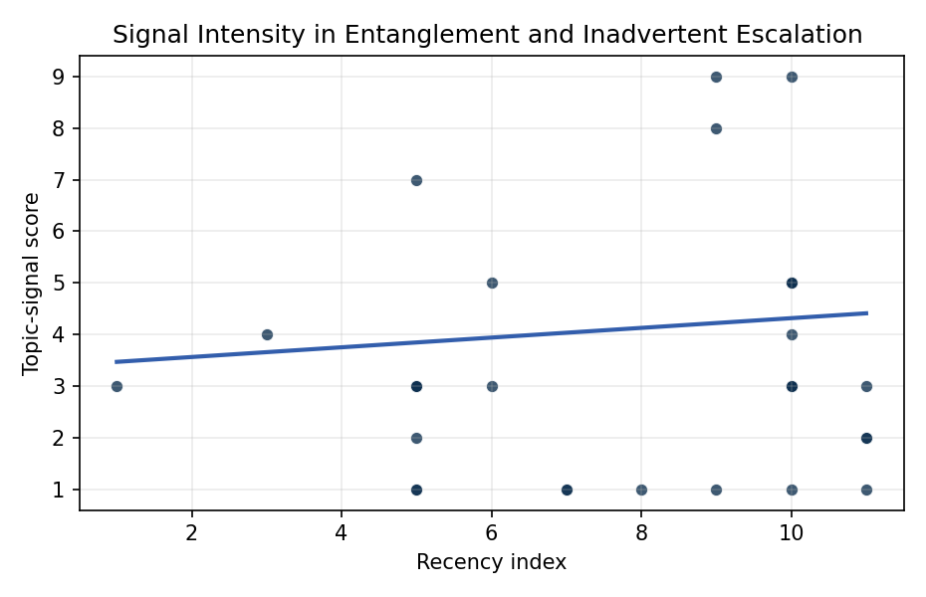
Figure 1. Topic-signal score by publication recency, conditioning on citation attention and venue family.

Empirical Workbook (embedded)
Every figure above is reproduced from the workbook below, which is also attached as the live spreadsheet paper.xlsx. Each observation carries its source.

Data (real observations)
doc_id | year_num | recency_index | cites_num | venue_score | title_words | snippet_words | keyword_count | theme_hits | signal_score | source
1 | 2024 | 9 | 0 | 1 | 13 | 13 | 3 | 3 | 8 | 10.64861/EIBC5616
2 | 2020 | 5 | 0 | 1 | 15 | 14 | 4 | 3 | 7 | https://amostech.space/year/2020/artificial-intelligence-and-autonomy-in-space-balancing-risks-and-benefits-for-deterrence-and-escalation-control/
3 | 2020 | 5 | 0 | 1 | 12 | 14 | 1 | 0 | 1 | https://amostech.space/year/2020/space-based-spooky-radar-orbit-determination-at-the-earth-moon-lagrange-points/
4 | 2025 | 10 | 0 | 1 | 12 | 14 | 10 | 2 | 4 | 10.64861/TFPO6156
5 | 2022 | 7 | 0 | 1 | 11 | 10 | 3 | 0 | 1 | https://amostech.space/year/2022/detecting-space-objects-in-event-camera-data-through-3d-point-cloud-processing/
6 | 2021 | 6 | 0 | 1 | 14 | 12 | 7 | 1 | 3 | https://amostech.space/year/2021/decentralized-space-information-sharing-as-a-key-enabler-of-trust-and-the-preservation-of-space/
7 | 2025 | 10 | 0 | 1 | 9 | 14 | 6 | 1 | 3 | 10.64861/VEWW9997
8 | 2018 | 3 | 0 | 1 | 10 | 14 | 6 | 1 | 4 | https://amostech.space/year/2018/space-debris-mapping-services-for-use-by-leo-satellite-operators/
9 | 2023 | 8 | 0 | 1 | 8 | 14 | 3 | 0 | 1 | 10.64861/TPIM7458
10 | 2016 | 1 | 0 | 1 | 7 | 13 | 7 | 1 | 3 | https://amostech.space/year/2016/satellite-based-emi-detection-identification-and-mitigation/
11 | 2025 | 10 | 0 | 1 | 9 | 14 | 3 | 2 | 5 | 10.64861/AZUD8556
12 | 2022 | 7 | 0 | 1 | 17 | 14 | 5 | 0 | 1 | https://amostech.space/year/2022/formation-flying-and-change-detection-for-the-unsw-canberra-space-m2-low-earth-orbit-formation-flying-cubesat-mission/
13 | 2026 | 11 | 0 | 2 | 15 | 14 | 10 | 1 | 3 | 10.1016/j.actaastro.2026.05.023
14 | 2024 | 9 | 2 | 2 | 15 | 14 | 6 | 3 | 9 | 10.1016/j.actaastro.2024.09.003
15 | 2025 | 10 | 0 | 2 | 9 | 14 | 13 | 1 | 3 | 10.1016/j.actaastro.2025.01.061
16 | 2021 | 6 | 30 | 2 | 14 | 14 | 13 | 2 | 5 | 10.1016/j.actaastro.2021.03.021
17 | 2026 | 11 | 0 | 2 | 13 | 13 | 10 | 1 | 2 | 10.1016/j.actaastro.2026.01.060
18 | 2025 | 10 | 0 | 2 | 15 | 13 | 15 | 2 | 5 | 10.1016/j.actaastro.2025.09.031
19 | 2025 | 10 | 0 | 2 | 16 | 13 | 15 | 3 | 9 | 10.1016/j.actaastro.2025.08.048
20 | 2025 | 10 | 2 | 2 | 12 | 14 | 12 | 2 | 5 | 10.1016/j.actaastro.2025.04.063
21 | 2024 | 9 | 16 | 2 | 17 | 11 | 10 | 0 | 1 | 10.1016/j.actaastro.2024.05.009
22 | 2026 | 11 | 0 | 2 | 16 | 14 | 7 | 0 | 1 | 10.1016/j.actaastro.2026.05.054
23 | 2025 | 10 | 1 | 2 | 20 | 12 | 15 | 0 | 1 | 10.1016/j.actaastro.2025.08.050
24 | 2025 | 10 | 1 | 2 | 10 | 11 | 5 | 1 | 3 | 10.1016/j.actaastro.2025.06.067
25 | 2020 | 5 | 0 | 3 | 6 | 0 | 0 | 1 | 3 | SFA Space Economy and Integrated Deterrence
26 | 2020 | 5 | 0 | 3 | 28 | 0 | 0 | 1 | 3 | SFA working paper arguing the space economy serves as both instrument and beneficiary of integrated deterrence, with UK-anchored investment data illustrating the sector’s strategic and economic weight.
27 | 2020 | 5 | 0 | 3 | 6 | 0 | 0 | 0 | 1 | Leveraging Circular Economy for Space Sustainability
28 | 2026 | 11 | 0 | 3 | 11 | 0 | 0 | 1 | 2 | 10.1177/00471178261418898
29 | 2020 | 5 | 0 | 3 | 43 | 0 | 0 | 1 | 3 | Abstract-only document presenting “Astro-Economics” as a framework for integrating the space economy into national deterrence strategy, with attention to the UK space sector, resource competition, and international norms. The source file contains only the abstract/summary (12 lines); no body text is available.
30 | 2020 | 5 | 0 | 3 | 41 | 0 | 0 | 0 | 2 | Stilwell et al. (ASCEND 2025) propose a policy-based orbital classification framework for LEO that draws on aviation airspace classification to establish performance-based entry requirements tied to congestion and collision risk, supported by econometric analysis of satellite-dependent Fortune 500/100 company financial impacts.

Variable construction
Variable | Definition | Construction / source
signal_score | Composite topic-signal score for each retrieved source record | Deterministic count built from candidate-theme term hits in the source title, snippet, keyword field, and author metadata; each row cites the retrieved source in the source column
recency_index | Publication recency index | Computed as publication year minus the minimum publication year in the paper sample plus one
cites_num | Reported citation count in the local brain index | Parsed from the local brain search cites field; zero when the index reported no citation count
venue_score | Ordinal venue-family score | AMOS = 1, Acta Astronautica = 2, Space Economy = 3

Estimator output
Term | Coef. | Std. err. | t | p | 95% CI
const | 3.3758 | 1.4186 | 2.3797 | 0.0173 | [0.5955, 6.1561]
recency_index | 0.094 | 0.1185 | 0.7934 | 0.4275 | [-0.1383, 0.3263]
cites_num | 0.0258 | 0.0536 | 0.482 | 0.6298 | [-0.0792, 0.1308]
venue_score | -0.4189 | 0.4388 | -0.9547 | 0.3397 | [-1.2789, 0.4411]
Fit: N = 30 R2 = 0.0319 R2_adj = -0.0798 F = 0.8319 F_p = 0.4885

