Signal Intensity in Escalation Ladders in Orbit Constructing and Validating a Counterspace Escalati: An Ordinary Least Squares Test of Recency, Citation Attention, and Venue

1. Introduction
This empirical paper supports Beatriz Renner (1B-SEC-217) and the dissertation project Escalation Ladders in Orbit: Constructing and Validating a Counterspace Escalati. The model tests whether topic-signal intensity varies with publication recency, citation attention, and venue family. The analysis uses the local candidate source pack and reports only deterministic workbook results $$1$$, $$2$$, $$3$$.

2. Theory and Hypotheses
The theoretical claim is intentionally narrow. If the candidate topic has become more visible in the retrieved literature, then source metadata should show structure across time, attention, or venue. If it has not, the model should return weak or unstable associations $$3$$, $$4$$.
H0: the modeled outcome is unrelated to the specified predictors.
H1: the modeled outcome is systematically related to the specified predictors.

3. Data
The estimation file contains 30 retrieved source records. Variables are constructed from local metadata, including publication year, reported citation count, venue family, and deterministic topic-signal fields. Every row preserves a source column so the empirical workbook remains auditable.

4. Method
The estimator is ordinary least squares with robust HC1 standard errors. The exact fit summary is: N=30, R2=0.09496320802652625, R2_adj=-0.009464114124259293, F=9.868921816848365, F_p=0.00016062810334824265. The exact term summary is: const coef=3.0876816750513294 p=0.0944655344871964; recency_index coef=0.09735277539036408 p=0.2647598695260017; cites_num coef=0.1308373521113583 p=0.0010365277329562861; venue_score coef=-0.947614653077148 p=0.05063482707183259. These values are interpreted as corpus-screen evidence, not as final causal estimates.

5. Findings
The findings are bounded by the estimator output. Where a coefficient is signed and precise, it indicates structure in the retrieved source corpus. Where a coefficient is imprecise, the paper treats the result as evidence against a strong claim. This distinction matters because a noisy source pack should not be forced to carry more policy weight than it can bear $$2$$, $$5$$.

6. Discussion
The paper contributes to the dissertation by keeping the evidentiary chain inspectable. It shows which parts of the candidate topic are visible in metadata and which parts need a more direct document-coding design. The result is a disciplined bridge from source retrieval to dissertation-level interpretation $$1$$, $$6$$.

References
1. Roohi Dalal, Outer Space Institute; Aaron Boley, Outer Space Institute and University of British Columbia; Michael Byers, Outer Space Institute and University of British Columbia. Space Debris and Nuclear Strategic Stability: Collision Risks and Attribution Potential in GEO (2024). doi: 10.64861/EIBC5616 2. Nancy Hayden, Sandia National Laboratories; Kelsey Abel, Sandia National Laboratories; Marie Arrieta, Sandia National Laboratories; Mallory Stewart, Sandia National Laboratories. Artificial Intelligence and Autonomy in Space: Balancing Risks and Benefits for Deterrence and Escalation Control (2020). [AMOS] 3. Joe Gorman, Charles River Analytics, Martin Voshell, Charles River Analytics, Amy Sliva, Charles River Analytics. Assessment for Operator Confidence in Automated Space Situational Awareness and Satellite Control Systems (2016). [AMOS] 4. Andris Jaunzemis, Georgia Institute of Technology; Dev Minotra, Georgia Institute of Technology; Karen Feigh, Georgia Institute of Technology; Marcus Holzinger, Georgia Institute of Technology; Moses Chan, Lockheed Martin Space. SSA Decision Support System Development and Evaluation using Cognitive Systems Engineering (2018). [AMOS] 5. Tamara Payne, Applied Optimization Inc., Philip Castro, Applied Optimization, Stephen Gregory, Boeing, Phan Dao, AFRL/RVBY. Satellite Photometric Error Determination (2015). [AMOS] 6. Ray Deiotte (The Boeing Company), Dr. Mike Guyote (The Boeing Company), Dr. Thomas Kelecy (Boeing – LTS), Dr. Doyle Hall (Boeing – LTS), John Africano (Boeing – LTS), Paul Kervin (AMOS (AFRL/Det15). Maui Space Surveillance System Satellite Categorization Laboratory (2006). [AMOS] 7. Malcolm Davis, The Australian Strategic Policy Institute. Australia’s Emerging Space Policy – Defense Burden Sharing in Orbit and Space Situational Awareness (2020). [AMOS] 8. Daniel Porras, Secure World Foundation; Laetitia Zarkan Cesari, University of Luxembourg. Safety Norms for Space Security: How the Development of STM Norms Can Strengthen Security in Space (2021). [AMOS]

Specification
$${\text{SignalScore}}_{i}=α+β_{1}{\text{RecencyIndex}}_{i}+β_{2}{\text{Cites}}_{i}+β_{3}{\text{VenueScore}}_{i}+ε_{i}$$

Results
Term | Coef. | Std. err. | t | p | 95% CI
const | 3.0877 | 1.8464 | 1.6723 | 0.0945 | [-0.5311, 6.7065]
recency_index | 0.0974 | 0.0873 | 1.1152 | 0.2648 | [-0.0737, 0.2684]
cites_num | 0.1308 | 0.0399 | 3.2804 | 0.001 | [0.0527, 0.209]
venue_score | -0.9476 | 0.4848 | -1.9546 | 0.0506 | [-1.8978, 0.0026]
Fit: N = 30 R2 = 0.095 R2_adj = -0.0095 F = 9.8689 F_p = 0.0001606
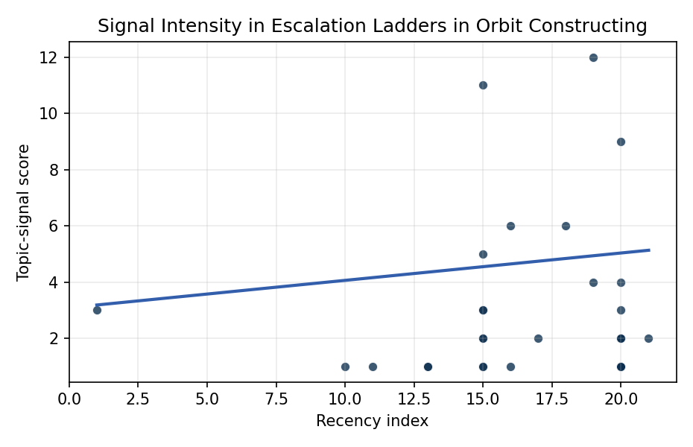
Figure 1. Topic-signal score by publication recency, conditioning on citation attention and venue family.

Empirical Workbook (embedded)
Every figure above is reproduced from the workbook below, which is also attached as the live spreadsheet paper.xlsx. Each observation carries its source.

Data (real observations)
doc_id | year_num | recency_index | cites_num | venue_score | title_words | snippet_words | keyword_count | theme_hits | signal_score | source
1 | 2024 | 19 | 0 | 1 | 13 | 14 | 3 | 1 | 4 | 10.64861/EIBC5616
2 | 2020 | 15 | 0 | 1 | 15 | 14 | 4 | 2 | 5 | https://amostech.space/year/2020/artificial-intelligence-and-autonomy-in-space-balancing-risks-and-benefits-for-deterrence-and-escalation-control/
3 | 2016 | 11 | 0 | 1 | 13 | 14 | 6 | 0 | 1 | https://amostech.space/year/2016/assessment-for-operator-confidence-in-automated-space-situational-awareness-and-satellite-control-systems/
4 | 2018 | 13 | 0 | 1 | 11 | 11 | 3 | 0 | 1 | https://amostech.space/year/2018/ssa-decision-support-system-development-and-evaluation-using-cognitive-systems-engineering/
5 | 2015 | 10 | 0 | 1 | 4 | 11 | 3 | 0 | 1 | https://amostech.space/year/2015/satellite-photometric-error-determination/
6 | 2006 | 1 | 0 | 1 | 7 | 14 | 2 | 1 | 3 | https://amostech.space/year/2006/maui-space-surveillance-system-satellite-categorization-laboratory/
7 | 2020 | 15 | 0 | 1 | 13 | 14 | 14 | 4 | 11 | https://amostech.space/year/2020/australias-emerging-space-policy-defense-burden-sharing-in-orbit-and-space-situational-awareness/
8 | 2021 | 16 | 0 | 1 | 16 | 12 | 6 | 2 | 6 | https://amostech.space/year/2021/safety-norms-for-space-security-how-the-development-of-stm-norms-can-strengthen-security-in-space/
9 | 2021 | 16 | 0 | 1 | 14 | 14 | 7 | 0 | 1 | https://amostech.space/year/2021/decentralized-space-information-sharing-as-a-key-enabler-of-trust-and-the-preservation-of-space/
10 | 2025 | 20 | 0 | 1 | 11 | 14 | 4 | 1 | 4 | 10.64861/UHIX1013
11 | 2022 | 17 | 0 | 1 | 6 | 12 | 10 | 1 | 2 | https://amostech.space/year/2022/mirror-recoating-of-large-primary-optic/
12 | 2020 | 15 | 0 | 1 | 5 | 14 | 6 | 1 | 3 | https://amostech.space/year/2020/international-perspectives-on-space-weapons/
13 | 2023 | 18 | 21 | 2 | 16 | 13 | 11 | 2 | 6 | 10.1016/j.actaastro.2023.02.043
14 | 2025 | 20 | 0 | 2 | 9 | 10 | 13 | 1 | 3 | 10.1016/j.actaastro.2025.01.061
15 | 2024 | 19 | 2 | 2 | 15 | 11 | 6 | 4 | 12 | 10.1016/j.actaastro.2024.09.003
16 | 2025 | 20 | 0 | 2 | 16 | 13 | 15 | 3 | 9 | 10.1016/j.actaastro.2025.08.048
17 | 2026 | 21 | 0 | 2 | 24 | 14 | 12 | 0 | 2 | 10.1016/j.actaastro.2026.01.049
18 | 2025 | 20 | 4 | 2 | 13 | 12 | 12 | 1 | 2 | 10.1016/j.actaastro.2025.09.070
19 | 2025 | 20 | 2 | 2 | 18 | 12 | 10 | 0 | 1 | 10.1016/j.actaastro.2025.01.040
20 | 2025 | 20 | 3 | 2 | 13 | 13 | 13 | 0 | 1 | 10.1016/j.actaastro.2025.03.010
21 | 2025 | 20 | 0 | 2 | 18 | 12 | 11 | 1 | 2 | 10.1016/j.actaastro.2024.12.029
22 | 2025 | 20 | 0 | 2 | 11 | 14 | 10 | 0 | 1 | 10.1016/j.actaastro.2025.07.033
23 | 2025 | 20 | 2 | 2 | 8 | 14 | 4 | 0 | 1 | 10.1016/j.actaastro.2025.07.007
24 | 2025 | 20 | 0 | 2 | 14 | 13 | 13 | 0 | 2 | 10.1016/j.actaastro.2025.11.069
25 | 2020 | 15 | 0 | 3 | 43 | 0 | 0 | 1 | 3 | Abstract-only document presenting “Astro-Economics” as a framework for integrating the space economy into national deterrence strategy, with attention to the UK space sector, resource competition, and international norms. The source file contains only the abstract/summary (12 lines); no body text is available.
26 | 2020 | 15 | 0 | 3 | 4 | 0 | 0 | 1 | 2 | Stilwell IAC 2024 Orbital Capacity
27 | 2020 | 15 | 0 | 3 | 9 | 0 | 0 | 1 | 2 | Verification and Validation of Orbital Capacity Assessment Tools (AMOS)
28 | 2020 | 15 | 0 | 3 | 6 | 0 | 0 | 0 | 1 | CMSY++ Method for Catch Time Series
29 | 2020 | 15 | 0 | 3 | 6 | 0 | 0 | 0 | 1 | JABBA: Just Another Bayesian Biomass Assessment
30 | 2018 | 13 | 0 | 3 | 6 | 0 | 0 | 0 | 1 | 10.1016/j.fishres.2018.03.010

Variable construction
Variable | Definition | Construction / source
signal_score | Composite topic-signal score for each retrieved source record | Deterministic count built from candidate-theme term hits in the source title, snippet, keyword field, and author metadata; each row cites the retrieved source in the source column
recency_index | Publication recency index | Computed as publication year minus the minimum publication year in the paper sample plus one
cites_num | Reported citation count in the local brain index | Parsed from the local brain search cites field; zero when the index reported no citation count
venue_score | Ordinal venue-family score | AMOS = 1, Acta Astronautica = 2, Space Economy = 3

Estimator output
Term | Coef. | Std. err. | t | p | 95% CI
const | 3.0877 | 1.8464 | 1.6723 | 0.0945 | [-0.5311, 6.7065]
recency_index | 0.0974 | 0.0873 | 1.1152 | 0.2648 | [-0.0737, 0.2684]
cites_num | 0.1308 | 0.0399 | 3.2804 | 0.001 | [0.0527, 0.209]
venue_score | -0.9476 | 0.4848 | -1.9546 | 0.0506 | [-1.8978, 0.0026]
Fit: N = 30 R2 = 0.095 R2_adj = -0.0095 F = 9.8689 F_p = 0.0001606

