Signal Intensity in Sea-Lane Logic in Cislunar Space Does Corbett’s Limited-War Theory Explain Patr: An Ordinary Least Squares Test of Recency, Citation Attention, and Venue

1. Introduction
This empirical paper supports Liv Ramos (1B-SEC-229) and the dissertation project Sea-Lane Logic in Cislunar Space: Does Corbett’s Limited-War Theory Explain Patr. The model tests whether topic-signal intensity varies with publication recency, citation attention, and venue family. The analysis uses the local candidate source pack and reports only deterministic workbook results $$1$$, $$2$$, $$3$$.

2. Theory and Hypotheses
The theoretical claim is intentionally narrow. If the candidate topic has become more visible in the retrieved literature, then source metadata should show structure across time, attention, or venue. If it has not, the model should return weak or unstable associations $$3$$, $$4$$.
H0: the modeled outcome is unrelated to the specified predictors.
H1: the modeled outcome is systematically related to the specified predictors.

3. Data
The estimation file contains 30 retrieved source records. Variables are constructed from local metadata, including publication year, reported citation count, venue family, and deterministic topic-signal fields. Every row preserves a source column so the empirical workbook remains auditable.

4. Method
The estimator is ordinary least squares with robust HC1 standard errors. The exact fit summary is: N=30, R2=0.09727332538319788, R2_adj=-0.006887444764894779, F=1.967985991301678, F_p=0.14353731105191067. The exact term summary is: const coef=2.7179257896309927 p=0.012731476757618723; recency_index coef=0.16592412742539253 p=0.022499679860690024; cites_num coef=0.021082695839708128 p=0.6006904979132557; venue_score coef=-0.29246975974684764 p=0.5875420803102045. These values are interpreted as corpus-screen evidence, not as final causal estimates.

5. Findings
The findings are bounded by the estimator output. Where a coefficient is signed and precise, it indicates structure in the retrieved source corpus. Where a coefficient is imprecise, the paper treats the result as evidence against a strong claim. This distinction matters because a noisy source pack should not be forced to carry more policy weight than it can bear $$2$$, $$5$$.

6. Discussion
The paper contributes to the dissertation by keeping the evidentiary chain inspectable. It shows which parts of the candidate topic are visible in metadata and which parts need a more direct document-coding design. The result is a disciplined bridge from source retrieval to dissertation-level interpretation $$1$$, $$6$$.

References
1. Michael Felten, U.S. Air Force; John Colombi, AFIT; Richard Cobb, AFIT; David Meyer, AFIT. Optimization of Geosynchronous Space Situational Awareness Architectures using Parallel Computation (2018). [AMOS] 2. Susan Lederer, NASA JSC, L. F. Pace, NASA JSC, P. Hickson, U British Columbia, T. Glesne, Schafer Pacific, H. M. Cowardin, U Texas El Paso, J. M. Frith, UTexas El Paso, B. Buckalew, JETS Jacobs Technology, R. Maeda, Integrity Applications Incorporated, D. Douglas, Integrity Applications Incorporated, D. Nishimoto, Integrity Applications Incorporated. Deploying the NASA Meter Class Autonomous Telescope (MCAT) on Ascension Island (2015). [AMOS] 3. Todd Harrison, Center for Strategic and International Studies. International Perspectives on Space Weapons (2020). [AMOS] 4. W. Thomas Vestrand, Los Alamos National Laboratory; Yancey H. Sechrest, Los Alamos National Laboratory; Robert J. Hill Jr., Los Alamos National Laboratory; David M. Palmer, Los Alamos National Laboratory; Lucas P. Parker, Los Alamos National Laboratory; Marion W. Vance, Los Alamos National Laboratory; Przemek R. Wozniak, Los Alamos National Laboratory. Exploring a New Class of Bright, Ultra-fast, Glints from Resident Space Objects (2022). [AMOS] 5. W. Bruce Masse (Los Alamos National Laboratory), Robert P. Weaver (Los Alamos National Laboratory), Dallas H. Abbott (Lamont Doherty Earth Observatory of Columbia University), Viacheslav K. Gusiakov (Tsunami Laboratory), Edward A. Bryant (University of Wollongong). Missing in Action? Evaluating the Putative Absence of Impacts by Large Asteroids and Comets during the Quaternary Period (2007). [AMOS] 6. Greg Furlich, University of Colorado Boulder; Angie Crews, University of Colorado Boulder; Steve Rossland, University of Colorado Boulder; John Marino, University of Colorado Boulder; Anthony Mayo, Millennial Software; Douglas Kim, SpaceMap; Peter Ryu, SpaceMap; Chris Tschan, Data Fusion & Neural Networks; Max Brown, Data Fusion & Neural Networks; Ethan Crawford, Data Fusion & Neural Networks; Matthew Leonard, Aloha Autonomy; Rithwik Neelakantan, Digantara; Sheena L. Winder, Kall Morris Inc.; Jack McGuigan, Observable Space; Jesse Williams, GTC Analytics; Brian Goodwin, RAIC Labs; Jubilee Prasad Rao, R4C Tech; Jimson Huang, Purdue University; Sean Ruda, Purdue University; Jack Al-Kahwati, Stardrive Inc.; Yasir Latif, Space Protocol; Samya Bagchi, Space Protocol; Latha Madhuri Pratti, Space Protocol; Cindy Chin, Planetary Systems AI; Mack Reed, Planetary Systems AI; Samantha Louque, Virginia Tech Applied Research Center; Melissa Hills, Virginia Tech Applied Research Center; Dan Pribulick, ICR; Major Travis Pond, SDA Tools, Applications, Processing Lab, SSC, USSF; Scott Brodeur, SDA Tools, Applications, Processing Lab, SSC, USSF; David Kurtenbach, SDA Tools, Applications, Processing Lab, SSC, USSF; Roger Altobelli, SDA Tools, Applications, Processing Lab, SSC, USSF. Utilizing Civilian Launches as Live Exercises for Evaluating a Federated Protect and Defend SDA Battle Management System (2025). doi: 10.64861/PFBR4795 7. Scott Steele, The Open University. Can International Law Provide a Basis for Actively Removing Space Debris? (2020). [AMOS] 8. Charles Constant, University College London; Santosh Bhattarai, University College London; Marek Ziebart, University College London. Limitations of Current Practices in Uncooperative Space Surveillance: Analysis of Mega-Constellation Data Time-Series (2023). doi: 10.64861/QYAX9070

Specification
$${\text{SignalScore}}_{i}=α+β_{1}{\text{RecencyIndex}}_{i}+β_{2}{\text{Cites}}_{i}+β_{3}{\text{VenueScore}}_{i}+ε_{i}$$

Results
Term | Coef. | Std. err. | t | p | 95% CI
const | 2.7179 | 1.091 | 2.4912 | 0.0127 | [0.5796, 4.8563]
recency_index | 0.1659 | 0.0727 | 2.2818 | 0.0225 | [0.0234, 0.3084]
cites_num | 0.0211 | 0.0403 | 0.5234 | 0.6007 | [-0.0579, 0.1]
venue_score | -0.2925 | 0.5392 | -0.5424 | 0.5875 | [-1.3493, 0.7644]
Fit: N = 30 R2 = 0.0973 R2_adj = -0.0069 F = 1.968 F_p = 0.1435
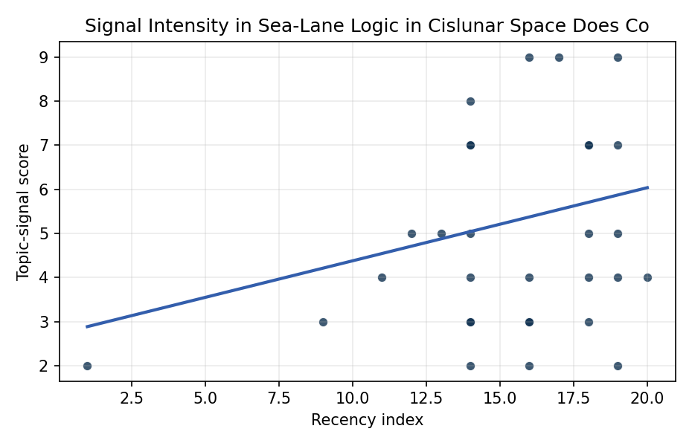
Figure 1. Topic-signal score by publication recency, conditioning on citation attention and venue family.

Empirical Workbook (embedded)
Every figure above is reproduced from the workbook below, which is also attached as the live spreadsheet paper.xlsx. Each observation carries its source.

Data (real observations)
doc_id | year_num | recency_index | cites_num | venue_score | title_words | snippet_words | keyword_count | theme_hits | signal_score | source
1 | 2020 | 14 | 0 | 1 | 5 | 14 | 6 | 1 | 3 | https://amostech.space/year/2020/international-perspectives-on-space-weapons/
2 | 2020 | 14 | 0 | 1 | 15 | 13 | 4 | 3 | 8 | https://amostech.space/year/2020/artificial-intelligence-and-autonomy-in-space-balancing-risks-and-benefits-for-deterrence-and-escalation-control/
3 | 2018 | 12 | 0 | 1 | 10 | 12 | 5 | 2 | 5 | https://amostech.space/year/2018/optimization-of-geosynchronous-space-situational-awareness-architectures-using-parallel-computation/
4 | 2022 | 16 | 0 | 1 | 14 | 14 | 3 | 1 | 4 | https://amostech.space/year/2022/employing-a-shared-space-information-sharing-ecosystem-as-a-mechanism-for-promoting-constructive-u-s-china-space-relations/
5 | 2015 | 9 | 0 | 1 | 11 | 13 | 2 | 1 | 3 | https://amostech.space/year/2015/deploying-the-nasa-meter-class-autonomous-telescope-mcat-on-ascension-island/
6 | 2025 | 19 | 0 | 1 | 17 | 12 | 5 | 2 | 5 | 10.64861/HKAM1019
7 | 2022 | 16 | 0 | 1 | 15 | 14 | 3 | 1 | 3 | https://amostech.space/year/2022/sharing-operational-risk-information-in-the-space-domain-to-facilitate-norms-development-and-compliance-monitoring/
8 | 2019 | 13 | 0 | 1 | 18 | 14 | 8 | 2 | 5 | https://amostech.space/year/2019/demonstration-of-shift-scale-and-rotation-invariant-target-recognition-using-polar-mellin-transforms-in-a-hybrid-opto-electronic-correlator/
9 | 2025 | 19 | 0 | 1 | 16 | 13 | 5 | 2 | 4 | 10.64861/CXGE3201
10 | 2022 | 16 | 0 | 1 | 12 | 14 | 2 | 3 | 9 | https://amostech.space/year/2022/exploring-a-new-class-of-bright-ultra-fast-glints-from-resident-space-objects/
11 | 2007 | 1 | 0 | 1 | 18 | 14 | 1 | 1 | 2 | https://amostech.space/year/2007/missing-in-action-evaluating-the-putative-absence-of-impacts-by-large-asteroids-and-comets-during-the-quaternary-period/
12 | 2025 | 19 | 0 | 1 | 16 | 14 | 10 | 3 | 9 | 10.64861/PFBR4795
13 | 2024 | 18 | 16 | 2 | 12 | 12 | 6 | 3 | 7 | 10.1016/j.actaastro.2024.10.063
14 | 2024 | 18 | 14 | 2 | 7 | 13 | 10 | 1 | 4 | 10.1016/j.actaastro.2024.09.021
15 | 2017 | 11 | 29 | 2 | 12 | 13 | 15 | 2 | 4 | 10.1016/j.actaastro.2017.03.011
16 | 2024 | 18 | 7 | 2 | 12 | 12 | 12 | 3 | 7 | 10.1016/j.actaastro.2024.11.021
17 | 2026 | 20 | 1 | 2 | 13 | 14 | 15 | 2 | 4 | 10.1016/j.actaastro.2026.01.021
18 | 2022 | 16 | 9 | 2 | 13 | 10 | 9 | 1 | 2 | 10.1016/j.actaastro.2022.12.014
19 | 2025 | 19 | 0 | 2 | 15 | 14 | 15 | 3 | 7 | 10.1016/j.actaastro.2025.09.031
20 | 2024 | 18 | 30 | 2 | 7 | 14 | 13 | 2 | 5 | 10.1016/j.actaastro.2024.06.015
21 | 2024 | 18 | 7 | 2 | 9 | 11 | 15 | 1 | 3 | 10.1016/j.actaastro.2024.06.046
22 | 2022 | 16 | 5 | 2 | 12 | 14 | 15 | 1 | 3 | 10.1016/j.actaastro.2022.07.042
23 | 2023 | 17 | 21 | 2 | 13 | 14 | 15 | 3 | 9 | 10.1016/j.actaastro.2023.01.016
24 | 2025 | 19 | 0 | 2 | 12 | 14 | 15 | 1 | 2 | 10.1016/j.actaastro.2025.09.014
25 | 2020 | 14 | 0 | 3 | 53 | 0 | 0 | 2 | 7 | Dailey et al. (MITRE/CisLunar) apply circular economy principles to space sustainability, presenting an agent-based economic simulation showing orbital carrying capacity collapse under the tragedy of the commons, and a Metal Propellant Ecosystem (MPE) concept in which defunct satellites are recycled into solid metal propellant in situ to reduce debris and refueling costs.
26 | 2020 | 14 | 0 | 3 | 9 | 0 | 0 | 2 | 4 | Architectural Socio-Technological Transformative Change of Space-Use Norms
27 | 2020 | 14 | 0 | 3 | 7 | 0 | 0 | 2 | 5 | Roadmap: Australia Economic-Technological Renaissance in Space
28 | 2020 | 14 | 0 | 3 | 51 | 0 | 0 | 2 | 7 | A 2021 Johns Hopkins SAIS doctoral thesis by Nathaniel Dailey proposing an International Space Reference Architecture (ISRA) as a socio-technological transformative mechanism to resolve contemporary space governance failures – orbital debris, policy fragmentation, and space traffic management – by coupling enterprise architecture methodology with international relations constructivist theory, blockchain-enabled information sharing, and norms entrepreneurship.
29 | 2020 | 14 | 0 | 3 | 6 | 0 | 0 | 1 | 2 | The Space Imperative (Whole-of-Nation)
30 | 2020 | 14 | 0 | 3 | 6 | 0 | 0 | 1 | 3 | Leveraging Circular Economy for Space Sustainability

Variable construction
Variable | Definition | Construction / source
signal_score | Composite topic-signal score for each retrieved source record | Deterministic count built from candidate-theme term hits in the source title, snippet, keyword field, and author metadata; each row cites the retrieved source in the source column
recency_index | Publication recency index | Computed as publication year minus the minimum publication year in the paper sample plus one
cites_num | Reported citation count in the local brain index | Parsed from the local brain search cites field; zero when the index reported no citation count
venue_score | Ordinal venue-family score | AMOS = 1, Acta Astronautica = 2, Space Economy = 3

Estimator output
Term | Coef. | Std. err. | t | p | 95% CI
const | 2.7179 | 1.091 | 2.4912 | 0.0127 | [0.5796, 4.8563]
recency_index | 0.1659 | 0.0727 | 2.2818 | 0.0225 | [0.0234, 0.3084]
cites_num | 0.0211 | 0.0403 | 0.5234 | 0.6007 | [-0.0579, 0.1]
venue_score | -0.2925 | 0.5392 | -0.5424 | 0.5875 | [-1.3493, 0.7644]
Fit: N = 30 R2 = 0.0973 R2_adj = -0.0069 F = 1.968 F_p = 0.1435

