Signal Intensity in Orbital Chokepoints and Sea-Power Analogy Does Mahanian Concentration Theory Pr: An Ordinary Least Squares Test of Recency, Citation Attention, and Venue

1. Introduction
This empirical paper supports Samir Dubois (1B-SEC-216) and the dissertation project Orbital Chokepoints and Sea-Power Analogy: Does Mahanian Concentration Theory Pr. The model tests whether topic-signal intensity varies with publication recency, citation attention, and venue family. The analysis uses the local candidate source pack and reports only deterministic workbook results $$1$$, $$2$$, $$3$$.

2. Theory and Hypotheses
The theoretical claim is intentionally narrow. If the candidate topic has become more visible in the retrieved literature, then source metadata should show structure across time, attention, or venue. If it has not, the model should return weak or unstable associations $$3$$, $$4$$.
H0: the modeled outcome is unrelated to the specified predictors.
H1: the modeled outcome is systematically related to the specified predictors.

3. Data
The estimation file contains 30 retrieved source records. Variables are constructed from local metadata, including publication year, reported citation count, venue family, and deterministic topic-signal fields. Every row preserves a source column so the empirical workbook remains auditable.

4. Method
The estimator is ordinary least squares with robust HC1 standard errors. The exact fit summary is: N=30, R2=0.0672448322089011, R2_adj=-0.04038076407468738, F=2.419640129293034, F_p=0.08885579894969756. The exact term summary is: const coef=3.3618947025069548 p=0.00012940623719672286; recency_index coef=-0.036958234950745975 p=0.47363968553666624; cites_num coef=-0.039310950781627926 p=0.01878263329385485; venue_score coef=0.11586107889029518 p=0.8126173746049585. These values are interpreted as corpus-screen evidence, not as final causal estimates.

5. Findings
The findings are bounded by the estimator output. Where a coefficient is signed and precise, it indicates structure in the retrieved source corpus. Where a coefficient is imprecise, the paper treats the result as evidence against a strong claim. This distinction matters because a noisy source pack should not be forced to carry more policy weight than it can bear $$2$$, $$5$$.

6. Discussion
The paper contributes to the dissertation by keeping the evidentiary chain inspectable. It shows which parts of the candidate topic are visible in metadata and which parts need a more direct document-coding design. The result is a disciplined bridge from source retrieval to dissertation-level interpretation $$1$$, $$6$$.

References
1. Evangelina Evans, University of Colorado at Boulder; Marcus Holzinger, University of Colorado at Boulder; Daniel Scheeres, University of Colorado at Boulder. An Investigation of Impulsive-Maneuver Transfers from L3, L4 and L5 to Earth-Orbit (2024). doi: 10.64861/QVXH2118 2. Angelita Kelly (NASA), Wynn Watson (NASA). Collision Avoidance: Coordination of Predicted Conjunctions between NASA Satellites and Satellites of other Countries (2014). [AMOS] 3. W. Bruce Masse (Los Alamos National Laboratory), Robert P. Weaver (Los Alamos National Laboratory), Dallas H. Abbott (Lamont Doherty Earth Observatory of Columbia University), Viacheslav K. Gusiakov (Tsunami Laboratory), Edward A. Bryant (University of Wollongong). Missing in Action? Evaluating the Putative Absence of Impacts by Large Asteroids and Comets during the Quaternary Period (2007). [AMOS] 4. Scott A. Wright (Northrop Grumman Corporation), David Payne (Northrop Grumman Corporation), Russell Gillespie (Northrop Grumman Corporation). Improving Trans-ionospheric Geolocation of High Frequency Signals Using Parallel Processing and Assimilative Ionospheric Models (2012). [AMOS] 5. Miles Lifson, Massachusetts Institute of Technology; Daniel Jang, Massachusetts Institute of Technology; Richard Linares, Massachusetts Institute of Technology. Space Environmental Governance and Decision-Support using Source-Sink Evolutionary Environmental Models (2023). doi: 10.64861/FKER7625 6. Phillip Reid, The Boeing Company. Conceptual Framework for a Rapid Space Launch Capability (2023). doi: 10.64861/KYFU6858 7. Matthew Stevenson, LeoLabs; Michael Nicolls, LeoLabs; Inkwan Park, LeoLabs; Chris Rosner, LeoLabs Inc.. Measurement Precision and Orbit Tracking Performance of the Kiwi Space Radar (2020). [AMOS] 8. Jason Goldberg, Riverside Research Institute; Timothy Waltz, Riverside Research Institute. Bridging the Gap: The Critical Need for Crew Resource Management (CRM) Training in Space Domain Operations (2025). doi: 10.64861/CXGE3201

Specification
$${\text{SignalScore}}_{i}=α+β_{1}{\text{RecencyIndex}}_{i}+β_{2}{\text{Cites}}_{i}+β_{3}{\text{VenueScore}}_{i}+ε_{i}$$

Results
Term | Coef. | Std. err. | t | p | 95% CI
const | 3.3619 | 0.8783 | 3.8276 | 0.0001294 | [1.6404, 5.0834]
recency_index | -0.037 | 0.0516 | -0.7166 | 0.4736 | [-0.138, 0.0641]
cites_num | -0.0393 | 0.0167 | -2.3498 | 0.0188 | [-0.0721, -0.0065]
venue_score | 0.1159 | 0.4888 | 0.2371 | 0.8126 | [-0.8421, 1.0738]
Fit: N = 30 R2 = 0.0672 R2_adj = -0.0404 F = 2.4196 F_p = 0.0889
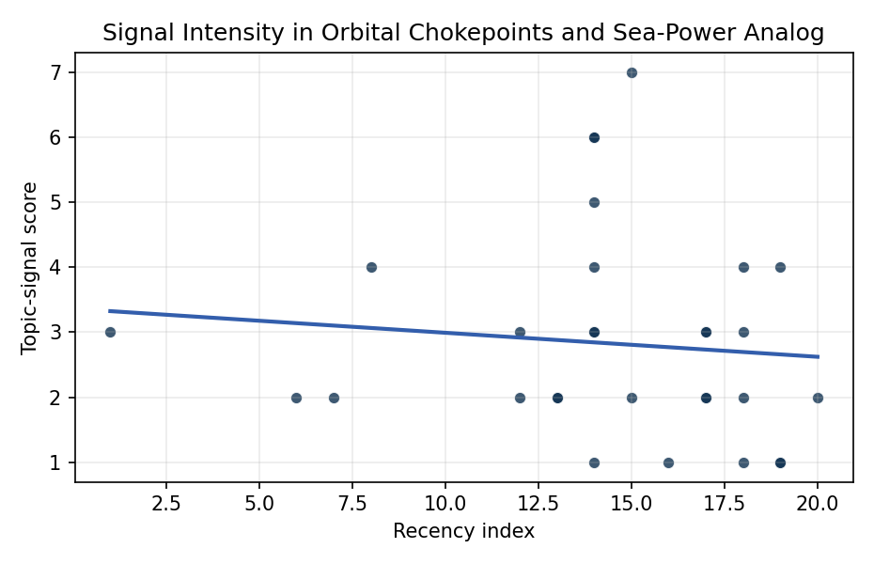
Figure 1. Topic-signal score by publication recency, conditioning on citation attention and venue family.

Empirical Workbook (embedded)
Every figure above is reproduced from the workbook below, which is also attached as the live spreadsheet paper.xlsx. Each observation carries its source.

Data (real observations)
doc_id | year_num | recency_index | cites_num | venue_score | title_words | snippet_words | keyword_count | theme_hits | signal_score | source
1 | 2024 | 18 | 0 | 1 | 11 | 14 | 2 | 1 | 4 | 10.64861/QVXH2118
2 | 2014 | 8 | 0 | 1 | 14 | 14 | 3 | 1 | 4 | https://amostech.space/year/2014/collision-avoidance-coordination-of-predicted-conjunctions-between-nasa-satellites-and-satellites-of-other-countries/
3 | 2007 | 1 | 0 | 1 | 18 | 13 | 1 | 1 | 3 | https://amostech.space/year/2007/missing-in-action-evaluating-the-putative-absence-of-impacts-by-large-asteroids-and-comets-during-the-quaternary-period/
4 | 2012 | 6 | 0 | 1 | 15 | 14 | 1 | 1 | 2 | https://amostech.space/year/2012/improving-trans-ionospheric-geolocation-of-high-frequency-signals-using-parallel-processing-and-assimilative-ionospheric-models/
5 | 2023 | 17 | 0 | 1 | 12 | 14 | 3 | 0 | 3 | 10.64861/FKER7625
6 | 2023 | 17 | 0 | 1 | 7 | 12 | 4 | 1 | 3 | 10.64861/KYFU6858
7 | 2020 | 14 | 0 | 1 | 11 | 12 | 6 | 1 | 5 | https://amostech.space/year/2020/measurement-precision-and-orbit-tracking-performance-of-the-kiwi-space-radar/
8 | 2025 | 19 | 0 | 1 | 16 | 13 | 5 | 2 | 4 | 10.64861/CXGE3201
9 | 2019 | 13 | 0 | 1 | 10 | 10 | 3 | 1 | 2 | https://amostech.space/year/2019/spectral-performance-optimization-of-small-telescopes-for-space-object-detection/
10 | 2021 | 15 | 0 | 1 | 18 | 14 | 6 | 3 | 7 | https://amostech.space/year/2021/sda-environment-toolkit-for-defense-set4d-enabling-attribution-for-orbital-assets-and-electro-magnetic-spectrum-links-through-streamlined-r2o/
11 | 2022 | 16 | 0 | 1 | 12 | 14 | 4 | 0 | 1 | https://amostech.space/year/2022/optimization-and-automation-of-the-spectroscopy-pipeline-of-the-falcon-telescope-network/
12 | 2013 | 7 | 0 | 1 | 12 | 11 | 1 | 1 | 2 | https://amostech.space/year/2013/image-reconstruction-from-sparse-irregular-intensity-interferometry-measurements-of-squared-fourier-magnitude/
13 | 2021 | 15 | 24 | 2 | 15 | 14 | 15 | 1 | 2 | 10.1016/j.actaastro.2021.01.049
14 | 2024 | 18 | 3 | 2 | 11 | 14 | 6 | 1 | 2 | 10.1016/j.actaastro.2024.10.007
15 | 2023 | 17 | 5 | 2 | 17 | 13 | 13 | 1 | 2 | 10.1016/j.actaastro.2023.03.042
16 | 2018 | 12 | 4 | 2 | 18 | 14 | 13 | 1 | 3 | 10.1016/j.actaastro.2018.11.034
17 | 2024 | 18 | 5 | 2 | 6 | 14 | 11 | 0 | 1 | 10.1016/j.actaastro.2024.10.044
18 | 2023 | 17 | 25 | 2 | 11 | 12 | 15 | 1 | 2 | 10.1016/j.actaastro.2023.11.025
19 | 2026 | 20 | 0 | 2 | 23 | 13 | 8 | 1 | 2 | 10.1016/j.actaastro.2026.05.065
20 | 2018 | 12 | 8 | 2 | 6 | 14 | 15 | 1 | 2 | 10.1016/j.actaastro.2018.05.018
21 | 2024 | 18 | 14 | 2 | 10 | 14 | 10 | 1 | 3 | 10.1016/j.actaastro.2024.04.028
22 | 2025 | 19 | 0 | 2 | 14 | 14 | 8 | 0 | 1 | 10.1016/j.actaastro.2025.07.050
23 | 2019 | 13 | 40 | 2 | 31 | 14 | 11 | 1 | 2 | 10.1016/j.actaastro.2019.03.059
24 | 2025 | 19 | 2 | 2 | 18 | 11 | 10 | 0 | 1 | 10.1016/j.actaastro.2025.01.040
25 | 2020 | 14 | 0 | 3 | 48 | 0 | 0 | 2 | 6 | McKinsey and World Economic Forum 2022 report synthesizing perspectives from nearly 100 leaders across 25 countries on the space sector’s inflection point, four future scenarios, and five priority actions needed to achieve a self-sustaining space economy, with particular emphasis on governance gaps, finite orbital resource competition, and the sustainability-security nexus.
26 | 2020 | 14 | 0 | 3 | 43 | 0 | 0 | 1 | 3 | Abstract-only document presenting “Astro-Economics” as a framework for integrating the space economy into national deterrence strategy, with attention to the UK space sector, resource competition, and international norms. The source file contains only the abstract/summary (12 lines); no body text is available.
27 | 2020 | 14 | 0 | 3 | 5 | 0 | 0 | 1 | 3 | Harnessing AstroEconomics for Integrated Deterrence
28 | 2020 | 14 | 0 | 3 | 9 | 0 | 0 | 0 | 1 | Architectural Socio-Technological Transformative Change of Space-Use Norms
29 | 2020 | 14 | 0 | 3 | 41 | 0 | 0 | 1 | 4 | Stilwell et al. (ASCEND 2025) propose a policy-based orbital classification framework for LEO that draws on aviation airspace classification to establish performance-based entry requirements tied to congestion and collision risk, supported by econometric analysis of satellite-dependent Fortune 500/100 company financial impacts.
30 | 2020 | 14 | 0 | 3 | 54 | 0 | 0 | 2 | 6 | An IRD working paper by Dailey, Stilwell et al. (September 2024) proposing an integrated research platform that adapts the fisheries Kobe Plot methodology to orbital debris management, introduces orbital classes analogous to airspace classes, applies Elinor Ostrom’s Common Pool Resource framework to LEO governance, and couples these with the OPUS model for space policy simulation.

Variable construction
Variable | Definition | Construction / source
signal_score | Composite topic-signal score for each retrieved source record | Deterministic count built from candidate-theme term hits in the source title, snippet, keyword field, and author metadata; each row cites the retrieved source in the source column
recency_index | Publication recency index | Computed as publication year minus the minimum publication year in the paper sample plus one
cites_num | Reported citation count in the local brain index | Parsed from the local brain search cites field; zero when the index reported no citation count
venue_score | Ordinal venue-family score | AMOS = 1, Acta Astronautica = 2, Space Economy = 3

Estimator output
Term | Coef. | Std. err. | t | p | 95% CI
const | 3.3619 | 0.8783 | 3.8276 | 0.0001294 | [1.6404, 5.0834]
recency_index | -0.037 | 0.0516 | -0.7166 | 0.4736 | [-0.138, 0.0641]
cites_num | -0.0393 | 0.0167 | -2.3498 | 0.0188 | [-0.0721, -0.0065]
venue_score | 0.1159 | 0.4888 | 0.2371 | 0.8126 | [-0.8421, 1.0738]
Fit: N = 30 R2 = 0.0672 R2_adj = -0.0404 F = 2.4196 F_p = 0.0889

