Signal Intensity in The Debris Taboo as an Emergent Norm Has Kinetic ASAT Testing Crossed a Measura: An Ordinary Least Squares Test of Recency, Citation Attention, and Venue

1. Introduction
This empirical paper supports Omar Ortiz (1B-SEC-210) and the dissertation project The Debris Taboo as an Emergent Norm: Has Kinetic ASAT Testing Crossed a Measura. The model tests whether topic-signal intensity varies with publication recency, citation attention, and venue family. The analysis uses the local candidate source pack and reports only deterministic workbook results $$1$$, $$2$$, $$3$$.

2. Theory and Hypotheses
The theoretical claim is intentionally narrow. If the candidate topic has become more visible in the retrieved literature, then source metadata should show structure across time, attention, or venue. If it has not, the model should return weak or unstable associations $$3$$, $$4$$.
H0: the modeled outcome is unrelated to the specified predictors.
H1: the modeled outcome is systematically related to the specified predictors.

3. Data
The estimation file contains 30 retrieved source records. Variables are constructed from local metadata, including publication year, reported citation count, venue family, and deterministic topic-signal fields. Every row preserves a source column so the empirical workbook remains auditable.

4. Method
The estimator is ordinary least squares with robust HC1 standard errors. The exact fit summary is: N=30, R2=0.1686933453174727, R2_adj=0.07277334670025803, F=2.923172655381721, F_p=0.05272389412397983. The exact term summary is: const coef=2.5325558039150606 p=0.04570299018464071; recency_index coef=0.18100271288038078 p=0.023166451119345944; cites_num coef=-0.03208747587380294 p=0.1949940787809915; venue_score coef=-0.5788932463821329 p=0.21234964252389077. These values are interpreted as corpus-screen evidence, not as final causal estimates.

5. Findings
The findings are bounded by the estimator output. Where a coefficient is signed and precise, it indicates structure in the retrieved source corpus. Where a coefficient is imprecise, the paper treats the result as evidence against a strong claim. This distinction matters because a noisy source pack should not be forced to carry more policy weight than it can bear $$2$$, $$5$$.

6. Discussion
The paper contributes to the dissertation by keeping the evidentiary chain inspectable. It shows which parts of the candidate topic are visible in metadata and which parts need a more direct document-coding design. The result is a disciplined bridge from source retrieval to dissertation-level interpretation $$1$$, $$6$$.

References
1. Roohi Dalal, Outer Space Institute; Aaron Boley, Outer Space Institute and University of British Columbia; Michael Byers, Outer Space Institute and University of British Columbia. Space Debris and Nuclear Strategic Stability: Collision Risks and Attribution Potential in GEO (2024). doi: 10.64861/EIBC5616 2. Todd Harrison, Center for Strategic and International Studies. International Perspectives on Space Weapons (2020). [AMOS] 3. Sarah Thiele, The University of British Columbia; Aaron C. Boley, The University of British Columbia. Investigating the Risks of Debris-generating ASAT Tests in the Presence of Megaconstellations (2021). [AMOS] 4. Andrew C. Nicholas, Naval Research Laboratory; Joshua M. Wolf, Naval Research Laboratory; Lee J. Kordella, U.S. Naval Research Laboratory; Charles M. Brown, Naval Research Laboratory; Ted T. Finne, Naval Research Laboratory; Kenneth Marr, Naval Research Laboratory; Scott A. Budzien, Naval Research Laboratory; Ivan J. Galysh, Naval Research Laboratory; Christoph R. Englert, Naval Research Laboratory. LARADO: A Sensor for On-orbit Detection of Lethal Non-Trackable Debris (2022). [AMOS] 5. Daiki Mori, NEC Aerospace Systems, Ltd.; Masatoshi Ebara, NEC Corporation; Takahiro Okada, NEC Corporation; Hideki Kimura, NEC Corporation. Commercial SSA capability in Japan (2019). [AMOS] 6. David Talent (Oceanit Laboratories, Inc.). An Assessment of the January 2007 Chinese ASAT Test on the LEO Environment (2007). [AMOS] 7. Ryo Kato, NEC Aerospace Systems, Ltd.; Takahito Sakaue, NEC Aerospace Systems,Ltd.; Daiki Mori, NEC Corporation; Makoto Tanaka, NEC Aerospace Systems, Ltd.; Taichiro Sano, NEC; Katsuaki Taya, NEC Corporation; Masatoshi Ebara, NEC Corporation; Ryosuke Nakazawa, NEC; Jun Yoshida, NEC; Ryosuke Togawa, NEC Corporation. Validity Evaluation of Anomaly Detection Using LSTM Autoencoder for Maneuver Detection (2023). doi: 10.64861/LQWT7494 8. David Buehler, AFRL/RV; Dane Fuller, AFIT/CSRA; John Colombi, AFIT/ENV; William Wiesel, AFIT/ENY; Dave Meyer, AFIT/ENY; Richard Cobb, AFIT/ENY. Utilizing Supercomputing to Analyze Risks of an Emergent Large-scale Debris Field in Low Earth Orbit (2018). [AMOS]

Specification
$${\text{SignalScore}}_{i}=α+β_{1}{\text{RecencyIndex}}_{i}+β_{2}{\text{Cites}}_{i}+β_{3}{\text{VenueScore}}_{i}+ε_{i}$$

Results
Term | Coef. | Std. err. | t | p | 95% CI
const | 2.5326 | 1.2675 | 1.9981 | 0.0457 | [0.0484, 5.0167]
recency_index | 0.181 | 0.0797 | 2.2707 | 0.0232 | [0.0248, 0.3372]
cites_num | -0.0321 | 0.0248 | -1.2959 | 0.195 | [-0.0806, 0.0164]
venue_score | -0.5789 | 0.4642 | -1.2471 | 0.2123 | [-1.4887, 0.3309]
Fit: N = 30 R2 = 0.1687 R2_adj = 0.0728 F = 2.9232 F_p = 0.0527
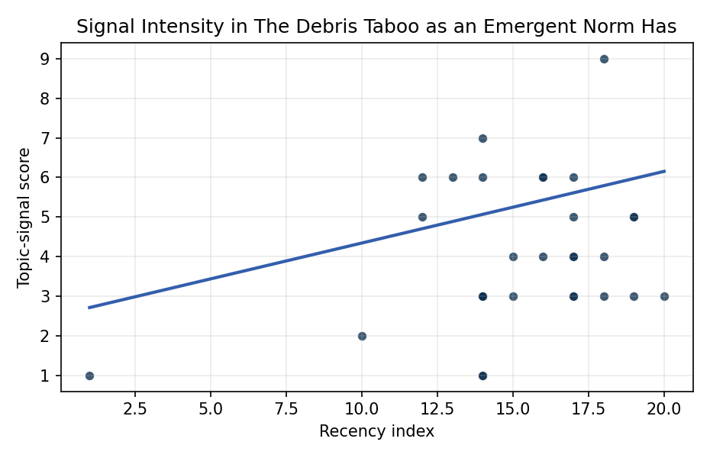
Figure 1. Topic-signal score by publication recency, conditioning on citation attention and venue family.

Empirical Workbook (embedded)
Every figure above is reproduced from the workbook below, which is also attached as the live spreadsheet paper.xlsx. Each observation carries its source.

Data (real observations)
doc_id | year_num | recency_index | cites_num | venue_score | title_words | snippet_words | keyword_count | theme_hits | signal_score | source
1 | 2021 | 15 | 0 | 1 | 13 | 13 | 6 | 1 | 4 | https://amostech.space/year/2021/investigating-the-risks-of-debris-generating-asat-tests-in-the-presence-of-megaconstellations/
2 | 2024 | 18 | 0 | 1 | 13 | 14 | 3 | 1 | 4 | 10.64861/EIBC5616
3 | 2020 | 14 | 0 | 1 | 5 | 14 | 6 | 1 | 3 | https://amostech.space/year/2020/international-perspectives-on-space-weapons/
4 | 2022 | 16 | 0 | 1 | 11 | 12 | 3 | 2 | 6 | https://amostech.space/year/2022/larado-a-sensor-for-on-orbit-detection-of-lethal-non-trackable-debris/
5 | 2019 | 13 | 0 | 1 | 5 | 14 | 3 | 2 | 6 | https://amostech.space/year/2019/commercial-ssa-capability-in-japan/
6 | 2007 | 1 | 0 | 1 | 12 | 12 | 1 | 0 | 1 | https://amostech.space/year/2007/an-assessment-of-the-january-2007-chinese-asat-test-on-the-leo-environment/
7 | 2023 | 17 | 0 | 1 | 11 | 14 | 5 | 1 | 5 | 10.64861/LQWT7494
8 | 2018 | 12 | 0 | 1 | 16 | 12 | 5 | 2 | 6 | https://amostech.space/year/2018/utilizing-supercomputing-to-analyze-risks-of-an-emergent-large-scale-debris-field-in-low-earth-orbit/
9 | 2018 | 12 | 0 | 1 | 7 | 12 | 3 | 2 | 5 | https://amostech.space/year/2018/fengyun-1c-debris-cloud-evolution-over-one-decade/
10 | 2025 | 19 | 0 | 1 | 14 | 12 | 6 | 1 | 5 | 10.64861/PHBD6598
11 | 2022 | 16 | 0 | 1 | 14 | 14 | 3 | 2 | 6 | https://amostech.space/year/2022/employing-a-shared-space-information-sharing-ecosystem-as-a-mechanism-for-promoting-constructive-u-s-china-space-relations/
12 | 2021 | 15 | 0 | 1 | 12 | 12 | 3 | 1 | 3 | https://amostech.space/year/2021/compact-solutions-for-detecting-space-and-ground-based-optical-threats-to-satellites/
13 | 2023 | 17 | 6 | 2 | 9 | 12 | 15 | 2 | 6 | 10.1016/j.actaastro.2023.08.002
14 | 2024 | 18 | 2 | 2 | 15 | 12 | 6 | 3 | 9 | 10.1016/j.actaastro.2024.09.003
15 | 2023 | 17 | 21 | 2 | 16 | 12 | 11 | 1 | 4 | 10.1016/j.actaastro.2023.02.043
16 | 2023 | 17 | 21 | 2 | 13 | 13 | 15 | 1 | 4 | 10.1016/j.actaastro.2023.01.016
17 | 2024 | 18 | 1 | 2 | 18 | 14 | 12 | 1 | 3 | 10.1016/j.actaastro.2024.09.057
18 | 2023 | 17 | 25 | 2 | 14 | 14 | 15 | 1 | 3 | 10.1016/j.actaastro.2023.07.009
19 | 2026 | 20 | 0 | 2 | 9 | 14 | 10 | 1 | 3 | 10.1016/j.actaastro.2026.04.055
20 | 2025 | 19 | 2 | 2 | 12 | 14 | 12 | 1 | 3 | 10.1016/j.actaastro.2025.04.063
21 | 2022 | 16 | 4 | 2 | 10 | 13 | 15 | 1 | 4 | 10.1016/j.actaastro.2022.10.021
22 | 2016 | 10 | 7 | 2 | 13 | 13 | 14 | 1 | 2 | 10.1016/j.actaastro.2016.05.009
23 | 2025 | 19 | 0 | 2 | 15 | 12 | 15 | 2 | 5 | 10.1016/j.actaastro.2025.09.031
24 | 2020 | 14 | 0 | 3 | 8 | 0 | 0 | 1 | 3 | Star Wars: Anti-Satellite Weapons and Orbital Debris
25 | 2023 | 17 | 0 | 3 | 8 | 0 | 0 | 1 | 3 | 10.1080/10242694.2023.2208020
26 | 2020 | 14 | 0 | 3 | 6 | 0 | 0 | 0 | 1 | The Space Imperative (Whole-of-Nation)
27 | 2020 | 14 | 0 | 3 | 64 | 0 | 0 | 2 | 6 | Behavioral Economics in Space: Shaping Normative Behaviors for Stability and Sustainability (white paper, unpublished working paper, N. Dailey or associated author, undated). Proposes applying behavioral economics principles, drawing on Kahneman and Gaddis, to shape normative behavior in space traffic coordination, SSA, and space domain awareness, and further integrates deterrence frameworks and strategic non-kinetic effects (DIME tools) to reinforce responsible conduct and deter adversarial behavior.
28 | 2020 | 14 | 0 | 3 | 4 | 0 | 0 | 0 | 1 | Behavioral Economics in Space
29 | 2020 | 14 | 0 | 3 | 10 | 0 | 0 | 1 | 3 | The Role of Space in Driving Sustainability, Security, and Development
30 | 2020 | 14 | 0 | 3 | 51 | 0 | 0 | 2 | 7 | A 2021 Johns Hopkins SAIS doctoral thesis by Nathaniel Dailey proposing an International Space Reference Architecture (ISRA) as a socio-technological transformative mechanism to resolve contemporary space governance failures – orbital debris, policy fragmentation, and space traffic management – by coupling enterprise architecture methodology with international relations constructivist theory, blockchain-enabled information sharing, and norms entrepreneurship.

Variable construction
Variable | Definition | Construction / source
signal_score | Composite topic-signal score for each retrieved source record | Deterministic count built from candidate-theme term hits in the source title, snippet, keyword field, and author metadata; each row cites the retrieved source in the source column
recency_index | Publication recency index | Computed as publication year minus the minimum publication year in the paper sample plus one
cites_num | Reported citation count in the local brain index | Parsed from the local brain search cites field; zero when the index reported no citation count
venue_score | Ordinal venue-family score | AMOS = 1, Acta Astronautica = 2, Space Economy = 3

Estimator output
Term | Coef. | Std. err. | t | p | 95% CI
const | 2.5326 | 1.2675 | 1.9981 | 0.0457 | [0.0484, 5.0167]
recency_index | 0.181 | 0.0797 | 2.2707 | 0.0232 | [0.0248, 0.3372]
cites_num | -0.0321 | 0.0248 | -1.2959 | 0.195 | [-0.0806, 0.0164]
venue_score | -0.5789 | 0.4642 | -1.2471 | 0.2123 | [-1.4887, 0.3309]
Fit: N = 30 R2 = 0.1687 R2_adj = 0.0728 F = 2.9232 F_p = 0.0527

