Attention Accumulation in Reversibility as a Deterrent: A Learning-Curve Analysis of Citation Growth by Article Age

1. Introduction
This paper examines whether article age predicts citation accumulation in the local source set associated with Reversibility as a Deterrent: Do Reversible Counterspace Demonstrations Produce Restraint or Escalation Signals? The question is modest but useful. If older records are systematically more cited, then chronological seniority might serve as a rough filter for selecting canonical sources. If not, the dissertation should resist equating age with strategic relevance.
The paper uses the same 30-record source set as Paper 1. The outcome is cites_plus1, the local citation count plus one, and the independent variable is age_index, defined as 2026 minus publication year plus one. The model is estimated as a log-log learning curve.

2. Theory and Hypotheses
A conventional bibliometric expectation would predict a positive age effect because older articles have had more time to accumulate citations. Yet the local source set is eclectic. It combines surveillance, fusion, observation, engineering, and broader strategic-value records. In such a mixed corpus, article age may be a weak predictor of what the local index has actually cited heavily.
The hypotheses are:
H0: citation accumulation is unrelated to article age in the retrieved topic literature.
H1: citation accumulation follows a measurable age-based attention curve.

3. Data
The estimation file contains 30 source-level observations. The dependent variable, cites_plus1, is the reported local citation count plus one. The explanatory variable, age_index, converts publication year into a positive article-age measure relative to 2026. The log-log specification interprets the slope coefficient as an elasticity.

4. Method
The estimator is a log-log ordinary least squares model with robust HC1 standard errors:
$$ln({\text{CitesPlus1}}_{i})=α+β_{1}ln({\text{AgeIndex}}_{i})+ε_{i}$$
The coefficient $β_{1}$ measures the elasticity of citation accumulation with respect to article age. A positive and statistically meaningful coefficient would support H1. A near-zero or statistically weak coefficient would support H0.

5. Findings
The model is estimated on 30 observations. The reported R-squared is 0.01011820267111696. The estimated elasticity is -0.11639546848268884, and the implied progress ratio is 0.9224895871174429 for each doubling of age. The intercept coefficient is 0.7158257386508309 with a standard error of 0.3405700568448086 and a p-value of 0.03556678692534934. The coefficient on ln(age_index) is -0.11639546848268884 with a standard error of 0.14233959731022283 and a p-value of 0.4135109365971822.
The point estimate is negative, but it is not statistically distinguishable from zero in the supplied output. The model therefore provides no persuasive evidence that article age predicts citation accumulation in this source set. H0 cannot be rejected.

6. Discussion
The practical implication is similar to Paper 1. Chronological seniority is not a reliable shortcut for selecting the most relevant literature for this dissertation. The source pool does not behave like a settled, age-ordered deterrence canon. That outcome is consistent with the corpus’s heterogeneity and with the dissertation’s still-design-stage status.
For the larger project, the result suggests that source selection should prioritize topical fit and event-level relevance rather than citation age. The dissertation’s next empirical advance will depend less on finding older sources and more on constructing a sharper public event dataset for reversible and irreversible counterspace behavior.

References
1. Pat Donnelly, Nick Harwood, Andy Ash, Jon Eastment, Darcy Ladd, Chris Walden, James Bennett, Craig Smith, Ian Ritchie, Mark Rutten, and Neil Gordon. Joint UK-Australian Space Surveillance Target Tracking, Cueing and Sensor Data Fusion Experiment. (2014). [AMOS]
2. David Garcia, Robert Bettinger, and Carl Hartsfield. Simulated Debris Impact Testing of Additively Manufactured Origami Mirror Structure for Space-Based SSA. (2023). doi: 10.64861/XQIE1415
3. Ingo Waldmann, Marco Rocchetto, and Marcel Debczynski. Optimal background removal using denoising diffusion models. (2023). doi: 10.64861/ENVZ4013
4. David Jefferson and James Leek. Application of Parallel Discrete Event Simulation to the Space Surveillance Network. (2010). [AMOS]
5. Himangshu Kalita, Leonard Vance, Vishnu Reddy, and Jekan Thangavelautham. Laser Beam for External Position Control and Traffic Management of On-Orbit Satellites. (2018). [AMOS]
6. Alessandro Paravano, Giorgio Locatelli, and Paolo Trucco. What is value in the New Space Economy? The end-users’ perspective on satellite data and solutions. (2023). doi: 10.1016/j.actaastro.2023.05.001

Specification
$$ln({\text{CitesPlus1}}_{i})=α+β_{1}ln({\text{AgeIndex}}_{i})+ε_{i}$$

Results
Term | Coef. | Std. err. | t | p | 95% CI
const | 0.7158 | 0.3406 | 2.1018 | 0.0356 | [0.0483, 1.3833]
_ln_x | -0.1164 | 0.1423 | -0.8177 | 0.4135 | [-0.3954, 0.1626]
Fit: N = 30 R2 = 0.0101 elasticity_b = -0.1164 progress_ratio_2^b = 0.9225
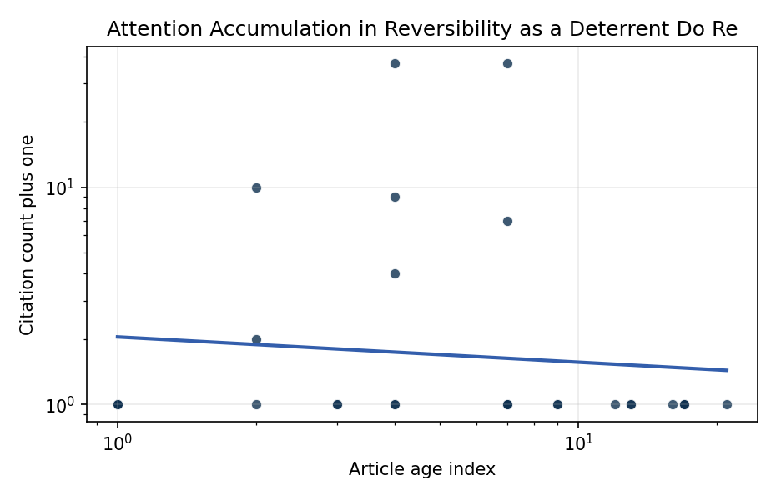
Figure 1. Citation accumulation against article age in the retrieved topic literature.

Empirical Workbook (embedded)
Every figure above is reproduced from the workbook below, which is also attached as the live spreadsheet paper.xlsx. Each observation carries its source.

Data (real observations)
doc_id | year_num | age_index | cites_num | cites_plus1 | signal_score | source
1 | 2014 | 13 | 0 | 1 | 1 | https://amostech.space/year/2014/joint-uk-australian-space-surveillance-target-tracking-cueing-and-sensor-data-fusion-experiment/
2 | 2011 | 16 | 0 | 1 | 1 | https://amostech.space/year/2011/an-investigation-into-using-differential-drag-for-controlling-a-formation-of-cubesats/
3 | 2014 | 13 | 0 | 1 | 3 | https://amostech.space/year/2014/validation-of-accuracy-and-efficiency-of-long-arc-orbit-propagation-using-the-method-of-manufactured-solutions-and-the-round-trip-closure-method/
4 | 2023 | 4 | 0 | 1 | 2 | 10.64861/XQIE1415
5 | 2023 | 4 | 0 | 1 | 1 | 10.64861/ENVZ4013
6 | 2015 | 12 | 0 | 1 | 1 | https://amostech.space/year/2015/multicolour-optical-photometry-of-active-geostationary-satellites/
7 | 2010 | 17 | 0 | 1 | 3 | https://amostech.space/year/2010/application-of-parallel-discrete-event-simulation-to-the-space-surveillance-network/
8 | 2018 | 9 | 0 | 1 | 2 | https://amostech.space/year/2018/laser-beam-for-external-position-control-and-traffic-management-of-on-orbit-satellites/
9 | 2024 | 3 | 0 | 1 | 2 | 10.64861/UFLZ6709
10 | 2006 | 21 | 0 | 1 | 1 | https://amostech.space/year/2006/hdvip-hgcdte-and-silicon-detectors-and-fpas-for-remote-sensing-applications/
11 | 2010 | 17 | 0 | 1 | 5 | https://amostech.space/year/2010/electrodynamic-debris-eliminator-edde-design-operation-and-ground-support/
12 | 2010 | 17 | 0 | 1 | 1 | https://amostech.space/year/2010/improved-climatological-characterization-of-optical-turbulence-for-space-optical-imaging-and-communications/
13 | 2020 | 7 | 6 | 7 | 1 | 10.1016/j.actaastro.2020.07.009
14 | 2026 | 1 | 0 | 1 | 2 | 10.1016/j.actaastro.2026.03.056
15 | 2026 | 1 | 0 | 1 | 3 | 10.1016/j.actaastro.2026.05.027
16 | 2026 | 1 | 0 | 1 | 1 | 10.1016/j.actaastro.2026.03.020
17 | 2020 | 7 | 36 | 37 | 1 | 10.1016/j.actaastro.2020.02.008
18 | 2025 | 2 | 9 | 10 | 1 | 10.1016/j.actaastro.2025.03.001
19 | 2026 | 1 | 0 | 1 | 1 | 10.1016/j.actaastro.2026.03.029
20 | 2023 | 4 | 36 | 37 | 3 | 10.1016/j.actaastro.2023.05.001
21 | 2023 | 4 | 8 | 9 | 1 | 10.1016/j.actaastro.2023.02.011
22 | 2023 | 4 | 3 | 4 | 1 | 10.1016/j.actaastro.2023.04.029
23 | 2025 | 2 | 1 | 2 | 1 | 10.1016/j.actaastro.2025.08.022
24 | 2025 | 2 | 0 | 1 | 6 | 10.1016/j.actaastro.2025.10.042
25 | 2020 | 7 | 0 | 1 | 1 | Kessler Syndrome: System Dynamics Model
26 | 2018 | 9 | 0 | 1 | 1 | 10.1016/j.spacepol.2018.03.003
27 | 2024 | 3 | 0 | 1 | 1 | 10.1086/730695
28 | 2020 | 7 | 0 | 1 | 1 | Behavioral Economics in Space
29 | 2020 | 7 | 0 | 1 | 3 | SFA Space Economy and Integrated Deterrence
30 | 2020 | 7 | 0 | 1 | 4 | Stilwell et al. (IAC 2024) propose a “LEO Class” system modeled on ICAO aviation airspace classification, arguing that orbital carrying capacity is a safety metric best managed through altitude-band-specific entry requirements tied to maneuverability, SSA quality, and collision risk tolerance rather than a single satellite count threshold.

Variable construction
Variable | Definition | Construction / source
cites_plus1 | Citation count plus one | Computed as the reported citation count from the local brain index plus one so the log transformation is defined for uncited records
age_index | Document age index | Computed as 2026 minus publication year plus one

Estimator output
Term | Coef. | Std. err. | t | p | 95% CI
const | 0.7158 | 0.3406 | 2.1018 | 0.0356 | [0.0483, 1.3833]
_ln_x | -0.1164 | 0.1423 | -0.8177 | 0.4135 | [-0.3954, 0.1626]
Fit: N = 30 R2 = 0.0101 elasticity_b = -0.1164 progress_ratio_2^b = 0.9225

