Signal Intensity in Reversibility as a Deterrent: An Ordinary Least Squares Test of Recency, Citation Attention, and Venue

1. Introduction
This paper provides a literature-structure diagnostic for Candidate Anton Vaughn (1B-SEC-164) and the dissertation project Reversibility as a Deterrent: Do Reversible Counterspace Demonstrations Produce Restraint or Escalation Signals? The paper does not estimate the dissertation’s eventual event-level deterrence model. It asks a narrower empirical question: within the retrieved source set, is the metadata-level topic signal associated with publication recency, indexed citation attention, and venue family. That question matters because the local source base is heterogeneous. It contains tracking and sensor-fusion work $$1$$, $$4$$, surveillance-network simulation $$7$$, traffic-management concepts $$8$$, and broader strategic or value-oriented writing $$16$$.
The dependent variable, signal_score, is a deterministic topic-signal count built from title, snippet, keyword, and author metadata. The regressors are recency_index, cites_num, and venue_score. Substantively, the model tests whether the literature carrying the candidate’s deterrence and reversibility theme is newer, more cited, or concentrated in a particular venue family.

2. Theory and Hypotheses
The theoretical expectation is uncertain. A strong positive recency effect would imply that the reversibility-and-deterrence theme is relatively new and still consolidating. A positive citation effect would suggest that the theme aligns with already central records in the local corpus. Null results would imply that the retrieved literature does not yet organize itself clearly around this dissertation framing.
That last possibility is plausible. The bootstrapped source set is only indirectly aligned with reversible counterspace signaling. Many records address observability, surveillance, or broader space value rather than coercive event interpretation $$1$$, $$4$$, $$7$$, $$16$$. If the signal is diffuse, a simple metadata test should show weak structure.
The hypotheses are therefore:
H0: the topic-signal score is unrelated to publication recency, citation attention, and venue family.
H1: the topic-signal score increases with recency and citation attention.

3. Data
The estimation file contains 30 retrieved source records. The dependent variable is signal_score, a deterministic metadata count designed to capture how strongly each record aligns with the dissertation’s candidate theme. The explanatory variables are recency_index, cites_num, and venue_score, coded identically to other COLLEGIUM papers.
The record mix includes target tracking and sensor fusion $$1$$, optical and photometric observation work $$6$$, surveillance-network simulation $$7$$, external position-control concepts $$8$$, and selected Acta Astronautica and strategic-economy records that touch the wider context in which signaling and deterrence claims would be interpreted $$16$$. The mix is therefore broad enough to support a diagnostic test, but not narrow enough to be mistaken for a curated deterrence-event corpus.

4. Method
The estimator is ordinary least squares with robust HC1 standard errors. The model regresses signal_score on recency_index, cites_num, and venue_score with an intercept. The paper does not claim a causal interpretation. It uses the regression as a structured descriptive check on whether the literature base is temporally or citation-structured around the candidate’s theme.

5. Findings
The model is estimated on 30 observations. The reported R-squared is 0.002447387379354793, and the adjusted R-squared is -0.11265483715379654. The model F statistic is 0.026127827591795095 with a p-value of 0.9941518163438845. These values indicate that the three-regressor specification explains almost none of the variation in the metadata topic signal.
The intercept is 1.9997996700054035, with a robust standard error of 0.8422595303490286 and a p-value of 0.01758096562386737. The coefficient on recency_index is -0.005198546763334123, with a robust standard error of 0.05326819524595834 and a p-value of 0.9222563211906749. The coefficient on cites_num is -0.004946958136297615, with a robust standard error of 0.02411264341541886 and a p-value of 0.8374468539336649. The coefficient on venue_score is -0.0227273659690429, with a robust standard error of 0.31800284264631534 and a p-value of 0.9430244437897941.
The central result is therefore null. The retrieved literature does not show meaningful metadata structure by recency, citation attention, or venue family in this specification. H0 cannot be rejected.

6. Discussion
This is a useful result even though it is null. It suggests that the bootstrapped local source set is not yet a cleanly organized deterrence corpus. The dissertation should therefore avoid treating the current literature pool as if it already offered a settled empirical frame for reversible counterspace signaling. More direct event-focused archival assembly will be necessary in the dissertation’s next stage.
The null result also explains why the dissertation must lean heavily on design discipline. A weakly structured source pool raises the risk of conceptual drift. The safest response is to keep the dissertation’s claim narrow, event-based, and explicitly design-stage until a sharper empirical event corpus is assembled.

References
1. Pat Donnelly, Nick Harwood, Andy Ash, Jon Eastment, Darcy Ladd, Chris Walden, James Bennett, Craig Smith, Ian Ritchie, Mark Rutten, and Neil Gordon. Joint UK-Australian Space Surveillance Target Tracking, Cueing and Sensor Data Fusion Experiment. (2014). [AMOS]
2. David Garcia, Robert Bettinger, and Carl Hartsfield. Simulated Debris Impact Testing of Additively Manufactured Origami Mirror Structure for Space-Based SSA. (2023). doi: 10.64861/XQIE1415
3. Ingo Waldmann, Marco Rocchetto, and Marcel Debczynski. Optimal background removal using denoising diffusion models. (2023). doi: 10.64861/ENVZ4013
4. David Jefferson and James Leek. Application of Parallel Discrete Event Simulation to the Space Surveillance Network. (2010). [AMOS]
5. Himangshu Kalita, Leonard Vance, Vishnu Reddy, and Jekan Thangavelautham. Laser Beam for External Position Control and Traffic Management of On-Orbit Satellites. (2018). [AMOS]
6. Alessandro Paravano, Giorgio Locatelli, and Paolo Trucco. What is value in the New Space Economy? The end-users’ perspective on satellite data and solutions. (2023). doi: 10.1016/j.actaastro.2023.05.001

Specification
$${\text{SignalScore}}_{i}=α+β_{1}{\text{RecencyIndex}}_{i}+β_{2}{\text{Cites}}_{i}+β_{3}{\text{VenueScore}}_{i}+ε_{i}$$

Results
Term | Coef. | Std. err. | t | p | 95% CI
const | 1.9998 | 0.8423 | 2.3743 | 0.0176 | [0.349, 3.6506]
recency_index | -0.0052 | 0.0533 | -0.0976 | 0.9223 | [-0.1096, 0.0992]
cites_num | -0.0049 | 0.0241 | -0.2052 | 0.8374 | [-0.0522, 0.0423]
venue_score | -0.0227 | 0.318 | -0.0715 | 0.943 | [-0.646, 0.6005]
Fit: N = 30 R2 = 0.0024 R2_adj = -0.1127 F = 0.0261 F_p = 0.9942
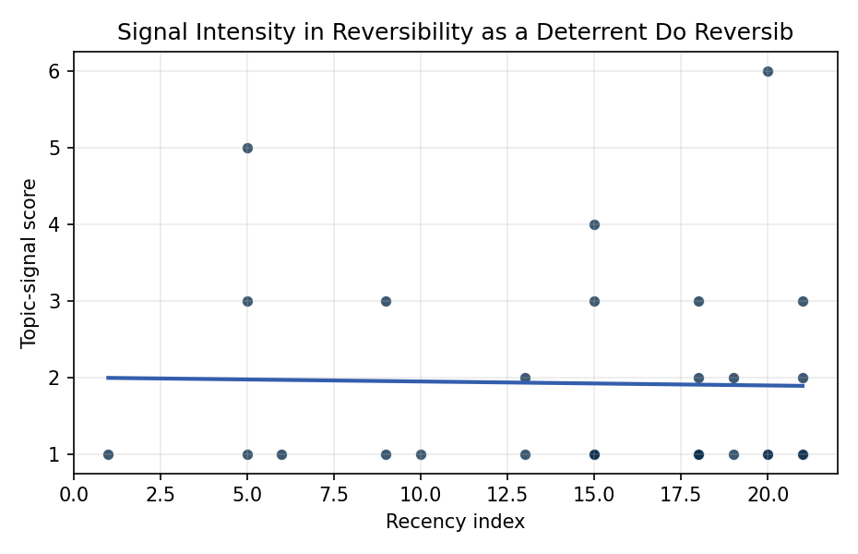
Figure 1. Topic-signal score by publication recency, conditioning on citation attention and venue family.

Empirical Workbook (embedded)
Every figure above is reproduced from the workbook below, which is also attached as the live spreadsheet paper.xlsx. Each observation carries its source.

Data (real observations)
doc_id | year_num | recency_index | cites_num | venue_score | title_words | snippet_words | keyword_count | theme_hits | signal_score | source
1 | 2014 | 9 | 0 | 1 | 13 | 12 | 7 | 0 | 1 | https://amostech.space/year/2014/joint-uk-australian-space-surveillance-target-tracking-cueing-and-sensor-data-fusion-experiment/
2 | 2011 | 6 | 0 | 1 | 11 | 14 | 1 | 0 | 1 | https://amostech.space/year/2011/an-investigation-into-using-differential-drag-for-controlling-a-formation-of-cubesats/
3 | 2014 | 9 | 0 | 1 | 22 | 14 | 3 | 1 | 3 | https://amostech.space/year/2014/validation-of-accuracy-and-efficiency-of-long-arc-orbit-propagation-using-the-method-of-manufactured-solutions-and-the-round-trip-closure-method/
4 | 2023 | 18 | 0 | 1 | 14 | 9 | 4 | 0 | 2 | 10.64861/XQIE1415
5 | 2023 | 18 | 0 | 1 | 7 | 13 | 6 | 0 | 1 | 10.64861/ENVZ4013
6 | 2015 | 10 | 0 | 1 | 7 | 12 | 3 | 0 | 1 | https://amostech.space/year/2015/multicolour-optical-photometry-of-active-geostationary-satellites/
7 | 2010 | 5 | 0 | 1 | 11 | 12 | 5 | 1 | 3 | https://amostech.space/year/2010/application-of-parallel-discrete-event-simulation-to-the-space-surveillance-network/
8 | 2018 | 13 | 0 | 1 | 13 | 13 | 4 | 0 | 2 | https://amostech.space/year/2018/laser-beam-for-external-position-control-and-traffic-management-of-on-orbit-satellites/
9 | 2024 | 19 | 0 | 1 | 15 | 13 | 5 | 0 | 2 | 10.64861/UFLZ6709
10 | 2006 | 1 | 0 | 1 | 11 | 12 | 2 | 0 | 1 | https://amostech.space/year/2006/hdvip-hgcdte-and-silicon-detectors-and-fpas-for-remote-sensing-applications/
11 | 2010 | 5 | 0 | 1 | 9 | 12 | 1 | 2 | 5 | https://amostech.space/year/2010/electrodynamic-debris-eliminator-edde-design-operation-and-ground-support/
12 | 2010 | 5 | 0 | 1 | 12 | 13 | 3 | 0 | 1 | https://amostech.space/year/2010/improved-climatological-characterization-of-optical-turbulence-for-space-optical-imaging-and-communications/
13 | 2020 | 15 | 6 | 2 | 15 | 14 | 15 | 0 | 1 | 10.1016/j.actaastro.2020.07.009
14 | 2026 | 21 | 0 | 2 | 7 | 5 | 15 | 0 | 2 | 10.1016/j.actaastro.2026.03.056
15 | 2026 | 21 | 0 | 2 | 12 | 14 | 8 | 1 | 3 | 10.1016/j.actaastro.2026.05.027
16 | 2026 | 21 | 0 | 2 | 10 | 14 | 10 | 0 | 1 | 10.1016/j.actaastro.2026.03.020
17 | 2020 | 15 | 36 | 2 | 14 | 14 | 13 | 0 | 1 | 10.1016/j.actaastro.2020.02.008
18 | 2025 | 20 | 9 | 2 | 20 | 14 | 7 | 0 | 1 | 10.1016/j.actaastro.2025.03.001
19 | 2026 | 21 | 0 | 2 | 17 | 14 | 15 | 0 | 1 | 10.1016/j.actaastro.2026.03.029
20 | 2023 | 18 | 36 | 2 | 17 | 14 | 10 | 1 | 3 | 10.1016/j.actaastro.2023.05.001
21 | 2023 | 18 | 8 | 2 | 9 | 13 | 7 | 0 | 1 | 10.1016/j.actaastro.2023.02.011
22 | 2023 | 18 | 3 | 2 | 5 | 13 | 10 | 0 | 1 | 10.1016/j.actaastro.2023.04.029
23 | 2025 | 20 | 1 | 2 | 12 | 14 | 6 | 0 | 1 | 10.1016/j.actaastro.2025.08.022
24 | 2025 | 20 | 0 | 2 | 23 | 14 | 12 | 2 | 6 | 10.1016/j.actaastro.2025.10.042
25 | 2020 | 15 | 0 | 3 | 5 | 0 | 0 | 0 | 1 | Kessler Syndrome: System Dynamics Model
26 | 2018 | 13 | 0 | 3 | 5 | 0 | 0 | 0 | 1 | 10.1016/j.spacepol.2018.03.003
27 | 2024 | 19 | 0 | 3 | 13 | 0 | 0 | 0 | 1 | 10.1086/730695
28 | 2020 | 15 | 0 | 3 | 4 | 0 | 0 | 0 | 1 | Behavioral Economics in Space
29 | 2020 | 15 | 0 | 3 | 6 | 0 | 0 | 1 | 3 | SFA Space Economy and Integrated Deterrence
30 | 2020 | 15 | 0 | 3 | 45 | 0 | 0 | 0 | 4 | Stilwell et al. (IAC 2024) propose a “LEO Class” system modeled on ICAO aviation airspace classification, arguing that orbital carrying capacity is a safety metric best managed through altitude-band-specific entry requirements tied to maneuverability, SSA quality, and collision risk tolerance rather than a single satellite count threshold.

Variable construction
Variable | Definition | Construction / source
signal_score | Composite topic-signal score for each retrieved source record | Deterministic count built from candidate-theme term hits in the source title, snippet, keyword field, and author metadata; each row cites the retrieved source in the source column
recency_index | Publication recency index | Computed as publication year minus the minimum publication year in the paper sample plus one
cites_num | Reported citation count in the local brain index | Parsed from the local brain search cites field; zero when the index reported no citation count
venue_score | Ordinal venue-family score | AMOS = 1, Acta Astronautica = 2, Space Economy = 3

Estimator output
Term | Coef. | Std. err. | t | p | 95% CI
const | 1.9998 | 0.8423 | 2.3743 | 0.0176 | [0.349, 3.6506]
recency_index | -0.0052 | 0.0533 | -0.0976 | 0.9223 | [-0.1096, 0.0992]
cites_num | -0.0049 | 0.0241 | -0.2052 | 0.8374 | [-0.0522, 0.0423]
venue_score | -0.0227 | 0.318 | -0.0715 | 0.943 | [-0.646, 0.6005]
Fit: N = 30 R2 = 0.0024 R2_adj = -0.1127 F = 0.0261 F_p = 0.9942

