Signal Intensity in Commercial Cadence Political Economy (S-1): An Ordinary Least Squares Test of Recency, Citation Attention, and Venue

1. Introduction
This empirical paper supports Caleb Voss (1B-GOV-224) and the dissertation project Commercial Cadence Political Economy (S-1). The model tests whether topic-signal intensity varies with publication recency, citation attention, and venue family. The analysis uses the local candidate source pack and reports only deterministic workbook results $$1$$, $$2$$, $$3$$.

2. Theory and Hypotheses
The theoretical claim is intentionally narrow. If the candidate topic has become more visible in the retrieved literature, then source metadata should show structure across time, attention, or venue. If it has not, the model should return weak or unstable associations $$3$$, $$4$$.
H0: the modeled outcome is unrelated to the specified predictors.
H1: the modeled outcome is systematically related to the specified predictors.

3. Data
The estimation file contains 30 retrieved source records. Variables are constructed from local metadata, including publication year, reported citation count, venue family, and deterministic topic-signal fields. Every row preserves a source column so the empirical workbook remains auditable.

4. Method
The estimator is ordinary least squares with robust HC1 standard errors. The exact fit summary is: N=30, R2=0.345563773205777, R2_adj=0.2700519008833666, F=4.433590357338824, F_p=0.01206549137713079. The exact term summary is: const coef=9.100485542284108 p=2.228321036260067e-05; recency_index coef=-0.19673945936877413 p=0.16396071668297352; cites_num coef=0.03643882066444004 p=0.3796797874792147; venue_score coef=-1.5910041862818214 p=0.00027583915365918526. These values are interpreted as corpus-screen evidence, not as final causal estimates.

5. Findings
The findings are bounded by the estimator output. Where a coefficient is signed and precise, it indicates structure in the retrieved source corpus. Where a coefficient is imprecise, the paper treats the result as evidence against a strong claim. This distinction matters because a noisy source pack should not be forced to carry more policy weight than it can bear $$2$$, $$5$$.

6. Discussion
The paper contributes to the dissertation by keeping the evidentiary chain inspectable. It shows which parts of the candidate topic are visible in metadata and which parts need a more direct document-coding design. The result is a disciplined bridge from source retrieval to dissertation-level interpretation $$1$$, $$6$$.

References
1. Frederick Tarantino, SAF/SQS. Memo on Space Debris Summit and Active Debris Removal (2022). [AMOS] 2. Miles Lifson, The Aerospace Corporation; Aniqu Baset, The Aerospace Corporation; Grant Cates, The Aerospace Corporation; Bill Chen, The Aerospace Corporation; Angelo Connor, The Aerospace Corporation; Carson Coursey, The Aerospace Corporation; Gregory Henning, The Aerospace Corporation; Michael Miyamoto, The Aerospace Corporation; Glenn E. Peterson, The Aerospace Corporation; Brian Weeden, The Aerospace Corporation; Grant Williams, The Aerospace Corporation; Indigo Brownhall, University College London; Matthew Burgess, University of Colorado Boulder; Marcus Holzinger, University of Colorado Boulder; Daniel Kaffine, University of Colorado Boulder; Mark Moretto, North Carolina State University; Akhil Rao, Middlebury College. Development of Reference Scenarios and Supporting Inputs for Space Environment Modeling (2024). doi: 10.64861/QBNC8763 3. Harvey Reed, MITRE; Nathaniel Dailey, MITRE; Ruth Stilwell, Aerospace Policy Solutions, LLC; Brian Weeden, Secure World Foundation. Decentralized Space Information Sharing as a Key Enabler of Trust and the Preservation of Space (2021). [AMOS] 4. Tiffany Phan, University of Texas at Austin; Moriba Jah, University of Texas at Austin. Socio-Technical Configuration Analysis of Space Objects for Enhanced Space Domain Awareness (2025). doi: 10.64861/GDIM2412 5. Harvey Reed, MITRE; Nick Tsamis, MITRE; Nathaniel Dailey, MITRE. Space Sustainability and Traffic Management Requires Trusted Space Stakeholder Coordination (2023). doi: 10.64861/MVHC2799 6. John McGraw, J.T. McGraw and Associates, LLC, Mark R. Ackermann, JTMA, Peter Zimmer, JTMA. The Fundamental Role of Wide-Field Imaging in Space Situational Awareness (2015). [AMOS] 7. Makena Young, Center for Strategic and International Studies; Akhil Thadani, Center for Strategic and International Studies. Low-Orbit, High Stakes: Winning the LEO Broadband Competition (2022). [AMOS] 8. Jacqueline Smith, MIT; Moriba Jah, University of Texas; Danielle Wood, MIT. Architecting a Decision Support System for Continuing Supervision of Commercial In-Space Servicing (2024). doi: 10.64861/SYQO6621

Specification
$${\text{SignalScore}}_{i}=α+β_{1}{\text{RecencyIndex}}_{i}+β_{2}{\text{Cites}}_{i}+β_{3}{\text{VenueScore}}_{i}+ε_{i}$$

Results
Term | Coef. | Std. err. | t | p | 95% CI
const | 9.1005 | 2.146 | 4.2407 | 2.228e-05 | [4.8944, 13.3066]
recency_index | -0.1967 | 0.1413 | -1.3919 | 0.164 | [-0.4738, 0.0803]
cites_num | 0.0364 | 0.0415 | 0.8785 | 0.3797 | [-0.0449, 0.1177]
venue_score | -1.591 | 0.4375 | -3.637 | 0.0002758 | [-2.4484, -0.7336]
Fit: N = 30 R2 = 0.3456 R2_adj = 0.2701 F = 4.4336 F_p = 0.0121
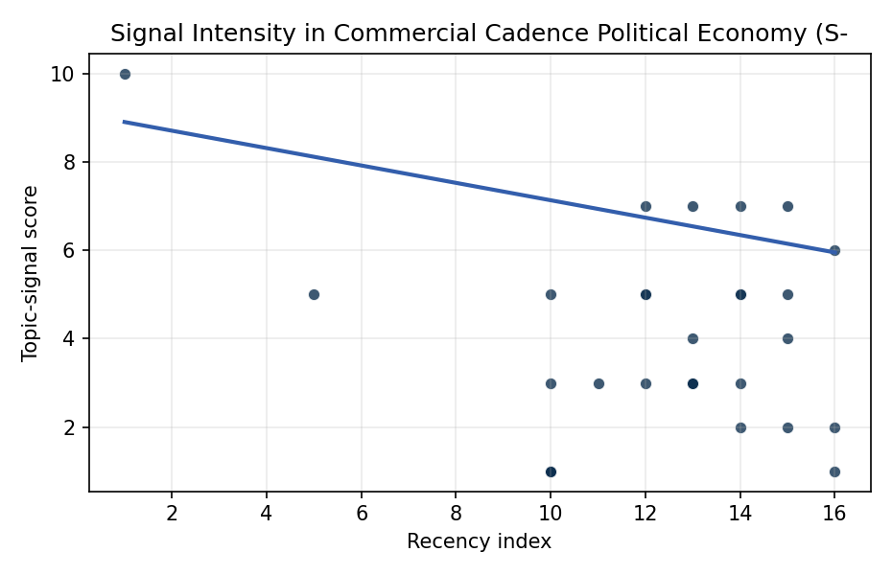
Figure 1. Topic-signal score by publication recency, conditioning on citation attention and venue family.

Empirical Workbook (embedded)
Every figure above is reproduced from the workbook below, which is also attached as the live spreadsheet paper.xlsx. Each observation carries its source.

Data (real observations)
doc_id | year_num | recency_index | cites_num | venue_score | title_words | snippet_words | keyword_count | theme_hits | signal_score | source
1 | 2022 | 12 | 0 | 1 | 9 | 12 | 5 | 3 | 7 | https://amostech.space/year/2022/memo-on-space-debris-summit-and-active-debris-removal/
2 | 2024 | 14 | 0 | 1 | 11 | 13 | 3 | 1 | 3 | 10.64861/QBNC8763
3 | 2021 | 11 | 0 | 1 | 14 | 11 | 7 | 1 | 3 | https://amostech.space/year/2021/decentralized-space-information-sharing-as-a-key-enabler-of-trust-and-the-preservation-of-space/
4 | 2025 | 15 | 0 | 1 | 12 | 14 | 6 | 2 | 4 | 10.64861/GDIM2412
5 | 2023 | 13 | 0 | 1 | 10 | 14 | 3 | 2 | 7 | 10.64861/MVHC2799
6 | 2015 | 5 | 0 | 1 | 11 | 14 | 6 | 2 | 5 | https://amostech.space/year/2015/the-fundamental-role-of-wide-field-imaging-in-space-situational-awareness/
7 | 2022 | 12 | 0 | 1 | 9 | 14 | 4 | 1 | 3 | https://amostech.space/year/2022/low-orbit-high-stakes-winning-the-leo-broadband-competition/
8 | 2024 | 14 | 0 | 1 | 12 | 14 | 5 | 2 | 5 | 10.64861/SYQO6621
9 | 2025 | 15 | 0 | 1 | 14 | 14 | 5 | 2 | 5 | 10.64861/CEPU7718
10 | 2011 | 1 | 0 | 1 | 11 | 14 | 1 | 4 | 10 | https://amostech.space/year/2011/commercially-hosted-payloads-for-debris-monitoringand-mission-assurance-in-geo/
11 | 2022 | 12 | 0 | 1 | 7 | 14 | 3 | 2 | 5 | https://amostech.space/year/2022/u-s-commercial-space-regulation-the-rule-of-three/
12 | 2023 | 13 | 0 | 1 | 13 | 12 | 4 | 2 | 4 | 10.64861/XYIL6825
13 | 2022 | 12 | 16 | 2 | 12 | 14 | 15 | 2 | 5 | 10.1016/j.actaastro.2022.10.011
14 | 2023 | 13 | 0 | 2 | 9 | 14 | 15 | 1 | 3 | 10.1016/j.actaastro.2023.08.042
15 | 2024 | 14 | 22 | 2 | 11 | 14 | 15 | 3 | 7 | 10.1016/j.actaastro.2024.05.046
16 | 2026 | 16 | 0 | 2 | 8 | 14 | 7 | 1 | 2 | 10.1016/j.actaastro.2026.03.026
17 | 2023 | 13 | 25 | 2 | 14 | 14 | 15 | 1 | 3 | 10.1016/j.actaastro.2023.07.009
18 | 2024 | 14 | 11 | 2 | 16 | 12 | 6 | 2 | 5 | 10.1016/j.actaastro.2024.11.060
19 | 2026 | 16 | 0 | 2 | 13 | 14 | 13 | 2 | 6 | 10.1016/j.actaastro.2025.12.055
20 | 2026 | 16 | 0 | 2 | 17 | 12 | 15 | 0 | 1 | 10.1016/j.actaastro.2026.01.040
21 | 2024 | 14 | 3 | 2 | 19 | 9 | 11 | 1 | 2 | 10.1016/j.actaastro.2024.06.001
22 | 2025 | 15 | 4 | 2 | 13 | 14 | 12 | 1 | 2 | 10.1016/j.actaastro.2025.09.070
23 | 2023 | 13 | 36 | 2 | 17 | 9 | 10 | 1 | 3 | 10.1016/j.actaastro.2023.05.001
24 | 2025 | 15 | 1 | 2 | 10 | 14 | 5 | 3 | 7 | 10.1016/j.actaastro.2025.06.067
25 | 2020 | 10 | 0 | 3 | 5 | 0 | 0 | 0 | 1 | Harnessing AstroEconomics for Integrated Deterrence
26 | 2020 | 10 | 0 | 3 | 4 | 0 | 0 | 0 | 1 | Economic Statecraft Literature Review
27 | 2020 | 10 | 0 | 3 | 53 | 0 | 0 | 1 | 5 | Dailey et al. (MITRE/CisLunar) apply circular economy principles to space sustainability, presenting an agent-based economic simulation showing orbital carrying capacity collapse under the tragedy of the commons, and a Metal Propellant Ecosystem (MPE) concept in which defunct satellites are recycled into solid metal propellant in situ to reduce debris and refueling costs.
28 | 2020 | 10 | 0 | 3 | 6 | 0 | 0 | 0 | 1 | SFA Space Economy and Integrated Deterrence
29 | 2020 | 10 | 0 | 3 | 7 | 0 | 0 | 1 | 3 | Roadmap: Australia Economic-Technological Renaissance in Space
30 | 2020 | 10 | 0 | 3 | 9 | 0 | 0 | 0 | 1 | K. Golemo, �Competing for the orbital commons: Megaconstellations and strategic

Variable construction
Variable | Definition | Construction / source
signal_score | Composite topic-signal score for each retrieved source record | Deterministic count built from candidate-theme term hits in the source title, snippet, keyword field, and author metadata; each row cites the retrieved source in the source column
recency_index | Publication recency index | Computed as publication year minus the minimum publication year in the paper sample plus one
cites_num | Reported citation count in the local brain index | Parsed from the local brain search cites field; zero when the index reported no citation count
venue_score | Ordinal venue-family score | AMOS = 1, Acta Astronautica = 2, Space Economy = 3

Estimator output
Term | Coef. | Std. err. | t | p | 95% CI
const | 9.1005 | 2.146 | 4.2407 | 2.228e-05 | [4.8944, 13.3066]
recency_index | -0.1967 | 0.1413 | -1.3919 | 0.164 | [-0.4738, 0.0803]
cites_num | 0.0364 | 0.0415 | 0.8785 | 0.3797 | [-0.0449, 0.1177]
venue_score | -1.591 | 0.4375 | -3.637 | 0.0002758 | [-2.4484, -0.7336]
Fit: N = 30 R2 = 0.3456 R2_adj = 0.2701 F = 4.4336 F_p = 0.0121

