Signal Intensity in SENTINEL agentic NOC/SOC vs GAO-25-108138: An Ordinary Least Squares Test of Recency, Citation Attention, and Venue

1. Introduction
This empirical paper supports Vera Abara (1B-ITI-205) and the dissertation project SENTINEL: agentic NOC/SOC vs GAO-25-108138. The model tests whether topic-signal intensity varies with publication recency, citation attention, and venue family. The analysis uses the local candidate source pack and reports only deterministic workbook results $$1$$, $$2$$, $$3$$.

2. Theory and Hypotheses
The theoretical claim is intentionally narrow. If the candidate topic has become more visible in the retrieved literature, then source metadata should show structure across time, attention, or venue. If it has not, the model should return weak or unstable associations $$3$$, $$4$$.
H0: the modeled outcome is unrelated to the specified predictors.
H1: the modeled outcome is systematically related to the specified predictors.

3. Data
The estimation file contains 30 retrieved source records. Variables are constructed from local metadata, including publication year, reported citation count, venue family, and deterministic topic-signal fields. Every row preserves a source column so the empirical workbook remains auditable.

4. Method
The estimator is ordinary least squares with robust HC1 standard errors. The exact fit summary is: N=30, R2=0.07712060910820506, R2_adj=-0.029365474456232832, F=0.8740215054799764, F_p=0.46721045728877053. The exact term summary is: const coef=2.589552444614521 p=0.09865507244384576; recency_index coef=0.1663847987760372 p=0.2377072730196058; cites_num coef=-0.0006836056901668875 p=0.9926297277715995; venue_score coef=-0.6519374656045693 p=0.26114081515755605. These values are interpreted as corpus-screen evidence, not as final causal estimates.

5. Findings
The findings are bounded by the estimator output. Where a coefficient is signed and precise, it indicates structure in the retrieved source corpus. Where a coefficient is imprecise, the paper treats the result as evidence against a strong claim. This distinction matters because a noisy source pack should not be forced to carry more policy weight than it can bear $$2$$, $$5$$.

6. Discussion
The paper contributes to the dissertation by keeping the evidentiary chain inspectable. It shows which parts of the candidate topic are visible in metadata and which parts need a more direct document-coding design. The result is a disciplined bridge from source retrieval to dissertation-level interpretation $$1$$, $$6$$.

References
1. Richard Stottler, Stottler Henke Associates, Inc, Dr. Chris Bowman, Data Fusion & Neural Networks. Satellite-Based EMI Detection, Identification, and Mitigation (2016). [AMOS] 2. Robert Zitz, SpaceLink Corporation; Jim Schwenke, SpaceLink Corporation; Rob Singh, SpaceLink Corporation; David Nemeth, SpaceLink Corporation; Behzad Koosha, SpaceLink Corporation. The Need for Speed – Just in Time Data Relay through Optical Communications Links (2022). [AMOS] 3. Garrett Fitzgerald, U. S. Space Force; Rachel Morris, Applied Decision Science; Laura G. Militello, Applied Decision Science; Justin Fletcher, USSF/SSC. Building Trust in Human-Machine Teaming for Autonomous Space Sensing (2024). doi: 10.64861/HWZS9386 4. Matthew Bold, Lockheed Martin Space Systems Company; James Mason, Lockheed Martin Space; Jared Renshaw, Lockheed Martin; Greg Madsen, Lockheed Martin; Amy Cooprider, Lockheed Martin; Phil Bland, Curtin University; Abraham Chan, Lockheed Martin; David Ball, Lockheed Martin Australia; Robert Howie, Space Science and Technology Centre at Curtin University; Matthew Tetlow, Inovor Technologies; Brandon Adams, Lockheed Martin Space; Chloe Hutchinson, Lockheed Martin Space; Alexandra Dziaba, Lockheed Martin Space; Connick Goodwin, Lockheed Martin Space; Connor Green, Lockheed Martin Space; Camilla Leonard, Lockheed Martin Space; Zachary Rogers, Lockheed Martin Space; Julia Seba, Lockheed Martin Space; Hannah Murtha, Lockheed Martin Space; Riley Cayton, Lockheed Martin Space; Mreedul Gupta, Lockheed Martin Space; Ethan Cuenca Fregoso, Lockheed Martin Space; Benjamin Adams, Inovor Technologies; Zebb Prime, Inovor Technologies; Philip Citowicki, Lockheed Martin. Proliferated Sensor Network (PSN) Performance Study & Architecture Design Optimization (2023). doi: 10.64861/UELE5506 5. Konstantinos Tsaprailis, National Kapodistrian University of Athens, Greece & National Observatory of Athens; George Choumos, National Kapodistrian University of Athens, Greece & National Observatory of Athens; Charalampos Kontoes, National Observatory of Athens; Vaios Lappas, National Kapodistrian University of Athens, Greece. Integrating AI in Space Operations: Spin Status Characterization and Initial Orbit Determination from Single Optical Tracks (2025). doi: 10.64861/WEXT5718 6. Lauren Hale, The Aerospace Corporation; Justin C. Last, The Aerospace Corporation; Jordan Denamur-Paul, The Aerospace Corporation; Richard Barber, The Aerospace Corporation. Partnering not Bossing: Better Leveraging of International Capabilities for Space Domain Awareness (2022). [AMOS] 7. Peng Mun Siew, Massachusetts Institute of Technology; Tory Smith, United States Space Force, Massachusetts Institute of Technology; Richard Linares, Massachusetts Institute of Technology; Ravi Ponmalai, Aerospace Corporation. Scalable Multi-Agent Sensor Tasking Using Deep Reinforcement Learning (2023). doi: 10.64861/LWLF6390 8. Manuel Schubert, Institute of Space Systems, Technische Universität Braunschweig, Germany; Christopher Kebschull, OKAPI:Orbits GmbH; Njord Eggen, OKAPI:Orbits GmbH; Simona Silvestri, Institute of Space Systems, Technische Universität Braunschweig, Germany. Applicability of the Sensor Network Simulator Tool Suite for Proximity Operations (2023). doi: 10.64861/IQLQ6181

Specification
$${\text{SignalScore}}_{i}=α+β_{1}{\text{RecencyIndex}}_{i}+β_{2}{\text{Cites}}_{i}+β_{3}{\text{VenueScore}}_{i}+ε_{i}$$

Results
Term | Coef. | Std. err. | t | p | 95% CI
const | 2.5896 | 1.5681 | 1.6514 | 0.0987 | [-0.4838, 5.6629]
recency_index | 0.1664 | 0.1409 | 1.1807 | 0.2377 | [-0.1098, 0.4426]
cites_num | -0.0006836 | 0.074 | -0.0092 | 0.9926 | [-0.1457, 0.1444]
venue_score | -0.6519 | 0.5802 | -1.1237 | 0.2611 | [-1.7891, 0.4852]
Fit: N = 30 R2 = 0.0771 R2_adj = -0.0294 F = 0.874 F_p = 0.4672
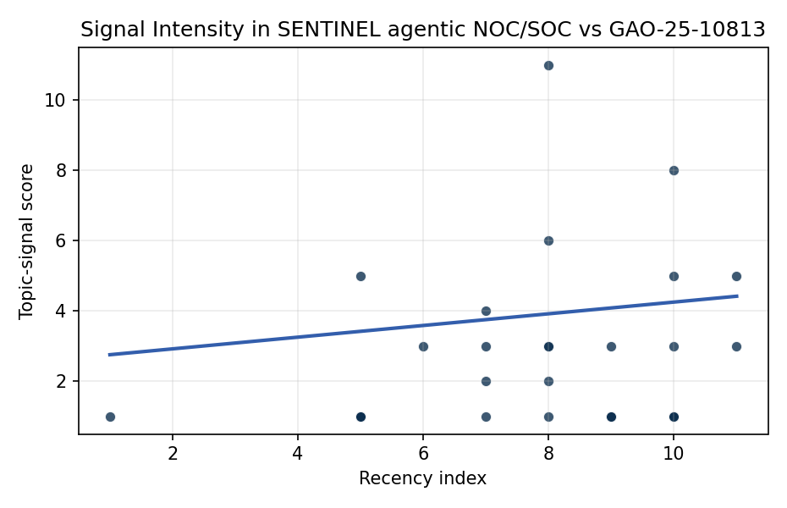
Figure 1. Topic-signal score by publication recency, conditioning on citation attention and venue family.

Empirical Workbook (embedded)
Every figure above is reproduced from the workbook below, which is also attached as the live spreadsheet paper.xlsx. Each observation carries its source.

Data (real observations)
doc_id | year_num | recency_index | cites_num | venue_score | title_words | snippet_words | keyword_count | theme_hits | signal_score | source
1 | 2016 | 1 | 0 | 1 | 7 | 14 | 7 | 0 | 1 | https://amostech.space/year/2016/satellite-based-emi-detection-identification-and-mitigation/
2 | 2022 | 7 | 0 | 1 | 13 | 14 | 7 | 1 | 2 | https://amostech.space/year/2022/the-need-for-speed-just-in-time-data-relay-through-optical-communications-links/
3 | 2024 | 9 | 0 | 1 | 10 | 10 | 5 | 0 | 1 | 10.64861/HWZS9386
4 | 2023 | 8 | 0 | 1 | 9 | 9 | 8 | 0 | 1 | 10.64861/UELE5506
5 | 2025 | 10 | 0 | 1 | 16 | 14 | 7 | 3 | 8 | 10.64861/WEXT5718
6 | 2022 | 7 | 0 | 1 | 12 | 14 | 11 | 1 | 3 | https://amostech.space/year/2022/partnering-not-bossing-better-leveraging-of-international-capabilities-for-space-domain-awareness/
7 | 2023 | 8 | 0 | 1 | 9 | 14 | 6 | 1 | 3 | 10.64861/LWLF6390
8 | 2023 | 8 | 0 | 1 | 11 | 13 | 6 | 4 | 11 | 10.64861/IQLQ6181
9 | 2024 | 9 | 0 | 1 | 9 | 14 | 3 | 1 | 3 | 10.64861/TWFE4121
10 | 2022 | 7 | 0 | 1 | 6 | 12 | 4 | 1 | 4 | https://amostech.space/year/2022/buying-space-trends-in-u-s-sda-acquisition/
11 | 2023 | 8 | 0 | 1 | 12 | 10 | 7 | 1 | 2 | 10.64861/WKDZ6860
12 | 2024 | 9 | 0 | 1 | 13 | 11 | 16 | 0 | 1 | 10.64861/WIDV9097
13 | 2025 | 10 | 1 | 2 | 15 | 13 | 15 | 1 | 3 | 10.1016/j.actaastro.2025.10.018
14 | 2025 | 10 | 10 | 2 | 18 | 14 | 15 | 0 | 1 | 10.1016/j.actaastro.2025.05.008
15 | 2026 | 11 | 0 | 2 | 16 | 11 | 15 | 2 | 5 | 10.1016/j.actaastro.2026.05.022
16 | 2025 | 10 | 0 | 2 | 14 | 10 | 15 | 0 | 1 | 10.1016/j.actaastro.2025.09.076
17 | 2023 | 8 | 9 | 2 | 16 | 4 | 13 | 1 | 3 | 10.1016/j.actaastro.2023.10.011
18 | 2025 | 10 | 1 | 2 | 20 | 11 | 15 | 0 | 1 | 10.1016/j.actaastro.2025.08.050
19 | 2022 | 7 | 3 | 2 | 8 | 11 | 14 | 0 | 1 | 10.1016/j.actaastro.2022.07.054
20 | 2024 | 9 | 28 | 2 | 14 | 10 | 13 | 0 | 1 | 10.1016/j.actaastro.2024.08.022
21 | 2025 | 10 | 2 | 2 | 13 | 6 | 5 | 0 | 1 | 10.1016/j.actaastro.2025.04.031
22 | 2025 | 10 | 2 | 2 | 12 | 12 | 12 | 2 | 5 | 10.1016/j.actaastro.2025.04.063
23 | 2026 | 11 | 0 | 2 | 7 | 9 | 9 | 1 | 3 | 10.1016/j.actaastro.2026.02.030
24 | 2023 | 8 | 21 | 2 | 14 | 12 | 15 | 2 | 6 | 10.1016/j.actaastro.2023.04.032
25 | 2020 | 5 | 0 | 3 | 10 | 0 | 0 | 0 | 1 | S. Huang, F. Zhang, H. Zhang, M. Gao, and K. Li, �Assessment and management impl
26 | 2020 | 5 | 0 | 3 | 47 | 0 | 0 | 0 | 1 | A comprehensive literature review synthesizing William J. Norris’s “Chinese Economic Statecraft” and David A. Baldwin’s “Economic Statecraft,” analyzing China’s use of state-controlled commercial actors, financial instruments, and sovereign wealth funds to advance strategic objectives, with extrapolation to the space economy as a new frontier for resource acquisition and geopolitical positioning.
27 | 2020 | 5 | 0 | 3 | 53 | 0 | 0 | 1 | 5 | Dailey et al. (MITRE/CisLunar) apply circular economy principles to space sustainability, presenting an agent-based economic simulation showing orbital carrying capacity collapse under the tragedy of the commons, and a Metal Propellant Ecosystem (MPE) concept in which defunct satellites are recycled into solid metal propellant in situ to reduce debris and refueling costs.
28 | 2020 | 5 | 0 | 3 | 4 | 0 | 0 | 0 | 1 | Economic Statecraft Literature Review
29 | 2020 | 5 | 0 | 3 | 9 | 0 | 0 | 0 | 1 | Architectural Socio-Technological Transformative Change of Space-Use Norms
30 | 2021 | 6 | 0 | 1 | 14 | 13 | 7 | 1 | 3 | https://amostech.space/year/2021/decentralized-space-information-sharing-as-a-key-enabler-of-trust-and-the-preservation-of-space/

Variable construction
Variable | Definition | Construction / source
signal_score | Composite topic-signal score for each retrieved source record | Deterministic count built from candidate-theme term hits in the source title, snippet, keyword field, and author metadata; each row cites the retrieved source in the source column
recency_index | Publication recency index | Computed as publication year minus the minimum publication year in the paper sample plus one
cites_num | Reported citation count in the local brain index | Parsed from the local brain search cites field; zero when the index reported no citation count
venue_score | Ordinal venue-family score | AMOS = 1, Acta Astronautica = 2, Space Economy = 3

Estimator output
Term | Coef. | Std. err. | t | p | 95% CI
const | 2.5896 | 1.5681 | 1.6514 | 0.0987 | [-0.4838, 5.6629]
recency_index | 0.1664 | 0.1409 | 1.1807 | 0.2377 | [-0.1098, 0.4426]
cites_num | -0.0006836 | 0.074 | -0.0092 | 0.9926 | [-0.1457, 0.1444]
venue_score | -0.6519 | 0.5802 | -1.1237 | 0.2611 | [-1.7891, 0.4852]
Fit: N = 30 R2 = 0.0771 R2_adj = -0.0294 F = 0.874 F_p = 0.4672

