Attention Accumulation in Debris CONOPs incentive-compatible cooperative remediation: A Learning-Curve Analysis of Citation Growth by Article Age

1. Introduction
This empirical paper supports Marina Adeyemi (1B-SDA-189) and the dissertation project Debris CONOPs: incentive-compatible cooperative remediation. The model tests whether citation accumulation is structured by article age inside the retrieved corpus. The analysis uses the local candidate source pack and reports only deterministic workbook results $$1$$, $$2$$, $$3$$.

2. Theory and Hypotheses
The theoretical claim is intentionally narrow. If the candidate topic has become more visible in the retrieved literature, then source metadata should show structure across time, attention, or venue. If it has not, the model should return weak or unstable associations $$3$$, $$4$$.
H0: the modeled outcome is unrelated to the specified predictors.
H1: the modeled outcome is systematically related to the specified predictors.

3. Data
The estimation file contains 30 retrieved source records. Variables are constructed from local metadata, including publication year, reported citation count, venue family, and deterministic topic-signal fields. Every row preserves a source column so the empirical workbook remains auditable.

4. Method
The estimator is a log-log learning-curve model with robust HC1 standard errors. The exact fit summary is: N=30, R2=0.17593145489555184, elasticity_b=-1.2189338505131952, progress_ratio_2^b=0.42960007475692913. The exact term summary is: const coef=3.0912587835129157 p=3.6131579191776304e-07; _ln_x coef=-1.2189338505131952 p=0.0007688071465113465. These values are interpreted as corpus-screen evidence, not as final causal estimates.

5. Findings
The findings are bounded by the estimator output. Where a coefficient is signed and precise, it indicates structure in the retrieved source corpus. Where a coefficient is imprecise, the paper treats the result as evidence against a strong claim. This distinction matters because a noisy source pack should not be forced to carry more policy weight than it can bear $$2$$, $$5$$.

6. Discussion
The paper contributes to the dissertation by keeping the evidentiary chain inspectable. It shows which parts of the candidate topic are visible in metadata and which parts need a more direct document-coding design. The result is a disciplined bridge from source retrieval to dissertation-level interpretation $$1$$, $$6$$.

References
1. Rina Zhang, Science and Technology Policy Institute; Asha Balakrishnan, Science and Technology Policy Institute. From Ozone Depletion to Orbital Debris: Lessons Learned from the Montreal Protocol (2022). [AMOS] 2. Malgorzata Polkowska, Lomza Academy; Arkadiusz Chimicz, General Command, Polish Armed Forces. Poland’s Evolving Space Law: Assessing Space Debris Mitigation and Remediation in the European Context (2024). doi: 10.64861/LFFV2455 3. Frederick Tarantino, SAF/SQS. Memo on Space Debris Summit and Active Debris Removal (2022). [AMOS] 4. Andrew Abraham, Lockheed Martin; Oliver Schultz, Lockheed Martin Space. Cooperative Tracking Aid for Space Domain Awareness (2023). doi: 10.64861/DNKW1345 5. Chris Tuttle, Clearspace Today, Inc.; Darren McKnight, LeoLabs; Tim Maclay, ClearSpace. Refining Active Debris Removal Strategies (2023). doi: 10.64861/LBPZ7861 6. Michael Copeland, Australian National University; Francis Bennet, Australian National University; Francois Rigaut, Australian National University; Visa Korkiakoski, Australian National University; I. Price, Australian National University; Celine d’Orgeville, Australian National University; Craig Smith, EOS Space Systems. Satellite and Debris Characterisation through Adaptive Optics Corrected Imaging (2018). [AMOS] 7. F. Bennet, Research School of Astronomy and Astrophysics – Australian National University and Space Environment Research Centre (SERC) Limited, M. Petkovic, Research School of Astronomy and Astrophysics – Australian National University and Space Environment Research Centre (SERC) Limited, B. Sheard, Space Environment Research Centre (SERC) Limited and EOS Space Systems, Ben Greene, Space Environment Research Centre (SERC) Limited and EOS Space Systems. High-Altitude Airborne Platform Characterisation of Adaptive Optic Corrected Ground Based Laser (2017). [AMOS] 8. Jaedong Seong, Korea Aerospace Research Institute (KARI); Okchul Jung, Korea Aerospace Research Institute (KARI); Dae Won Chung, Korea Aerospace Research Institute (KARI). KARI Recent Activities on SSA & STM (2019). [AMOS]

Specification
$$ln({\text{CitesPlus1}}_{i})=α+β_{1}ln({\text{AgeIndex}}_{i})+ε_{i}$$

Results
Term | Coef. | Std. err. | t | p | 95% CI
const | 3.0913 | 0.6075 | 5.0883 | 3.613e-07 | [1.9005, 4.282]
_ln_x | -1.2189 | 0.3624 | -3.3638 | 0.0007688 | [-1.9292, -0.5087]
Fit: N = 30 R2 = 0.1759 elasticity_b = -1.2189 progress_ratio_2^b = 0.4296
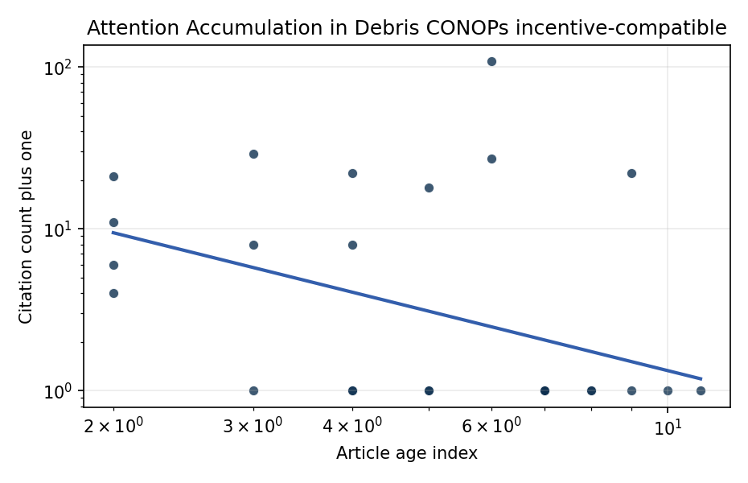
Figure 1. Citation accumulation against article age in the retrieved topic literature.

Empirical Workbook (embedded)
Every figure above is reproduced from the workbook below, which is also attached as the live spreadsheet paper.xlsx. Each observation carries its source.

Data (real observations)
doc_id | year_num | age_index | cites_num | cites_plus1 | signal_score | source
1 | 2022 | 5 | 0 | 1 | 6 | https://amostech.space/year/2022/from-ozone-depletion-to-orbital-debris-lessons-learned-from-the-montreal-protocol/
2 | 2024 | 3 | 0 | 1 | 5 | 10.64861/LFFV2455
3 | 2022 | 5 | 0 | 1 | 5 | https://amostech.space/year/2022/memo-on-space-debris-summit-and-active-debris-removal/
4 | 2023 | 4 | 0 | 1 | 3 | 10.64861/DNKW1345
5 | 2023 | 4 | 0 | 1 | 4 | 10.64861/LBPZ7861
6 | 2018 | 9 | 0 | 1 | 5 | https://amostech.space/year/2018/satellite-and-debris-characterisation-through-adaptive-optics-corrected-imaging/
7 | 2017 | 10 | 0 | 1 | 4 | https://amostech.space/year/2017/high-altitude-airborne-platform-characterisation-of-adaptive-optic-corrected-ground-based-laser/
8 | 2019 | 8 | 0 | 1 | 5 | https://amostech.space/year/2019/kari-recent-activities-on-ssa-stm/
9 | 2020 | 7 | 0 | 1 | 4 | https://amostech.space/year/2020/contribution-from-ssa-data-to-the-definition-of-a-space-sustainability-rating/
10 | 2019 | 8 | 0 | 1 | 4 | https://amostech.space/year/2019/space-environment-management-a-common-sense-framework-for-controlling-orbital-debris-risk/
11 | 2020 | 7 | 0 | 1 | 6 | https://amostech.space/year/2020/international-perspectives-on-space-weapons/
12 | 2016 | 11 | 0 | 1 | 4 | https://amostech.space/year/2016/comparison-of-envisataes-attitude-simulation-and-real-optical-and-slr-observations-in-order-to-refine-the-satellite-attitude-model/
13 | 2021 | 6 | 107 | 108 | 5 | 10.1016/j.actaastro.2021.01.021
14 | 2024 | 3 | 7 | 8 | 5 | 10.1016/j.actaastro.2024.11.050
15 | 2023 | 4 | 21 | 22 | 6 | 10.1016/j.actaastro.2023.01.016
16 | 2018 | 9 | 21 | 22 | 4 | 10.1016/j.actaastro.2018.01.028
17 | 2022 | 5 | 17 | 18 | 5 | 10.1016/j.actaastro.2022.05.045
18 | 2025 | 2 | 20 | 21 | 4 | 10.1016/j.actaastro.2025.01.007
19 | 2025 | 2 | 3 | 4 | 3 | 10.1016/j.actaastro.2025.06.029
20 | 2025 | 2 | 5 | 6 | 5 | 10.1016/j.actaastro.2025.03.034
21 | 2024 | 3 | 28 | 29 | 8 | 10.1016/j.actaastro.2024.08.022
22 | 2021 | 6 | 26 | 27 | 5 | 10.1016/j.actaastro.2021.08.051
23 | 2025 | 2 | 10 | 11 | 5 | 10.1016/j.actaastro.2025.07.027
24 | 2023 | 4 | 7 | 8 | 5 | 10.1016/j.actaastro.2023.10.044
25 | 2020 | 7 | 0 | 1 | 4 | 10.1016/j.jsse.2020.07.016
26 | 2020 | 7 | 0 | 1 | 4 | The Economics of Orbital Debris Generation, Accumulation, Mitigation, Remediation
27 | 2020 | 7 | 0 | 1 | 1 | A comprehensive literature review synthesizing William J. Norris’s “Chinese Economic Statecraft” and David A. Baldwin’s “Economic Statecraft,” analyzing China’s use of state-controlled commercial actors, financial instruments, and sovereign wealth funds to advance strategic objectives, with extrapolation to the space economy as a new frontier for resource acquisition and geopolitical positioning.
28 | 2020 | 7 | 0 | 1 | 1 | Leveraging Circular Economy for Space Sustainability
29 | 2020 | 7 | 0 | 1 | 4 | McKinsey and World Economic Forum 2022 report synthesizing perspectives from nearly 100 leaders across 25 countries on the space sector’s inflection point, four future scenarios, and five priority actions needed to achieve a self-sustaining space economy, with particular emphasis on governance gaps, finite orbital resource competition, and the sustainability-security nexus.
30 | 2020 | 7 | 0 | 1 | 4 | MITRE/Aspen Institute (2022) whole-of-nation framework paper arguing that commercial, civil, and military space sectors share sustainability and governance challenges requiring unified U.S. leadership on norms, streamlined mission authorization, and sustained cross-sector coordination.

Variable construction
Variable | Definition | Construction / source
cites_plus1 | Citation count plus one | Computed as the reported citation count from the local brain index plus one so the log transformation is defined for uncited records
age_index | Document age index | Computed as 2026 minus publication year plus one

Estimator output
Term | Coef. | Std. err. | t | p | 95% CI
const | 3.0913 | 0.6075 | 5.0883 | 3.613e-07 | [1.9005, 4.282]
_ln_x | -1.2189 | 0.3624 | -3.3638 | 0.0007688 | [-1.9292, -0.5087]
Fit: N = 30 R2 = 0.1759 elasticity_b = -1.2189 progress_ratio_2^b = 0.4296

