Signal Intensity in SSR Business Case rating-to-behavior: An Ordinary Least Squares Test of Recency, Citation Attention, and Venue

1. Introduction
This empirical paper supports Lena Yoon (1B-GOV-232) and the dissertation project SSR Business Case: rating-to-behavior. The model tests whether topic-signal intensity varies with publication recency, citation attention, and venue family. The analysis uses the local candidate source pack and reports only deterministic workbook results $$1$$, $$2$$, $$3$$.

2. Theory and Hypotheses
The theoretical claim is intentionally narrow. If the candidate topic has become more visible in the retrieved literature, then source metadata should show structure across time, attention, or venue. If it has not, the model should return weak or unstable associations $$3$$, $$4$$.
H0: the modeled outcome is unrelated to the specified predictors.
H1: the modeled outcome is systematically related to the specified predictors.

3. Data
The estimation file contains 30 retrieved source records. Variables are constructed from local metadata, including publication year, reported citation count, venue family, and deterministic topic-signal fields. Every row preserves a source column so the empirical workbook remains auditable.

4. Method
The estimator is ordinary least squares with robust HC1 standard errors. The exact fit summary is: N=30, R2=0.25652437147772733, R2_adj=0.17073872203284968, F=7.675207425617432, F_p=0.0007821381177479286. The exact term summary is: const coef=6.875846144272956 p=8.893725464571936e-06; recency_index coef=0.13150490490389502 p=0.5421851446923563; cites_num coef=0.2395271514558316 p=0.49603581910889194; venue_score coef=-1.7424526033073837 p=0.003371006558837238. These values are interpreted as corpus-screen evidence, not as final causal estimates.

5. Findings
The findings are bounded by the estimator output. Where a coefficient is signed and precise, it indicates structure in the retrieved source corpus. Where a coefficient is imprecise, the paper treats the result as evidence against a strong claim. This distinction matters because a noisy source pack should not be forced to carry more policy weight than it can bear $$2$$, $$5$$.

6. Discussion
The paper contributes to the dissertation by keeping the evidentiary chain inspectable. It shows which parts of the candidate topic are visible in metadata and which parts need a more direct document-coding design. The result is a disciplined bridge from source retrieval to dissertation-level interpretation $$1$$, $$6$$.

References
1. Francesca Letizia, European Space Agency; Stijn Lemmens, ESA/ESOC Space Debris Office; Danielle Wood, Space Enabled Research Group, MIT Media Lab; Minoo Rathnasabapathy, Space Enabled Research Group at the MIT Media Lab; Miles Lifson, MIT Media Lab- Space Enabled Research Group; Riley Stiendl, Massachusetts Institute of Technology; Moriba Jah, University of Texas at Austin; Nikolai Khlystov, World Economic Forum; Maksim Soshkin, World Economic Forum; Simon Potter, Bryce Space and Technology. Contribution from SSA Data to the Definition of a Space Sustainability Rating (2020). [AMOS] 2. Todd Harrison, Center for Strategic and International Studies. International Perspectives on Space Weapons (2020). [AMOS] 3. Matthew Stevenson, LeoLabs; Darren McKnight, LeoLabs; Hugh Lewis, University of Southampton; Chris Kunstadter, AXA XL; Rachit Bhatia, LeoLabs. Identifying the Statistically-Most-Concerning Conjunctions in LEO (2021). [AMOS] 4. Sergei Nikolaev (Lawrence Livermore National Laboratory), Donald Phillion (Lawrence Livermore National Laboratory), H. Keo Springer (Lawrence Livermore National Laboratory), Willem deVries (Lawrence Livermore National Laboratory), Ming Jiang (Lawrence Livermore National Laboratory), Alex Pertica (Lawrence Livermore National Laboratory), John Henderson (Lawrence Livermore National Laboratory), Matthew Horsley (Lawrence Livermore National Laboratory), Scot Olivier (Lawrence Livermore National Laboratory). Brute Force Modeling of the Kessler Syndrome (2012). [AMOS] 5. Ben Lane, ExoAnalytic Solutions, Mark Poole, ExoAnalytic Solutions, Matt Camp, ExoAnalytic Solutions, Jeremy Murray-Krezan, AFRL. Using Machine Learning for Advanced Anomaly Detection and Classification (2016). [AMOS] 6. Yasir Latif, Space Protocol; Anirban Chowdhury, Space Protocol; Samya Bagchi, Space Protocol. On-chain Validation of Tracking Data Messages (TDM) Using Distributed Deep Learning on a Proof of Stake (PoS) Blockchain (2024). doi: 10.64861/OHUO6863 7. Neera Jain, Purdue University; Mariel Borowitz, Sam Nunn School of International Affairs, Georgia Institute of Technology. A System-of-Systems Approach Towards Future Space Traffic Management Autonomy and Policy Co-Design (2023). doi: 10.64861/CKGQ5448 8. Christopher J. Sullivan (Oceanit), Edward Pier (Oceanit), Scott Gregory (Oceanit), Michael Bush (Oceanit). Space Situational Awareness using Market Based Agents (2012). [AMOS]

Specification
$${\text{SignalScore}}_{i}=α+β_{1}{\text{RecencyIndex}}_{i}+β_{2}{\text{Cites}}_{i}+β_{3}{\text{VenueScore}}_{i}+ε_{i}$$

Results
Term | Coef. | Std. err. | t | p | 95% CI
const | 6.8758 | 1.5478 | 4.4425 | 8.894e-06 | [3.8423, 9.9094]
recency_index | 0.1315 | 0.2158 | 0.6095 | 0.5422 | [-0.2914, 0.5544]
cites_num | 0.2395 | 0.3519 | 0.6807 | 0.496 | [-0.4501, 0.9292]
venue_score | -1.7425 | 0.5943 | -2.9317 | 0.0034 | [-2.9074, -0.5776]
Fit: N = 30 R2 = 0.2565 R2_adj = 0.1707 F = 7.6752 F_p = 0.0007821
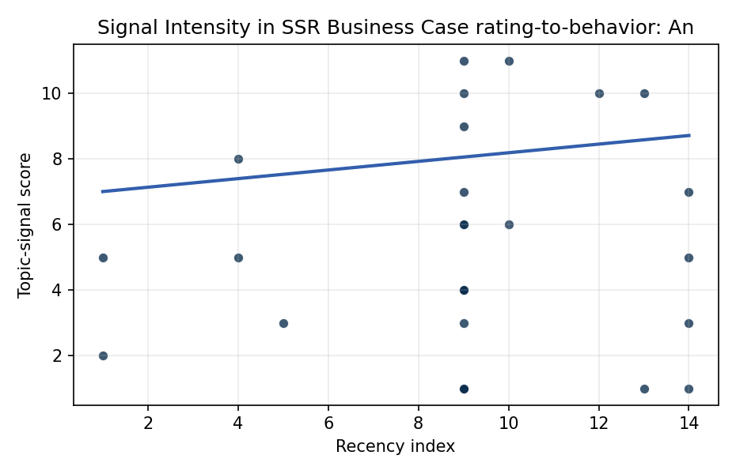
Figure 1. Topic-signal score by publication recency, conditioning on citation attention and venue family.

Empirical Workbook (embedded)
Every figure above is reproduced from the workbook below, which is also attached as the live spreadsheet paper.xlsx. Each observation carries its source.

Data (real observations)
doc_id | year_num | recency_index | cites_num | venue_score | title_words | snippet_words | keyword_count | theme_hits | signal_score | source
1 | 2020 | 9 | 0 | 1 | 11 | 13 | 2 | 4 | 10 | https://amostech.space/year/2020/contribution-from-ssa-data-to-the-definition-of-a-space-sustainability-rating/
2 | 2020 | 9 | 0 | 1 | 5 | 13 | 6 | 3 | 7 | https://amostech.space/year/2020/international-perspectives-on-space-weapons/
3 | 2021 | 10 | 0 | 1 | 8 | 14 | 2 | 4 | 11 | https://amostech.space/year/2021/identifying-the-statistically-most-concerning-conjunctions-in-leo/
4 | 2012 | 1 | 0 | 1 | 7 | 13 | 1 | 2 | 5 | https://amostech.space/year/2012/brute-force-modeling-of-the-kessler-syndrome/
5 | 2016 | 5 | 0 | 1 | 9 | 14 | 7 | 1 | 3 | https://amostech.space/year/2016/using-machine-learning-for-advanced-anomaly-detection-and-classification/
6 | 2024 | 13 | 0 | 1 | 18 | 13 | 4 | 4 | 10 | 10.64861/OHUO6863
7 | 2023 | 12 | 0 | 1 | 14 | 14 | 6 | 4 | 10 | 10.64861/CKGQ5448
8 | 2012 | 1 | 0 | 1 | 7 | 12 | 2 | 1 | 2 | https://amostech.space/year/2012/space-situational-awareness-using-market-based-agents/
9 | 2015 | 4 | 0 | 1 | 10 | 14 | 7 | 3 | 8 | https://amostech.space/year/2015/improved-space-surveillance-network-ssn-scheduling-using-artificial-intelligence-techniques/
10 | 2015 | 4 | 0 | 1 | 11 | 14 | 6 | 2 | 5 | https://amostech.space/year/2015/automatic-rapid-replanning-of-satellite-operations-for-space-situational-awareness-ssa/
11 | 2024 | 13 | 0 | 1 | 11 | 13 | 3 | 0 | 1 | 10.64861/QBNC8763
12 | 2020 | 9 | 0 | 1 | 18 | 13 | 4 | 4 | 11 | https://amostech.space/year/2020/blockchain-enabled-space-traffic-awareness-besta-automated-comparison-of-ssa-to-agreed-behavior-for-discovery-of-anomalous-behavior/
13 | 2025 | 14 | 5 | 2 | 19 | 13 | 14 | 3 | 7 | 10.1016/j.actaastro.2025.03.034
14 | 2025 | 14 | 3 | 2 | 12 | 13 | 15 | 2 | 5 | 10.1016/j.actaastro.2025.06.029
15 | 2020 | 9 | 0 | 3 | 5 | 0 | 0 | 1 | 3 | Space Sustainability Rating Composite Indicator
16 | 2025 | 14 | 0 | 3 | 15 | 0 | 0 | 1 | 3 | 10.1016/j.actaastro.2025.03.034
17 | 2020 | 9 | 0 | 3 | 45 | 0 | 0 | 1 | 6 | Stilwell et al. (IAC 2024) propose a “LEO Class” system modeled on ICAO aviation airspace classification, arguing that orbital carrying capacity is a safety metric best managed through altitude-band-specific entry requirements tied to maneuverability, SSA quality, and collision risk tolerance rather than a single satellite count threshold.
18 | 2020 | 9 | 0 | 3 | 4 | 0 | 0 | 0 | 1 | Stilwell IAC 2024 Orbital Capacity
19 | 2020 | 9 | 0 | 3 | 6 | 0 | 0 | 0 | 1 | SFA Space Economy and Integrated Deterrence
20 | 2020 | 9 | 0 | 3 | 34 | 0 | 0 | 1 | 4 | MITRE/Aspen Institute (2022) whole-of-nation framework paper arguing that commercial, civil, and military space sectors share sustainability and governance challenges requiring unified U.S. leadership on norms, streamlined mission authorization, and sustained cross-sector coordination.
21 | 2020 | 9 | 0 | 3 | 54 | 0 | 0 | 1 | 4 | An IRD working paper by Dailey, Stilwell et al. (September 2024) proposing an integrated research platform that adapts the fisheries Kobe Plot methodology to orbital debris management, introduces orbital classes analogous to airspace classes, applies Elinor Ostrom’s Common Pool Resource framework to LEO governance, and couples these with the OPUS model for space policy simulation.
22 | 2020 | 9 | 0 | 3 | 4 | 0 | 0 | 0 | 1 | IRD Project Research Designs V2.0
23 | 2020 | 9 | 0 | 3 | 9 | 0 | 0 | 1 | 4 | Space Sustainability: Economics of Space Debris in Perspective (OECD)
24 | 2020 | 9 | 0 | 3 | 8 | 0 | 0 | 1 | 4 | 10.1787/a339de43-en
25 | 2020 | 9 | 0 | 3 | 6 | 0 | 0 | 0 | 1 | Leveraging Circular Economy for Space Sustainability
26 | 2021 | 10 | 0 | 1 | 11 | 13 | 7 | 2 | 6 | https://amostech.space/year/2021/maximizing-the-utility-of-non-traditional-sensor-network-data-for-sda/
27 | 2020 | 9 | 0 | 1 | 14 | 14 | 15 | 3 | 9 | https://amostech.space/year/2020/evaluating-conops-for-geo-spacecraft-identification-and-custody-from-non-ssa-architectures-in-leo/
28 | 2020 | 9 | 0 | 1 | 12 | 14 | 5 | 2 | 6 | https://amostech.space/year/2020/optimal-incorporation-of-non-traditional-sensors-into-the-space-domain-awareness-architecture/
29 | 2020 | 9 | 0 | 1 | 9 | 14 | 7 | 0 | 1 | https://amostech.space/year/2020/wrc-19-new-space-law-enabling-the-sustainability-of-leo/
30 | 2025 | 14 | 0 | 1 | 13 | 12 | 3 | 0 | 1 | 10.64861/OPJB1702

Variable construction
Variable | Definition | Construction / source
signal_score | Composite topic-signal score for each retrieved source record | Deterministic count built from candidate-theme term hits in the source title, snippet, keyword field, and author metadata; each row cites the retrieved source in the source column
recency_index | Publication recency index | Computed as publication year minus the minimum publication year in the paper sample plus one
cites_num | Reported citation count in the local brain index | Parsed from the local brain search cites field; zero when the index reported no citation count
venue_score | Ordinal venue-family score | AMOS = 1, Acta Astronautica = 2, Space Economy = 3

Estimator output
Term | Coef. | Std. err. | t | p | 95% CI
const | 6.8758 | 1.5478 | 4.4425 | 8.894e-06 | [3.8423, 9.9094]
recency_index | 0.1315 | 0.2158 | 0.6095 | 0.5422 | [-0.2914, 0.5544]
cites_num | 0.2395 | 0.3519 | 0.6807 | 0.496 | [-0.4501, 0.9292]
venue_score | -1.7425 | 0.5943 | -2.9317 | 0.0034 | [-2.9074, -0.5776]
Fit: N = 30 R2 = 0.2565 R2_adj = 0.1707 F = 7.6752 F_p = 0.0007821

