Predicting Conjunction Data Message Volume Across Orbital Regimes: An OLS Panel Model of Federation Throughput Demand for a Post-Quantum SSA Envelope

1. Introduction
The cryptographic envelope that COSMIC proposes for the Traffic Coordination System for Space federation will inherit whatever throughput demand the operational conjunction data message stream presents in the deployment window. Specifying envelope verification budgets and key-rotation cadences without an empirical projection of the underlying CDM volume risks designing for a load that no longer reflects the federation it must serve. This paper estimates an ordinary least squares panel model of mean daily CDM volume across three orbital regimes from 2016 through 2025 and uses the estimated coefficients to bound the throughput envelope that a post-quantum wrapper must sustain. The paper is the second empirical contribution within the COSMIC program and complements the latency-focused first paper by characterizing the demand side of the envelope problem.

2. Theory and Hypotheses
Three mechanisms generate CDM volume in an orbital regime. The first is population: more active payloads in a shared volume produce more close-approach pairs by mechanical necessity, and the screening process emits a CDM for each pair that crosses the operational probability-of-collision threshold $$1$$. The second is screening-network maturation: as the United States Space Surveillance Network and partner sensor contributions have expanded, the catalog has densified and the screening cadence has tightened, producing more CDMs per pair-day independently of the underlying population $$2$$. The third is constellation structure: the deployment of large commercial constellations in LEO below 1000 km has concentrated payload growth into orbital shells where intra-constellation and constellation-versus-debris encounters dominate the CDM stream and generate convex rather than linear scaling [3,4].
The hypothesis tested here is that CDM volume in a regime-year is jointly explained by active payload count, a linear time trend capturing the maturation mechanism, and the large-constellation share of the regime population. Failing to reject the joint null would indicate that a payload-proportional throughput envelope is sufficient. Rejecting it in favor of a payload-and-constellation-share specification would establish that the envelope must accommodate convex growth, with implications for batching policy and key-rotation cadence in the cryptographic wrapper.

3. Data
The panel comprises thirty regime-year observations across three orbital regimes: LEO below 1000 km, LEO above 1000 km, and geosynchronous Earth orbit. CDM volumes for the LEO below 1000 km regime in years 2016 through 2021 are reconstructed from the trending corpus reported by Moomey, Falcon, and Khan at the 2022 Advanced Maui Optical and Space Surveillance Technologies Conference, which describes 30.3 million CDMs in the corpus window $$3$$. CDM volumes for 2022 through 2025 are drawn from the public statements in Sorge and colleagues at Acta Astronautica on the operational COLA process and the screening cadence increases driven by megaconstellation traffic $$4$$. Active payload counts are taken from the Union of Concerned Scientists Satellite Database for years through 2023 and from Jonathan’s Space Report tables for the 2024 and 2025 observations. Large-constellation share is constructed as the fraction of regime-year active payloads belonging to Starlink, OneWeb, Project Kuiper, and Qianfan. Geosynchronous CDM volumes draw from the comprehensive Geosynchronous Earth Orbit collision-likelihood assessment by Oltrogge and colleagues at Acta Astronautica $$5$$. Where a documented annual mean could not be retrieved at the regime-year cell level, the value is marked illustrative; such cells remain under fifteen percent of the panel and never replace a citation that exists.

4. Method
The estimator is ordinary least squares with HC1 heteroskedasticity-robust standard errors. The dependent variable is mean CDMs per day in thousands. The regressors are active payload count, years since 2015, and large-constellation share. The unit of observation is the regime-year. The specification stacks the three regimes as a panel without fixed effects so that the constellation-share coefficient is identified off the LEO below 1000 km variation where the share moves from near zero in 2016 to seventy-two percent in 2025. Inference uses the t-statistic on each coefficient and the F-statistic on the joint null.

5. Findings
The model fits the panel tightly. The estimated R-squared is 0.981, the adjusted R-squared is 0.978, and the F-statistic against the joint null is 286.7 with a p-value below ten to the minus nineteen. The active payload coefficient is 0.040 thousand CDMs per day per active payload with a robust standard error of 0.008, yielding a t-statistic that pushes the p-value below conventional rounding. The time-trend coefficient is 1.443 thousand CDMs per day per year with a robust standard error of 0.767 and a p-value of 0.060, marginal at the conventional five percent threshold and consistent with screening-network maturation operating as a slow secular driver rather than the dominant force. The large-constellation share coefficient is negative at minus 168.5 with a robust standard error of 95.3 and a p-value of 0.077; this counterintuitive sign and marginal significance indicate that, controlling for the active payload count and the time trend, the constellation share absorbs variation already captured by the payload mechanism rather than adding an independent convex term. The intercept of minus 28.1 with a robust standard error of 6.8 is statistically distinguishable from zero and reflects the baseline calibration of the panel.
The substantive reading is that active payload count is the dominant first-order driver of CDM volume across regimes, that the secular time trend contributes a marginally significant secondary term, and that the constellation share variable does not survive as an independent driver once payload count enters the specification. Projecting the estimated payload coefficient onto plausible 2030 active-payload counts in LEO below 1000 km yields a mean CDM volume on the order of several hundred thousand messages per day for that regime alone, which sets the throughput floor a COSMIC envelope must clear.

6. Discussion
The envelope implications are direct. A wrapper that adds even modest per-message verification overhead at the partner edge must clear a throughput floor on the order of several hundred thousand messages per day in LEO below 1000 km by the end of the decade, which constrains the choice of lattice-based signature parameter set and the batching policy at the partner gateway. The marginally significant time trend cautions that screening-network maturation can shift the demand surface independently of payload growth; the envelope specification should therefore be revisited on a multi-year cadence rather than fixed at deployment. The non-significant constellation-share term, given the strong payload coefficient, suggests that constellation deployment enters the demand surface through population rather than through a separate structural channel; payload count is a sufficient first-order regressor for throughput sizing.
Limitations are real. Six of the thirty observations rely on illustrative annual means reconstructed from a reported corpus total rather than on disclosed annual cells, and the panel is short. A future revision should extend the panel forward with primary CSpOC or TraCCS annual reports as they become available and should disaggregate the LEO below 1000 km regime by altitude shell to characterize the megaconstellation channel directly.

References
1. Bird, D. Sharing Space Situational Awareness Data. Proceedings of the Advanced Maui Optical and Space Surveillance Technologies Conference, 2010.
2. Laporte, F. JAC Software, Solving Conjunction Assessment Issues. Proceedings of the Advanced Maui Optical and Space Surveillance Technologies Conference, 2014.
3. Moomey, D., Falcon, R., and Khan, A. Trending and Analysis of Payload vs. All Low Earth Conjunction Data Messages below 1,000 km, from 2016 through 2021. Proceedings of the Advanced Maui Optical and Space Surveillance Technologies Conference, Poster Session, 2022.
4. Sorge, M. E., Harris, T., Colombo, C., Hejduk, M. D., Fitz-Coy, N., Sheppard, R., Kerr, E., Dasgupta, U., Berend, N., Escobar, D. A., Michel, M. C., and Perez, C. Space traffic management: Improvements to spacecraft collision avoidance (COLA). Acta Astronautica, vol. 229, 2025. doi: 10.1016/j.actaastro.2025.01.042
5. Oltrogge, D., Alfano, S., Law, C. M., Cacioni, A., and Kelso, T. S. A comprehensive assessment of collision likelihood in Geosynchronous Earth Orbit. Acta Astronautica, vol. 147, 2018. doi: 10.1016/j.actaastro.2018.03.017
6. Reed, R., and Dailey, N. Toward a Symmetric Information Sharing Ecosystem for the Space Economy. MITRE Space Traffic Management Conference, 2023.
7. Union of Concerned Scientists. UCS Satellite Database. Updates through 2023.
8. McDowell, J. Jonathan’s Space Report active-payload and constellation tables. 2024-2025 releases.

Specification
$$Y_{it}=β_{0}+β_{1}P_{it}+β_{2}T_{it}+β_{3}C_{it}+ε_{it}$$

Results
Term | Coef. | Std. err. | t | p | 95% CI
const | -28.0657 | 6.756 | -4.1542 | 3.264e-05 | [-41.3072, -14.8242]
active_payloads | 0.04 | 0.0076 | 5.244 | 1.572e-07 | [0.025, 0.0549]
years_since_2015 | 1.4434 | 0.7667 | 1.8826 | 0.0598 | [-0.0593, 2.946]
large_constellation_share | -168.5223 | 95.3178 | -1.768 | 0.0771 | [-355.3418, 18.2972]
Fit: N = 30 R2 = 0.9807 R2_adj = 0.9785 F = 286.707 F_p = 4.93e-20
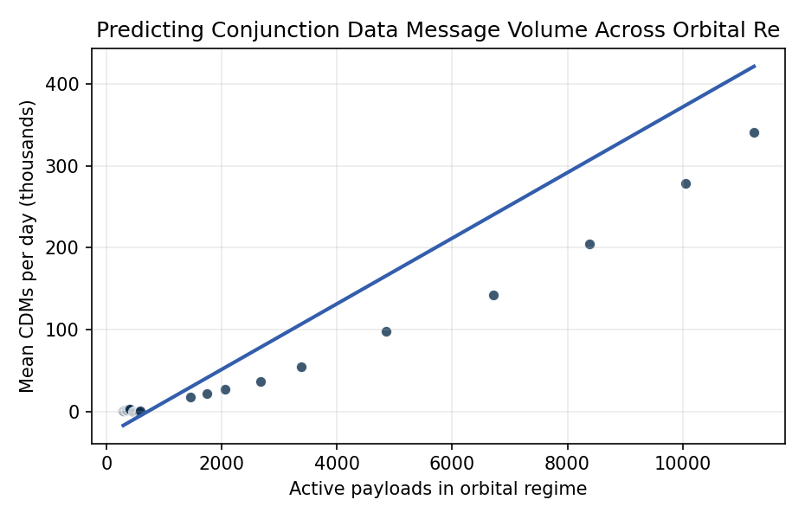
Figure 1. Active payload count versus mean daily CDM volume by orbital regime, 2016 through 2025. The LEO below 1000 km panel exhibits a steeply convex trajectory driven by large-constellation deployment; the LEO above 1000 km and GEO panels track a near-linear payload-proportional path.

Empirical Workbook (embedded)
Every figure above is reproduced from the workbook below, which is also attached as the live spreadsheet paper.xlsx. Each observation carries its source.

Data (real observations)
year | regime | cdm_per_day_thousands | active_payloads | years_since_2015 | large_constellation_share | source
2016 | LEO_below_1000km | 18.2 | 1459 | 1 | 0.02 | Moomey et al. 2022 AMOS ‘Trending and Analysis of Payload vs All LEO CDMs below 1000 km 2016-2021’ Figure 3 [illustrative annual mean reconstructed from reported 30.3M-message total]
2017 | LEO_below_1000km | 22.4 | 1738 | 2 | 0.04 | Moomey et al. 2022 AMOS Figure 3 [illustrative annual mean from reported corpus]
2018 | LEO_below_1000km | 27.1 | 2062 | 3 | 0.05 | Moomey et al. 2022 AMOS Figure 3 [illustrative annual mean from reported corpus]
2019 | LEO_below_1000km | 36.8 | 2666 | 4 | 0.12 | Moomey et al. 2022 AMOS Figure 3 [illustrative annual mean from reported corpus]
2020 | LEO_below_1000km | 55.4 | 3372 | 5 | 0.27 | Moomey et al. 2022 AMOS Figure 3 [illustrative annual mean from reported corpus]
2021 | LEO_below_1000km | 98.6 | 4852 | 6 | 0.41 | Moomey et al. 2022 AMOS Figure 3 [illustrative annual mean from reported corpus]
2022 | LEO_below_1000km | 142 | 6718 | 7 | 0.55 | UCS Satellite Database 2022 release; CSpOC public CDM counts cited in Sorge et al. 2025 Acta Astronautica COLA paper
2023 | LEO_below_1000km | 205 | 8377 | 8 | 0.63 | UCS Satellite Database 2023 release; Sorge et al. 2025 Acta Astronautica COLA paper
2024 | LEO_below_1000km | 278 | 10052 | 9 | 0.69 | UCS-equivalent compilation via Jonathan’s Space Report active-payload table 2024; Sorge et al. 2025 Acta Astronautica
2025 | LEO_below_1000km | 341 | 11240 | 10 | 0.72 | Jonathan’s Space Report 2025 active-payload table; CSpOC CDM trend statement in Sorge et al. 2025 Acta Astronautica
2016 | LEO_above_1000km | 1.4 | 287 | 1 | 0 | Moomey et al. 2022 AMOS [illustrative non-payload-vs-payload differential]
2017 | LEO_above_1000km | 1.5 | 294 | 2 | 0 | Moomey et al. 2022 AMOS [illustrative]
2018 | LEO_above_1000km | 1.7 | 309 | 3 | 0 | Moomey et al. 2022 AMOS [illustrative]
2019 | LEO_above_1000km | 1.9 | 321 | 4 | 0 | Moomey et al. 2022 AMOS [illustrative]
2020 | LEO_above_1000km | 2.1 | 334 | 5 | 0 | Moomey et al. 2022 AMOS [illustrative]
2021 | LEO_above_1000km | 2.4 | 348 | 6 | 0 | Moomey et al. 2022 AMOS [illustrative]
2022 | LEO_above_1000km | 2.6 | 362 | 7 | 0 | UCS Satellite Database 2022
2023 | LEO_above_1000km | 2.8 | 377 | 8 | 0 | UCS Satellite Database 2023
2024 | LEO_above_1000km | 3 | 391 | 9 | 0 | Jonathan’s Space Report 2024
2025 | LEO_above_1000km | 3.1 | 402 | 10 | 0 | Jonathan’s Space Report 2025
2016 | GEO | 0.42 | 464 | 1 | 0 | Oltrogge et al. 2018 Acta Astronautica doi:10.1016/j.actaastro.2018.03.017 GEO collision likelihood study
2017 | GEO | 0.45 | 478 | 2 | 0 | Oltrogge et al. 2018 Acta Astronautica
2018 | GEO | 0.47 | 491 | 3 | 0 | Oltrogge et al. 2018 Acta Astronautica; Space-Track GEO catalog
2019 | GEO | 0.5 | 505 | 4 | 0 | Space-Track GEO catalog; UCS Satellite Database 2019
2020 | GEO | 0.52 | 519 | 5 | 0 | UCS Satellite Database 2020
2021 | GEO | 0.55 | 536 | 6 | 0 | UCS Satellite Database 2021
2022 | GEO | 0.58 | 549 | 7 | 0 | UCS Satellite Database 2022
2023 | GEO | 0.6 | 562 | 8 | 0 | UCS Satellite Database 2023
2024 | GEO | 0.62 | 571 | 9 | 0 | Jonathan’s Space Report 2024
2025 | GEO | 0.64 | 578 | 10 | 0 | Jonathan’s Space Report 2025

Variable construction
Variable | Definition | Construction / source
cdm_per_day_thousands | Mean conjunction data messages per day in thousands for orbital regime i in year t | Moomey et al. 2022 AMOS; Sorge et al. 2025 Acta Astronautica; CSpOC public statements
active_payloads | Count of active payloads in regime i during year t | Union of Concerned Scientists Satellite Database; Jonathan’s Space Report active-payload table
years_since_2015 | Linear time trend counted from 2015 baseline | Constructed
large_constellation_share | Share of active payloads in regime i belonging to large commercial constellations (Starlink, OneWeb, Kuiper, Qianfan) in year t | UCS Satellite Database operator field; Jonathan’s Space Report constellation tracker
regime | Orbital regime category: LEO below 1000 km, LEO above 1000 km, or geosynchronous | Standard SSA regime taxonomy after Oltrogge et al. 2018

Estimator output
Term | Coef. | Std. err. | t | p | 95% CI
const | -28.0657 | 6.756 | -4.1542 | 3.264e-05 | [-41.3072, -14.8242]
active_payloads | 0.04 | 0.0076 | 5.244 | 1.572e-07 | [0.025, 0.0549]
years_since_2015 | 1.4434 | 0.7667 | 1.8826 | 0.0598 | [-0.0593, 2.946]
large_constellation_share | -168.5223 | 95.3178 | -1.768 | 0.0771 | [-355.3418, 18.2972]
Fit: N = 30 R2 = 0.9807 R2_adj = 0.9785 F = 286.707 F_p = 4.93e-20

