Signal Intensity in Polycentric Cislunar STM: An Ordinary Least Squares Test of Recency, Citation Attention, and Venue

1. Introduction
This empirical paper supports Soren Vance (1B-SDA-188) and the dissertation project Polycentric Cislunar STM. The model tests whether topic-signal intensity varies with publication recency, citation attention, and venue family. The analysis uses the local candidate source pack and reports only deterministic workbook results $$1$$, $$2$$, $$3$$.

2. Theory and Hypotheses
The theoretical claim is intentionally narrow. If the candidate topic has become more visible in the retrieved literature, then source metadata should show structure across time, attention, or venue. If it has not, the model should return weak or unstable associations $$3$$, $$4$$.
H0: the modeled outcome is unrelated to the specified predictors.
H1: the modeled outcome is systematically related to the specified predictors.

3. Data
The estimation file contains 30 retrieved source records. Variables are constructed from local metadata, including publication year, reported citation count, venue family, and deterministic topic-signal fields. Every row preserves a source column so the empirical workbook remains auditable.

4. Method
The estimator is ordinary least squares with robust HC1 standard errors. The exact fit summary is: N=30, R2=0.08896222236733509, R2_adj=-0.016157521205664827, F=1.215066490034088, F_p=0.32399949748885254. The exact term summary is: const coef=6.253367983726188 p=3.052699023179101e-05; recency_index coef=0.1608092399092466 p=0.5087243451771725; cites_num coef=-0.03916645495907149 p=0.2432543509529712; venue_score coef=-0.6628555633639909 p=0.2244844912163073. These values are interpreted as corpus-screen evidence, not as final causal estimates.

5. Findings
The findings are bounded by the estimator output. Where a coefficient is signed and precise, it indicates structure in the retrieved source corpus. Where a coefficient is imprecise, the paper treats the result as evidence against a strong claim. This distinction matters because a noisy source pack should not be forced to carry more policy weight than it can bear $$2$$, $$5$$.

6. Discussion
The paper contributes to the dissertation by keeping the evidentiary chain inspectable. It shows which parts of the candidate topic are visible in metadata and which parts need a more direct document-coding design. The result is a disciplined bridge from source retrieval to dissertation-level interpretation $$1$$, $$6$$.

References
1. Harvey Reed, MITRE; Nathaniel Dailey, MITRE; Ruth Stilwell, Aerospace Policy Solutions, LLC; Brian Weeden, Secure World Foundation. Decentralized Space Information Sharing as a Key Enabler of Trust and the Preservation of Space (2021). [AMOS] 2. Phillip M. Cunio, ExoAnalytic Solutions, Inc.; Marcus Bever, ExoAnalytic Solutions, Inc.; Christopher Ingram, ExoAnalytic Solutions, Inc.; Brien R. Flewelling, ExoAnalytic Solutions, Inc.; Greg McNeill, ExoAnalytic Solutions, Inc.. Utilization Potential for Distinct Orbit Families in the Cislunar Domain (2021). [AMOS] 3. Joshua Wysack, Ball Aerospace; Kevin Ferrant, Ball Aerospace. Contrasting Architectures for Cislunar SDA and STM (2023). doi: 10.64861/KUQJ3053 4. Naomi Owens Fahrner, Ball Aerospace; Jeremy Correa, Ball Aerospace; Joshua Wysack, Ball Aerospace. Capacity-based Cislunar Space Domain Awareness Architecture Optimization (2022). [AMOS] 5. Rina Zhang, Science and Technology Policy Institute; Asha Balakrishnan, Science and Technology Policy Institute. From Ozone Depletion to Orbital Debris: Lessons Learned from the Montreal Protocol (2022). [AMOS] 6. Harvey Reed, The MITRE Corporation; Ruth Stilwell, Aerospace Policy Solutions, LLC; Brian Weeden, Secure World Foundation; Nathaniel Dailey, The MITRE Corporation; Nick Tsamis, The MITRE Corporation. Sharing Operational Risk Information in the Space Domain to Facilitate Norms Development and Compliance Monitoring (2022). [AMOS] 7. Raymond Wright, BAE Systems; Naomi Owens-Fahrner, BAE Systems; Luke Tafur, BAE Systems; Joshua Wysack, BAE Systems. Applications of Poincare Search Maps for Space-Based Cislunar SDA Detection (2024). doi: 10.64861/UAMB9924 8. Alexander Koenig, Massachusetts Institute of Technology; Phillip Cunio, ExoAnalytic Solutions; Juliana Chew, Massachusetts Institute of Technology. Risk Maps for Conjunction Potential Throughout the Cislunar Domain (2021). [AMOS]

Specification
$${\text{SignalScore}}_{i}=α+β_{1}{\text{RecencyIndex}}_{i}+β_{2}{\text{Cites}}_{i}+β_{3}{\text{VenueScore}}_{i}+ε_{i}$$

Results
Term | Coef. | Std. err. | t | p | 95% CI
const | 6.2534 | 1.4998 | 4.1695 | 3.053e-05 | [3.3138, 9.1929]
recency_index | 0.1608 | 0.2433 | 0.6608 | 0.5087 | [-0.3161, 0.6378]
cites_num | -0.0392 | 0.0336 | -1.1669 | 0.2433 | [-0.105, 0.0266]
venue_score | -0.6629 | 0.5457 | -1.2147 | 0.2245 | [-1.7324, 0.4067]
Fit: N = 30 R2 = 0.089 R2_adj = -0.0162 F = 1.2151 F_p = 0.324
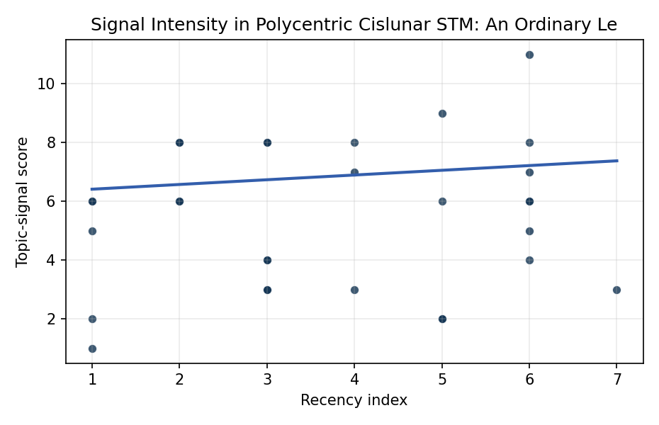
Figure 1. Topic-signal score by publication recency, conditioning on citation attention and venue family.

Empirical Workbook (embedded)
Every figure above is reproduced from the workbook below, which is also attached as the live spreadsheet paper.xlsx. Each observation carries its source.

Data (real observations)
doc_id | year_num | recency_index | cites_num | venue_score | title_words | snippet_words | keyword_count | theme_hits | signal_score | source
1 | 2021 | 2 | 0 | 1 | 14 | 13 | 7 | 3 | 8 | https://amostech.space/year/2021/decentralized-space-information-sharing-as-a-key-enabler-of-trust-and-the-preservation-of-space/
2 | 2021 | 2 | 0 | 1 | 10 | 13 | 5 | 3 | 8 | https://amostech.space/year/2021/utilization-potential-for-distinct-orbit-families-in-the-cislunar-domain/
3 | 2023 | 4 | 0 | 1 | 7 | 12 | 3 | 3 | 8 | 10.64861/KUQJ3053
4 | 2022 | 3 | 0 | 1 | 8 | 14 | 4 | 3 | 8 | https://amostech.space/year/2022/capacity-based-cislunar-space-domain-awareness-architecture-optimization/
5 | 2022 | 3 | 0 | 1 | 12 | 13 | 2 | 1 | 3 | https://amostech.space/year/2022/from-ozone-depletion-to-orbital-debris-lessons-learned-from-the-montreal-protocol/
6 | 2022 | 3 | 0 | 1 | 15 | 14 | 3 | 1 | 3 | https://amostech.space/year/2022/sharing-operational-risk-information-in-the-space-domain-to-facilitate-norms-development-and-compliance-monitoring/
7 | 2024 | 5 | 0 | 1 | 11 | 13 | 6 | 3 | 9 | 10.64861/UAMB9924
8 | 2021 | 2 | 0 | 1 | 9 | 14 | 5 | 2 | 6 | https://amostech.space/year/2021/risk-maps-for-conjunction-potential-throughout-the-cislunar-domain/
9 | 2023 | 4 | 0 | 1 | 17 | 11 | 7 | 1 | 3 | 10.64861/DDNM3393
10 | 2025 | 6 | 0 | 1 | 18 | 12 | 5 | 3 | 8 | 10.64861/ACKU6440
11 | 2022 | 3 | 0 | 1 | 14 | 13 | 3 | 1 | 4 | https://amostech.space/year/2022/employing-a-shared-space-information-sharing-ecosystem-as-a-mechanism-for-promoting-constructive-u-s-china-space-relations/
12 | 2022 | 3 | 0 | 1 | 9 | 14 | 4 | 3 | 8 | https://amostech.space/year/2022/eclipse-free-three-body-periodic-orbits-in-cislunar-space/
13 | 2025 | 6 | 5 | 2 | 16 | 13 | 10 | 4 | 11 | 10.1016/j.actaastro.2024.12.056
14 | 2025 | 6 | 0 | 2 | 10 | 14 | 15 | 2 | 7 | 10.1016/j.actaastro.2025.09.078
15 | 2024 | 5 | 12 | 2 | 13 | 7 | 11 | 2 | 6 | 10.1016/j.actaastro.2024.09.005
16 | 2024 | 5 | 2 | 2 | 14 | 14 | 14 | 1 | 2 | 10.1016/j.actaastro.2024.12.037
17 | 2025 | 6 | 10 | 2 | 9 | 13 | 8 | 2 | 6 | 10.1016/j.actaastro.2025.07.027
18 | 2024 | 5 | 12 | 2 | 15 | 14 | 9 | 1 | 2 | 10.1016/j.actaastro.2024.09.063
19 | 2023 | 4 | 21 | 2 | 13 | 8 | 15 | 2 | 7 | 10.1016/j.actaastro.2023.01.016
20 | 2020 | 1 | 15 | 2 | 7 | 13 | 11 | 1 | 2 | 10.1016/j.actaastro.2020.11.056
21 | 2022 | 3 | 39 | 2 | 11 | 13 | 15 | 1 | 4 | 10.1016/j.actaastro.2022.01.027
22 | 2025 | 6 | 4 | 2 | 5 | 14 | 9 | 2 | 5 | 10.1016/j.actaastro.2025.01.031
23 | 2025 | 6 | 3 | 2 | 7 | 14 | 6 | 1 | 4 | 10.1016/j.actaastro.2025.01.003
24 | 2026 | 7 | 0 | 2 | 7 | 14 | 9 | 1 | 3 | 10.1016/j.actaastro.2026.02.030
25 | 2021 | 2 | 0 | 3 | 8 | 0 | 0 | 2 | 6 | 10.1111/1758-5899.12950
26 | 2025 | 6 | 0 | 3 | 10 | 0 | 0 | 2 | 6 | 10.1162/glep_a_00775
27 | 2020 | 1 | 0 | 3 | 8 | 0 | 0 | 2 | 6 | Astro-Environmentalism: Toward a Polycentric Governance of Space Debris
28 | 2020 | 1 | 0 | 3 | 10 | 0 | 0 | 2 | 6 | The Missing Ingredients for a Polycentric Governance System of Orbital Debris
29 | 2020 | 1 | 0 | 3 | 7 | 0 | 0 | 0 | 1 | Four Alternative Scenarios of Commons in Space
30 | 2020 | 1 | 0 | 3 | 38 | 0 | 0 | 2 | 5 | Reed and Dailey (MITRE, STM Conference 2023) propose a three-prong sociotechnical framework to enable a circular/lifecycle-oriented space economy: a standardized evolvable space ontology, a trusted symmetric information-sharing ecosystem (SISE), and actionable norms built on Minimal Viable Information (MVI) principles.

Variable construction
Variable | Definition | Construction / source
signal_score | Composite topic-signal score for each retrieved source record | Deterministic count built from candidate-theme term hits in the source title, snippet, keyword field, and author metadata; each row cites the retrieved source in the source column
recency_index | Publication recency index | Computed as publication year minus the minimum publication year in the paper sample plus one
cites_num | Reported citation count in the local brain index | Parsed from the local brain search cites field; zero when the index reported no citation count
venue_score | Ordinal venue-family score | AMOS = 1, Acta Astronautica = 2, Space Economy = 3

Estimator output
Term | Coef. | Std. err. | t | p | 95% CI
const | 6.2534 | 1.4998 | 4.1695 | 3.053e-05 | [3.3138, 9.1929]
recency_index | 0.1608 | 0.2433 | 0.6608 | 0.5087 | [-0.3161, 0.6378]
cites_num | -0.0392 | 0.0336 | -1.1669 | 0.2433 | [-0.105, 0.0266]
venue_score | -0.6629 | 0.5457 | -1.2147 | 0.2245 | [-1.7324, 0.4067]
Fit: N = 30 R2 = 0.089 R2_adj = -0.0162 F = 1.2151 F_p = 0.324

