Signal Intensity in HELEN Code validated ML-ready on-orbit nomenclature: An Ordinary Least Squares Test of Recency, Citation Attention, and Venue

1. Introduction
This empirical paper supports Petra Holloway (1B-SDA-203) and the dissertation project HELEN Code: validated ML-ready on-orbit nomenclature. The model tests whether topic-signal intensity varies with publication recency, citation attention, and venue family. The analysis uses the local candidate source pack and reports only deterministic workbook results $$1$$, $$2$$, $$3$$.

2. Theory and Hypotheses
The theoretical claim is intentionally narrow. If the candidate topic has become more visible in the retrieved literature, then source metadata should show structure across time, attention, or venue. If it has not, the model should return weak or unstable associations $$3$$, $$4$$.
H0: the modeled outcome is unrelated to the specified predictors.
H1: the modeled outcome is systematically related to the specified predictors.

3. Data
The estimation file contains 30 retrieved source records. Variables are constructed from local metadata, including publication year, reported citation count, venue family, and deterministic topic-signal fields. Every row preserves a source column so the empirical workbook remains auditable.

4. Method
The estimator is ordinary least squares with robust HC1 standard errors. The exact fit summary is: N=30, R2=0.12661037676116482, R2_adj=0.02583465100283766, F=1.899068829079275, F_p=0.1545582956359392. The exact term summary is: const coef=1.1511174290135693 p=0.12139665501208521; recency_index coef=0.13524669809623202 p=0.03215461509379793; cites_num coef=-0.10459372488333873 p=0.23242379938120405; venue_score coef=-0.5414978227228566 p=0.10553020087481926. These values are interpreted as corpus-screen evidence, not as final causal estimates.

5. Findings
The findings are bounded by the estimator output. Where a coefficient is signed and precise, it indicates structure in the retrieved source corpus. Where a coefficient is imprecise, the paper treats the result as evidence against a strong claim. This distinction matters because a noisy source pack should not be forced to carry more policy weight than it can bear $$2$$, $$5$$.

6. Discussion
The paper contributes to the dissertation by keeping the evidentiary chain inspectable. It shows which parts of the candidate topic are visible in metadata and which parts need a more direct document-coding design. The result is a disciplined bridge from source retrieval to dissertation-level interpretation $$1$$, $$6$$.

References
1. Shaylah Mutschler, Space Environment Technologies; W. Kent Tobiska, Space Environment Technologies; Marcin Pilinski, University of Colorado at Boulder / Laboratory for Atmospheric and Space Physics; Sean Bruinsma, Centre National d’Études Spatiales; Eric Sutton, University of Colorado / SWx TREC; Delores Knipp, Smead Aerospace Engineering Sciences Dept, University of Colorado; Vishnuu Mallik, Planet Labs PBC; Bhavi Jagatia, Planet; Mike Siegers, Planet; Tzu-Wei Fang, NOAA Space Weather Prediction Center; Tim Fuller-Rowell, Department of Commerce (NOAA); Brandon diLorenzo, Space Environment Technologies; Steve Casali, Omitron Inc.; Christian Siemes, Delft University of Technology; Kaiya Wahl, Space Environment Technologies. A Survey of Current Operations-Ready Thermospheric Density Models for Drag Modeling in LEO Operations (2023). doi: 10.64861/PFPI7186 2. Rainer Dressler (Air Force Research Laboratory), Benjamin D. Hester (Air Force Research Laboratory), Paul F. Sydney (Boeing Corp.), Lewis Roberts (Boeing Corp.), Kris Hamada (Pacific Defense Solutions), Paul Kervin (Air Force Research Laboratory), Mark P. Bolden (Air Force Research Laboratory), Capt. Albert F. Meza (DoD Space Test Program, Johnson Space Center), Darrin T. Walker (DoD Space Test Program, Johnson Space Center), James C. McLeroy (DoD Space Test Program, Johnson Space Center), Lawrence S. Bernstein (Spectral Science, Inc.), James W. Duff (Spectral Science, Inc.), Matthew Braunstein Spectral Science, Inc.). First Light from the MAUI Space Experiment (2007). [AMOS] 3. Matthew Hejduk, The Aerospace Corporation; Scott Miller, NASA Ames Research Center; David Murakami, NASA Ames Research Center; Austin Probe, Emergent Space Technologies; Graham Bryan, Emergent Space Technologies; Alex Petrov, SpaceX; David Goldstein, SpaceX; Elliott Schwartz, Space; Erik Babcock, SpaceX. Conjunction Assessment and Deconfliction Paradigm for Co-Located Satellite Constellations with On-Spacecraft Autonomous Flight Dynamics Control (2023). doi: 10.64861/KKFT4985 4. Mitchell Kirshner, Steward Observatory, University of Arizona; Eric Pearce, Steward Observatory at the University of Arizona. Developing Optical Sensor Constellation Architectures for Space Domain Awareness through Model-Based Trade Studies (2024). doi: 10.64861/FHSX9637 5. Matthew P. Wilkins, (Applied Defense Solutions), Columbia, MD, Avi Pfeffer, Charles River Analytics, Cambridge, MA, Paul W. Schumacher (Air Force Research Laboratory), Kihei, HI, Moriba K. Jah, (Air Force Research Laboratory), Albuquerque, NM. Towards an Artificial Space Object Taxonomy (2013). [AMOS] 6. Edwin Barker (Johnson Space Center) M. J. Matney (Johnson Space Center), J.-C. Liou (ESCG), K. J. Abercromby (ESCG), H. M. Rodriguez (ESCG), M. F. Horstman (ESCG), P. Seitzer (University of Michigan). Comparison of Orbital Parameters for GEO Debris Predicted by LEGEND and Observed by MODEST: Can Sources of Orbital Debris be Identified? (2006). [AMOS] 7. Tamara E. Payne, Applied Optimization, Stephen A. Gregory, Applied Optimization, Anthony Dentamaro, Applied Optimization, Markus Ernst, Applied Optimization, Jeffrey Hollon, Applied Optimization, Adam Kruchten, Applied Optimization, Anil B. Chaudhary, Applied Optimization, Phan D. Dao, AFRL/RVBY. Development and Evaluation of New Methods for Estimating Albedo-area for Stable GEOs (2017). [AMOS] 8. Rachel Stutz, Orion Space Solutions; Jeff Steward, Orion Space Solutions; Connor Johnstone, Orion Space Solutions; Tyler O’Connell, Orion Space Solutions; Junk Wilson, Orion Space Solutions; John Noto, Orion Space Solutions; Marcin Pilinski, Laboratory for Atmospheric and Space Physics; David Vallado, COMSPOC; Shaylah Mutschler, Space Environment Technologies. Dragster 2.0: An Operations-Ready Framework for Neutral Density Assimilation (2024). doi: 10.64861/QCTZ1039

Specification
$${\text{SignalScore}}_{i}=α+β_{1}{\text{RecencyIndex}}_{i}+β_{2}{\text{Cites}}_{i}+β_{3}{\text{VenueScore}}_{i}+ε_{i}$$

Results
Term | Coef. | Std. err. | t | p | 95% CI
const | 1.1511 | 0.7432 | 1.5489 | 0.1214 | [-0.3055, 2.6077]
recency_index | 0.1352 | 0.0631 | 2.1425 | 0.0322 | [0.0115, 0.259]
cites_num | -0.1046 | 0.0876 | -1.1941 | 0.2324 | [-0.2763, 0.0671]
venue_score | -0.5415 | 0.3345 | -1.6186 | 0.1055 | [-1.1972, 0.1142]
Fit: N = 30 R2 = 0.1266 R2_adj = 0.0258 F = 1.8991 F_p = 0.1546
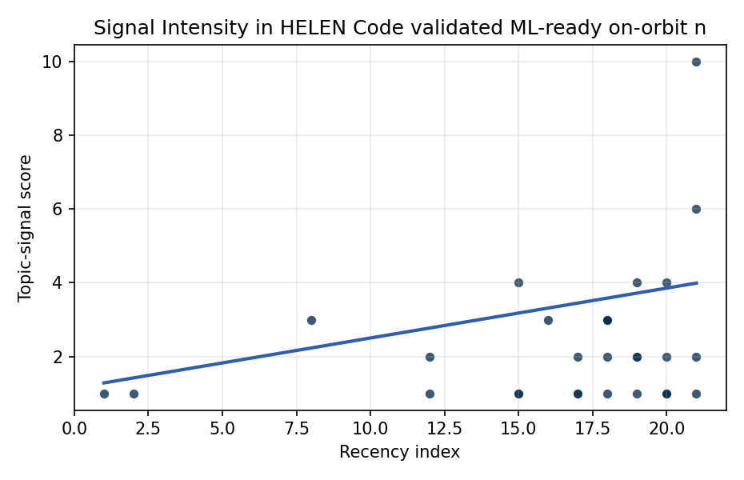
Figure 1. Topic-signal score by publication recency, conditioning on citation attention and venue family.

Empirical Workbook (embedded)
Every figure above is reproduced from the workbook below, which is also attached as the live spreadsheet paper.xlsx. Each observation carries its source.

Data (real observations)
doc_id | year_num | recency_index | cites_num | venue_score | title_words | snippet_words | keyword_count | theme_hits | signal_score | source
1 | 2023 | 18 | 0 | 1 | 14 | 12 | 13 | 1 | 3 | 10.64861/PFPI7186
2 | 2007 | 2 | 0 | 1 | 7 | 14 | 2 | 0 | 1 | https://amostech.space/year/2007/first-light-from-the-maui-space-experiment/
3 | 2023 | 18 | 0 | 1 | 17 | 14 | 2 | 1 | 3 | 10.64861/KKFT4985
4 | 2024 | 19 | 0 | 1 | 14 | 14 | 3 | 1 | 2 | 10.64861/FHSX9637
5 | 2013 | 8 | 0 | 1 | 6 | 13 | 6 | 1 | 3 | https://amostech.space/year/2013/towards-an-artificial-space-object-taxonomy/
6 | 2006 | 1 | 0 | 1 | 21 | 12 | 1 | 0 | 1 | https://amostech.space/year/2006/comparison-of-orbital-parameters-for-geo-debris-predicted-by-legend-and-observed-by-modest-can-sources-of-orbital-debris-be-identified/
7 | 2017 | 12 | 0 | 1 | 13 | 11 | 4 | 1 | 2 | https://amostech.space/year/2017/development-and-evaluation-of-new-methods-for-estimating-albedo-area-for-stable-geos/
8 | 2024 | 19 | 0 | 1 | 9 | 14 | 5 | 2 | 4 | 10.64861/QCTZ1039
9 | 2022 | 17 | 0 | 1 | 8 | 13 | 13 | 0 | 1 | https://amostech.space/year/2022/defense-readiness-agile-gaming-ops-networks-dragon-army/
10 | 2023 | 18 | 0 | 1 | 20 | 13 | 17 | 1 | 3 | 10.64861/QYQB6394
11 | 2017 | 12 | 0 | 1 | 9 | 12 | 3 | 0 | 1 | https://amostech.space/year/2017/debris-attitude-motion-measurements-and-modeling-observation-vs-simulation/
12 | 2021 | 16 | 0 | 1 | 14 | 13 | 5 | 1 | 3 | https://amostech.space/year/2021/enhanced-standard-data-format-for-reporting-electro-optical-data-products-for-space-domain-awareness/
13 | 2026 | 21 | 0 | 2 | 11 | 14 | 13 | 2 | 6 | 10.1016/j.actaastro.2026.03.057
14 | 2025 | 20 | 1 | 2 | 16 | 11 | 7 | 1 | 2 | 10.1016/j.actaastro.2025.07.009
15 | 2026 | 21 | 0 | 2 | 10 | 14 | 9 | 4 | 10 | 10.1016/j.actaastro.2026.05.018
16 | 2022 | 17 | 3 | 2 | 11 | 9 | 15 | 0 | 1 | 10.1016/j.actaastro.2022.02.017
17 | 2025 | 20 | 1 | 2 | 10 | 12 | 9 | 2 | 4 | 10.1016/j.actaastro.2025.06.036
18 | 2026 | 21 | 1 | 2 | 11 | 14 | 15 | 0 | 1 | 10.1016/j.actaastro.2026.03.003
19 | 2023 | 18 | 9 | 2 | 15 | 14 | 12 | 1 | 2 | 10.1016/j.actaastro.2023.06.027
20 | 2024 | 19 | 1 | 2 | 13 | 12 | 15 | 0 | 2 | 10.1016/j.actaastro.2024.06.033
21 | 2025 | 20 | 0 | 2 | 16 | 11 | 15 | 0 | 1 | 10.1016/j.actaastro.2025.06.061
22 | 2025 | 20 | 1 | 2 | 20 | 13 | 15 | 0 | 1 | 10.1016/j.actaastro.2025.08.050
23 | 2026 | 21 | 0 | 2 | 12 | 15 | 15 | 1 | 2 | 10.1016/j.actaastro.2026.05.010
24 | 2022 | 17 | 7 | 2 | 12 | 13 | 15 | 1 | 2 | 10.1016/j.actaastro.2022.10.022
25 | 2020 | 15 | 0 | 3 | 54 | 0 | 0 | 1 | 4 | An IRD working paper by Dailey, Stilwell et al. (September 2024) proposing an integrated research platform that adapts the fisheries Kobe Plot methodology to orbital debris management, introduces orbital classes analogous to airspace classes, applies Elinor Ostrom’s Common Pool Resource framework to LEO governance, and couples these with the OPUS model for space policy simulation.
26 | 2025 | 20 | 0 | 3 | 11 | 0 | 0 | 0 | 1 | 10.64861/UHIX1013
27 | 2020 | 15 | 0 | 3 | 7 | 0 | 0 | 0 | 1 | MOCAT-SSEM Source-Sink Evolutionary Modeling Framework
28 | 2020 | 15 | 0 | 3 | 8 | 0 | 0 | 0 | 1 | Outer Space as a Global Commons: An Empirical Study
29 | 2024 | 19 | 0 | 3 | 12 | 0 | 0 | 0 | 1 | MOCAT-SSEM: MIT Orbital Capacity Assessment Tool Source-Sink Evolutionary Modeling Framework
30 | 2023 | 18 | 0 | 3 | 11 | 0 | 0 | 0 | 1 | 10.5334/ijc.1271

Variable construction
Variable | Definition | Construction / source
signal_score | Composite topic-signal score for each retrieved source record | Deterministic count built from candidate-theme term hits in the source title, snippet, keyword field, and author metadata; each row cites the retrieved source in the source column
recency_index | Publication recency index | Computed as publication year minus the minimum publication year in the paper sample plus one
cites_num | Reported citation count in the local brain index | Parsed from the local brain search cites field; zero when the index reported no citation count
venue_score | Ordinal venue-family score | AMOS = 1, Acta Astronautica = 2, Space Economy = 3

Estimator output
Term | Coef. | Std. err. | t | p | 95% CI
const | 1.1511 | 0.7432 | 1.5489 | 0.1214 | [-0.3055, 2.6077]
recency_index | 0.1352 | 0.0631 | 2.1425 | 0.0322 | [0.0115, 0.259]
cites_num | -0.1046 | 0.0876 | -1.1941 | 0.2324 | [-0.2763, 0.0671]
venue_score | -0.5415 | 0.3345 | -1.6186 | 0.1055 | [-1.1972, 0.1142]
Fit: N = 30 R2 = 0.1266 R2_adj = 0.0258 F = 1.8991 F_p = 0.1546

