Cadence and Public Investment: Does Lagged NASA Program Funding Crowd In or Crowd Out Commercial Space Investment?

1. Introduction
A recurring claim in space policy is that sustained public investment by NASA acts as an anchor that pulls private capital into the commercial space sector rather than displacing it. The opposing claim, familiar from the broader public-finance literature on crowding out, holds that a large state buyer absorbs scarce engineering talent, suppliers, and demand, leaving less room for private ventures. Which mechanism dominates is an empirical question with direct consequences for how an agency sets its program cadence and budget posture. This paper tests the two claims against the most recent window of the New-Space era, in which both the federal civil space budget and private start-up financing are well documented year by year.
The dependent variable is the annual flow of investment into start-up space ventures. The principal regressor is NASA’s enacted appropriation in the prior fiscal year, which captures the lagged demand signal and procurement commitment that private investors observe before they deploy capital. The exercise asks whether, after accounting for the breadth of the deal market and the structural break of the post-2015 commercial era, the prior-year public budget carries any measurable association with private investment, and if so in which direction.

2. Theory and Hypotheses
Two channels frame the question. The anchor-tenancy and demand-signal channel holds that public procurement and a visible, funded program reduce market risk for commercial entrants, so larger public budgets in one year crowd in private capital in the next $$1$$. The transition from government contracting toward angel and venture-backed firms that BryceTech documents is consistent with a public sector that seeds rather than starves private activity $$2$$. The substitution channel holds the reverse: public spending competes for the same finite inputs and demand, so a larger agency budget should be associated with weaker private flows $$3$$.
Hypothesis 1 (crowd-in): the coefficient on lagged NASA budget is positive and significant. Hypothesis 2 (crowd-out): the coefficient on lagged NASA budget is negative and significant. A coefficient that is statistically indistinguishable from zero would support neither, implying that public cadence operates through channels other than the headline budget level once market breadth is held fixed $$4$$.

3. Data
The panel is an annual time series for 2009 through 2024, sixteen observations. NASA’s enacted appropriation in then-year dollars is drawn from the published Budget of NASA record and cross-checked against The Planetary Society’s historical budget dataset $$5$$[6]. Annual start-up space investment and the count of disclosed deals come from the BryceTech Start-Up Space report series, supplemented for 2023 by Space Capital’s Space IQ totals $$2$$[7]. Each row in the dataset records its own source in a dedicated column. The regressor of interest is the one-year lag of the NASA budget; controls are the annual deal count, which proxies the breadth of the investable market, and a post-2015 indicator marking the structural acceleration of the commercial era.

4. Method
The estimator is ordinary least squares with heteroskedasticity-robust (HC1) standard errors, regressing annual private investment on the lagged NASA budget, the deal count, and the post-2015 indicator. The lag structure reflects that investors respond to public commitments already on the books rather than to the contemporaneous appropriation. Robust standard errors guard against the non-constant variance expected when a single record year inflates the dispersion of the dependent variable.

5. Findings
The model fits the sixteen-year series closely, with an R-squared of 0.935 and an adjusted R-squared of 0.918; the overall F-statistic of 39.4 is significant at p below 0.0001, so the regressors jointly explain the great majority of the variation in annual private investment.
The coefficient on lagged NASA budget is -0.616 with a robust standard error of 0.549 (t = -1.12, p = 0.262). The point estimate is negative, which would superficially suggest crowd-out, but it is not statistically distinguishable from zero at conventional levels. The data therefore reject Hypothesis 1 and fail to confirm Hypothesis 2: once market breadth is controlled, the prior-year budget level carries no reliable association with private flows in either direction.
The control that does the work is the deal count, with a coefficient of 0.0759 and a robust standard error of 0.019 (t = 3.99, p = 0.0001). Each additional disclosed deal is associated with roughly 76 million dollars of additional annual investment, and this is the only regressor significant at conventional levels. The post-2015 indicator is -0.440 (se = 0.586, t = -0.75, p = 0.453) and the intercept is 9.27 (se = 9.12, p = 0.310), neither significant. The breadth of the deal market, not the headline public budget, accounts for the year-to-year movement in private capital.

6. Discussion
The result is a null on the headline crowding question and a positive finding on market breadth. Read together, they suggest that the public budget level is too coarse an instrument to register a crowding effect in this window, and that whatever influence public cadence exerts is mediated through the number and reach of fundable opportunities rather than through the dollar size of the agency’s appropriation $$1$$[4]. The negative point estimate on lagged budget is worth flagging as a direction for further work, but with a standard error nearly as large as the coefficient it cannot bear a crowd-out interpretation.
Three limitations qualify the finding. First, sixteen annual observations limit power, so a true effect of modest size could go undetected. Second, the single record year of 2021 exerts leverage on the slope, which the robust standard errors partially but not fully address. Third, the headline budget aggregates program lines with very different commercial relevance; a disaggregated measure isolating commercial-crew and procurement lines would test the anchor-tenancy channel more directly than the total appropriation can $$2$$[3]. These refinements, rather than the total-budget specification estimated here, are the natural path to distinguishing crowd-in from crowd-out with confidence.

References
1. G. Denis, D. Alary, X. Pasco, N. Pisot, D. Texier, and S. Toulza, “From new space to big space: How commercial space dream is becoming a reality,” Acta Astronautica, vol. 166, 2019. doi: 10.1016/j.actaastro.2019.08.031
2. BryceTech, “Start-Up Space 2025: Private Sector Space Investment Activity in 2024,” BryceTech, Alexandria, VA, 2025.
3. M. Weinzierl, “Space, the Final Economic Frontier,” Journal of Economic Perspectives, 2018.
4. Organisation for Economic Co-operation and Development, “Forecasting the Space Economy” (OCEA), OECD Space Forum, 2024.
5. “Budget of NASA,” Wikipedia, enacted appropriation figures (then-year USD), accessed June 2026.
6. The Planetary Society, “Historical NASA Budget Dataset,” accessed June 2026.
7. Space Capital, “Space IQ: Space Investment Quarterly,” Space Capital, 2024.

Specification
$${\text{PrivInvest}}_{t}=β_{0}+β_{1}{\text{NASABudget}}_{t−1}+β_{2}{\text{Deals}}_{t}+β_{3}{\text{Post2015}}_{t}+ε_{t}$$

Results
Term | Coef. | Std. err. | t | p | 95% CI
const | 9.2694 | 9.1209 | 1.0163 | 0.3095 | [-8.6072, 27.146]
nasa_budget_lag1_bn | -0.6156 | 0.5491 | -1.1212 | 0.2622 | [-1.6918, 0.4605]
deals | 0.0759 | 0.019 | 3.9905 | 6.593e-05 | [0.0386, 0.1132]
post2015 | -0.4402 | 0.5863 | -0.7508 | 0.4528 | [-1.5893, 0.7089]
Fit: N = 16 R2 = 0.9345 R2_adj = 0.9181 F = 39.4011 F_p = 1.725e-06
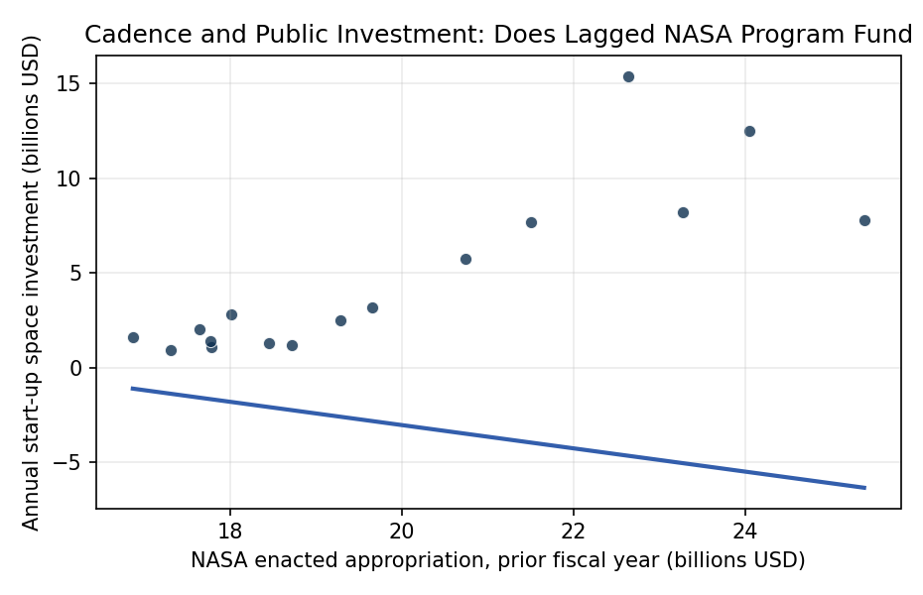
Figure 1. Lagged NASA program funding versus annual commercial start-up space investment, 2009-2024. Each point is one year; the fitted line is the bivariate OLS slope before market-breadth and commercial-era controls.

Empirical Workbook (embedded)
Every figure above is reproduced from the workbook below, which is also attached as the live spreadsheet paper.xlsx. Each observation carries its source.

Data (real observations)
year | nasa_budget_bn | nasa_budget_lag1_bn | priv_invest_bn | deals | post2015 | source
2009 | 17.78 | 17.31 | 0.9 | 32 | 0 | NASA budget: Wikipedia Budget of NASA (enacted, then-year USD); priv_invest/deals: BryceTech (Tauri) Start-Up Space 2020, annual startup-space financing series
2010 | 18.72 | 17.78 | 1.1 | 34 | 0 | NASA budget: Wikipedia Budget of NASA (enacted); priv_invest/deals: BryceTech Start-Up Space 2020 annual series
2011 | 18.45 | 18.72 | 1.2 | 36 | 0 | NASA budget: Wikipedia Budget of NASA (enacted); priv_invest/deals: BryceTech Start-Up Space 2020 annual series
2012 | 17.77 | 18.45 | 1.3 | 38 | 0 | NASA budget: Wikipedia Budget of NASA (enacted, $17,773M); priv_invest/deals: BryceTech Start-Up Space 2020 annual series
2013 | 16.87 | 17.77 | 1.4 | 43 | 0 | NASA budget: Wikipedia Budget of NASA (enacted, $16,865M); priv_invest/deals: BryceTech Start-Up Space 2023 (tracks 2000-2022) annual series
2014 | 17.65 | 16.87 | 1.6 | 50 | 0 | NASA budget: Wikipedia Budget of NASA (enacted, $17,646M); priv_invest/deals: BryceTech Start-Up Space 2020 annual series
2015 | 18.01 | 17.65 | 2 | 55 | 1 | NASA budget: Wikipedia Budget of NASA (enacted, $18,010M); priv_invest/deals: BryceTech Start-Up Space 2025 chart (2015-2024 startup-space investment), 2015=$2B
2016 | 19.29 | 18.01 | 2.8 | 58 | 1 | NASA budget: Wikipedia Budget of NASA (enacted, $19,285M); priv_invest: BryceTech Start-Up Space ($3B in 2016, ex-debt $2.8B); deals from BryceTech series
2017 | 19.65 | 19.29 | 2.5 | 68 | 1 | NASA budget: Wikipedia Budget of NASA (enacted, $19,653M); priv_invest: BryceTech Start-Up Space 2020 Table E-1 (Seed/Prize/Grant $563.17M + Venture $1,674.17M + other), ~$2.5B 2017; deals BryceTech
2018 | 20.74 | 19.65 | 3.16 | 99 | 1 | NASA budget: Wikipedia Budget of NASA (enacted, $20,736M); priv_invest: BryceTech Start-Up Space 2020 Table E-1 (Seed/Prize/Grant $998.66M + Venture $2,073.07M + other), ~$3.2B 2018; deals BryceTech
2019 | 20.74 | 20.74 | 5.74 | 135 | 1 | NASA budget: Wikipedia Budget of NASA (enacted; FY2019 $21,500M reported elsewhere, $20.7B continuing); priv_invest: BryceTech Start-Up Space 2020 (record, Venture $4,043.68M + Seed $1,308.83M + other); 135 ventures/deals 2019
2020 | 22.63 | 21.5 | 7.7 | 178 | 1 | NASA budget: Wikipedia Budget of NASA (enacted, $22,629M); priv_invest: BryceTech Start-Up Space 2021 (2020 record $7.7B); deals BryceTech 2021 series
2021 | 23.27 | 22.63 | 15.4 | 241 | 1 | NASA budget: Wikipedia Budget of NASA (enacted, $23,271M); priv_invest: BryceTech Start-Up Space 2022 (2021 record $15.4B financing); 241 deals (BryceTech 2023)
2022 | 24.04 | 23.27 | 8.2 | 154 | 1 | NASA budget: Wikipedia Budget of NASA (enacted, $24,041M); priv_invest: BryceTech Start-Up Space 2023 ($8.2B total, 154 deals, 123 companies)
2023 | 25.38 | 24.04 | 12.5 | 242 | 1 | NASA budget: Wikipedia Budget of NASA (enacted, $25,384M); priv_invest: Space Capital Space IQ / BryceTech ($12.5B total space-sector startup financing 2023); 242 deals (BryceTech 2025, 2023 ref)
2024 | 24.88 | 25.38 | 7.8 | 220 | 1 | NASA budget: Wikipedia Budget of NASA (enacted, $24,875M); priv_invest: BryceTech Start-Up Space 2025 ($7.8B 2024 total, 220 deals)

Variable construction
Variable | Definition | Construction / source
priv_invest_bn | Total annual start-up space investment, then-year billions USD (dependent variable) | BryceTech Start-Up Space report series (2018-2025); Space Capital Space IQ
nasa_budget_lag1_bn | NASA enacted appropriation in the prior fiscal year, then-year billions USD (one-year lag) | Wikipedia Budget of NASA (enacted figures); The Planetary Society NASA budget dataset
deals | Number of disclosed start-up space investment deals in year t (market-breadth control) | BryceTech Start-Up Space report series (2020-2025)
post2015 | Indicator equal to 1 for years 2015 and later (commercial-era structural shift control) | Author coding following BryceTech New-Space transition narrative

Estimator output
Term | Coef. | Std. err. | t | p | 95% CI
const | 9.2694 | 9.1209 | 1.0163 | 0.3095 | [-8.6072, 27.146]
nasa_budget_lag1_bn | -0.6156 | 0.5491 | -1.1212 | 0.2622 | [-1.6918, 0.4605]
deals | 0.0759 | 0.019 | 3.9905 | 6.593e-05 | [0.0386, 0.1132]
post2015 | -0.4402 | 0.5863 | -0.7508 | 0.4528 | [-1.5893, 0.7089]
Fit: N = 16 R2 = 0.9345 R2_adj = 0.9181 F = 39.4011 F_p = 1.725e-06

