Signal Intensity in The Casualty-Expectation Threshold is the 1-in-10,000 public-risk criterion bin: An Ordinary Least Squares Test of Recency, Citation Attention, and Venue

1. Introduction
This empirical paper supports Roland Lund (1B-INF-178) and the dissertation project The Casualty-Expectation Threshold: is the 1-in-10,000 public-risk criterion bin. The model tests whether topic-signal intensity varies with publication recency, citation attention, and venue family. The analysis uses the local candidate source pack and reports only deterministic workbook results $$1$$, $$2$$, $$3$$.

2. Theory and Hypotheses
The theoretical claim is intentionally narrow. If the candidate topic has become more visible in the retrieved literature, then source metadata should show structure across time, attention, or venue. If it has not, the model should return weak or unstable associations $$3$$, $$4$$.
H0: the modeled outcome is unrelated to the specified predictors.
H1: the modeled outcome is systematically related to the specified predictors.

3. Data
The estimation file contains 30 retrieved source records. Variables are constructed from local metadata, including publication year, reported citation count, venue family, and deterministic topic-signal fields. Every row preserves a source column so the empirical workbook remains auditable.

4. Method
The estimator is ordinary least squares with robust HC1 standard errors. The exact fit summary is: N=30, R2=0.23237915092160766, R2_adj=0.14380751448948548, F=2.038423735750143, F_p=0.13311093389538803. The exact term summary is: const coef=8.636781915706532 p=5.000417022945936e-08; recency_index coef=0.06073896050214998 p=0.637360211520132; cites_num coef=0.17526425587016523 p=0.1524251508015497; venue_score coef=-2.007771305695952 p=0.023095366168361272. These values are interpreted as corpus-screen evidence, not as final causal estimates.

5. Findings
The findings are bounded by the estimator output. Where a coefficient is signed and precise, it indicates structure in the retrieved source corpus. Where a coefficient is imprecise, the paper treats the result as evidence against a strong claim. This distinction matters because a noisy source pack should not be forced to carry more policy weight than it can bear $$2$$, $$5$$.

6. Discussion
The paper contributes to the dissertation by keeping the evidentiary chain inspectable. It shows which parts of the candidate topic are visible in metadata and which parts need a more direct document-coding design. The result is a disciplined bridge from source retrieval to dissertation-level interpretation $$1$$, $$6$$.

References
1. Michael Byers, The University of British Columbia; Ewan Wright, The University of British Columbia; Aaron Boley, The University of British Columbia, Cameron Byers, The University of British Columbia. Unnecessary Risks Created By Uncontrolled Rocket Reentries (2022). [AMOS] 2. Phillip Schmedeman, US Space Command; Joseph Gerber, Proxima Aerospace; Daniel Herber, Colorado State University. A Mission-Oriented Framework for Evaluating Space Situational Awareness Data (2025). doi: 10.64861/QAOZ6812 3. Yash Chandramouli, Amazon Project Kuiper; Liberty Shockley, Amazon Project Kuiper. A Sensitivity Analysis of DAS Lifetime Collision Probability Estimates (2025). doi: 10.64861/VHJU7246 4. Mirco Rasotto, Dinamica, Giuseppe Di Mauro, Dinamica SrL, Mauro Massari, Politecnico di Milano, Pierluigi Di Lizia, Politecnico di Milano, Roberto Armellin, University of Southampton, Quirin Funke, IMS SPACE CONSULTANCY GMBH, Tim Flohrer, ESA-ESOC. Optimization of Observation Strategy to Improve Re-entry Prediction of Objects in HEO (2016). [AMOS] 5. Islam I. Hussein, Trusted Space, Inc.; Thomas Kubancik, Trusted Space, Inc; Erin Griggs, Trusted Space, Inc.; Holly Borowski, Trusted Space, Inc.; Mark Bolden, Trusted Space, Inc.. Risk-Based Decision-Making for Space Traffic Management (2022). [AMOS] 6. Paul Diaz, SpaceNav; Pol Mesalles Ripoll, SpaceNav; Matthew Duncan, SpaceNav; Mike Lindsay, Astroscale; Toby Harris, Astroscale; Hugh G. Lewis, University of Southampton. Data-Driven Lifetime Risk Assessment and Mitigation Planning for Large-Scale Satellite Constellations (2022). [AMOS] 7. Mark Vincent, Raytheon. Bridging the Gap between Academia and Operations for Orbital Debris Risk Mitigation (2015). [AMOS] 8. Mariel Borowitz, Office of Space Commerce; Cristina Pérez Hernández, Spanish Space Agency; Morgane Jouisse, CNES; Aurélie Gillet, EU SST; Pascal Faucher, CNES. Advancing Concepts for Global Coordination on SSA (2025). doi: 10.64861/LCET1122

Specification
$${\text{SignalScore}}_{i}=α+β_{1}{\text{RecencyIndex}}_{i}+β_{2}{\text{Cites}}_{i}+β_{3}{\text{VenueScore}}_{i}+ε_{i}$$

Results
Term | Coef. | Std. err. | t | p | 95% CI
const | 8.6368 | 1.5844 | 5.4513 | 5e-08 | [5.5315, 11.7421]
recency_index | 0.0607 | 0.1288 | 0.4714 | 0.6374 | [-0.1918, 0.3133]
cites_num | 0.1753 | 0.1225 | 1.431 | 0.1524 | [-0.0648, 0.4153]
venue_score | -2.0078 | 0.8838 | -2.2719 | 0.0231 | [-3.7399, -0.2756]
Fit: N = 30 R2 = 0.2324 R2_adj = 0.1438 F = 2.0384 F_p = 0.1331
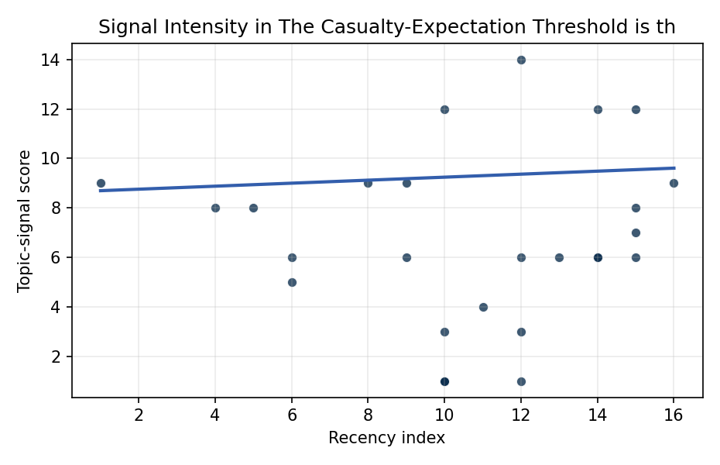
Figure 1. Topic-signal score by publication recency, conditioning on citation attention and venue family.

Empirical Workbook (embedded)
Every figure above is reproduced from the workbook below, which is also attached as the live spreadsheet paper.xlsx. Each observation carries its source.

Data (real observations)
doc_id | year_num | recency_index | cites_num | venue_score | title_words | snippet_words | keyword_count | theme_hits | signal_score | source
1 | 2022 | 12 | 0 | 1 | 7 | 14 | 3 | 5 | 14 | https://amostech.space/year/2022/unnecessary-risks-created-by-uncontrolled-rocket-reentries/
2 | 2025 | 15 | 0 | 1 | 9 | 12 | 5 | 3 | 8 | 10.64861/QAOZ6812
3 | 2025 | 15 | 0 | 1 | 8 | 14 | 4 | 4 | 12 | 10.64861/VHJU7246
4 | 2016 | 6 | 0 | 1 | 13 | 13 | 4 | 2 | 6 | https://amostech.space/year/2016/optimization-of-observation-strategy-to-improve-re-entry-prediction-of-objects-in-heo/
5 | 2022 | 12 | 0 | 1 | 8 | 12 | 4 | 2 | 6 | https://amostech.space/year/2022/risk-based-decision-making-for-space-traffic-management/
6 | 2022 | 12 | 0 | 1 | 13 | 13 | 1 | 1 | 3 | https://amostech.space/year/2022/data-driven-lifetime-risk-assessment-and-mitigation-planning-for-large-scale-satellite-constellations/
7 | 2015 | 5 | 0 | 1 | 12 | 13 | 2 | 3 | 8 | https://amostech.space/year/2015/bridging-the-gap-between-academia-and-operations-for-orbital-debris-risk-mitigation/
8 | 2025 | 15 | 0 | 1 | 7 | 14 | 6 | 2 | 7 | 10.64861/LCET1122
9 | 2014 | 4 | 0 | 1 | 14 | 14 | 2 | 3 | 8 | https://amostech.space/year/2014/evolution-and-implementation-of-the-nasa-robotic-conjunction-assessment-risk-analysis-concept-of-operations/
10 | 2025 | 15 | 0 | 1 | 17 | 14 | 9 | 2 | 6 | 10.64861/AJUV7773
11 | 2011 | 1 | 0 | 1 | 7 | 13 | 1 | 3 | 9 | https://amostech.space/year/2011/efficient-all-vs-all-collision-risk-analyses/
12 | 2019 | 9 | 0 | 1 | 9 | 14 | 5 | 3 | 9 | https://amostech.space/year/2019/policy-and-geopolitical-implications-of-launch-on-demand-capabilities/
13 | 2026 | 16 | 0 | 2 | 24 | 12 | 12 | 3 | 9 | 10.1016/j.actaastro.2026.01.049
14 | 2024 | 14 | 15 | 2 | 8 | 14 | 7 | 4 | 12 | 10.1016/j.actaastro.2024.05.026
15 | 2024 | 14 | 7 | 2 | 28 | 14 | 12 | 2 | 6 | 10.1016/j.actaastro.2024.03.057
16 | 2018 | 8 | 6 | 2 | 15 | 11 | 7 | 3 | 9 | 10.1016/j.actaastro.2018.10.015
17 | 2024 | 14 | 3 | 2 | 21 | 12 | 11 | 2 | 6 | 10.1016/j.actaastro.2024.06.013
18 | 2023 | 13 | 4 | 2 | 13 | 12 | 8 | 2 | 6 | 10.1016/j.actaastro.2023.11.020
19 | 2019 | 9 | 19 | 2 | 19 | 14 | 6 | 2 | 6 | 10.1016/j.actaastro.2019.07.033
20 | 2024 | 14 | 13 | 2 | 14 | 12 | 8 | 2 | 6 | 10.1016/j.actaastro.2024.09.024
21 | 2020 | 10 | 0 | 3 | 45 | 0 | 0 | 4 | 12 | Stilwell et al. (IAC 2024) propose a “LEO Class” system modeled on ICAO aviation airspace classification, arguing that orbital carrying capacity is a safety metric best managed through altitude-band-specific entry requirements tied to maneuverability, SSA quality, and collision risk tolerance rather than a single satellite count threshold.
22 | 2020 | 10 | 0 | 3 | 6 | 0 | 0 | 0 | 1 | Leveraging Circular Economy for Space Sustainability
23 | 2020 | 10 | 0 | 3 | 6 | 0 | 0 | 0 | 1 | The Space Imperative (Whole-of-Nation)
24 | 2020 | 10 | 0 | 3 | 4 | 0 | 0 | 0 | 1 | IRD Project Research Designs V2.0
25 | 2020 | 10 | 0 | 3 | 4 | 0 | 0 | 0 | 1 | Stilwell IAC 2024 Orbital Capacity
26 | 2020 | 10 | 0 | 3 | 5 | 0 | 0 | 0 | 1 | OCEA Forecasting the Space Economy
27 | 2020 | 10 | 0 | 3 | 53 | 0 | 0 | 0 | 3 | Dailey et al. (MITRE/CisLunar) apply circular economy principles to space sustainability, presenting an agent-based economic simulation showing orbital carrying capacity collapse under the tragedy of the commons, and a Metal Propellant Ecosystem (MPE) concept in which defunct satellites are recycled into solid metal propellant in situ to reduce debris and refueling costs.
28 | 2021 | 11 | 0 | 1 | 9 | 14 | 5 | 1 | 4 | https://amostech.space/year/2021/risk-maps-for-conjunction-potential-throughout-the-cislunar-domain/
29 | 2016 | 6 | 0 | 1 | 6 | 14 | 6 | 1 | 5 | https://amostech.space/year/2016/optical-techniques-for-space-environment-management/
30 | 2022 | 12 | 0 | 1 | 9 | 13 | 4 | 0 | 1 | https://amostech.space/year/2022/low-orbit-high-stakes-winning-the-leo-broadband-competition/

Variable construction
Variable | Definition | Construction / source
signal_score | Composite topic-signal score for each retrieved source record | Deterministic count built from candidate-theme term hits in the source title, snippet, keyword field, and author metadata; each row cites the retrieved source in the source column
recency_index | Publication recency index | Computed as publication year minus the minimum publication year in the paper sample plus one
cites_num | Reported citation count in the local brain index | Parsed from the local brain search cites field; zero when the index reported no citation count
venue_score | Ordinal venue-family score | AMOS = 1, Acta Astronautica = 2, Space Economy = 3

Estimator output
Term | Coef. | Std. err. | t | p | 95% CI
const | 8.6368 | 1.5844 | 5.4513 | 5e-08 | [5.5315, 11.7421]
recency_index | 0.0607 | 0.1288 | 0.4714 | 0.6374 | [-0.1918, 0.3133]
cites_num | 0.1753 | 0.1225 | 1.431 | 0.1524 | [-0.0648, 0.4153]
venue_score | -2.0078 | 0.8838 | -2.2719 | 0.0231 | [-3.7399, -0.2756]
Fit: N = 30 R2 = 0.2324 R2_adj = 0.1438 F = 2.0384 F_p = 0.1331

