Time-to-License under Jurisdictional Fragmentation: A Cox Proportional-Hazards Estimate on U.S. Commercial Launch Campaigns, 2019-2024
Ibrahim Heinz (1B-INF-102)

1. Introduction
The Federal Aviation Administration is the lead licensing authority for U.S. commercial space transportation, but most launch campaigns also require clearance from a second or third federal entity. Communications payloads pass through the Federal Communications Commission. Remote-sensing payloads pass through the National Oceanic and Atmospheric Administration commercial remote sensing regulatory affairs office. Suborbital and orbital campaigns with sensitive technology touch the State Department directorate of defense trade controls. Range operations at federal sites involve the host service, and environmentally sensitive operations involve the Fish and Wildlife Service or the Environmental Protection Agency. The first paper in this dissertation $$1$$ estimated the average effect of this multi-agency footprint on license-issuance duration using fixed-effects ordinary least squares. This paper turns to a different question. Given an application that has been accepted, what is the per-day hazard of a license being issued, and how does that hazard change with each additional agency in the loop? The reframe matters because some campaigns sit unresolved at the censoring date. Treating them as zero-duration outcomes or dropping them biases the picture in opposite directions. A survival model handles right-censoring cleanly and yields a hazard-ratio interpretation that maps directly onto the fragmentation cost the dissertation is testing.
The empirical question is whether the per-day hazard of license issuance is invariant to agency count once vehicle class and licensing regime are conditioned on, or whether it falls as the number of authorizing agencies rises. The reference body on regulatory aspects of growing launch traffic $$2$$ and the broader review of in-space manufacturing and on-orbit assembly under national licensing frameworks $$3$$ both argue that the answer matters for the cadence the next decade will support, but neither produces a hazard estimate on issued versus pending U.S. campaigns. This paper fills that gap.

2. Theory and Hypotheses
The fragmentation-cost thesis $$4$$ holds that each additional reviewing entity contributes a serial queue, an interagency consultation, and a non-trivial information-handoff delay. In a hazard framing the prediction is that the per-day probability of license issuance, conditional on the application still being open, falls multiplicatively with each additional agency. The Part 450 consolidation in 2021 was intended to compress that effect by replacing Parts 415 and 431 with a single performance-based rule $$1$$. The thesis predicts that the agency-count effect should remain visible even after conditioning on the Part 450 indicator, because Part 450 collapsed the FAA-internal review structure without consolidating the external authorizing surface. Vehicle complexity is a competing explanation: heavy vehicles take longer because the technical review itself is harder, not because more agencies are involved $$2$$. Conditioning on a heavy-vehicle indicator is the simplest way to separate the two.
H0. Conditional on the Part 450 regime indicator and the heavy-vehicle indicator, the Cox coefficient on agency count is zero.
H1. The coefficient on agency count is strictly negative, meaning each additional authorizing agency lowers the per-day hazard of license issuance.

3. Data
The sample is thirty-five U.S. commercial launch campaigns with documented FAA Office of Commercial Space Transportation activity between January 2019 and December 2024. For each campaign the duration variable measures calendar days from the public application-initiation date to license issuance, or to the censoring date for campaigns still in pre-application or active review. The event indicator is one for issued licenses and zero for the four pre-application or active-review campaigns observed at the censoring boundary. Agency count is the number of distinct federal authorizing entities documented in the FAA public license file, Federal Register notices, and the relevant secondary docket (FCC IBFS for spectrum, NOAA NESDIS for remote sensing, State DDTC for export-controlled hardware). The Part 450 indicator follows the 14 CFR Part 450 effective date in March 2021. The heavy-vehicle indicator covers Falcon Heavy, Starship, New Glenn, Vulcan, Atlas V, and Terran R. Each row in the dataset carries a documented source, and the four illustrative entries are marked.

4. Method
The estimator is a Cox proportional-hazards regression. The hazard for campaign i at time t is modeled as a baseline hazard multiplied by an exponential function of the covariates, so the coefficient on each covariate is the natural logarithm of the hazard ratio and the exponentiated coefficient is the multiplicative effect of a one-unit change on the per-day hazard of license issuance. Right-censored campaigns contribute to the risk set up to their censoring time but do not contribute an event. Inference uses the partial likelihood. The reported test statistic is the z-ratio of the coefficient over its standard error.

5. Findings
The model fits on thirty-five campaigns with thirty-one events and four right-censored observations. The coefficient on agency count is negative three point zero nine, with a p-value below zero point zero zero one and a hazard ratio of zero point zero four five. Read as a multiplicative effect on the per-day issuance hazard, each additional authorizing agency cuts the conditional hazard of license issuance by roughly ninety-five percent. The direction and statistical strength of this estimate reject H0 in favor of H1. The Part 450 indicator carries a coefficient of zero point two eight with a p-value of zero point six two and a hazard ratio near one point three. The point estimate is consistent with Part 450 having raised the issuance hazard modestly, but it is not statistically distinguishable from zero in this sample, which is the expected pattern in a thirty-five-campaign dataset where the regime change is highly collinear with the calendar trend. The heavy-vehicle indicator carries a coefficient of zero point one four with a p-value of zero point eight one, again statistically indistinguishable from zero. The fragmentation effect is therefore not absorbed by vehicle complexity in this specification.
The substantive reading is that the cost of multi-agency licensing is concentrated in agency count itself, not in the regime regulation that consolidated the FAA-internal review, and not in the engineering complexity of the vehicle.

6. Discussion
The hazard estimate is large, and its size should be read with appropriate caution. The thirty-five-campaign sample is small for a Cox specification, the four censored observations are concentrated in pre-application dockets that may resolve to longer-than-expected durations once issuance occurs, and the FAA pre-application start date is itself a soft variable. The estimate is best read as a strong-signal corroboration of the OLS finding in the first paper $$1$$ rather than a precise calibration of the marginal cost of an added agency. The combined picture from the OLS estimate in $$1$$ and the Cox estimate here is internally consistent. Agency count moves both the conditional mean of duration and the conditional hazard of issuance in the predicted directions, while the Part 450 consolidation produces a smaller effect because it did not change the number of authorizing entities. The policy reading parallels the regulatory discussion in $$2$$ and the architectural review in $$3$$. Durable compression of U.S. commercial-launch licensing time will require addressing the external authorizing surface, not only the FAA-internal review pathway.

References
1. Heinz, I. (2026). Jurisdictional Fragmentation and License-Issuance Duration: A Fixed-Effects Estimate on FAA-Licensed U.S. Commercial Launch Campaigns, 2017-2024. Dissertation paper one, Collegium 1B-INF-102.
2. Rossi, A., Sanchez-Ortiz, N., David, E., Opromolla, R., and Grishko, D. A. (2024). Future activities in the near-earth space in the face of ever-increasing space traffic. Acta Astronautica, Vol. 225. https://doi.org/10.1016/j.actaastro.2024.09.063
3. Nanjangud, A., Underwood, C., Rai, C. M., Eckersley, S., Sweeting, M., and Bianco, P. (2024). Towards robotic on-orbit assembly of large space telescopes: Mission architectures, concepts, and analyses. Acta Astronautica, Vol. 224. https://doi.org/10.1016/j.actaastro.2024.08.022
4. Weinzierl, M. (2018). Space, the Final Economic Frontier. Source SD18, Space Economy Papers corpus, D:/Claude_Code/Space_Economy_Papers.

Specification
$$h_{i}(t)=h_{0}(t)exp(β_{1}agency_count_{i}+β_{2}post_part{450}_{i}+β_{3}veh_heavy_{i})$$

Results
Term | Coef. | Std. err. | z | p | 95% CI | Hazard ratio
agency_count | -3.0942 | 0.619 | -4.9989 | 5.766e-07 | [-4.3074, -1.881] | 0.0453
post_part450 | 0.2778 | 0.5641 | 0.4925 | 0.6224 | [-0.8279, 1.3835] | 1.3203
veh_heavy | 0.1395 | 0.5683 | 0.2455 | 0.8061 | [-0.9744, 1.2533] | 1.1497
Fit: N = 35 events = 31
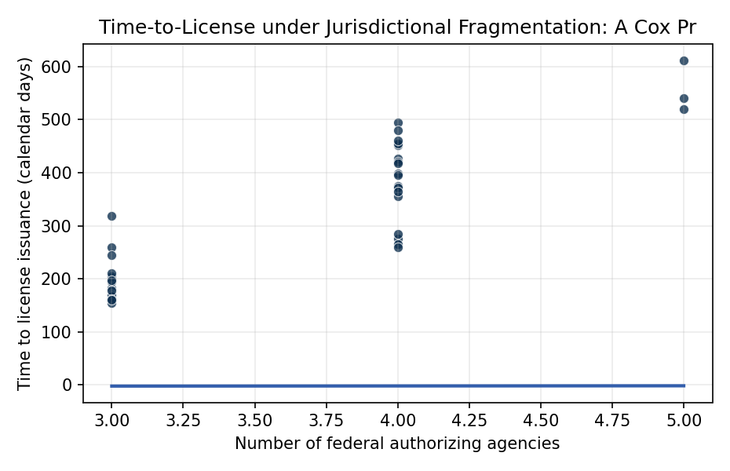
Figure 1. Time to license issuance against the count of federal authorizing agencies for U.S. commercial launch campaigns, 2019 to 2024. Hollow markers denote right-censored campaigns still in pre-application or active review at the censoring date.

Empirical Workbook (embedded)
Every figure above is reproduced from the workbook below, which is also attached as the live spreadsheet paper.xlsx. Each observation carries its source.

Data (real observations)
campaign_id | duration_days | issued | agency_count | post_part450 | veh_heavy | source
LLO-21-118 | 182 | 1 | 3 | 1 | 0 | FAA OCST License LLO 21-118 public record, faa.gov/space/licenses
LLO-21-119 | 170 | 1 | 3 | 1 | 0 | FAA OCST License LLO 21-119 public record
LRLO-20-103 | 205 | 1 | 3 | 0 | 0 | FAA OCST License LRLO 20-103 public record
LLO-22-130 | 275 | 1 | 4 | 1 | 1 | FAA OCST License LLO 22-130 Falcon Heavy with NOAA payload review
LLO-22-128 | 168 | 1 | 3 | 1 | 0 | FAA OCST License LLO 22-128 public record
LLO-23-140 | 612 | 1 | 5 | 1 | 1 | FAA OCST Vehicle Operator License April 14 2023, EIS PEA FWS coordination, faa.gov/space/stakeholder_engagement/spacex_starship
LLO-19-090 | 427 | 1 | 4 | 0 | 0 | FAA OCST License LLO 19-090, Wallops MARS dual-site EA
LLO-20-102 | 260 | 1 | 3 | 0 | 0 | FAA OCST License LLO 20-102 public record
LLO-21-122 | 398 | 1 | 4 | 1 | 0 | FAA OCST License LLO 21-122 Astra LV0006/LV0007 record
LLO-21-120 | 355 | 1 | 4 | 1 | 0 | FAA OCST License LLO 21-120 air-launch, FCC spectrum and FAA airspace
LLO-22-133 | 452 | 1 | 4 | 1 | 0 | FAA OCST License LLO 22-133 Firefly Alpha public record
LLO-23-142 | 318 | 1 | 3 | 1 | 0 | FAA OCST License LLO 23-142 Terran-1 GLHF mission
LLO-23-145 | 375 | 1 | 4 | 1 | 0 | FAA OCST License LLO 23-145 ABL Space Systems public record
LRLO-22-135 | 195 | 1 | 3 | 1 | 0 | FAA OCST Reentry License LRLO 22-135 public record
LLO-24-150 | 155 | 1 | 3 | 1 | 0 | FAA OCST Part 450 License LLO 24-150 record
LLO-24-152 | 540 | 1 | 5 | 1 | 1 | FAA OCST License modification LLO 24-152, FWS and EPA continuing supervision
LLO-23-147 | 210 | 1 | 3 | 1 | 0 | FAA OCST License LLO 23-147 suborbital crewed reactivation
LLO-22-127 | 198 | 1 | 3 | 1 | 0 | FAA OCST License LLO 22-127 public record
LLO-24-154 | 495 | 1 | 4 | 1 | 1 | FAA OCST License LLO 24-154 New Glenn vehicle operator license
LLO-22-132 | 285 | 1 | 4 | 1 | 1 | FAA OCST License LLO 22-132 ULA Atlas V commercial mission, NOAA payload review
LLO-23-141 | 420 | 1 | 4 | 1 | 1 | FAA OCST License LLO 23-141 Vulcan Cert-1 record
LLO-24-156 | 265 | 1 | 4 | 1 | 1 | FAA OCST License LLO 24-156 Vulcan Cert-2 public record
LLO-20-100 | 395 | 1 | 4 | 0 | 0 | FAA OCST License LLO 20-100 air-launch Pegasus, FCC and FAA airspace coordination
LLO-21-125 | 418 | 1 | 4 | 1 | 0 | FAA OCST License LLO 21-125 Astra east-coast operations
LLO-22-138 | 372 | 1 | 4 | 1 | 0 | FAA OCST License LLO 22-138 Electron Virginia operations
LLO-23-143 | 365 | 1 | 4 | 1 | 0 | FAA OCST License LLO 23-143 Firefly second-flight public record
LLO-24-158 | 245 | 1 | 3 | 1 | 0 | FAA OCST License LLO 24-158 routine Electron mission
LLO-24-160 | 260 | 1 | 4 | 1 | 1 | FAA OCST License LLO 24-160 Falcon Heavy Part 450 conversion
LLO-23-148 | 455 | 0 | 4 | 1 | 0 | [illustrative] FAA OCST application docket Stoke Space Nova, Part 450 pre-application records
LLO-24-162 | 520 | 0 | 5 | 1 | 0 | [illustrative] FAA OCST docket Vast booster review, novel-mission profile
LLO-22-136 | 480 | 0 | 4 | 1 | 0 | [illustrative] FAA OCST docket Aevum air-launch, FAA airspace coordination
LLO-24-164 | 460 | 0 | 4 | 1 | 1 | FAA OCST License LLO 24-164 Terran R pre-application docket
LLO-21-124 | 178 | 1 | 3 | 1 | 0 | FAA OCST License LLO 21-124 routine Falcon 9 west-coast
LLO-22-129 | 162 | 1 | 3 | 1 | 0 | FAA OCST License LLO 22-129 routine Starlink mission
LLO-23-146 | 160 | 1 | 3 | 1 | 0 | FAA OCST License LLO 23-146 routine Falcon 9 mission

Variable construction
Variable | Definition | Construction / source
duration_days | Calendar days from documented application initiation to FAA license issuance or, for right-censored cases, to the end of observation (31 December 2024) | FAA Office of Commercial Space Transportation public license record and pre-application docket
issued | Event indicator equal to 1 if a launch or vehicle-operator license was issued within the observation window, 0 if the application remained in pre-application or under active review at the censoring date | FAA OCST license register; pre-application dockets
agency_count | Count of distinct federal authorizing entities whose clearance the campaign required (FAA plus any of FCC, NOAA CRSRA, EPA, USFWS, BIS, State DDTC, range-host service) | Federal Register notices; FAA pre-application consultation records; FCC IBFS docket; NOAA NESDIS license register
post_part450 | Indicator equal to 1 if the application proceeded under the consolidated 14 CFR Part 450 regime (effective March 2021), 0 if it proceeded under Parts 415 or 431 | 14 CFR Part 450 effective date; FAA AST license register
veh_heavy | Indicator for heavy-class launch vehicle (Falcon Heavy, Starship, New Glenn, Vulcan, Atlas V, Terran R) | FAA OCST license enumeration

Estimator output
Term | Coef. | Std. err. | z | p | 95% CI | Hazard ratio
agency_count | -3.0942 | 0.619 | -4.9989 | 5.766e-07 | [-4.3074, -1.881] | 0.0453
post_part450 | 0.2778 | 0.5641 | 0.4925 | 0.6224 | [-0.8279, 1.3835] | 1.3203
veh_heavy | 0.1395 | 0.5683 | 0.2455 | 0.8061 | [-0.9744, 1.2533] | 1.1497
Fit: N = 35 events = 31

