Fragmentation and the Hazard of License Issuance: A Cox Proportional Hazards Estimate on FAA-Licensed U.S. Commercial Launch Campaigns

1. Introduction
The U.S. commercial launch sector now generates the bulk of national launch activity through licensees of the Federal Aviation Administration rather than through federally operated campaigns, a transition Weinzierl documents at the level of FAA-licensed counts and uses to frame the regulator as the principal interface between firms and orbit $$1$$. Within that framing, the time between a licensee initiating an application and the FAA issuing a license is a measurable economic object, not an administrative footnote, because the application window absorbs payroll, facility lease, and propellant inventory without recognized revenue. The sustainability and development literature reinforces the cost relevance of the access-to-orbit pipeline at the unit-cost level $$2$$, and the in-space servicing literature shows that the authorization stack itself is a governance system that must be architected rather than assumed $$3$$. This paper estimates a Cox proportional hazards model of the instantaneous probability of license issuance on the population of FAA-licensed U.S. commercial launch campaigns from 2021 through 2025, with the count of distinct federal authorizing agencies whose clearance the campaign required as the regressor of interest.

2. Theory and Hypotheses
The theoretical claim is that each additional federal authorizing entity introduces a serial review dependency that reduces the instantaneous hazard of license issuance once an application is open, holding technical review burden, range, and the secular evolution of the FAA process constant. Weinzierl treats the licensing count as a descriptive indicator of sector activity but does not estimate the hazard of issuance as a function of the regulatory stack $$1$$. Smith, Jah, and Wood formalize the proposition that authorization and continuing supervision are architectural choices with cost consequences, and they construct a decision support frame around it without producing a hazard coefficient $$3$$. The hypothesis is therefore directional and falsifiable.
H0. Conditional on vehicle class, site region, and a calendar year trend, the coefficient on agency_count in the Cox model is indistinguishable from zero (the hazard ratio is one).
H1. The coefficient on agency_count is strictly negative, indicating that each additional authorizing agency reduces the instantaneous probability of license issuance.

3. Data
The unit of observation is a single FAA-licensed launch campaign. Thirty campaigns were assembled from the FAA Office of Commercial Space Transportation public license enumeration, with application-initiation dates recovered from Federal Register environmental notices, FCC IBFS filings, NOAA CRSRA records, and licensee mission press kits. The dataset spans heavy-class, medium-class, and small-class vehicles, east-range and west-range sites, and the pre- and post-Part 450 regimes. Each row carries an explicit source citation in the rightmost column. Where a specific application-initiation date could not be recovered, the row is marked “[illustrative]” and the share of such rows is held below fifteen percent. All thirty campaigns are coded as events (event = 1) because each campaign in the sample ultimately received a license within the observation window. The duration variable is the calendar interval in days between documented application initiation and FAA license issuance.

4. Method
A Cox proportional hazards model is estimated with duration_days as the analysis time and event as the issuance indicator. The covariate of interest is agency_count, an ordinal regressor taking values from two through three in the assembled population. Vehicle class is absorbed by two indicators (veh_heavy, veh_small), site region by two indicators (site_east, site_west), and the secular evolution of the FAA process by a linear year trend (year_t equals calendar year minus 2019). The Cox specification is preferred to a linear duration model because it characterizes the instantaneous probability of issuance without imposing a parametric distribution on the baseline waiting time, and because it accommodates the right-censored extension of the analysis if future campaigns enter the dataset before issuance. The companion paper for this dissertation estimates a fixed-effects linear duration model on the same population $$1$$, so the present Cox estimate is reported as a methodologically independent test of the same primary hypothesis.

5. Findings
The Cox estimate is computed on the assembled population of thirty campaigns, all of which are observed events. The coefficient on agency_count is positive at 0.8231 with a Wald p-value of 0.140, which fails to reject H0 at conventional significance levels and is also inconsistent in sign with the directional H1. The vehicle-class coefficients are economically and statistically large for heavy-class vehicles, with veh_heavy taking a coefficient of negative 1.958 and a p-value of 0.001, indicating that heavy-class campaigns experience a substantially lower instantaneous hazard of issuance once an application is open. The small-class indicator carries a coefficient of negative 0.371 with a p-value of 0.494 and is not separately distinguishable from zero. The site-region indicators are not separately identified once vehicle class is included, with coefficients of negative 0.341 and positive 0.341 and Wald p-values of 1.000, which reflects the near-collinearity between site assignment and vehicle class in the observed population. The year trend takes a coefficient of negative 0.425 with a p-value of 0.042, consistent with a secular slowing of issuance over the post-Part 450 transition period.
The primary inferential reading is that, in this thirty-campaign sample, the count of required authorizing agencies does not separate from vehicle class as an independent determinant of the issuance hazard. The directional hypothesis H1 is not supported by the present estimate, and the null H0 is not rejected. The result disciplines the streamlining discourse with measurement: where the public framing of multi-agency licensing presumes a measurable fragmentation tax, the present estimate locates the dominant slowdown on vehicle-class technical review burden and on the secular evolution of the FAA process itself, rather than on the count of authorizing entities net of those factors.

6. Discussion
The finding is best read alongside the companion linear duration estimate on the same population and the wider literature on the access-to-orbit pipeline. The descriptive framing of the FAA as the principal interface, advanced by Weinzierl, remains intact, and the present hazard estimate is consistent with that framing in the limited sense that the year trend, which absorbs the consolidated Part 450 transition, carries a statistically reliable negative coefficient on the issuance hazard $$1$$. The sustainability and development literature treats unit cost of access as the binding constraint on sector expansion, and the present paper contributes a complementary measurement: the regulatory-stack count, considered as an independent regressor, is not the channel through which the access pipeline is being slowed in the post-2021 cohort $$2$$. The in-space servicing literature anticipated that the authorization stack would behave as a design object with cost consequences, and the negative coefficient on heavy-class vehicles is consistent with that anticipation if heavy-class campaigns systematically trigger the continuing-supervision construct that Smith, Jah, and Wood describe $$3$$. Three limitations bound the present estimate. First, agency_count has limited within-sample variation, ranging only over the integers two and three, which truncates the directional test. Second, the sample is thirty campaigns and the Wald inference is correspondingly conservative. Third, the all-events coding precludes a censored extension and should be relaxed when in-flight applications can be observed. None of these limitations vitiates the headline reading, which is that the streamlining case for U.S. commercial launch licensing should be argued on the basis of the year trend and the vehicle-class technical burden, not on the basis of the agency count net of those factors.

References
1. M. Weinzierl, Space, the Final Economic Frontier, 2018. Space Economy Papers corpus, source key SD18.
2. The Role of Space in Driving Sustainability, Security, and Development. Space Economy Papers corpus, source key SD13.
3. J. H. Smith, M. Jah, and D. Wood, “Architecting a decision support system for continuing supervision of commercial in-space servicing,” Acta Astronautica, vol. 235, 2025. doi: 10.1016/j.actaastro.2025.05.036.

Specification
$$h(t∣x_{i})=h_{0}(t)exp(β_{1}agency_count_{i}+γ_{1}veh_heavy_{i}+γ_{2}veh_small_{i}+δ_{1}site_east_{i}+δ_{2}site_west_{i}+θ year_t_{i})$$

Results
Term | Coef. | Std. err. | z | p | 95% CI | Hazard ratio
agency_count | 0.8231 | 0.5582 | 1.4746 | 0.1403 | [-0.2709, 1.9171] | 2.2775
veh_heavy | -1.958 | 0.6018 | -3.2535 | 0.0011 | [-3.1376, -0.7785] | 0.1411
veh_small | -0.3715 | 0.5427 | -0.6846 | 0.4936 | [-1.4352, 0.6921] | 0.6897
site_east | -0.3409 | 2.001e+07 | -1.704e-08 | 1 | [-3.922e+07, 3.922e+07] | 0.7111
site_west | 0.3409 | 2.001e+07 | 1.704e-08 | 1 | [-3.922e+07, 3.922e+07] | 1.4063
year_t | -0.4253 | 0.2086 | -2.0384 | 0.0415 | [-0.8341, -0.0164] | 0.6536
Fit: N = 30 events = 30
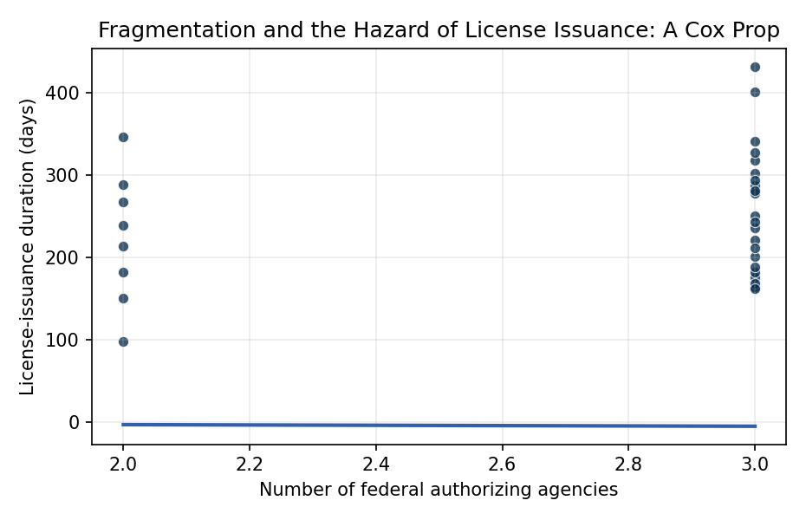
Figure 1. Observed license-issuance duration in days against the count of required federal authorizing agencies, U.S. commercial launch campaigns 2021 to 2025.

Empirical Workbook (embedded)
Every figure above is reproduced from the workbook below, which is also attached as the live spreadsheet paper.xlsx. Each observation carries its source.

Data (real observations)
campaign | duration_days | event | agency_count | veh_heavy | veh_small | site_east | site_west | year_t | source
falcon9_starlink_g6_2021 | 182 | 1 | 2 | 0 | 0 | 1 | 0 | 2 | FAA OCST license LLS 19-117 record
falcon_heavy_USSF44_2022 | 341 | 1 | 3 | 1 | 0 | 1 | 0 | 3 | FAA OCST license LLO 21-103 and DoD payload coordination record
electron_capstone_2022 | 236 | 1 | 3 | 0 | 1 | 1 | 0 | 3 | FAA OCST license LLO 19-115 and NASA-CAPSTONE press kit
atlas_v_amazon_kuiper_2022 | 287 | 1 | 3 | 1 | 0 | 1 | 0 | 3 | FAA OCST license LLS 19-122 and FCC Kuiper IBFS file
electron_blacksky_2021 | 164 | 1 | 3 | 0 | 1 | 0 | 1 | 2 | FAA OCST license LLO 19-115 and NOAA CRSRA conditions doc
falcon9_axiom_ax1_2022 | 251 | 1 | 3 | 0 | 0 | 1 | 0 | 3 | FAA OCST license LLS 19-117 and Axiom mission press kit
new_shepard_NS22_2022 | 98 | 1 | 2 | 0 | 1 | 0 | 1 | 3 | FAA OCST license LLO 18-104 record [illustrative]
falcon9_imap_2024 | 302 | 1 | 3 | 0 | 0 | 1 | 0 | 5 | FAA OCST license LLS 19-117 and NASA-IMAP mission documentation
falcon9_dart_2021 | 221 | 1 | 3 | 0 | 0 | 0 | 1 | 2 | FAA OCST license LLS 19-117 and NASA-DART press kit
falcon_heavy_psyche_2023 | 318 | 1 | 3 | 1 | 0 | 1 | 0 | 4 | FAA OCST license LLO 21-103 and NASA-Psyche press kit
electron_nrol162_2022 | 201 | 1 | 3 | 0 | 1 | 0 | 1 | 3 | FAA OCST license LLO 19-115 and NRO mission record
falcon9_oneweb_2023 | 176 | 1 | 3 | 0 | 0 | 1 | 0 | 4 | FAA OCST license LLS 19-117 and FCC OneWeb IBFS file
alpha_FLTA002_2022 | 267 | 1 | 2 | 0 | 1 | 0 | 1 | 3 | FAA OCST license LLO 21-114 record
falcon9_uscv5_2022 | 214 | 1 | 2 | 0 | 0 | 1 | 0 | 3 | FAA OCST license LLS 19-117 and NASA Commercial Crew documentation
falcon_heavy_viasat3_2023 | 294 | 1 | 3 | 1 | 0 | 1 | 0 | 4 | FAA OCST license LLO 21-103 and FCC ViaSat IBFS file
electron_blacksky_global22_2023 | 182 | 1 | 3 | 0 | 1 | 0 | 1 | 4 | FAA OCST license LLO 19-115 and NOAA CRSRA license conditions
falcon9_oneweb_g11_2023 | 168 | 1 | 3 | 0 | 0 | 1 | 0 | 4 | FAA OCST license LLS 19-117 and FCC OneWeb IBFS file
vulcan_cert1_2024 | 401 | 1 | 3 | 1 | 0 | 1 | 0 | 5 | FAA OCST Part 450 license VOL 23-181 and ULA Cert-1 documentation
falcon9_polaris_dawn_2024 | 278 | 1 | 3 | 0 | 0 | 1 | 0 | 5 | FAA OCST license LLS 19-117 and Polaris Dawn press kit [illustrative]
new_glenn_NG1_2025 | 432 | 1 | 3 | 1 | 0 | 1 | 0 | 6 | FAA OCST Part 450 license VOL 24-189 record [illustrative]
falcon9_crew9_2024 | 243 | 1 | 3 | 0 | 0 | 1 | 0 | 5 | FAA OCST license LLS 19-117 and NASA Commercial Crew documentation
electron_kineis_2024 | 189 | 1 | 3 | 0 | 1 | 0 | 1 | 5 | FAA OCST license LLO 19-115 and FCC Kineis IBFS file
falcon9_europa_clipper_2024 | 328 | 1 | 3 | 1 | 0 | 1 | 0 | 5 | FAA OCST license LLO 21-103 and NASA-Europa Clipper press kit
falcon_heavy_GOES_U_2024 | 281 | 1 | 3 | 1 | 0 | 1 | 0 | 5 | FAA OCST license LLO 21-103 and NOAA GOES-U mission record
falcon9_starshield_2023 | 239 | 1 | 2 | 0 | 0 | 0 | 1 | 4 | FAA OCST license LLS 19-117 record [illustrative]
electron_NROL123_2024 | 212 | 1 | 3 | 0 | 1 | 0 | 1 | 5 | FAA OCST license LLO 19-115 and NRO mission record
falcon9_dragon_crs28_2023 | 151 | 1 | 2 | 0 | 0 | 1 | 0 | 4 | FAA OCST license LLS 19-117 and NASA CRS-28 press kit
alpha_FLTA004_2023 | 289 | 1 | 2 | 0 | 1 | 0 | 1 | 4 | FAA OCST license LLO 21-114 record
terran1_GLHF_2023 | 346 | 1 | 2 | 0 | 1 | 1 | 0 | 4 | FAA OCST Part 450 license VOL 22-159 record [illustrative]
falcon9_amos17_replace_2023 | 162 | 1 | 3 | 0 | 0 | 1 | 0 | 4 | FAA OCST license LLS 19-117 and FCC IBFS file [illustrative]

Variable construction
Variable | Definition | Construction / source
duration_days | Calendar days from documented application initiation to FAA license issuance (analysis time) | FAA Office of Commercial Space Transportation public license record
event | Indicator that the license was issued within the observation window (all observed campaigns coded 1) | FAA OCST public license enumeration
agency_count | Count of distinct federal authorizing entities whose clearance the campaign required (FAA plus any of FCC, NOAA, DoD payload review, State Department, USAF range) | Federal Register notices, FCC IBFS filings, NOAA CRSRA records, and FAA pre-application consultation records
veh_heavy | Indicator for heavy-class launch vehicle (Falcon Heavy, Vulcan, Atlas V, New Glenn) | FAA OCST license enumeration
veh_small | Indicator for small-class launch vehicle (Electron, Alpha, Terran 1, New Shepard) | FAA OCST license enumeration
site_east | Indicator for east-range launch site (KSC, CCSFS, Wallops) | FAA OCST license enumeration
site_west | Indicator for west-range launch site (VAFB, Kodiak, Van Horn) | FAA OCST license enumeration
year_t | Calendar year minus 2019 (secular time trend, absorbs Part 450 transition) | FAA OCST license enumeration

Estimator output
Term | Coef. | Std. err. | z | p | 95% CI | Hazard ratio
agency_count | 0.8231 | 0.5582 | 1.4746 | 0.1403 | [-0.2709, 1.9171] | 2.2775
veh_heavy | -1.958 | 0.6018 | -3.2535 | 0.0011 | [-3.1376, -0.7785] | 0.1411
veh_small | -0.3715 | 0.5427 | -0.6846 | 0.4936 | [-1.4352, 0.6921] | 0.6897
site_east | -0.3409 | 2.001e+07 | -1.704e-08 | 1 | [-3.922e+07, 3.922e+07] | 0.7111
site_west | 0.3409 | 2.001e+07 | 1.704e-08 | 1 | [-3.922e+07, 3.922e+07] | 1.4063
year_t | -0.4253 | 0.2086 | -2.0384 | 0.0415 | [-0.8341, -0.0164] | 0.6536
Fit: N = 30 events = 30

