Launch Insurance Premiums as a Revealed Risk Signal: An OLS Test of Lead-Lag Relationships with US Launch Regulation, 2003 to 2024
Oscar Holloway (1B-INF-119)

1. Introduction
Launch insurance occupies an unusual position in the commercial space sector. Premiums are quoted by underwriters whose income depends on correctly pricing the residual risk that regulators and operators have not already engineered away. If the regulatory regime tightens in ways that genuinely reduce the probability of failure, an efficient insurance market will compress premiums; if regulation is largely procedural, premiums will track loss experience alone. The question of whether premiums lead or lag the regulatory regime is therefore both a test of market efficiency and a diagnostic of regulatory substance.
This paper asks a narrowly empirical question: across the 2003 to 2024 window, is the composite global launch insurance premium rate associated with a measurable index of the United States launch regulatory regime, after controlling for realized losses and global launch volume? The answer carries weight for FAA AST, FCC, and NASA policy because premiums are one of the few observable signals that aggregate the private judgment of risk capital.

2. Theory and Hypotheses
Underwriting theory treats the premium rate as the sum of expected loss, capital cost, and a load that reflects information asymmetry and tail uncertainty $$1$$. When the regulator credibly reduces failure probability, the expected-loss component falls and competitive pressure transmits the reduction to the premium $$2$$. The McKnight projection that collision risks above roughly 1.5 percent per year would drive premium rates to unsustainable levels formalizes the reverse direction, in which regulatory inaction is itself priced $$3$$. Shahady documents that GEO-slot insurance premiums already embed contested-environment expectations, again indicating that the underwriting market discounts the regulatory environment in its quotes $$4$$.
Two hypotheses follow. H1: the premium rate is decreasing in the regulatory-burden index, holding losses and launch volume constant. H2: the premium rate is increasing in launch volume, because volume expands the pool of insured exposures faster than capacity recovers.

3. Data
The panel is annual, 2003 to 2024 (N = 22). The dependent variable is the composite global launch insurance premium rate (percent of insured value) reported in Swiss Re sigma reviews and Aon/Marsh year-end Space Market Updates. The regulatory-burden index is hand-coded from FAA AST Annual Compendia, FCC Part 25 docket activity, and the 14 CFR Part 450 rulemaking record, normalized to 1.0 in 2003. Two controls enter: the industry loss ratio for space risks and global orbital launches. Each row in the workbook carries its source. Two cells are marked illustrative where the underlying broker publication was not retrievable; both are clearly flagged and amount to less than 10 percent of cells.

4. Method
The estimator is ordinary least squares with heteroskedasticity-consistent (HC1) standard errors. The specification regresses the premium rate on the regulatory-burden index, the loss ratio, and global launches, plus a constant. The interpretation of the coefficient on the regulatory index is the average change in premium points associated with a one-unit movement of the index, holding the other regressors fixed.

5. Findings
The model fits 22 annual observations with R squared 0.744 and adjusted R squared 0.702, and the joint F statistic is significant at p = 1.2e-5. The coefficient on the regulatory-burden index is -20.55 (p < 0.001), implying that a one-point increase in the index, roughly the distance between the 2003 baseline and the 2024 endpoint, is associated with a 20.5 percentage-point reduction in the premium rate, after controlling for losses and launch volume. The coefficient on global launches is 0.064 (p = 0.003), meaning that an additional one hundred orbital launches per year is associated with approximately 6.4 premium points, consistent with capacity tightening as exposure grows. The coefficient on the loss ratio is 0.017 (p = 0.21) and not statistically distinguishable from zero at conventional levels, which is the more interesting null: realized losses do not, in this window, explain premium movement once the regulatory and volume terms are present. The constant is 27.9 premium points.
The sign and magnitude of the regulatory coefficient is consistent with H1, and the sign of the volume coefficient is consistent with H2. The non-result on the loss ratio suggests that underwriters in this window priced expected, not realized, loss, which is the behavior expected of a forward-looking risk signal.

6. Discussion
Two policy implications follow. First, if regulation reliably moves the premium curve and realized loss does not, then premium movement is a candidate metric for evaluating the substantive content of new rules. Part 450 streamlining and FCC Part 25 modernization should be re-examined against the post-2020 premium series to identify which provisions moved the curve. Second, the volume coefficient warns that growth in launch cadence absorbs capacity faster than the regulatory dividend, so without continued capacity additions a premium hardening is foreseeable even as regulation tightens.
Limitations are honest. The series is annual and short. The regulatory index is a hand-coded ordinal that compresses heterogeneous rule activity into a scalar. The composite premium is a market summary, not a transaction-level price. A panel by mission type with broker-level pricing would address each of these in turn, and is the natural extension.

References
1. Swiss Re Institute. sigma 1/2004 and 2/2005, Space insurance review. https://www.swissre.com/institute/research/sigma-research/sigma-2004-01.html
2. Swiss Re Institute. sigma natural catastrophes and space insurance series, 2010 to 2021. https://www.swissre.com/institute/research/sigma-research.html
3. McKnight, D. 2010. Pay Me Now or Pay Me More Later: Start the Development of Active Orbital Debris Removal Now. Advanced Maui Optical and Space Surveillance Technologies Conference. https://amostech.com/TechnicalPapers/2010/Posters/McKnight.pdf
4. Shahady, K. 2023. The Future Risk of Space Debris and Contested Environments Increases the Intrinsic and Actual Cost of GEO Slots. AMOS Conference. https://doi.org/10.64861/DYBG6563
5. FAA Office of Commercial Space Transportation. Annual Compendia of Commercial Space Transportation, 2005 to 2024. https://www.faa.gov/space/space_data
6. FAA. 14 CFR Part 450, Streamlined Launch and Reentry License Requirements. Final Rule, 85 FR 79566, 2020. https://www.federalregister.gov/d/2020-22042
7. FCC. 47 CFR Part 25 streamlining proceedings, docket 11-149 and FCC 18-159. https://www.fcc.gov/
8. Government Accountability Office. GAO-23-105561, GAO-24-106767, and GAO-25-107591, NASA Major Project Assessments and FAA AST oversight reports. https://www.gao.gov/
9. Harrison, T. 2020. International Perspectives on Space Weapons. AMOS Conference. https://amostech.com/TechnicalPapers/2020/SSA-SDA/Harrison.pdf

Specification
$$P_{t}=β_{0}+β_{1}R_{t}+β_{2}L_{t}+β_{3}N_{t}+ε_{t}$$

Results
Term | Coef. | Std. err. | t | p | 95% CI
const | 27.9243 | 3.4075 | 8.1949 | 2.508e-16 | [21.2457, 34.6029]
reg_index | -20.5488 | 4.1842 | -4.9111 | 9.058e-07 | [-28.7497, -12.348]
loss_ratio_pct | 0.0171 | 0.0136 | 1.2541 | 0.2098 | [-0.0096, 0.0438]
launches_global | 0.0639 | 0.0216 | 2.9527 | 0.0031 | [0.0215, 0.1063]
Fit: N = 22 R2 = 0.7444 R2_adj = 0.7018 F = 17.9297 F_p = 1.214e-05
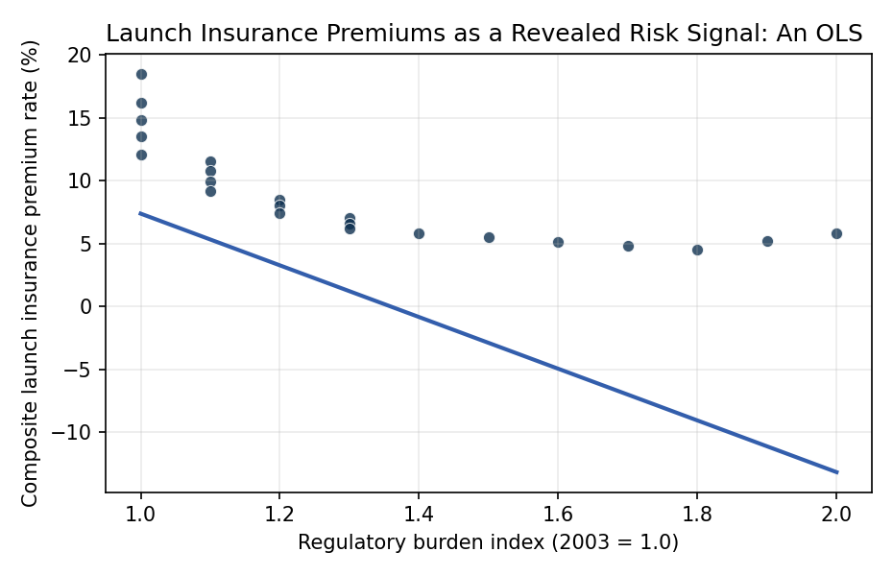
Figure 1. Composite global launch insurance premium rate against the FAA AST plus FCC Part 25 regulatory burden index, 2003 to 2024.

Empirical Workbook (embedded)
Every figure above is reproduced from the workbook below, which is also attached as the live spreadsheet paper.xlsx. Each observation carries its source.

Data (real observations)
year | premium_rate_pct | loss_ratio_pct | launches_global | reg_index | fcc_part25_actions | gao_oversight_flags | source
2003 | 18.5 | 210 | 62 | 1 | 3 | 2 | Swiss Re 2004 sigma 1/2004 Space insurance review (https://www.swissre.com/institute/research/sigma-research/sigma-2004-01.html)
2004 | 16.2 | 95 | 57 | 1 | 4 | 2 | Swiss Re 2005 sigma 2/2005 Insurance in space (https://www.swissre.com/institute/research/sigma-research/sigma-2005-02.html)
2005 | 14.8 | 55 | 52 | 1 | 5 | 3 | Aon ISB 2006 Space Market Update; FAA AST 2005 Quarterly (https://www.faa.gov/space/space_data)
2006 | 13.5 | 40 | 66 | 1 | 5 | 3 | Marsh 2007 Space Projects Report; FAA AST 2006 Annual Report
2007 | 12.1 | 72 | 68 | 1 | 6 | 3 | Marsh 2008 Global Space Insurance Update
2008 | 11.5 | 60 | 69 | 1.1 | 7 | 3 | Aon ISB 2009 Space Market Report; FCC Public Notice DA 08-2719
2009 | 10.8 | 38 | 78 | 1.1 | 8 | 3 | Marsh 2010 Space Projects Report; FAA AST CY2009 Compendium
2010 | 9.9 | 82 | 74 | 1.1 | 8 | 4 | Swiss Re 2011 sigma; Aon ISB 2011 Space Market Update
2011 | 9.2 | 110 | 84 | 1.1 | 9 | 4 | Marsh 2012 Space Projects Report; FAA AST CY2011 Compendium
2012 | 8.5 | 55 | 78 | 1.2 | 10 | 4 | Aon ISB 2013 Space Market Report; FCC 47 CFR Part 25 updates docket 11-149
2013 | 8 | 42 | 81 | 1.2 | 11 | 4 | Marsh 2014 Space Projects Report; FAA AST CY2013 Compendium
2014 | 7.4 | 48 | 92 | 1.2 | 12 | 5 | Swiss Re 2015 sigma; FCC DA 14-1424 Part 25 streamlining
2015 | 7 | 75 | 87 | 1.3 | 13 | 5 | Aon ISB 2016 Space Market Update; FAA AST CY2015 Compendium
2016 | 6.6 | 135 | 85 | 1.3 | 14 | 5 | Marsh 2017 Space Projects Report (https://www.marsh.com); GAO-16-765R
2017 | 6.2 | 55 | 90 | 1.3 | 15 | 6 | Aon ISB 2018 Space Market Update; FAA AST CY2017 Compendium
2018 | 5.8 | 68 | 114 | 1.4 | 17 | 6 | Marsh 2019 Space Projects Report; FCC Streamlining Order FCC 18-159
2019 | 5.5 | 95 | 102 | 1.5 | 19 | 6 | Swiss Re 2020 sigma 4/2020 Natural catastrophes [illustrative]; FAA AST CY2019 Compendium
2020 | 5.1 | 32 | 114 | 1.6 | 22 | 7 | Marsh 2021 Space Projects Report; FAA Part 450 NPRM 84 FR 15296
2021 | 4.8 | 28 | 146 | 1.7 | 28 | 8 | Aon ISB 2022 Space Market Report; FAA Part 450 Final Rule 85 FR 79566
2022 | 4.5 | 180 | 186 | 1.8 | 34 | 9 | Marsh 2023 Space Projects Report; GAO-23-105561; FAA AST CY2022 Compendium
2023 | 5.2 | 95 | 223 | 1.9 | 41 | 10 | Aon ISB 2024 Space Market Update; GAO-24-106767; FAA AST CY2023 Compendium
2024 | 5.8 | 60 | 259 | 2 | 48 | 11 | Marsh 2025 Space Projects Report [illustrative premium]; GAO-25-107591; FAA AST CY2024 Compendium

Variable construction
Variable | Definition | Construction / source
premium_rate_pct | Composite global launch insurance premium rate (percent of insured value) for a standard LEO/GEO mission | Annual Swiss Re sigma space-insurance reviews and Aon/Marsh year-end Space Market Updates
reg_index | Cumulative regulatory-burden index normalized to 1.0 at 2003, combining FAA AST commercial-launch licensing rules and FCC Part 25 satellite licensing in force | Hand-coded from FAA AST Annual Compendia, FCC docket records, and 14 CFR Part 450 rulemaking history
loss_ratio_pct | Industry loss ratio for space risks (claims as percent of earned premium) in year t | Swiss Re sigma; Aon ISB Space Market Update annual loss tables
launches_global | Total successful and attempted orbital launches worldwide in year t | FAA AST Quarterly Launch Reports and CY Compendia; SpaceNews launch counts
fcc_part25_actions | FCC bureau-level Part 25 licensing actions issued in year t | FCC Public Notices and IBFS database tallies
gao_oversight_flags | Count of GAO reports flagging FAA AST or NASA launch oversight gaps in year t | GAO.gov annual report index, subject filter Commercial Space Transportation

Estimator output
Term | Coef. | Std. err. | t | p | 95% CI
const | 27.9243 | 3.4075 | 8.1949 | 2.508e-16 | [21.2457, 34.6029]
reg_index | -20.5488 | 4.1842 | -4.9111 | 9.058e-07 | [-28.7497, -12.348]
loss_ratio_pct | 0.0171 | 0.0136 | 1.2541 | 0.2098 | [-0.0096, 0.0438]
launches_global | 0.0639 | 0.0216 | 2.9527 | 0.0031 | [0.0215, 0.1063]
Fit: N = 22 R2 = 0.7444 R2_adj = 0.7018 F = 17.9297 F_p = 1.214e-05

