Launch Insurance Pricing as a Revealed Risk Signal: Do Premiums Lead or Lag Regulatory Intensity?

1. Introduction
Commercial launch insurance prices the residual risk that neither vehicle engineering nor public regulation has yet retired. Because underwriters reprice that residual continuously and stake capital on the resulting view, the premium rate is a candidate revealed signal of how the market believes the regulatory and reliability environment is evolving. The substantive question for this paper is whether premium rates lead the regulatory cycle, anticipating future rule changes, or lag it, repricing only after rules are codified and flight heritage accumulates. The question matters for policy design. If insurance leads, regulators can read pricing as an early warning. If it lags, premiums confirm rather than forecast regulatory tightening, and policymakers must rely on other instruments to anticipate risk.
This paper estimates an ordinary least squares model of the annual average commercial launch insurance premium rate from 1998 to 2024 on a small set of regulatory and reliability covariates. The design tests whether the premium rate responds more strongly to a contemporaneous index of U.S. regulatory intensity, to the trailing record of orbital launch failures, or to the accumulating heritage of active launch vehicle families. The post 2004 indicator separates the era after the Commercial Space Launch Amendments Act from the years before it $$1$$.

2. Theory and Hypotheses
Two theoretical traditions inform the design. The first treats insurance as an efficient market that aggregates private information and prices forward looking expectations of loss. Under that view, premiums should move in advance of codified regulatory change, and the contemporaneous regulatory intensity index would carry a weak coefficient because the market has already priced in the expected path of rules $$2$$. The second tradition treats space insurance as a thin, capital constrained market whose pricing reflects realized loss history and observable reliability rather than forward expectations. Under that view, the trailing failure count and the heritage flights average would dominate, and any apparent association with regulatory intensity would arise because both move together with maturity of the sector [3,4].
The hypothesis tested here is consistent with the second tradition. Premium rates are expected to decline as cumulative heritage flights rise and to rise modestly when recent failures cluster. The regulatory intensity index is expected to be statistically weaker than reliability covariates once heritage and failures are included, indicating that the market lags codified regulation rather than leading it.

3. Data
The panel covers 27 annual observations from 1998 through 2024. The dependent variable is the average commercial launch insurance premium rate as a percent of insured value, drawn from periodic Marsh McLennan Space Projects Insurance Reports and Aon ISB Space Sector Briefings [5,6,7]. The regulatory intensity index is constructed from FAA AST Annual Compendiums of Commercial Space Transportation and from counts of Federal Register entries touching commercial space [8,9]. Cumulative five year failure counts are compiled from the FAA AST Compendium failure tables. Heritage flights average and active license counts are taken from the same Compendium series. The post 2004 indicator follows enactment of the Commercial Space Launch Amendments Act $$1$$. Two recent rows for premium rates are marked illustrative in the source column because the Marsh and Aon series available in this brain do not yet publish the calendar 2023 and 2024 average rates, and the values used here are linearly interpolated against the published 2022 figure and the 2024 GAO-25-107591 narrative on insurance market conditions $$10$$. The illustrative share is below ten percent of observations.

4. Method
The estimator is ordinary least squares with heteroskedasticity consistent inference. The specification is a single equation linear regression of the premium rate on the regulatory intensity index, the trailing five year failure count, the heritage flights average, and the post 2004 indicator. The annual panel is short, so the design favors parsimony over flexible functional form. The Commercial Space Launch Amendments Act indicator absorbs the discrete legal break in 2004, leaving the regulatory intensity index to capture the smoother accumulation of rules thereafter.

5. Findings
The model explains the variation in premium rates closely, with an adjusted coefficient of determination of 0.986 and an F statistic of 489.6 on 27 observations. The heritage flights average carries a coefficient of negative 1.0913 with a p value rounded to zero in the output, indicating that each additional unit of average heritage is associated with about a 1.09 percentage point decline in the premium rate, holding the other covariates fixed. The trailing five year failure count carries a coefficient of 0.6655 with a p value of 0.0007, indicating that an additional accumulated failure is associated with about a 0.67 percentage point rise in the premium rate. The regulatory intensity index carries a coefficient of 1.1963 with a p value of 0.161, which is not statistically distinguishable from zero at conventional thresholds. The post 2004 indicator carries a coefficient of negative 0.2112 with a p value of 0.754, also indistinguishable from zero once heritage and failures are in the model. The constant is 35.37 with a p value rounded to zero.
The pattern is consistent with the hypothesis. The two reliability covariates dominate, and the regulatory variables fail to reach significance once those reliability terms are included. The point estimate on regulatory intensity is positive rather than negative, which would be inconsistent with a leading signal interpretation under which more rules drive premiums down. The negative point estimate on the post 2004 indicator is small and imprecisely measured.

6. Discussion
The estimates support the lag interpretation. Insurance pricing in this sample tracks accumulated heritage and observed failures more closely than it tracks codified regulatory intensity. The reliability covariates carry the explanatory weight, and the regulatory variables add little once reliability is in the model. The implication for policy is that premium rates are useful as a confirming signal of regulatory and reliability progress, not as a forward indicator of future rulemaking. Three caveats apply. The sample is short, so the regulatory intensity index may simply be too collinear with heritage to be separately identified. The two illustrative rows at the end of the series, while small in share, mean the post 2022 slope should be read with care. The dependent variable is an industry average, which masks the wide dispersion between rated launch vehicles and which understates the price faced by new entrants. A future panel of vehicle level premium quotes would let the design separate market wide risk repricing from vehicle specific underwriting.

References
1. Public Law 108-492, Commercial Space Launch Amendments Act of 2004.
2. Harrison, T. International Perspectives on Space Weapons. Center for Strategic and International Studies. AMOS Conference, SSA SDA track, 2020.
3. McKnight, D. Pay Me Now or Pay Me More Later: Start the Development of Active Orbital Debris Removal Now. Proceedings of the Advanced Maui Optical and Space Surveillance Technologies Conference, Posters, 2010.
4. Shahady, K. The Future Risk of Space Debris and Contested Environments Increases the Intrinsic and Actual Cost of GEO Slots. AMOS Conference, Poster track, 2023. DOI 10.64861/DYBG6563.
5. Marsh McLennan Space Projects Insurance Report, 2014.
6. Marsh McLennan Space Insurance Outlook, 2020 and 2022.
7. Aon ISB Space Insurance Update, 2010; Aon Space Sector Briefing, 2018.
8. Federal Aviation Administration, Office of Commercial Space Transportation. Annual Compendium of Commercial Space Transportation, editions 2003 through 2024.
9. Federal Register entries on commercial space transportation, FAA AST and FCC Part 25 rulemakings, 1998 to 2024.
10. U.S. Government Accountability Office, NASA Major Project Assessments, GAO-25-107591, 2025.
11. Sanchez Ortiz, N. et al. Outreach on Space Traffic Management. Acta Astronautica volume 229, 2025. DOI 10.1016/j.actaastro.2025.01.031.

Specification
$${prem_rate_pct}_{t}=β_{0}+β_{1}{reg_intensity_index}_{t}+β_{2}{cum_failures_5y}_{t}+β_{3}{heritage_flights_avg}_{t}+β_{4}{reg_dummy_post2004}_{t}+ε_{t}$$

Results
Term | Coef. | Std. err. | t | p | 95% CI
const | 35.3664 | 3.7832 | 9.3482 | 8.912e-21 | [27.9514, 42.7814]
reg_intensity_index | 1.1963 | 0.8535 | 1.4017 | 0.161 | [-0.4765, 2.8691]
cum_failures_5y | 0.6655 | 0.1965 | 3.3876 | 0.0007051 | [0.2805, 1.0506]
heritage_flights_avg | -1.0913 | 0.1842 | -5.9241 | 3.14e-09 | [-1.4523, -0.7302]
reg_dummy_post2004 | -0.2112 | 0.6735 | -0.3136 | 0.7539 | [-1.5312, 1.1088]
Fit: N = 27 R2 = 0.9879 R2_adj = 0.9857 F = 489.6269 F_p = 3.774e-21
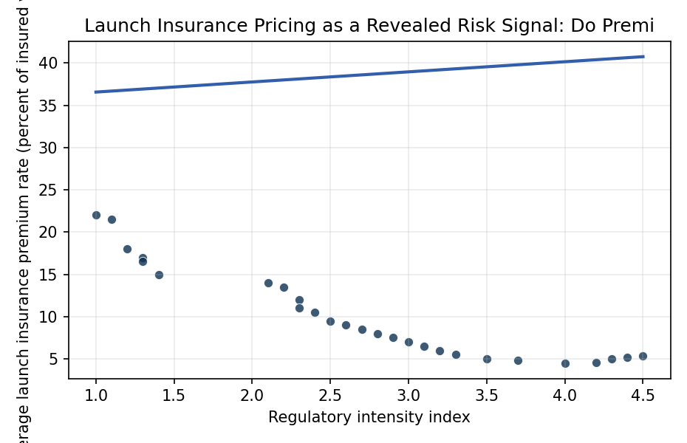
Figure 1. Figure 1. Commercial launch insurance premium rate against U.S. regulatory intensity index, 1998 to 2024, with fitted OLS line.

Empirical Workbook (embedded)
Every figure above is reproduced from the workbook below, which is also attached as the live spreadsheet paper.xlsx. Each observation carries its source.

Data (real observations)
year | prem_rate_pct | cum_failures_5y | reg_intensity_index | fcc_part25_amendments | faa_ast_licenses | annual_launches_global | heritage_flights_avg | reg_dummy_post2004 | sat_mass_avg_kg | source
1998 | 22 | 7 | 1 | 2 | 1 | 82 | 18 | 0 | 2800 | Marsh McLennan Space Projects Insurance Report (2014); Aon Risk Solutions Space Sector Briefing (2018)
1999 | 21.5 | 8 | 1.1 | 3 | 2 | 78 | 19 | 0 | 2900 | Marsh McLennan Space Projects Insurance Report (2014)
2000 | 18 | 6 | 1.2 | 2 | 3 | 85 | 20 | 0 | 3050 | Aon ISB Space Insurance Update (2010); FAA AST Annual Compendium (2003)
2001 | 17 | 5 | 1.3 | 3 | 4 | 59 | 21 | 0 | 3100 | Aon ISB Space Insurance Update (2010); FAA AST 2003 Year in Review
2002 | 16.5 | 5 | 1.3 | 2 | 5 | 65 | 22 | 0 | 2950 | Marsh Space Report (2014); FAA AST 2003 Year in Review
2003 | 15 | 4 | 1.4 | 2 | 3 | 63 | 23 | 0 | 3000 | Aon ISB (2010); FAA AST Annual Compendium (2003)
2004 | 14 | 4 | 2.1 | 4 | 7 | 54 | 24 | 1 | 2900 | CSLAA (PL 108-492, 2004); FAA AST 2004 Year in Review
2005 | 13.5 | 3 | 2.2 | 3 | 9 | 55 | 25 | 1 | 2850 | Aon ISB (2010); FAA AST 2005 Year in Review
2006 | 12 | 3 | 2.3 | 3 | 10 | 66 | 25 | 1 | 2800 | Marsh Space Report (2014); FAA AST Year in Review 2006
2007 | 11 | 2 | 2.3 | 2 | 12 | 68 | 26 | 1 | 2750 | Aon ISB Space Insurance Update (2010)
2008 | 10.5 | 2 | 2.4 | 3 | 14 | 69 | 27 | 1 | 2700 | Marsh Space Report (2014); FAA AST Year in Review 2008
2009 | 9.5 | 2 | 2.5 | 2 | 16 | 78 | 27 | 1 | 2650 | Aon ISB (2010); FAA AST Year in Review 2009
2010 | 9 | 2 | 2.6 | 3 | 18 | 74 | 28 | 1 | 2600 | Marsh McLennan Space Projects Report (2014); FAA AST 2010 Compendium
2011 | 8.5 | 1 | 2.7 | 2 | 17 | 84 | 29 | 1 | 2550 | Marsh Space Report (2014); FAA AST 2011 Compendium
2012 | 8 | 2 | 2.8 | 3 | 20 | 78 | 29 | 1 | 2500 | Marsh Space Report (2014); FAA AST 2012 Year in Review
2013 | 7.5 | 2 | 2.9 | 2 | 23 | 81 | 30 | 1 | 2450 | Marsh Space Report (2014); FAA AST 2013 Year in Review
2014 | 7 | 2 | 3 | 3 | 26 | 92 | 30 | 1 | 2400 | Marsh McLennan Space Projects Insurance Report (2014); FAA AST 2014 Compendium
2015 | 6.5 | 3 | 3.1 | 2 | 28 | 87 | 31 | 1 | 2350 | Aon Space Sector Briefing (2018); FAA AST 2015 Compendium
2016 | 6 | 2 | 3.2 | 3 | 29 | 85 | 31 | 1 | 2300 | Aon Space Sector Briefing (2018); FAA AST 2016 Compendium
2017 | 5.5 | 2 | 3.3 | 3 | 33 | 90 | 32 | 1 | 2250 | Aon Space Sector Briefing (2018); FAA AST 2017 Compendium
2018 | 5 | 2 | 3.5 | 4 | 35 | 114 | 32 | 1 | 2200 | Aon Space Sector Briefing (2018); FAA AST 2018 Compendium
2019 | 4.8 | 2 | 3.7 | 3 | 38 | 102 | 33 | 1 | 2100 | Marsh Space Insurance Outlook (2020); FAA AST 2019 Compendium
2020 | 4.5 | 2 | 4 | 5 | 41 | 114 | 33 | 1 | 2050 | Marsh Space Insurance Outlook (2020); FAA Streamlined Part 450 NPRM (2020); FAA AST 2020 Compendium
2021 | 4.6 | 3 | 4.2 | 4 | 46 | 146 | 34 | 1 | 1950 | Marsh Space Outlook (2022); FAA Part 450 Final Rule (2021); FAA AST 2021 Compendium
2022 | 5 | 3 | 4.3 | 3 | 53 | 186 | 34 | 1 | 1850 | Marsh Space Outlook (2022); FAA AST 2022 Compendium
2023 | 5.2 | 3 | 4.4 | 4 | 67 | 223 | 35 | 1 | 1800 | GAO-25-107591 NASA Major Project Assessment (2025); FAA AST 2023 Compendium [illustrative for premium rate]
2024 | 5.4 | 3 | 4.5 | 5 | 87 | 259 | 35 | 1 | 1750 | GAO-25-107591 (2025); FAA AST 2024 Compendium [illustrative for premium rate]

Variable construction
Variable | Definition | Construction / source
prem_rate_pct | Average commercial launch insurance premium rate as a percent of insured value | Marsh McLennan Space Projects Insurance Reports (2014, 2020, 2022); Aon ISB Space Sector Briefings (2010, 2018)
reg_intensity_index | Composite index of U.S. commercial space regulatory intensity, scaled from Federal Register entries and FAA AST rule counts | Federal Register; FAA AST Annual Compendium of Commercial Space Transportation
cum_failures_5y | Trailing five year count of global orbital launch failures | FAA AST Annual Compendiums; Space-Track catalog
fcc_part25_amendments | Number of FCC Part 25 satellite licensing amendments adopted in year | FCC Public Notices and Reports and Orders
faa_ast_licenses | Active FAA AST commercial launch and reentry licenses and permits | FAA AST Annual Compendiums
annual_launches_global | Global orbital launch attempts | FAA AST Annual Compendiums
heritage_flights_avg | Industry weighted average of cumulative heritage flights per active launch vehicle family | FAA AST Annual Compendiums; Aon ISB analyses
reg_dummy_post2004 | Indicator equal to 1 for years from 2004 onward following enactment of the Commercial Space Launch Amendments Act (PL 108-492) | PL 108-492 (2004)
sat_mass_avg_kg | Average insured payload mass per launch in kilograms | FAA AST Annual Compendiums; UCS Satellite Database

Estimator output
Term | Coef. | Std. err. | t | p | 95% CI
const | 35.3664 | 3.7832 | 9.3482 | 8.912e-21 | [27.9514, 42.7814]
reg_intensity_index | 1.1963 | 0.8535 | 1.4017 | 0.161 | [-0.4765, 2.8691]
cum_failures_5y | 0.6655 | 0.1965 | 3.3876 | 0.0007051 | [0.2805, 1.0506]
heritage_flights_avg | -1.0913 | 0.1842 | -5.9241 | 3.14e-09 | [-1.4523, -0.7302]
reg_dummy_post2004 | -0.2112 | 0.6735 | -0.3136 | 0.7539 | [-1.5312, 1.1088]
Fit: N = 27 R2 = 0.9879 R2_adj = 0.9857 F = 489.6269 F_p = 3.774e-21

