Signal Intensity in Reentry Predictability and Airspace Risk do tracking-data quality gaps drive ov: An Ordinary Least Squares Test of Recency, Citation Attention, and Venue

1. Introduction
This empirical paper supports Imogen Cabrera (1B-INF-177) and the dissertation project Reentry Predictability and Airspace Risk: do tracking-data quality gaps drive ov. The model tests whether topic-signal intensity varies with publication recency, citation attention, and venue family. The analysis uses the local candidate source pack and reports only deterministic workbook results $$1$$, $$2$$, $$3$$.

2. Theory and Hypotheses
The theoretical claim is intentionally narrow. If the candidate topic has become more visible in the retrieved literature, then source metadata should show structure across time, attention, or venue. If it has not, the model should return weak or unstable associations $$3$$, $$4$$.
H0: the modeled outcome is unrelated to the specified predictors.
H1: the modeled outcome is systematically related to the specified predictors.

3. Data
The estimation file contains 30 retrieved source records. Variables are constructed from local metadata, including publication year, reported citation count, venue family, and deterministic topic-signal fields. Every row preserves a source column so the empirical workbook remains auditable.

4. Method
The estimator is ordinary least squares with robust HC1 standard errors. The exact fit summary is: N=30, R2=0.27713138523002867, R2_adj=0.1937234681411858, F=4.882770270590446, F_p=0.0079887668499366. The exact term summary is: const coef=6.354614420838378 p=0.00021790770010188568; recency_index coef=0.27597932482343435 p=0.0659586116422608; cites_num coef=0.007126411314898072 p=0.8996033338927809; venue_score coef=-1.67292911012338 p=0.008019199887619692. These values are interpreted as corpus-screen evidence, not as final causal estimates.

5. Findings
The findings are bounded by the estimator output. Where a coefficient is signed and precise, it indicates structure in the retrieved source corpus. Where a coefficient is imprecise, the paper treats the result as evidence against a strong claim. This distinction matters because a noisy source pack should not be forced to carry more policy weight than it can bear $$2$$, $$5$$.

6. Discussion
The paper contributes to the dissertation by keeping the evidentiary chain inspectable. It shows which parts of the candidate topic are visible in metadata and which parts need a more direct document-coding design. The result is a disciplined bridge from source retrieval to dissertation-level interpretation $$1$$, $$6$$.

References
1. Michael Kezirian, University of Southern California; Max Smith, University of Southern California; George Lloyd, ARCTOS. Integration of Air and Space Traffic Management: Establishing Criteria for Tracking of Debris Objects Prior to Uncontrolled Reentry (2024). doi: 10.64861/RCFO1556 2. James Reilly, Booz Allen Hamilton; Matthew Blackford, Booz Allen Hamilton; Jillian Mueller, Booz Allen Hamilton. Challenges in Space Traffic Management (2023). doi: 10.64861/UCTN1793 3. Peng Mun Siew, Massachusetts Institute of Technology; Tory Smith, United States Space Force, Massachusetts Institute of Technology; Richard Linares, Massachusetts Institute of Technology; Ravi Ponmalai, Aerospace Corporation. Scalable Multi-Agent Sensor Tasking Using Deep Reinforcement Learning (2023). doi: 10.64861/LWLF6390 4. Julia Briden, Massachusetts Institute of Technology; Nicolette Clark, Massachusetts Institute of Technology; Peng Mun Siew, Massachusetts Institute of Technology; Richard Linares, Massachusetts Institute of Technology; Tzu-Wei Fang, National Oceanic and Atmospheric Administration. Impact of Space Weather on Space Assets and Satellite Launches (2022). [AMOS] 5. Andrew Abraham, Lockheed Martin; Oliver Schultz, Lockheed Martin Space. Cooperative Tracking Aid for Space Domain Awareness (2023). doi: 10.64861/DNKW1345 6. Cassien Jobic, CNES; Emmanuel Delande, CNES; Johannes Gelhaus, DLR; Cornelius Vogt, German Space Agency at DLR; Alessandra Di Cecco, ASI; Valentin Baral, CNES; Cristina Pérez Hernández, CDTI; Daniel Stelmecke, DLR; Matthieu Thierry, CNES. Presentation of the European Union Space Surveillance and Tracking (EU-SST) R&D Plan (2023). doi: 10.64861/DZFF7826 7. Charles Constant, University College London; Santosh Bhattarai, University College London; Marek Ziebart, University College London. Limitations of Current Practices in Uncooperative Space Surveillance: Analysis of Mega-Constellation Data Time-Series (2023). doi: 10.64861/QYAX9070 8. Sean O’Neil, MITRE. Predicting Custody of Objects in Cislunar Space (2023). doi: 10.64861/IIRV1868

Specification
$${\text{SignalScore}}_{i}=α+β_{1}{\text{RecencyIndex}}_{i}+β_{2}{\text{Cites}}_{i}+β_{3}{\text{VenueScore}}_{i}+ε_{i}$$

Results
Term | Coef. | Std. err. | t | p | 95% CI
const | 6.3546 | 1.7187 | 3.6973 | 0.0002179 | [2.986, 9.7232]
recency_index | 0.276 | 0.1501 | 1.8387 | 0.066 | [-0.0182, 0.5702]
cites_num | 0.0071 | 0.0565 | 0.1262 | 0.8996 | [-0.1036, 0.1178]
venue_score | -1.6729 | 0.631 | -2.6513 | 0.008 | [-2.9097, -0.4362]
Fit: N = 30 R2 = 0.2771 R2_adj = 0.1937 F = 4.8828 F_p = 0.008
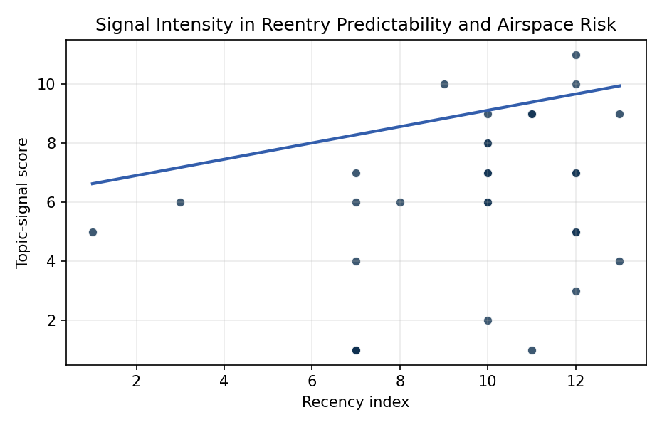
Figure 1. Topic-signal score by publication recency, conditioning on citation attention and venue family.

Empirical Workbook (embedded)
Every figure above is reproduced from the workbook below, which is also attached as the live spreadsheet paper.xlsx. Each observation carries its source.

Data (real observations)
doc_id | year_num | recency_index | cites_num | venue_score | title_words | snippet_words | keyword_count | theme_hits | signal_score | source
1 | 2024 | 11 | 0 | 1 | 18 | 14 | 2 | 3 | 9 | 10.64861/RCFO1556
2 | 2023 | 10 | 0 | 1 | 5 | 14 | 4 | 3 | 9 | 10.64861/UCTN1793
3 | 2023 | 10 | 0 | 1 | 12 | 14 | 5 | 2 | 8 | 10.64861/DZFF7826
4 | 2023 | 10 | 0 | 1 | 9 | 14 | 6 | 2 | 7 | 10.64861/LWLF6390
5 | 2022 | 9 | 0 | 1 | 10 | 14 | 6 | 4 | 10 | https://amostech.space/year/2022/impact-of-space-weather-on-space-assets-and-satellite-launches/
6 | 2023 | 10 | 0 | 1 | 7 | 13 | 4 | 2 | 6 | 10.64861/DNKW1345
7 | 2014 | 1 | 0 | 1 | 14 | 14 | 2 | 2 | 5 | https://amostech.space/year/2014/evolution-and-implementation-of-the-nasa-robotic-conjunction-assessment-risk-analysis-concept-of-operations/
8 | 2023 | 10 | 0 | 1 | 15 | 14 | 11 | 3 | 8 | 10.64861/QYAX9070
9 | 2023 | 10 | 0 | 1 | 7 | 14 | 4 | 2 | 6 | 10.64861/IIRV1868
10 | 2020 | 7 | 0 | 1 | 7 | 14 | 5 | 2 | 7 | https://amostech.space/year/2020/a-constellation-of-sensors-optimized-for-maneuver-tracking/
11 | 2021 | 8 | 0 | 1 | 9 | 13 | 5 | 2 | 6 | https://amostech.space/year/2021/risk-maps-for-conjunction-potential-throughout-the-cislunar-domain/
12 | 2025 | 12 | 0 | 1 | 15 | 14 | 3 | 3 | 7 | 10.64861/QXJB5158
13 | 2024 | 11 | 15 | 2 | 8 | 14 | 7 | 3 | 9 | 10.1016/j.actaastro.2024.05.026
14 | 2026 | 13 | 0 | 2 | 24 | 14 | 12 | 3 | 9 | 10.1016/j.actaastro.2026.01.049
15 | 2025 | 12 | 11 | 2 | 9 | 14 | 15 | 3 | 7 | 10.1016/j.actaastro.2025.01.042
16 | 2025 | 12 | 4 | 2 | 5 | 14 | 9 | 1 | 3 | 10.1016/j.actaastro.2025.01.031
17 | 2016 | 3 | 42 | 2 | 9 | 14 | 15 | 2 | 6 | 10.1016/j.actaastro.2016.04.015
18 | 2024 | 11 | 12 | 2 | 15 | 14 | 9 | 0 | 1 | 10.1016/j.actaastro.2024.09.063
19 | 2025 | 12 | 4 | 2 | 5 | 14 | 8 | 2 | 5 | 10.1016/j.actaastro.2025.01.043
20 | 2025 | 12 | 1 | 2 | 16 | 14 | 15 | 4 | 11 | 10.1016/j.actaastro.2025.01.068
21 | 2026 | 13 | 1 | 2 | 11 | 14 | 15 | 2 | 4 | 10.1016/j.actaastro.2026.03.003
22 | 2023 | 10 | 4 | 2 | 13 | 11 | 8 | 3 | 7 | 10.1016/j.actaastro.2023.11.020
23 | 2025 | 12 | 0 | 2 | 11 | 13 | 12 | 2 | 5 | 10.1016/j.actaastro.2025.01.037
24 | 2023 | 10 | 14 | 2 | 8 | 9 | 15 | 1 | 2 | 10.1016/j.actaastro.2023.04.040
25 | 2025 | 12 | 0 | 3 | 11 | 0 | 0 | 3 | 10 | EU SST Conjunction Data Messages, Reentry Predictions, and Fragmentation Event Services
26 | 2020 | 7 | 0 | 3 | 7 | 0 | 0 | 1 | 4 | EU SST Conjunction, Reentry, and Fragmentation Services
27 | 2020 | 7 | 0 | 3 | 4 | 0 | 0 | 0 | 1 | Stilwell IAC 2024 Orbital Capacity
28 | 2020 | 7 | 0 | 3 | 6 | 0 | 0 | 0 | 1 | Stilwell et al ASCEND 2025 Orbital Classification
29 | 2020 | 7 | 0 | 3 | 4 | 0 | 0 | 0 | 1 | IRD Project Research Designs V2.0
30 | 2020 | 7 | 0 | 3 | 41 | 0 | 0 | 2 | 6 | Stilwell et al. (ASCEND 2025) propose a policy-based orbital classification framework for LEO that draws on aviation airspace classification to establish performance-based entry requirements tied to congestion and collision risk, supported by econometric analysis of satellite-dependent Fortune 500/100 company financial impacts.

Variable construction
Variable | Definition | Construction / source
signal_score | Composite topic-signal score for each retrieved source record | Deterministic count built from candidate-theme term hits in the source title, snippet, keyword field, and author metadata; each row cites the retrieved source in the source column
recency_index | Publication recency index | Computed as publication year minus the minimum publication year in the paper sample plus one
cites_num | Reported citation count in the local brain index | Parsed from the local brain search cites field; zero when the index reported no citation count
venue_score | Ordinal venue-family score | AMOS = 1, Acta Astronautica = 2, Space Economy = 3

Estimator output
Term | Coef. | Std. err. | t | p | 95% CI
const | 6.3546 | 1.7187 | 3.6973 | 0.0002179 | [2.986, 9.7232]
recency_index | 0.276 | 0.1501 | 1.8387 | 0.066 | [-0.0182, 0.5702]
cites_num | 0.0071 | 0.0565 | 0.1262 | 0.8996 | [-0.1036, 0.1178]
venue_score | -1.6729 | 0.631 | -2.6513 | 0.008 | [-2.9097, -0.4362]
Fit: N = 30 R2 = 0.2771 R2_adj = 0.1937 F = 4.8828 F_p = 0.008

