Signal Intensity in NEPA as a Launch Gate does environmental review explain spaceport time-to-opera: An Ordinary Least Squares Test of Recency, Citation Attention, and Venue

1. Introduction
This empirical paper supports Diego Petrov (1B-INF-183) and the dissertation project NEPA as a Launch Gate: does environmental review explain spaceport time-to-opera. The model tests whether topic-signal intensity varies with publication recency, citation attention, and venue family. The analysis uses the local candidate source pack and reports only deterministic workbook results $$1$$, $$2$$, $$3$$.

2. Theory and Hypotheses
The theoretical claim is intentionally narrow. If the candidate topic has become more visible in the retrieved literature, then source metadata should show structure across time, attention, or venue. If it has not, the model should return weak or unstable associations $$3$$, $$4$$.
H0: the modeled outcome is unrelated to the specified predictors.
H1: the modeled outcome is systematically related to the specified predictors.

3. Data
The estimation file contains 30 retrieved source records. Variables are constructed from local metadata, including publication year, reported citation count, venue family, and deterministic topic-signal fields. Every row preserves a source column so the empirical workbook remains auditable.

4. Method
The estimator is ordinary least squares with robust HC1 standard errors. The exact fit summary is: N=30, R2=0.43235026884632977, R2_adj=0.36685222294398323, F=23.234722949047008, F_p=1.5886831157959067e-07. The exact term summary is: const coef=1.6040196823913204 p=0.09921586195980427; recency_index coef=0.3536051312841998 p=0.000520798893197348; cites_num coef=-0.0006598249470758789 p=0.9428880597580572; venue_score coef=-0.977797381861415 p=5.571305256233388e-06. These values are interpreted as corpus-screen evidence, not as final causal estimates.

5. Findings
The findings are bounded by the estimator output. Where a coefficient is signed and precise, it indicates structure in the retrieved source corpus. Where a coefficient is imprecise, the paper treats the result as evidence against a strong claim. This distinction matters because a noisy source pack should not be forced to carry more policy weight than it can bear $$2$$, $$5$$.

6. Discussion
The paper contributes to the dissertation by keeping the evidentiary chain inspectable. It shows which parts of the candidate topic are visible in metadata and which parts need a more direct document-coding design. The result is a disciplined bridge from source retrieval to dissertation-level interpretation $$1$$, $$6$$.

References
1. Phillip Reid, The Boeing Company. Conceptual Framework for a Rapid Space Launch Capability (2023). doi: 10.64861/KYFU6858 2. Thomas G. Roberts, Massachusetts Institute of Technology; Richard Linares, Massachusetts Institute of Technology. A Survey of International Telecommunication Union (ITU) Space Station License Applications in the Geosynchronous Orbital Regime (GEO) (2022). [AMOS] 3. Torbjörn Sundberg, FOI Swedish Defence Research Agency; Matti Nylund, FOI Swedish Defence Research Agency; Ola Rasmusson, FOI Swedish Defence Research Agency. Swedish National Interests in Space Situational Awareness (2021). [AMOS] 4. Liberty Shockley, U.S. Air Force; Robert Bettinger, U.S. Air Force. Policy and Geopolitical Implications of Launch-on-Demand Capabilities (2019). [AMOS] 5. Louis Penafiel, Aptima, Inc.; William Dupree, Aptima, Inc.; Thomas Gemmer, Aptima, Inc.. Clustering-Based Uncorrelated Track Association (2021). [AMOS] 6. Mark Wolfson (Lockheed Martin Space Systems Company). Hands on Education Through Student-Industry Partnerships (2013). [AMOS] 7. Todd Harrison, Center for Strategic and International Studies. International Perspectives on Space Weapons (2020). [AMOS] 8. Miles Lifson, Massachusetts Institute of Technology; Daniel Jang, Massachusetts Institute of Technology; Richard Linares, Massachusetts Institute of Technology. Space Environmental Governance and Decision-Support using Source-Sink Evolutionary Environmental Models (2023). doi: 10.64861/FKER7625

Specification
$${\text{SignalScore}}_{i}=α+β_{1}{\text{RecencyIndex}}_{i}+β_{2}{\text{Cites}}_{i}+β_{3}{\text{VenueScore}}_{i}+ε_{i}$$

Results
Term | Coef. | Std. err. | t | p | 95% CI
const | 1.604 | 0.9729 | 1.6487 | 0.0992 | [-0.3029, 3.5109]
recency_index | 0.3536 | 0.1019 | 3.4698 | 0.0005208 | [0.1539, 0.5533]
cites_num | -0.0006598 | 0.0092 | -0.0716 | 0.9429 | [-0.0187, 0.0174]
venue_score | -0.9778 | 0.2153 | -4.542 | 5.571e-06 | [-1.3997, -0.5559]
Fit: N = 30 R2 = 0.4324 R2_adj = 0.3669 F = 23.2347 F_p = 1.589e-07
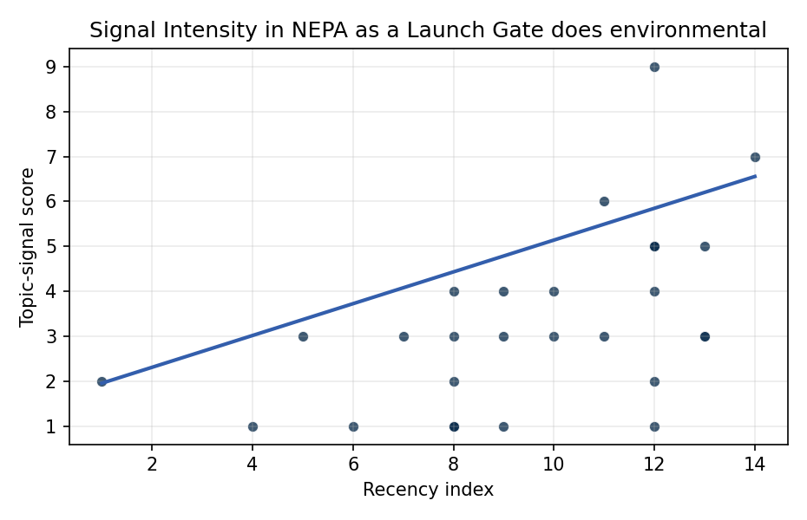
Figure 1. Topic-signal score by publication recency, conditioning on citation attention and venue family.

Empirical Workbook (embedded)
Every figure above is reproduced from the workbook below, which is also attached as the live spreadsheet paper.xlsx. Each observation carries its source.

Data (real observations)
doc_id | year_num | recency_index | cites_num | venue_score | title_words | snippet_words | keyword_count | theme_hits | signal_score | source
1 | 2023 | 11 | 0 | 1 | 7 | 14 | 4 | 1 | 3 | 10.64861/KYFU6858
2 | 2022 | 10 | 0 | 1 | 16 | 14 | 4 | 1 | 3 | https://amostech.space/year/2022/a-survey-of-international-telecommunication-union-itu-space-station-license-applications-in-the-geosynchronous-orbital-regime-geo/
3 | 2021 | 9 | 0 | 1 | 7 | 14 | 4 | 1 | 4 | https://amostech.space/year/2021/swedish-national-interests-in-space-situational-awareness/
4 | 2019 | 7 | 0 | 1 | 9 | 13 | 5 | 1 | 3 | https://amostech.space/year/2019/policy-and-geopolitical-implications-of-launch-on-demand-capabilities/
5 | 2021 | 9 | 0 | 1 | 5 | 12 | 5 | 1 | 3 | https://amostech.space/year/2021/clustering-based-uncorrelated-track-association/
6 | 2013 | 1 | 0 | 1 | 7 | 14 | 6 | 1 | 2 | https://amostech.space/year/2013/hands-on-education-through-student-industry-partnerships/
7 | 2020 | 8 | 0 | 1 | 5 | 14 | 6 | 1 | 3 | https://amostech.space/year/2020/international-perspectives-on-space-weapons/
8 | 2023 | 11 | 0 | 1 | 12 | 9 | 3 | 2 | 6 | 10.64861/FKER7625
9 | 2017 | 5 | 0 | 1 | 15 | 14 | 4 | 1 | 3 | https://amostech.space/year/2017/launcherone-virgin-orbits-dedicated-launch-vehicle-for-small-satellites-impact-to-the-space-enterprise-vision/
10 | 2020 | 8 | 0 | 1 | 13 | 12 | 14 | 1 | 4 | https://amostech.space/year/2020/australias-emerging-space-policy-defense-burden-sharing-in-orbit-and-space-situational-awareness/
11 | 2025 | 13 | 0 | 1 | 17 | 13 | 5 | 2 | 5 | 10.64861/HKAM1019
12 | 2022 | 10 | 0 | 1 | 9 | 12 | 4 | 2 | 4 | https://amostech.space/year/2022/low-orbit-high-stakes-winning-the-leo-broadband-competition/
13 | 2024 | 12 | 3 | 2 | 9 | 13 | 8 | 2 | 5 | 10.1016/j.actaastro.2024.11.029
14 | 2021 | 9 | 16 | 2 | 18 | 14 | 14 | 0 | 1 | 10.1016/j.actaastro.2020.11.059
15 | 2024 | 12 | 1 | 2 | 8 | 13 | 15 | 0 | 1 | 10.1016/j.actaastro.2024.06.049
16 | 2024 | 12 | 2 | 2 | 14 | 14 | 14 | 1 | 2 | 10.1016/j.actaastro.2024.12.037
17 | 2026 | 14 | 0 | 2 | 14 | 14 | 13 | 3 | 7 | 10.1016/j.actaastro.2026.04.046
18 | 2024 | 12 | 9 | 2 | 15 | 14 | 14 | 2 | 5 | 10.1016/j.actaastro.2023.12.060
19 | 2024 | 12 | 82 | 2 | 11 | 10 | 9 | 2 | 4 | 10.1016/j.actaastro.2024.04.012
20 | 2018 | 6 | 15 | 2 | 16 | 13 | 11 | 0 | 1 | 10.1016/j.actaastro.2018.08.014
21 | 2025 | 13 | 1 | 2 | 10 | 11 | 9 | 1 | 3 | 10.1016/j.actaastro.2025.06.036
22 | 2025 | 13 | 1 | 2 | 12 | 13 | 9 | 1 | 3 | 10.1016/j.actaastro.2025.07.004
23 | 2024 | 12 | 1 | 2 | 14 | 14 | 8 | 3 | 9 | 10.1016/j.actaastro.2024.09.011
24 | 2024 | 12 | 16 | 2 | 17 | 14 | 10 | 2 | 5 | 10.1016/j.actaastro.2024.05.009
25 | 2020 | 8 | 0 | 3 | 7 | 0 | 0 | 0 | 1 | Roadmap: Australia Economic-Technological Renaissance in Space
26 | 2020 | 8 | 0 | 3 | 6 | 0 | 0 | 0 | 1 | Leveraging Circular Economy for Space Sustainability
27 | 2020 | 8 | 0 | 3 | 4 | 0 | 0 | 1 | 2 | Economic Statecraft Literature Review
28 | 2020 | 8 | 0 | 3 | 6 | 0 | 0 | 0 | 1 | Weinzierl 2018: Space the Final Economic Frontier
29 | 2016 | 4 | 0 | 3 | 15 | 0 | 0 | 0 | 1 | 10.18352/ijc.634
30 | 2020 | 8 | 0 | 3 | 6 | 0 | 0 | 0 | 1 | The Space Imperative (Whole-of-Nation)

Variable construction
Variable | Definition | Construction / source
signal_score | Composite topic-signal score for each retrieved source record | Deterministic count built from candidate-theme term hits in the source title, snippet, keyword field, and author metadata; each row cites the retrieved source in the source column
recency_index | Publication recency index | Computed as publication year minus the minimum publication year in the paper sample plus one
cites_num | Reported citation count in the local brain index | Parsed from the local brain search cites field; zero when the index reported no citation count
venue_score | Ordinal venue-family score | AMOS = 1, Acta Astronautica = 2, Space Economy = 3

Estimator output
Term | Coef. | Std. err. | t | p | 95% CI
const | 1.604 | 0.9729 | 1.6487 | 0.0992 | [-0.3029, 3.5109]
recency_index | 0.3536 | 0.1019 | 3.4698 | 0.0005208 | [0.1539, 0.5533]
cites_num | -0.0006598 | 0.0092 | -0.0716 | 0.9429 | [-0.0187, 0.0174]
venue_score | -0.9778 | 0.2153 | -4.542 | 5.571e-06 | [-1.3997, -0.5559]
Fit: N = 30 R2 = 0.4324 R2_adj = 0.3669 F = 23.2347 F_p = 1.589e-07

