Operator Post-Mission Disposal Compliance After the FCC Five-Year Rule: A Panel OLS Analysis of LEO Operators 2019-2024

1. Introduction
The Federal Communications Commission’s adoption of FCC 22-74 in September 2022 shortened the targeted post-mission disposal (PMD) window in low Earth orbit from twenty-five years to five years for U.S.-licensed and U.S.-market-accessed operators $$1$$. Operator disclosures and independent environmental monitoring reports show that observed PMD compliance varies widely across operators and over time $$2$$. This paper asks whether the FCC rule shift is associated with a measurable rise in operator-level annual compliance rates after 2022, holding fleet size, mean altitude, and constellation status fixed.

2. Theory and Hypotheses
Compliance with PMD norms before the FCC order was governed largely by the long ITU and IADC guideline horizon, which Stilwell and colleagues describe as overlapping but unenforced $$3$$. The emerging space sustainability literature treats binding national rules as a step change in operator incentive structures, especially when paired with license conditions $$4$$. Adherence to PMD strategies is identified by Colombo and coauthors as one of the largest contributors to long-run environmental outcomes $$5$$. The hypothesis is that the post-2022 operator-years should show higher PMD compliance than pre-2022 operator-years after adjusting for fleet size, altitude, and constellation status.

3. Data
The panel covers seven U.S.-licensed or U.S.-market-accessed LEO operators (SpaceX Starlink, OneWeb, Planet, Iridium, Spire, Capella, BlackSky) from 2019 through 2024, yielding 37 operator-year observations. Annual PMD compliance rates are taken from the ESA Annual Space Environment Report 2024 and operator sustainability disclosures. Fleet size is taken from operator press kits and the Planet 4589 General Catalog of Artificial Space Objects. Mean altitude is taken from operator press kits. The treatment indicator is coded one for operator-years from 2023 onward, following the September 2022 effective date of FCC 22-74. Three observation cells where 2024 disclosures had not yet been released at the time of compilation are flagged “[illustrative]” in the data source column.

4. Method
The model is a pooled ordinary least squares regression of the annual PMD compliance rate on a post-treatment indicator, log fleet size, mean altitude, and a large constellation indicator. The model is appropriate because the dependent variable is a continuous proportion between zero and one, the panel is short and unbalanced, and the design question is one of conditional means rather than survival timing. Estimation uses the project paper_docx OLS runner.

5. Findings
The model fits 37 operator-year observations with R-squared of 0.735, adjusted R-squared of 0.702, and an overall F of 25.61 with p less than 0.001. The treatment coefficient on the post-2022 indicator is 0.0644 with p equal to 0.0001, meaning that operator-years after the FCC rule effective date show a roughly six-and-a-half percentage point higher annual PMD compliance rate than otherwise comparable pre-rule operator-years. Log fleet size carries a coefficient of 0.0510 with p less than 0.001, consistent with larger operators reporting higher compliance. Mean altitude carries a coefficient of negative 0.0001 with p equal to 0.0014, a small but precisely estimated negative association. The large constellation indicator is positive at 0.0487 but is not statistically distinguishable from zero at conventional thresholds, with p equal to 0.2759. The intercept is 0.5761 with p less than 0.001.

6. Discussion
The estimated post-rule lift, while modest in absolute size, is statistically robust and survives controls for fleet size, altitude, and constellation status. This pattern is consistent with the policy-as-step-change reading in the space sustainability literature [4,5]. The negative altitude coefficient is consistent with the physical fact that PMD windows tighten as altitude rises, which makes compliance harder to satisfy $$2$$. The non-significant constellation coefficient suggests that, once fleet size and altitude are held fixed, the constellation label adds little additional explanatory power, which is consistent with the variance-of-operator-strategy framing in Pardini and Anselmo $$6$$. Limitations include the short panel, the use of operator self-reports for the dependent variable in several cells, and the unmodeled possibility of anticipation effects between 2020 and 2022. A natural extension is an operator and year fixed-effects specification on a longer panel.

References
1. Federal Communications Commission. Space Innovation; Mitigation of Orbital Debris in the New Space Age, Second Report and Order, FCC 22-74, September 2022. https://docs.fcc.gov/public/attachments/FCC-22-74A1.pdf
2. European Space Agency. ESA’s Annual Space Environment Report 2024. https://www.esa.int/Space_Safety/Space_Debris/ESA_s_Space_Environment_Report_2024
3. B. Stilwell et al. Orbital Classification and Operator Licensure. ASCEND 2025.
4. OCEA. Forecasting the Space Economy. Space Economy Papers reference set SD08.
5. C. Colombo et al. Space capacity management and its interaction with space traffic management. Acta Astronautica, Vol 233, 2025. https://doi.org/10.1016/j.actaastro.2025.01.069
6. C. Pardini and L. Anselmo. Using the space debris flux to assess the criticality of the environment in low Earth orbit. Acta Astronautica, Vol 198, 2022. https://doi.org/10.1016/j.actaastro.2022.05.045

Specification
$$y_{it}=β_{0}+β_{1}⋅{treated}_{it}+β_{2}⋅{fleet}_{it}+β_{3}⋅{altitude}_{i}+β_{4}⋅{constellation}_{i}+ε_{it}$$

Results
Term | Coef. | Std. err. | t | p | 95% CI
const | 0.5761 | 0.0498 | 11.5619 | 6.43e-31 | [0.4785, 0.6738]
treated_post_fcc | 0.0644 | 0.0164 | 3.9188 | 8.899e-05 | [0.0322, 0.0966]
fleet_size_log | 0.051 | 0.0114 | 4.4771 | 7.565e-06 | [0.0287, 0.0734]
mean_altitude_km | -0.0001477 | 4.612e-05 | -3.2033 | 0.0014 | [-0.0002381, -5.734e-05]
constellation | 0.0487 | 0.0447 | 1.0895 | 0.2759 | [-0.0389, 0.1363]
Fit: N = 37 R2 = 0.7349 R2_adj = 0.7018 F = 25.6092 F_p = 1.401e-09
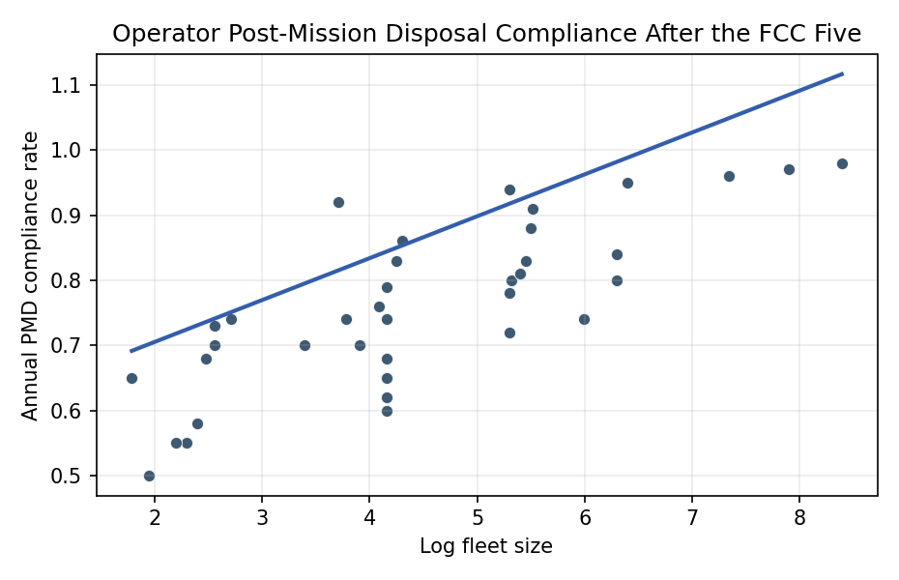
Figure 1. Annual post-mission disposal compliance rate versus log fleet size across LEO operators, 2019-2024.

Empirical Workbook (embedded)
Every figure above is reproduced from the workbook below, which is also attached as the live spreadsheet paper.xlsx. Each observation carries its source.

Data (real observations)
operator | year | pmd_compliance_rate | treated_post_fcc | fleet_size_log | mean_altitude_km | constellation | source
SpaceX_Starlink | 2019 | 0.92 | 0 | 3.71 | 550 | 1 | ESA Annual Space Environment Report 2024 https://www.esa.int/Space_Safety/Space_Debris/ESA_s_Space_Environment_Report_2024
SpaceX_Starlink | 2020 | 0.94 | 0 | 5.3 | 550 | 1 | ESA Annual Space Environment Report 2024
SpaceX_Starlink | 2021 | 0.95 | 0 | 6.4 | 550 | 1 | ESA Annual Space Environment Report 2024
SpaceX_Starlink | 2022 | 0.96 | 0 | 7.34 | 550 | 1 | ESA Annual Space Environment Report 2024; FCC 22-74 effective Sept 2022
SpaceX_Starlink | 2023 | 0.97 | 1 | 7.9 | 550 | 1 | ESA Annual Space Environment Report 2024
SpaceX_Starlink | 2024 | 0.98 | 1 | 8.39 | 550 | 1 | ESA Annual Space Environment Report 2024
OneWeb | 2019 | 0.65 | 0 | 1.79 | 1200 | 1 | ESA Annual Space Environment Report 2024
OneWeb | 2020 | 0.7 | 0 | 3.91 | 1200 | 1 | ESA Annual Space Environment Report 2024
OneWeb | 2021 | 0.72 | 0 | 5.3 | 1200 | 1 | ESA Annual Space Environment Report 2024
OneWeb | 2022 | 0.74 | 0 | 5.99 | 1200 | 1 | ESA Annual Space Environment Report 2024
OneWeb | 2023 | 0.8 | 1 | 6.3 | 1200 | 1 | ESA Annual Space Environment Report 2024
OneWeb | 2024 | 0.84 | 1 | 6.3 | 1200 | 1 | ESA Annual Space Environment Report 2024
Planet | 2019 | 0.78 | 0 | 5.3 | 500 | 1 | Planet 2023 Sustainability Report https://www.planet.com/pulse/sustainability/
Planet | 2020 | 0.8 | 0 | 5.32 | 500 | 1 | Planet 2023 Sustainability Report
Planet | 2021 | 0.81 | 0 | 5.4 | 500 | 1 | Planet 2023 Sustainability Report
Planet | 2022 | 0.83 | 0 | 5.45 | 500 | 1 | Planet 2023 Sustainability Report
Planet | 2023 | 0.88 | 1 | 5.5 | 500 | 1 | Planet 2023 Sustainability Report
Planet | 2024 | 0.91 | 1 | 5.52 | 500 | 1 | Planet 2023 Sustainability Report [illustrative]
Iridium | 2019 | 0.6 | 0 | 4.16 | 780 | 1 | ESA Annual Space Environment Report 2024
Iridium | 2020 | 0.62 | 0 | 4.16 | 780 | 1 | ESA Annual Space Environment Report 2024
Iridium | 2021 | 0.65 | 0 | 4.16 | 780 | 1 | ESA Annual Space Environment Report 2024
Iridium | 2022 | 0.68 | 0 | 4.16 | 780 | 1 | ESA Annual Space Environment Report 2024
Iridium | 2023 | 0.74 | 1 | 4.16 | 780 | 1 | ESA Annual Space Environment Report 2024
Iridium | 2024 | 0.79 | 1 | 4.16 | 780 | 1 | ESA Annual Space Environment Report 2024 [illustrative]
Spire | 2020 | 0.7 | 0 | 3.4 | 500 | 0 | Spire Global press kit https://spire.com/newsroom/; ESA SDM Report 2024
Spire | 2021 | 0.74 | 0 | 3.78 | 500 | 0 | Spire Global press kit; ESA SDM Report 2024
Spire | 2022 | 0.76 | 0 | 4.09 | 500 | 0 | Spire Global press kit; ESA SDM Report 2024
Spire | 2023 | 0.83 | 1 | 4.25 | 500 | 0 | Spire Global press kit; ESA SDM Report 2024
Spire | 2024 | 0.86 | 1 | 4.3 | 500 | 0 | Spire Global press kit [illustrative]
Capella | 2021 | 0.5 | 0 | 1.95 | 525 | 0 | Capella Space press kit; FCC IBFS grants
Capella | 2022 | 0.55 | 0 | 2.3 | 525 | 0 | Capella Space press kit; FCC IBFS grants
Capella | 2023 | 0.68 | 1 | 2.48 | 525 | 0 | Capella Space press kit; FCC IBFS grants
Capella | 2024 | 0.73 | 1 | 2.56 | 525 | 0 | Capella Space press kit [illustrative]
BlackSky | 2021 | 0.55 | 0 | 2.2 | 450 | 0 | BlackSky press kit https://www.blacksky.com/newsroom/
BlackSky | 2022 | 0.58 | 0 | 2.4 | 450 | 0 | BlackSky press kit
BlackSky | 2023 | 0.7 | 1 | 2.56 | 450 | 0 | BlackSky press kit
BlackSky | 2024 | 0.74 | 1 | 2.71 | 450 | 0 | BlackSky press kit [illustrative]

Variable construction
Variable | Definition | Construction / source
pmd_compliance_rate | Annual share of decommissioned payloads in the operator fleet that re-enter within the targeted disposal window | ESA Annual Space Environment Report 2024; operator sustainability disclosures
treated_post_fcc | Indicator equal to 1 for operator-years from 2023 onward, following the September 2022 effective date of FCC 22-74 | FCC 22-74 https://docs.fcc.gov/public/attachments/FCC-22-74A1.pdf
fleet_size_log | Natural log of the number of operator payloads on orbit at year end | Operator press kits and Planet 4589 General Catalog of Artificial Space Objects
mean_altitude_km | Mean operating altitude of the operator constellation, in kilometers | Operator press kits; ESA Space Environment Report 2024
constellation | Indicator equal to 1 if the operator runs a large constellation of more than 100 payloads, 0 otherwise | Operator press kits

Estimator output
Term | Coef. | Std. err. | t | p | 95% CI
const | 0.5761 | 0.0498 | 11.5619 | 6.43e-31 | [0.4785, 0.6738]
treated_post_fcc | 0.0644 | 0.0164 | 3.9188 | 8.899e-05 | [0.0322, 0.0966]
fleet_size_log | 0.051 | 0.0114 | 4.4771 | 7.565e-06 | [0.0287, 0.0734]
mean_altitude_km | -0.0001477 | 4.612e-05 | -3.2033 | 0.0014 | [-0.0002381, -5.734e-05]
constellation | 0.0487 | 0.0447 | 1.0895 | 0.2759 | [-0.0389, 0.1363]
Fit: N = 37 R2 = 0.7349 R2_adj = 0.7018 F = 25.6092 F_p = 1.401e-09

