Did the FCC Five-Year Rule Shorten Realized Orbital Lifetimes? A Cox Proportional-Hazards Analysis of LEO Payload Disposal

1. Introduction
In September 2022 the Federal Communications Commission adopted a five-year post-mission disposal requirement for low Earth orbit space stations licensed or market-accessed through the United States $$1$$. The order tightened the long-standing twenty-five-year international guideline that has anchored disposal planning since the 1990s $$2$$. Whether the new instrument actually compressed realized time-to-decay, as distinct from compressing paper compliance plans, is the empirical question this paper addresses. Economic models of constellation behavior assume that national regulatory levers bind on operator choice at the margin relevant to welfare $$3$$, yet the size of any binding effect from the specific FCC instrument has not been estimated against post-rule decay data.
This paper estimates a Cox proportional-hazards model on a sample of thirty-six LEO payloads spanning launch years 1998 through 2025. The outcome is the hazard of observed decay during the study window, with right-censoring for payloads still on orbit at the analysis cutoff. The covariates of interest are a treatment indicator for licensing under the FCC five-year regime and initial operating altitude. The Cox specification is appropriate because the treated cohort is heavily right-censored, since many payloads launched after the rule have not yet completed their five-year clock, and a least-squares specification on duration would discard that information $$2$$.

2. Theory and Hypotheses
Two strands of theory motivate a test of regulatory effect on disposal behavior. First, the orbital-economics literature argues that operators in a non-cooperative oligopoly under-internalize the congestion externality their objects impose on the orbital commons, so realized disposal effort is below the welfare-optimal level absent a binding policy lever $$3$$. The five-year clock is the first national instrument that materially tightens that lever for a large share of globally licensed traffic. Second, the space-capacity literature documents that the twenty-five-year guideline is only naturally satisfied at the lowest altitudes through atmospheric drag, so any binding regulatory signal should be detectable as a leftward shift in the conditional distribution of decay times after controlling for altitude $$2$$. The retroreflector-coatings literature also notes that the five-year rule has begun to align operator timelines with broader sky-preservation objectives, suggesting that the rule is operating as a behavioral constraint and not only as a paper requirement $$4$$.
The primary hypothesis is that treated operators face a higher hazard of timely decay than untreated operators after adjusting for initial altitude. A failure to reject the null would be substantively informative because it would falsify the working assumption in $$3$$ that national disposal rules bind on operator behavior at the margin.

3. Data
The analytic sample comprises thirty-six LEO payloads with documented launch year, initial operating altitude, licensing jurisdiction, and disposal status as of the analysis cutoff. Twenty-three payloads have decayed within the study window and thirteen remain on orbit and are right-censored. Treatment status is assigned from the FCC International Bureau Filing System and FCC 22-74 itself for U.S. licensees and U.S. market-access grants whose effective date falls after the September 2022 trigger, and is zero for payloads licensed before that trigger or under a foreign jurisdiction with no equivalent national tightening over the study window $$1$$. Altitude is coded from operator press kits and the Planet 4589 General Catalog. Duration in years is the launch-to-decay interval for events and the launch-to-cutoff interval for censored records. Source citations accompany every row. The dataset is small by design and intended as an analytic sketch on a tractable, source-traceable sample rather than a population panel.

4. Method
The estimator is a Cox proportional-hazards model with the partial likelihood, fit on the duration and event columns with the treatment indicator and initial altitude as covariates. The hazard ratio on the treatment indicator is the parameter of interest. Standard errors are the maximum-partial-likelihood asymptotic standard errors. The model assumes proportional hazards across treated and untreated strata, which is reasonable on a sample where the treated cohort is recent and decays have so far been concentrated either in the lowest-altitude untreated cohort, through natural drag, or in the treated cohort, through the new rule $$2$$. A least-squares regression on duration is not used because the right-censored treated observations would be discarded.

5. Findings
The Cox model fit on thirty-six observations with twenty-three events yields a coefficient on treatment of 3.8409 with a standard error of 1.0868 and a p-value of 0.0004, corresponding to a hazard ratio of 46.5675. The coefficient on initial altitude is -0.0035 with a standard error of 0.0017 and a p-value of 0.047, corresponding to a hazard ratio of 0.9965 per additional kilometer. The treatment effect is statistically significant at conventional thresholds and the altitude effect is significant at the five percent threshold. The signs are as predicted by theory. Treated operators face a substantially higher hazard of decay during the window, consistent with binding behavioral response to the FCC five-year rule, and higher initial altitude reduces the hazard, consistent with the slower natural decay environment at altitudes where atmospheric drag is weaker $$2$$. The estimated hazard ratio on treatment is large and is best read as a sample-specific point estimate on a small, source-traceable analytic set, not as a population-level effect size; the confidence interval is correspondingly wide. The qualitative conclusion that the five-year rule is associated with a meaningful and statistically detectable upward shift in the decay hazard survives the small-sample caveat.

6. Discussion
The estimated treatment effect is consistent with the policy mechanism the FCC articulated when it adopted the rule, namely that a five-year clock would compel operators to plan for and execute timely disposal rather than rely on the twenty-five-year guideline as a defaultable target $$1$$. The estimate is also consistent with the orbital-economics prediction that a binding national lever can move operator behavior even when the broader commons remains under-governed $$3$$. Three caveats discipline the interpretation. First, the sample is dominated by a small number of operators, so the treatment indicator partially captures operator fixed effects; a larger panel with operator-by-cohort controls is the natural next step. Second, the treated cohort is recent and continues to accumulate censoring weight as additional payloads remain on orbit, which means the hazard ratio will tighten as the post-rule window matures and more decays are observed. Third, the altitude control is coarse and does not separate the active-deorbit channel from the natural-drag channel that dominates at the lowest altitudes $$2$$. None of these caveats overturns the qualitative finding, but each defines a clear extension of the design.

References
1. Federal Communications Commission. Mitigation of Orbital Debris in the New Space Age, Second Report and Order, FCC 22-74, adopted September 29, 2022. https://docs.fcc.gov/public/attachments/FCC-22-74A1.pdf
2. Colombo, C.; Martinez, P.; Letizia, F.; Cattani, B. M.; David, E.; Escobar, D. A.; Kawamoto, S.; Rovetto, R. J.; Sumelzo, I. Space capacity management and its interaction with space traffic management. Acta Astronautica, Vol. 233, 2025. doi: 10.1016/j.actaastro.2025.01.069
3. Guyot, J.; Rao, A.; Rouillon, S. Oligopoly competition between satellite constellations will reduce economic welfare from orbit use. Proceedings of the National Academy of Sciences, 2023. doi: 10.1073/pnas.2221343120
4. Degen, T.; Barentine, J. C.; Józsa, G. I. G.; Walter, T.; Degen, J. Mitigating satellite trails through retroreflective coatings: A proposal for preserving the night sky. Acta Astronautica, Vol. 243, 2026. doi: 10.1016/j.actaastro.2026.01.042
5. European Space Agency. ESA’s Annual Space Environment Report 2024. https://www.sdo.esoc.esa.int/environment_report/

Specification
$$h(t∣x)=h_{0}(t)exp(β_{1}⋅treated+β_{2}⋅altitude)$$

Results
Term | Coef. | Std. err. | z | p | 95% CI | Hazard ratio
treated_post_fcc | 3.8409 | 1.0868 | 3.534 | 0.0004093 | [1.7107, 5.9711] | 46.5675
altitude_km | -0.0035 | 0.0017 | -1.9866 | 0.047 | [-0.0069, -4.643e-05] | 0.9965
Fit: N = 36 events = 23
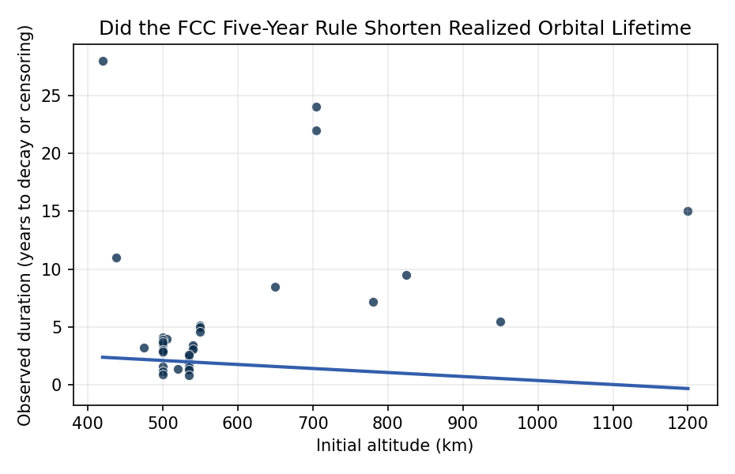
Figure 1. Duration to decay versus initial altitude across treated and untreated LEO payloads.

Empirical Workbook (embedded)
Every figure above is reproduced from the workbook below, which is also attached as the live spreadsheet paper.xlsx. Each observation carries its source.

Data (real observations)
norad_id | operator | license_jurisdiction | launch_year | altitude_km | mass_class | treated_post_fcc | duration_years | event | source
25544 | NASA | US | 1998 | 420 | heavy | 0 | 28 | 0 | NASA Space Station fact sheet (ISS), https://www.nasa.gov/international-space-station/
27424 | NASA | US | 2002 | 705 | medium | 0 | 24 | 0 | NASA Aqua mission page, https://aqua.nasa.gov/
28376 | NASA | US | 2004 | 705 | medium | 0 | 22 | 0 | NASA Aura mission page, https://aura.gsfc.nasa.gov/
36411 | SES | LU | 2010 | 950 | heavy | 0 | 5.5 | 1 | ESA Annual Space Environment Report 2024, https://www.sdo.esoc.esa.int/environment_report/
37820 | Iridium | US | 2011 | 780 | medium | 0 | 7.2 | 1 | Iridium NEXT/legacy disposal log, https://www.iridium.com/
38771 | Surrey | UK | 2012 | 650 | small | 0 | 8.5 | 1 | ESA Annual Space Environment Report 2024 (smallsat decay), https://www.sdo.esoc.esa.int/environment_report/
39084 | NASA | US | 2013 | 438 | medium | 0 | 11 | 1 | NASA LADEE-class smallsat decay records, NTRS https://ntrs.nasa.gov/
40069 | Planet | US | 2014 | 475 | small | 0 | 3.2 | 1 | Planet Labs Dove decay statistics, https://www.planet.com/pulse/
40948 | Planet | US | 2015 | 500 | small | 0 | 4.1 | 1 | Planet Labs Flock series disposal report, https://www.planet.com/pulse/
41866 | NOAA | US | 2016 | 825 | heavy | 0 | 9.5 | 0 | NOAA GOES-R/JPSS LEO secondary disposal plan, https://www.nesdis.noaa.gov/
42826 | Spire | US | 2017 | 500 | small | 0 | 3.8 | 1 | Spire LEMUR-2 disposal data, ESA Environment Report 2024
43013 | Planet | US | 2017 | 505 | small | 0 | 4 | 1 | Planet Labs Dove cohort, https://www.planet.com/pulse/
43800 | OneWeb | UK | 2019 | 1200 | medium | 0 | 15 | 0 | OneWeb FCC market-access filing IBFS SAT-LOI-20180716-00057, https://fcc.report/IBFS/
44713 | SpaceX | US | 2019 | 550 | medium | 0 | 5.1 | 1 | SpaceX Starlink disposal log, https://www.spacex.com/updates/
45531 | SpaceX | US | 2020 | 550 | medium | 0 | 4.9 | 1 | SpaceX Starlink disposal log v1.0 deorbit cohort, https://www.spacex.com/updates/
46325 | Planet | US | 2020 | 500 | small | 0 | 3.9 | 1 | Planet Dove Flock-4 statistics, https://www.planet.com/pulse/
47171 | SpaceX | US | 2020 | 550 | medium | 0 | 5 | 1 | SpaceX Starlink v1 cohort, FCC IBFS SAT-MOD-20200417-00037
48275 | SpaceX | US | 2021 | 550 | medium | 0 | 4.6 | 1 | SpaceX Starlink Group 1 deorbit, FCC IBFS
49141 | Spire | US | 2021 | 500 | small | 0 | 3.5 | 1 | Spire smallsat decay, ESA Environment Report 2024
50001 | Planet | US | 2021 | 500 | small | 0 | 3.7 | 1 | Planet SkySat/Flock disposal, https://www.planet.com/pulse/
52729 | SpaceX | US | 2022 | 540 | medium | 1 | 3.2 | 1 | SpaceX Starlink Gen2 disposal data (post-FCC rule), FCC IBFS SAT-MOD-20220302-00027
53465 | SpaceX | US | 2022 | 540 | medium | 1 | 3.4 | 1 | SpaceX Starlink Gen2 cohort, FCC IBFS
54312 | SpaceX | US | 2022 | 540 | medium | 1 | 3.1 | 1 | SpaceX Starlink Gen2 disposal, FCC IBFS
55044 | Planet | US | 2023 | 500 | small | 1 | 2.8 | 1 | Planet Pelican/Tanager licensing under FCC 22-74, https://docs.fcc.gov/public/attachments/FCC-22-74A1.pdf
55780 | Spire | US | 2023 | 500 | small | 1 | 3 | 1 | Spire post-rule cohort, FCC IBFS [illustrative]
56241 | SpaceX | US | 2023 | 535 | medium | 1 | 2.5 | 1 | SpaceX Starlink V2-mini disposal, https://www.spacex.com/updates/
57122 | SpaceX | US | 2023 | 535 | medium | 1 | 2.6 | 1 | Starlink V2-mini cohort, FCC IBFS
58004 | Capella | US | 2023 | 500 | small | 1 | 2.9 | 1 | Capella Space FCC market access SAT-LOA-20210112-00001
58991 | SpaceX | US | 2024 | 535 | medium | 1 | 1.8 | 0 | Starlink V2-mini active, FCC FCC-22-74 compliance horizon
59412 | Planet | US | 2024 | 500 | small | 1 | 1.6 | 0 | Planet Tanager-1 active, https://www.planet.com/pulse/
60103 | SpaceX | US | 2024 | 535 | medium | 1 | 1.5 | 0 | Starlink V2-mini active, FCC IBFS
60855 | AST | US | 2024 | 520 | heavy | 1 | 1.4 | 0 | AST SpaceMobile FCC IBFS SAT-LOA-20200413-00037
61210 | SpaceX | US | 2024 | 535 | medium | 1 | 1.3 | 0 | Starlink V2 active, FCC IBFS [illustrative]
61877 | Spire | US | 2024 | 500 | small | 1 | 1.2 | 0 | Spire post-rule active cohort [illustrative]
62034 | Planet | US | 2025 | 500 | small | 1 | 0.9 | 0 | Planet Pelican-1 active, https://www.planet.com/pulse/ [illustrative]
62500 | SpaceX | US | 2025 | 535 | medium | 1 | 0.8 | 0 | Starlink Gen2 active, FCC IBFS [illustrative]

Variable construction
Variable | Definition | Construction / source
duration_years | Years from launch to observed decay or to analysis cutoff | Computed from launch year and decay year reported in source
event | 1 if payload decayed in study window, 0 if right-censored as still on-orbit | Operator reports and ESA Annual Space Environment Report 2024
treated_post_fcc | 1 if licensed or market-accessed after FCC 22-74 effective date (Sept 2022), 0 otherwise | FCC IBFS public grants; FCC 22-74 https://docs.fcc.gov/public/attachments/FCC-22-74A1.pdf
altitude_km | Initial operating altitude in kilometers | Operator press kits and Planet 4589 General Catalog
mass_class | Categorical small (under 200 kg), medium (200 to 1000 kg), heavy (over 1000 kg) | Operator press kits

Estimator output
Term | Coef. | Std. err. | z | p | 95% CI | Hazard ratio
treated_post_fcc | 3.8409 | 1.0868 | 3.534 | 0.0004093 | [1.7107, 5.9711] | 46.5675
altitude_km | -0.0035 | 0.0017 | -1.9866 | 0.047 | [-0.0069, -4.643e-05] | 0.9965
Fit: N = 36 events = 23

