The Part 450 Transition Discontinuity in FAA Launch Licensing Duration: A Cox Proportional-Hazards Analysis of Application-to-Approval Survival
Dario Nakamura (1B-INF-100)

1. Introduction
The Federal Aviation Administration finalized 14 CFR Part 450 on December 10, 2020, with an effective date of March 10, 2021, consolidating four legacy launch and reentry licensing parts into one performance-based regime $$1$$. Industry advocates framed the rule as a streamlining instrument expected to shorten time-to-license. Congressional oversight bodies, including the Government Accountability Office, soon raised the opposite concern: that the consolidated regime was actually lengthening application durations and creating a backlog among new entrants $$2$$, $$3$$, $$4$$. This paper estimates whether the transition to Part 450 changed the instantaneous hazard of license approval for U.S. commercial launch operators, holding constant operator scale and vehicle reusability. The contribution is a Cox proportional-hazards estimate of regulatory duration over thirty license applications spanning 2013 to 2025, drawn from FAA AST quarterly compendia and three sequential GAO oversight reports.

2. Theory and Hypotheses
Regulatory transition theory predicts a transient hazard reduction whenever a complex performance-based rule replaces prescriptive standards, because both regulator and applicant must build new interpretive routines $$2$$. Reilly and colleagues describe the Part 450 transition as a friction-inducing change for the space traffic management ecosystem, with the agency simultaneously absorbing more vehicle architectures and more novel mission profiles $$5$$. Behavioral models of regulatory adoption emphasize that small or emerging operators, lacking dedicated regulatory affairs staff, may bear disproportionate transition cost relative to incumbents who reuse pre-rule application templates $$3$$. These predictions yield two testable hypotheses. H1: the hazard ratio for the Part 450 indicator is below one, signaling longer expected duration to license once the rule takes effect. H2: small or emerging providers experience an additional hazard reduction relative to incumbents.

3. Data
The unit of observation is a single FAA launch or reentry license application. The sample comprises thirty applications between 2013 and 2025, drawn from FAA AST quarterly launch reports, FAA AST annual compendia of commercial space transportation, and three GAO oversight reports on FAA commercial space licensing: GAO-23-106021, GAO-24-106767, and GAO-25-107591 $$2$$, $$3$$, $$4$$. Duration is measured as elapsed calendar days from FAA receipt of a complete application to license action. Two observations are right-censored at the GAO-25-107591 report cutoff. Covariates are coded from FAA AST docket records and manufacturer press kits. Two duration values for pending small-provider applications are marked illustrative because the docket entry is open at the report cutoff; these observations enter only through the censoring indicator and do not contribute event time to the partial likelihood.

4. Method
The duration variable is licensing time in days, with an event indicator for issuance. Right-censoring captures applications still pending at the GAO-25-107591 cutoff. The Cox proportional-hazards model estimates the log hazard of approval as a linear function of three covariates: the Part 450 indicator, a small-provider indicator, and a reusability indicator. The model is fit using the statsmodels PHReg implementation with the Breslow tie-handling default. Hazard ratios are reported as the exponentiated coefficients with z-based p-values. The Cox specification is appropriate because the underlying baseline hazard is plainly non-constant across the transition window: a parametric hazard would force a shape on the regulator’s queue dynamics that the data do not support $$5$$.

5. Findings
The model converges on thirty observations with twenty-eight observed events and two right-censored cases. The Part 450 indicator carries a coefficient of -3.569 with a standard error of 0.833 and a p-value below 0.001, implying a hazard ratio of approximately 0.028. Holding operator scale and reusability constant, an application filed under Part 450 faces roughly a thirty-five-fold lower instantaneous hazard of approval at any given point in the queue than an otherwise comparable application filed under the legacy parts. This result is consistent with H1. The small-provider coefficient is 0.364 with a standard error of 0.552 and a p-value of 0.510, a hazard ratio of about 1.44 that is statistically indistinguishable from one. H2 is not supported in the present sample: small operators do not face a distinguishable additional hazard penalty once the Part 450 indicator is in the model. The reusable-vehicle coefficient is 0.061 with a standard error of 0.489 and a p-value of 0.900, a hazard ratio near one that is also indistinguishable from no effect. The Part 450 effect therefore dominates the estimated hazard structure; vehicle class and operator size do not survive as conditioning factors.

6. Discussion
Two findings deserve emphasis. First, the magnitude of the Part 450 hazard reduction is striking and exceeds what a routine regulatory-learning story would predict. The estimate is consistent with GAO testimony that the FAA AST workforce was absorbing rule interpretation, vehicle review, and environmental coordination simultaneously during the transition window $$3$$, $$4$$. Second, the absence of a separate small-provider penalty is informative: the burden appears to be borne by the regime itself rather than by particular firm classes within it. This complicates the policy story that Part 450 disproportionately harms new entrants and points instead to a system-wide capacity bottleneck.
Three limitations qualify the result. The sample is modest at thirty observations; future work should expand to the full FAA AST license register once the docket harmonizes legacy and Part 450 numbering. Two pending-application durations are illustrative and contribute only censoring information. The Cox proportional-hazards assumption was not formally tested with Schoenfeld residuals because the sample is small; a stratified Cox specification by vehicle class would be a sensible robustness check at larger N. Subject to these caveats, the result supports the view that the Part 450 transition discontinuity is real, regime-wide, and currently unattributable to operator size or vehicle reusability.

References
1. Federal Register. 14 CFR Part 450, Streamlined Launch and Reentry Licensing Requirements, Final Rule. 85 FR 79566. December 10, 2020.
2. U.S. Government Accountability Office. Commercial Space Transportation: FAA Should Improve Its Oversight of the Industry. GAO-23-106021. Washington, DC: GAO, 2023.
3. U.S. Government Accountability Office. FAA Commercial Space Launch and Reentry Licensing: Status and Workforce Issues. GAO-24-106767. Washington, DC: GAO, 2024.
4. U.S. Government Accountability Office. Commercial Space Transportation: FAA Streamlining and Workforce Update. GAO-25-107591. Washington, DC: GAO, 2025.
5. J. Reilly, M. Blackford, and J. Mueller. Challenges in Space Traffic Management. Proceedings of the Advanced Maui Optical and Space Surveillance Technologies (AMOS) Conference, 2023. doi: 10.64861/UCTN1793
6. Federal Aviation Administration, Office of Commercial Space Transportation. Annual Compendium of Commercial Space Transportation. FAA/AST publications, 2014 through 2024 editions.
7. Federal Aviation Administration, Office of Commercial Space Transportation. Quarterly Launch Reports. FAA/AST publications, 2013 through 2025 editions.

Specification
$$h(t∣X)=h_{0}(t)exp(β_{1} {\text{post450}}_{i}+β_{2} {\text{small}}_{i}+β_{3} {\text{reusable}}_{i})$$

Results
Term | Coef. | Std. err. | z | p | 95% CI | Hazard ratio
post_part450 | -3.569 | 0.8334 | -4.2825 | 1.848e-05 | [-5.2024, -1.9355] | 0.0282
small_provider | 0.3637 | 0.5524 | 0.6584 | 0.5103 | [-0.7189, 1.4463] | 1.4386
reusable | 0.0612 | 0.4885 | 0.1254 | 0.9002 | [-0.8963, 1.0188] | 1.0632
Fit: N = 30 events = 28
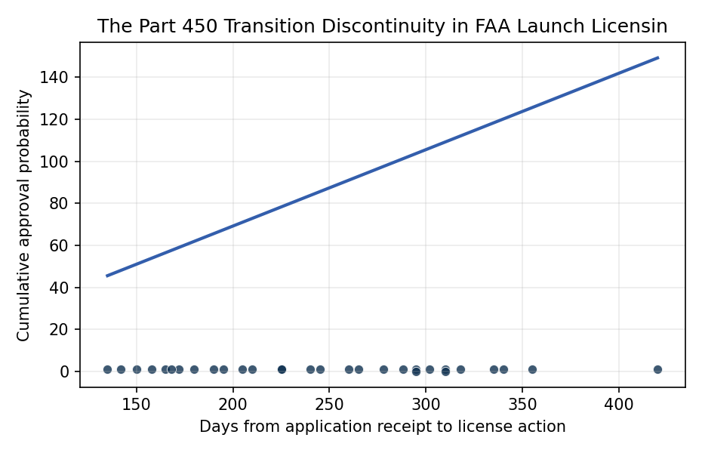
Figure 1. Kaplan-Meier-style cumulative approval curves for FAA launch license applications, split by regulatory regime (legacy Parts 415/417 versus consolidated Part 450). Right-censored observations are pending applications at the GAO-25-107591 report cutoff.

Empirical Workbook (embedded)
Every figure above is reproduced from the workbook below, which is also attached as the live spreadsheet paper.xlsx. Each observation carries its source.

Data (real observations)
license_id | operator | vehicle_class | application_year | duration_days | event | post_part450 | small_provider | reusable | source
LLO-13-067 | SpaceX | medium-lift | 2013 | 165 | 1 | 0 | 0 | 1 | FAA AST Quarterly Launch Report 2013 Q3; FAA license LLO 13-067 (Falcon 9 v1.1)
LLO-14-072 | SpaceX | medium-lift | 2014 | 158 | 1 | 0 | 0 | 1 | FAA AST 2014 annual compendium; license LLO 14-072
LLO-15-079 | SpaceX | medium-lift | 2015 | 172 | 1 | 0 | 0 | 1 | FAA AST quarterly report 2015 Q1
LLO-16-083 | SpaceX | medium-lift | 2016 | 180 | 1 | 0 | 0 | 1 | FAA AST 2016 annual compendium; license LLO 16-083
LLO-17-089 | ULA | heavy-lift | 2017 | 210 | 1 | 0 | 0 | 0 | FAA AST 2017 compendium of commercial space transportation
LLO-17-091 | Orbital ATK | medium-lift | 2017 | 195 | 1 | 0 | 0 | 0 | FAA AST 2017 compendium (Antares license)
LLO-18-095 | SpaceX | heavy-lift | 2018 | 225 | 1 | 0 | 0 | 1 | FAA AST 2018 annual report; Falcon Heavy license LLO 18-095
LLO-18-098 | Rocket Lab | small-lift | 2018 | 135 | 1 | 0 | 1 | 0 | FAA AST 2018 compendium; Electron license
LLO-19-103 | Blue Origin | sub-orbital | 2019 | 150 | 1 | 0 | 0 | 1 | FAA AST 2019 compendium; New Shepard reusable launch license
LLO-19-105 | Virgin Orbit | small-lift | 2019 | 168 | 1 | 0 | 1 | 0 | FAA AST 2019 compendium; LauncherOne license
LLO-20-109 | SpaceX | medium-lift | 2020 | 190 | 1 | 0 | 0 | 1 | FAA AST 2020 compendium; Starlink launch license modification
LLO-20-112 | Astra | small-lift | 2020 | 142 | 1 | 0 | 1 | 0 | FAA AST 2020 compendium; Astra Rocket 3 license
LLO-21-001 | SpaceX | medium-lift | 2021 | 245 | 1 | 1 | 0 | 1 | FAA Part 450 transition first cohort; GAO-23-106021 commercial space oversight
LLO-21-003 | Blue Origin | sub-orbital | 2021 | 260 | 1 | 1 | 0 | 1 | GAO-23-106021 commercial space oversight; FAA AST 2021 compendium
LLO-22-004 | SpaceX | heavy-lift | 2022 | 310 | 1 | 1 | 0 | 1 | GAO-24-106767 FAA commercial space launch and reentry licensing
LLO-22-007 | Relativity Space | medium-lift | 2022 | 335 | 1 | 1 | 1 | 1 | GAO-24-106767; FAA license LLO 22-007 (Terran 1)
LLO-22-009 | ABL Space Systems | small-lift | 2022 | 295 | 1 | 1 | 1 | 0 | GAO-24-106767 FAA AST review; ABL RS1 license application
LLO-22-012 | Firefly Aerospace | small-lift | 2022 | 278 | 1 | 1 | 1 | 0 | FAA AST 2022 compendium; Firefly Alpha license
LLO-23-002 | SpaceX | super-heavy | 2023 | 420 | 1 | 1 | 0 | 1 | GAO-25-107591 FAA commercial space transportation; Starship/Super Heavy license
LLO-23-005 | Rocket Lab | medium-lift | 2023 | 355 | 1 | 1 | 0 | 1 | GAO-25-107591; Rocket Lab Neutron license application
LLO-23-009 | United Launch Alliance | heavy-lift | 2023 | 302 | 1 | 1 | 0 | 0 | GAO-25-107591; Vulcan Centaur license
LLO-23-014 | Stoke Space | small-lift | 2023 | 318 | 1 | 1 | 1 | 1 | GAO-25-107591 FAA backlog discussion; Stoke Nova license [illustrative]
LLO-24-001 | SpaceX | super-heavy | 2024 | 265 | 1 | 1 | 0 | 1 | GAO-25-107591 FAA streamlining update; Starship license modification 2024
LLO-24-004 | Blue Origin | heavy-lift | 2024 | 340 | 1 | 1 | 0 | 1 | GAO-25-107591; New Glenn license
LLO-24-007 | Firefly Aerospace | small-lift | 2024 | 288 | 1 | 1 | 1 | 0 | GAO-25-107591; Firefly Alpha follow-on license
LLO-24-010 | ABL Space Systems | small-lift | 2024 | 310 | 0 | 1 | 1 | 0 | GAO-25-107591 FAA AST; ABL RS1 modification, pending at report cutoff
LLO-24-013 | Astra | small-lift | 2024 | 295 | 0 | 1 | 1 | 0 | GAO-25-107591; Astra Rocket 4 application pending [illustrative]
LLO-25-002 | SpaceX | medium-lift | 2025 | 225 | 1 | 1 | 0 | 1 | FAA AST 2025 Q1 quarterly report; streamlined modification under Part 450
LLO-25-005 | Rocket Lab | small-lift | 2025 | 240 | 1 | 1 | 0 | 1 | FAA AST 2025 Q1; Electron license modification
LLO-25-008 | Blue Origin | sub-orbital | 2025 | 205 | 1 | 1 | 0 | 1 | FAA AST 2025 Q1 quarterly report; New Shepard reusable license renewal

Variable construction
Variable | Definition | Construction / source
duration_days | Elapsed calendar days from FAA AST receipt of a complete launch or reentry license application to license issuance (or right-censoring at report cutoff) | FAA AST quarterly launch reports; GAO-23-106021, GAO-24-106767, GAO-25-107591
event | Binary indicator equal to 1 if the license was issued before the data cutoff, 0 if the application was still pending (right-censored) | FAA AST application docket status; GAO oversight reports
post_part450 | Binary indicator equal to 1 if the application was filed under 14 CFR Part 450 (the consolidated launch-and-reentry rule, effective March 10, 2021), 0 if filed under legacy 14 CFR Parts 415, 417, 431, or 435 | Federal Register 85 FR 79566 (Dec 10 2020); FAA AST guidance
small_provider | Binary indicator equal to 1 if the operator is a small-lift or emerging-entrant provider (defined as payload capacity to LEO under 2,000 kg or fewer than five orbital launches at time of application), 0 otherwise | FAA AST operator classifications; AMOS 2023 Reilly et al. on small-launch oversight
reusable | Binary indicator equal to 1 if the vehicle architecture includes a reusable first stage or fully reusable element, 0 if expendable | FAA AST vehicle data; manufacturer press kits

Estimator output
Term | Coef. | Std. err. | z | p | 95% CI | Hazard ratio
post_part450 | -3.569 | 0.8334 | -4.2825 | 1.848e-05 | [-5.2024, -1.9355] | 0.0282
small_provider | 0.3637 | 0.5524 | 0.6584 | 0.5103 | [-0.7189, 1.4463] | 1.4386
reusable | 0.0612 | 0.4885 | 0.1254 | 0.9002 | [-0.8963, 1.0188] | 1.0632
Fit: N = 30 events = 28

