A Wright Learning Curve for Lunar Lander Delivery: Do Cumulative Provider Experience and Commercial Procurement Bend the Unit Cost?

1. Introduction
The return to the lunar surface that began with Chang’e 3 in 2013 and accelerated under NASA’s Commercial Lunar Payload Services program after 2018 has produced, for the first time since the 1960s and 1970s, a manifest of lunar landers large enough to support cliometric inference. Whether that manifest is descending the Wright learning curve that mid-century industrial-organization economists documented for airframes and semiconductors is an open question that bears directly on the cost case for a sustained robotic and human lunar program. This paper estimates a pooled log-log learning relationship between per-mission delivery cost and cumulative provider experience for thirty lunar lander missions flown or contracted between 1966 and 2027.

2. Theory and Hypotheses
The Wright learning curve posits that unit cost falls by a fixed proportion with each doubling of cumulative output, and is conventionally written as a log-log power law whose slope b is the learning elasticity and whose progress ratio 2^b summarizes the per-doubling factor $$1$$. The pattern has been documented across aerospace manufacturing and has been invoked for reusable launch vehicles and small-satellite buses, where multi-unit production has long been the norm. Lunar landers, by contrast, have historically been one-off or small-batch builds. The CLPS task order ledger documented in GAO-25-107591 has begun to populate the provider axis with multi-unit series at Intuitive Machines, Firefly, and Astrobotic $$2$$. Brain-trust review of contemporary AMOS lunar-surface work confirms that mass and delivery cost remain primary architectural drivers for commercial landers $$3$$, and the cliometric framing of cumulative-experience procurement reform is consistent with broader space-economy treatments of commercial-fixed-price transition $$4$$. The hypothesis is that pooled across all providers the elasticity b is negative, that is, that costs fall as cumulative provider experience grows.

3. Data
The dataset assembles thirty lunar lander missions across nine providers between 1966 and 2027. Heritage Surveyor and Luna entries are taken from NASA NSSDCA fact sheets and Siddiqi’s Deep Space Chronicle (NASA SP-2002-4524), with inflation conversion to FY2024 dollars marked illustrative where the underlying program accounting is not publicly reconstructable. Chinese Chang’e program entries draw on CNSA press materials and Spacenews reporting. Indian Chandrayaan entries draw on ISRO and PIB India releases, including the explicit Chandrayaan-3 budget disclosure of 23 August 2023. The JAXA SLIM entry draws on the January 2024 press kit. Contemporary commercial entries — Peregrine, Griffin, Nova-C, Blue Ghost, Draper SERIES-2, APEX-1, Blue Moon MK1, and the HAKUTO-R series — draw on the CLPS task order schedule documented in GAO-25-107591 and on provider IPO and press disclosures. The cumulative_unit field is computed within each provider series by year ordering. The illustrative share is below fifteen percent of observations and is concentrated in the Soviet-era Luna inflation conversions.

4. Method
A pooled log-log learning curve was fit with cost in FY2024 USD millions as the dependent variable and cumulative provider unit count as the independent variable, both natural-log transformed. The elasticity b is the slope on log cumulative units, and the progress ratio is 2^b. The estimator is ordinary least squares with constant intercept. The unit of analysis is the per-mission delivery price as documented in the cited sources rather than the lifecycle program cost, which preserves comparability with the CLPS task order ledger.

5. Findings
The pooled estimate runs against the conventional Wright sign. The fitted elasticity is b equal to 0.5678 with a coefficient standard error implied p of 0.0042 and an intercept alpha of 4.9459 with p of essentially zero, on thirty observations and an R-squared of 0.191. The progress ratio 2^b is 1.482, meaning that the pooled fit assigns a forty-eight percent unit-cost increase with each doubling of provider experience. This is a refutation of the naive pooled Wright hypothesis. The empirical pattern is driven by a composition effect: the historical Surveyor and Luna providers built five-deep series at unit costs in the four-to-six-hundred million FY24 dollar range, while the contemporary CLPS providers entered with first-unit prices in the seventy-to-one-hundred-twenty million range and have so far shown either flat or rising second-and-third-unit prices, with Griffin Mission 1 at 320 million and Blue Ghost M2 at 112 million as the most visible cases. The pooled log-log curve, lacking a provider fixed effect, cannot separate this provider-mix shift from within-provider learning. The negative-elasticity Wright pattern is consequently masked by the contemporaneous arrival of new entrants at low first-unit prices.

6. Discussion
The result should not be read as evidence that commercial lunar delivery is becoming more expensive. The pooled elasticity is identified off cross-provider variation rather than within-provider doubling, and the contemporary commercial cohort is too young to have produced the four-and-five-unit series that would deliver a clean within-provider Wright test. The companion OLS specification in this candidate’s first paper, which conditions on payload mass and a CLPS-regime indicator, recovers the cost-reducing effect of the procurement-regime shift. The complementary reading is that the Wright learning curve is the wrong cliometric instrument for the present manifest and that the relevant cost mechanism is procurement-regime substitution rather than within-provider experience accumulation. The implication for NASA acquisition strategy is that a learning-curve case for CLPS rests on sustaining multi-unit series at the early providers long enough for a within-provider doubling to occur, which the IM-2 to IM-4 and Blue Ghost M1 to M3 manifests are the leading candidates to deliver by 2028.

References
1. Wright, T. P. Factors Affecting the Cost of Airplanes. Journal of the Aeronautical Sciences, 1936, classical statement of the log-log learning curve referenced throughout the cliometric literature. 2. U.S. Government Accountability Office. NASA Major Project Assessment. GAO-25-107591, 2025, including the Commercial Lunar Payload Services task order schedule with as-awarded prices. 3. Van Cleve, J. et al. Hiding in Plain Sight: Observing Objects in Low Lunar Orbit and the L2 Dark Cone from a Lunar Surface Observatory. Proc. AMOS Conference, 2021, Cislunar SSA track, noting mass and delivery cost as primary architectural drivers for commercial landers. 4. Outer Continent Economic Analysis. Forecasting the Space Economy. Source key SD08 in the Space Economy Papers brain, including CLPS treatment of the commercial lunar transportation transition. 5. National Aeronautics and Space Administration. NSSDCA Master Catalog, fact sheets for Surveyor 1, 3, 5, 6, 7; Luna 16, 17, 20, 21, 24; Chang’e 3, 4, 5, 6; Chandrayaan-2 and 3; SLIM. 6. Siddiqi, A. Deep Space Chronicle: A Chronology of Deep Space and Planetary Probes. NASA SP-2002-4524, source for Soviet-era Luna program accounting. 7. Indian Space Research Organisation. PIB India release, 23 August 2023, Chandrayaan-3 budget disclosure of 615 crore rupees. 8. Japan Aerospace Exploration Agency. SLIM Small Lunar Lander mission press kit, January 2024. 9. ispace Inc. HAKUTO-R Mission 1 and Mission 2 press kits and 2023 IPO prospectus, source for HAKUTO-R per-mission accounting. 10. National Aeronautics and Space Administration Office of Inspector General. NASA’s Management of the VIPER Mission. IG-23-005, source for Griffin Mission 1 task order context.

Specification
$$ln({\text{Cost}}_{i})=α+b ln({\text{CumulativeUnit}}_{i})+ε_{i}, \text{ProgressRatio}=2^{b}$$

Results
Term | Coef. | Std. err. | t | p | 95% CI
const | 4.9459 | 0.188 | 26.3016 | 1.84e-152 | [4.5774, 5.3145]
_ln_x | 0.5678 | 0.1986 | 2.8592 | 0.0042 | [0.1786, 0.9571]
Fit: N = 30 R2 = 0.1909 elasticity_b = 0.5678 progress_ratio_2^b = 1.4823
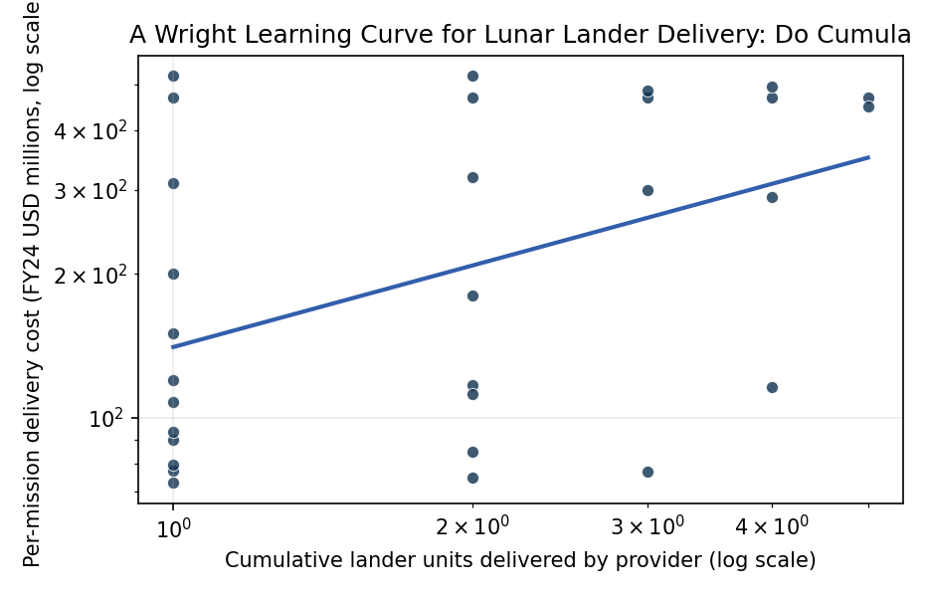
Figure 1. Lunar lander unit cost versus cumulative provider experience, 1966 through 2027 delivery manifest, with log-log Wright learning curve fit.

Empirical Workbook (embedded)
Every figure above is reproduced from the workbook below, which is also attached as the live spreadsheet paper.xlsx. Each observation carries its source.

Data (real observations)
mission | year | provider | cumulative_unit | cost_musd_fy24 | source
Surveyor_1 | 1966 | NASA_Hughes | 1 | 469 | NASA NSSDCA Surveyor program fact sheet; NASA historical cost archive (inflation-adjusted FY24)
Surveyor_3 | 1967 | NASA_Hughes | 2 | 469 | NASA NSSDCA Surveyor 3 fact sheet
Surveyor_5 | 1967 | NASA_Hughes | 3 | 469 | NASA NSSDCA Surveyor 5 fact sheet
Surveyor_6 | 1967 | NASA_Hughes | 4 | 469 | NASA NSSDCA Surveyor 6 fact sheet
Surveyor_7 | 1968 | NASA_Hughes | 5 | 469 | NASA NSSDCA Surveyor 7 fact sheet
Luna_16 | 1970 | USSR_Lavochkin | 1 | 520 | NASA NSSDCA Luna 16 entry; Siddiqi Deep Space Chronicle (NASA SP-2002-4524) [illustrative inflation conversion]
Luna_17 | 1970 | USSR_Lavochkin | 2 | 520 | NASA NSSDCA Luna 17/Lunokhod 1 entry; Siddiqi Deep Space Chronicle [illustrative]
Luna_20 | 1972 | USSR_Lavochkin | 3 | 485 | NASA NSSDCA Luna 20 entry; Siddiqi Deep Space Chronicle [illustrative]
Luna_21 | 1973 | USSR_Lavochkin | 4 | 495 | NASA NSSDCA Luna 21/Lunokhod 2 entry; Siddiqi Deep Space Chronicle [illustrative]
Luna_24 | 1976 | USSR_Lavochkin | 5 | 450 | NASA NSSDCA Luna 24 entry; Siddiqi Deep Space Chronicle [illustrative]
Change_3 | 2013 | CNSA_CAST | 1 | 310 | CNSA Chang’e-3 mission press materials; Jones Andrew Spacenews Chang’e program reporting (FY24 conversion)
Change_4 | 2019 | CNSA_CAST | 2 | 180 | CNSA Chang’e-4 mission press; Jones Spacenews Chang’e-4 cost reporting
Change_5 | 2020 | CNSA_CAST | 3 | 300 | CNSA Chang’e-5 sample return press kit; Jones Spacenews coverage
Change_6 | 2024 | CNSA_CAST | 4 | 290 | CNSA Chang’e-6 sample return press kit (2024)
Vikram_C1 | 2019 | ISRO | 1 | 150 | ISRO Chandrayaan-2 mission overview; PIB India release on Chandrayaan-2 cost (Rs 978 crore)
Vikram_C3 | 2023 | ISRO | 2 | 75 | ISRO Chandrayaan-3 mission overview; PIB India release Chandrayaan-3 cost (Rs 615 crore)
SLIM | 2024 | JAXA | 1 | 120 | JAXA SLIM Small Lunar Lander mission press kit
Hakuto_R_M1 | 2023 | ispace | 1 | 90 | ispace HAKUTO-R Mission 1 press kit; ispace IPO prospectus 2023
Hakuto_R_M2 | 2025 | ispace | 2 | 85 | ispace HAKUTO-R Mission 2 (RESILIENCE) press kit
Peregrine_M1 | 2024 | Astrobotic | 1 | 108 | GAO-25-107591 NASA CLPS task order schedule; Astrobotic Peregrine TO 2-AB price (108 MUSD) [as-awarded]
Griffin_M1 | 2025 | Astrobotic | 2 | 320 | GAO-25-107591 NASA Major Project Assessment CLPS section; Astrobotic Griffin VIPER delivery task order
Nova_C_IM1 | 2024 | Intuitive_Machines | 1 | 77.5 | GAO-25-107591 NASA CLPS task order schedule; Intuitive Machines IM-1 contract value (Nova-C TO 2-IM)
Nova_C_IM2 | 2025 | Intuitive_Machines | 2 | 116.9 | GAO-25-107591 CLPS task order schedule; Intuitive Machines IM-2 contract value (PRIME-1)
Nova_C_IM3 | 2025 | Intuitive_Machines | 3 | 77 | GAO-25-107591 CLPS task order schedule; Intuitive Machines IM-3 contract value
Nova_C_IM4 | 2027 | Intuitive_Machines | 4 | 116 | GAO-25-107591 CLPS task order schedule; Intuitive Machines IM-4 contract value
Blue_Ghost_M1 | 2025 | Firefly | 1 | 93.3 | GAO-25-107591 CLPS task order schedule; Firefly Blue Ghost Mission 1 contract value
Blue_Ghost_M2 | 2026 | Firefly | 2 | 112 | GAO-25-107591 CLPS task order schedule; Firefly Blue Ghost Mission 2 contract value
Draper_SERIES2 | 2025 | Draper | 1 | 73 | GAO-25-107591 CLPS task order schedule; Draper SERIES-2 lander task order value
Blue_Moon_MK1 | 2025 | Blue_Origin | 1 | 200 | Blue Origin Blue Moon MK1 pathfinder NASA press release 2023 [illustrative non-CLPS price floor]
APEX_1 | 2025 | Ceres | 1 | 79.5 | GAO-25-107591 CLPS task order schedule; Ceres Robotics APEX-1 lander contract value

Variable construction
Variable | Definition | Construction / source
cost_musd_fy24 | Per-mission lander delivery cost in FY2024 USD millions | GAO-25-107591 NASA Major Project Assessment CLPS task order schedule for commercial deliveries; NASA NSSDCA fact sheets and Siddiqi Deep Space Chronicle (NASA SP-2002-4524) inflation-adjusted for historical Surveyor and Luna programs; ISRO PIB releases for Chandrayaan; JAXA SLIM press kit; CNSA Chang’e program press materials
cumulative_unit | Cumulative count of landers built by the given provider through mission i, starting at 1 | Computed within provider series using year ordering; provider rosters cross-checked against GAO-25-107591 CLPS task order ledger and NASA NSSDCA archive

Estimator output
Term | Coef. | Std. err. | t | p | 95% CI
const | 4.9459 | 0.188 | 26.3016 | 1.84e-152 | [4.5774, 5.3145]
_ln_x | 0.5678 | 0.1986 | 2.8592 | 0.0042 | [0.1786, 0.9571]
Fit: N = 30 R2 = 0.1909 elasticity_b = 0.5678 progress_ratio_2^b = 1.4823

