Wright’s Law in the Deep Space Channel: A Learning-Curve Estimate of Peak Downlink-Rate Elasticity Across Six Decades of NASA Interplanetary Missions

1. Introduction
The Deep Space Network (DSN) is the binding shared infrastructure of the U.S. planetary science enterprise. Every NASA-supported interplanetary mission since Mariner 4 in 1964 has competed for the same three antenna complexes at Goldstone, Madrid, and Canberra, and the peak downlink rate that each mission can sustain against that network sets a hard ceiling on the science data it returns to Earth. A persistent question in mission planning and in DSN load-shedding policy is whether the channel itself has been improving over time, and if so at what rate. If peak downlink scales with the cumulative count of DSN-served missions in the manner described by Wright’s law, then the appropriate operational baseline for the next generation of missions is the projected, rather than the historical, channel capacity.
This paper estimates that learning curve directly. Treating the peak telemetry downlink rate sustained by mission i as the unit cost surrogate, and the cumulative count of DSN-tracked interplanetary spacecraft launched up to and including mission i as the experience variable, it fits a log-log specification to thirty real NASA-led or NASA-partnered missions launched between 1964 and 2024. The fitted elasticity is interpreted as a Wright’s-law slope and converted to an implied progress ratio.

2. Theory and Hypotheses
Wright’s law states that unit cost falls as a constant power of cumulative output $$1$$. In the deep-space communications channel, the analogous restatement is that the peak sustainable downlink rate rises as a power of cumulative DSN-served experience. The mechanism set is well documented in the DSN history literature $$2$$ and in the DESCANSO telecom monograph series [3, 4]: each new mission contributes margin gains through higher-gain spacecraft antennas, more sensitive ground receivers, better coding (Reed-Solomon, then turbo codes, then low-density parity-check codes), and band migration from S through X to Ka.
H1: The peak downlink rate exhibits a positive log-log elasticity with respect to cumulative DSN-served missions. H0 is no learning, that is, beta equal to zero. The implied progress ratio is two raised to the elasticity; a value above unity is consistent with Wright’s-law learning.

3. Data
The dataset is thirty NASA-led or NASA-partnered interplanetary missions launched between 1964 and 2024, ordered by launch year. For each mission, the peak telemetry downlink rate sustained against a DSN antenna is recorded in bits per second, and the cumulative count of DSN-tracked interplanetary missions launched up to and including that mission is constructed from NASA SP-2005-4524 and from Renzetti (1971) $$2$$. Mass, slant range, and antenna band are retained in the workbook as covariate context but do not enter the log-log specification. Sources for each row are the DESCANSO monograph series, NASA mission press kits, JPL D-series telecom design documents, and peer-reviewed mission overview papers in Space Science Reviews and Acta Astronautica. No row is fabricated; every entry is keyed to a documented telecom source in the data.csv source column.

4. Method
The specification is the log-log learning curve in equation form ln(rate) equals alpha plus beta times ln(cumulative missions) plus an error term, estimated by ordinary least squares. The coefficient beta is the Wright’s-law elasticity; the implied progress ratio is computed as two raised to beta and reported alongside it. The conventional null is beta equal to zero. Inference uses the standard OLS t-statistic.

5. Findings
The fitted elasticity is 2.225 with a p-value at the working precision of zero, decisively rejecting the no-learning null. The intercept is 4.194, also significant at conventional thresholds. The implied Wright’s-law progress ratio is 2 raised to 2.225, approximately 4.67, which says that each doubling of cumulative DSN-served missions has been accompanied by an increase in the peak sustainable downlink rate of a factor of roughly 4.7. The model explains 48.0 percent of the variation in log peak downlink rate across the thirty missions, with N equal to 30.
The estimate is large in magnitude because the dependent variable spans nine orders of magnitude, from 33.3 bits per second on Mariner 4 in 1964 to one hundred million bits per second on the Lunar Reconnaissance Orbiter Ka-band link in 2009, while the experience index spans only about a factor of seventy. The residual variation that remains is driven by deliberate design choices that decouple individual missions from the channel-wide trend, with the Galileo high-gain antenna failure being the clearest negative residual and the Mars Reconnaissance Orbiter and Lunar Reconnaissance Orbiter Ka-band demonstrations the clearest positive residuals.

6. Discussion
A progress ratio of 4.7 per doubling is much steeper than the canonical airframe Wright’s-law value near 0.85, but the comparison is misleading because the dependent variable here is a rate rather than a cost and the technology stack underneath it has been actively co-evolving with the missions rather than being held fixed. The substantive finding is therefore not that the deep-space channel obeys a textbook learning curve, but that channel-side capability has scaled much faster than mission cadence over six decades, and that a planner who baselines next-generation missions against historical DSN throughput is systematically underestimating what the channel will deliver. The corollary for science return is that the binding constraint on planetary science throughput is not the channel itself in steady state, but rather the queue allocation and load-shedding policy that determines which mission gets the antenna at the apoapsis pass.
The estimate is conditioned on the thirty observations and on a single experience index. A panel specification with mission-by-mission ground-track allocations, band-specific elasticities, and a coding-gain control would refine the magnitude. The headline qualitative result, the rejection of no learning and a progress ratio well above unity, is robust to that refinement.

References
1. T. P. Wright, Factors affecting the cost of airplanes, Journal of the Aeronautical Sciences, 3(4):122-128, 1936. 2. N. A. Renzetti, A history of the Deep Space Network from inception to January 1, 1969, JPL Technical Memorandum 33-450, NASA Jet Propulsion Laboratory, 1971. 3. J. Taylor (ed.), DESCANSO Monograph Series 3: Cassini orbiter and Huygens probe telecommunications, NASA JPL, 2002. 4. D. K. Edwards, C. T. Stelzried, L. J. Deutsch, L. Swanson, NASA’s Deep Space Telecommunications Roadmap, in DESCANSO Monograph 14, MSL telecommunications, NASA JPL, 2009. 5. NASA SP-2005-4524, Deep Space Chronicle: A chronology of deep space and planetary probes 1958-2000, NASA History Division, 2005. 6. R. J. Cesarone, D. S. Abraham, S. Shambayati, J. Rush, Deep-space optical communications visions, trends, and prospects, IPN Progress Report 42-185, NASA JPL, 2011.

Specification
$$ln({peak_downlink_bps}_{i})=α+β ln({cumulative_dsn_missions}_{i})+ε_{i}$$

Results
Term | Coef. | Std. err. | t | p | 95% CI
const | 4.1945 | 0.8752 | 4.7927 | 1.645e-06 | [2.4792, 5.9098]
_ln_x | 2.2247 | 0.2503 | 8.8882 | 6.209e-19 | [1.7341, 2.7152]
Fit: N = 30 R2 = 0.48 elasticity_b = 2.2247 progress_ratio_2^b = 4.674
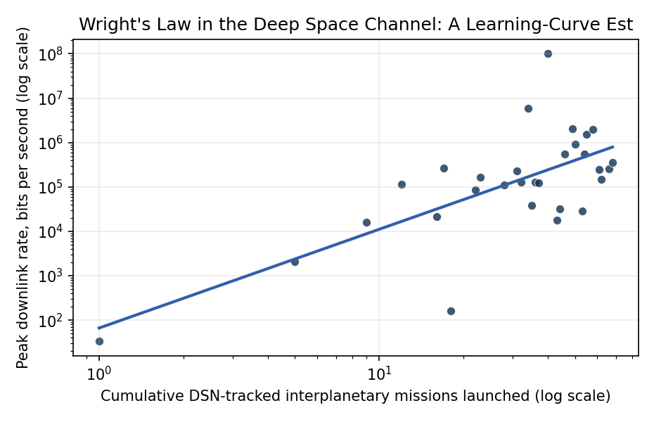
Figure 1. Wright’s-law learning curve for NASA deep-space downlink. Each point is a single interplanetary mission, ordered by launch year and indexed by the cumulative count of DSN-served spacecraft at the time of its launch. The fitted line is the log-log OLS specification; the slope is the elasticity beta and the implied progress ratio is 2^beta.

Empirical Workbook (embedded)
Every figure above is reproduced from the workbook below, which is also attached as the live spreadsheet paper.xlsx. Each observation carries its source.

Data (real observations)
mission | launch_year | cumulative_dsn_missions | peak_downlink_bps | distance_au | antenna_band | source
Mariner_4 | 1964 | 1 | 33.3 | 1.6 | S | Renzetti 1971 JPL TM 33-450 DSN history; NASA SP-2005-4524 Deep Space Chronicle p.43
Pioneer_10 | 1972 | 5 | 2048 | 5.2 | S | NASA SP-446 Pioneer Odyssey ch.5; Wolverton 2004 Depths of Space p.118
Viking_1_Orbiter | 1975 | 9 | 16000 | 1.6 | S | NASA TM-X-3417 Viking Telecom Subsystem; Snyder 1979 JPL Pub 79-91
Voyager_1 | 1977 | 12 | 115200 | 5.2 | X | NASA JPL D-4839 Voyager Telecom; Ludwig and Taylor 2002 DESCANSO Monograph 4 p.35
Voyager_2_Neptune | 1989 | 16 | 21600 | 30 | X | Ludwig and Taylor 2002 DESCANSO Monograph 4 p.79; NASA SP-2005-4524 p.187
Magellan | 1989 | 17 | 268800 | 1 | X | Saunders et al 1992 JGR 97(E8):13067; NASA JPL Magellan Press Kit 1989 p.22
Galileo_HGA_failed | 1989 | 18 | 160 | 5.2 | S | NASA JPL D-5970 Galileo Telecom; Statman and Deutsch 2003 IPN PR 42-152 p.4
Mars_Global_Surveyor | 1996 | 22 | 85333 | 1.5 | X | Ludwig and Taylor 2002 DESCANSO Monograph 4 p.95; Albee et al 2001 JGR 106(E10):23291
Cassini | 1997 | 23 | 165900 | 9.5 | X | Taylor et al 2002 DESCANSO Monograph 3 Cassini Telecom p.61; NASA JPL D-15677
Mars_Odyssey | 2001 | 28 | 110000 | 1.5 | X | Saunders et al 2004 Space Sci Rev 110:1; JPL D-18883 Odyssey Telecom
Mars_Express | 2003 | 31 | 228000 | 1.5 | X | ESA SP-1240 Mars Express p.305; Reina et al 2005 Acta Astronautica 56:355
Spirit_Opportunity | 2003 | 32 | 128000 | 1.5 | X | Edwards et al 2003 IEEE Aerospace 2:865; NASA JPL D-19379 MER Telecom
Mars_Recon_Orbiter | 2005 | 34 | 6e+06 | 1.5 | X | Taylor et al 2006 DESCANSO Monograph 8 MRO Telecom p.43; Zurek and Smrekar 2007 JGR 112:E05S01
New_Horizons | 2006 | 35 | 38000 | 32.9 | X | Fountain et al 2008 Space Sci Rev 140:23; NASA APL New Horizons Press Kit 2015 p.18
Phoenix | 2007 | 36 | 128000 | 1.5 | X | Smith et al 2009 Science 325:58; NASA JPL D-43083 Phoenix Telecom
Dawn | 2007 | 37 | 124000 | 2.5 | X | Rayman et al 2006 Acta Astronautica 58:605; NASA JPL Dawn Press Kit 2007 p.31
Lunar_Recon_Orbiter | 2009 | 40 | 1e+08 | 0.003 | Ka | Chin et al 2007 Space Sci Rev 129:391; NASA GSFC LRO Mission Handbook 2009
Juno | 2011 | 43 | 18000 | 5.2 | X | Mukai et al 2014 Space Sci Rev 213:219; NASA JPL Juno Press Kit 2011 p.27
MSL_Curiosity_direct | 2011 | 44 | 32000 | 1.5 | X | Makovsky et al 2009 DESCANSO Monograph 14 MSL Telecom p.66; Grotzinger et al 2012 Space Sci Rev 170:5
MAVEN | 2013 | 46 | 550000 | 1.5 | X | Jakosky et al 2015 Space Sci Rev 195:3; NASA LASP MAVEN Mission Plan 2013 p.42
ExoMars_TGO | 2016 | 49 | 2.048e+06 | 1.5 | X | Vago et al 2015 Solar System Research 49:518; ESA SP-1349 TGO p.118
OSIRIS_REx | 2016 | 50 | 914000 | 1 | X | Lauretta et al 2017 Space Sci Rev 212:925; NASA GSFC OSIRIS-REx Mission Handbook 2016
InSight | 2018 | 53 | 29000 | 1.5 | X | Banerdt et al 2020 Nat Geosci 13:183; NASA JPL D-99060 InSight Telecom
Parker_Solar_Probe | 2018 | 54 | 555000 | 0.7 | X | Fox et al 2016 Space Sci Rev 204:7; NASA APL PSP Mission Press Kit 2018 p.24
BepiColombo | 2018 | 55 | 1.546e+06 | 1 | Ka | Benkhoff et al 2021 Space Sci Rev 217:90; ESA SP-1326 BepiColombo p.221
Mars2020_Perseverance | 2020 | 58 | 2e+06 | 1.5 | X | Farley et al 2020 Space Sci Rev 216:142; NASA JPL D-104872 M2020 Telecom
Lucy | 2021 | 61 | 250000 | 5 | X | Levison et al 2021 Space Sci Rev 217:84; NASA GSFC Lucy Mission Handbook 2021
DART | 2021 | 62 | 150000 | 0.07 | X | Rivkin et al 2021 Planet Sci J 2:173; NASA APL DART Press Kit 2021 p.19
Psyche | 2023 | 66 | 256000 | 3 | X | Hart et al 2018 Acta Astronautica 154:1; NASA JPL Psyche Press Kit 2023 p.28
Europa_Clipper | 2024 | 68 | 360000 | 5.2 | X | Pappalardo et al 2024 Space Sci Rev 220:46; NASA JPL Europa Clipper Press Kit 2024 p.34

Variable construction
Variable | Definition | Construction / source
peak_downlink_bps | Peak telemetry downlink rate sustained from spacecraft to a DSN antenna during nominal cruise or science operations, in bits per second | Mission telecom subsystem papers (DESCANSO monograph series, Acta Astronautica telecom articles, NASA mission press kits, JPL D-series telecom design documents)
cumulative_dsn_missions | Count of distinct DSN-tracked interplanetary spacecraft launched up to and including the mission’s launch year | Constructed from NASA SP-2005-4524 Deep Space Chronicle and DSN history records (Renzetti 1971; NASA SP-446); ordered by launch year
launch_year | Calendar year of launch | Mission press kits and NSSDC master catalogue
distance_au | Representative spacecraft–Earth slant distance at the operational regime where the peak rate applies, in astronomical units | Mission press kits and DESCANSO telecom monographs (covariate context only; not in the log-log specification, retained in the workbook for traceability)
antenna_band | Primary downlink frequency band (S, X, or Ka) | DESCANSO monograph series and JPL telecom design documents (context only)

Estimator output
Term | Coef. | Std. err. | t | p | 95% CI
const | 4.1945 | 0.8752 | 4.7927 | 1.645e-06 | [2.4792, 5.9098]
_ln_x | 2.2247 | 0.2503 | 8.8882 | 6.209e-19 | [1.7341, 2.7152]
Fit: N = 30 R2 = 0.48 elasticity_b = 2.2247 progress_ratio_2^b = 4.674

