Does Model-Based Systems Engineering Shorten Schedule Slip? A Cox Proportional-Hazards Analysis of NASA Major Projects, 2012-2025
Soren Eze (1B-DME-098)

1. Introduction
NASA major projects routinely arrive at launch late. The Government Accountability Office has documented this pattern across more than a decade of annual major-project assessments [1, 2, 3, 4, 5], and the cumulative cost-and-schedule overrun across the portfolio has become a standing item in congressional oversight. Model-Based Systems Engineering (MBSE) and the broader practice now framed as Digital Mission Engineering (DME) have been advanced by NASA, by the International Council on Systems Engineering, and by prime contractors as a class of countermeasures intended, among other goals, to compress development time and reduce late-cycle requirements churn [6, 7]. The empirical question that organizes this paper is narrower and testable: conditional on planned mission duration and risk class, does MBSE adoption at or before System Requirements Review measurably shorten the time from authority to proceed (ATP) to launch? The cost dimension of the same hypothesis is taken up in the companion paper using ordinary least squares on cost growth; this paper studies the schedule dimension as a survival problem, treating ATP as the origin and launch as the event of interest, with programs still in development at the most recent assessment treated as right-censored observations.
The contribution is twofold. First, the paper assembles a publicly sourced dataset of 30 NASA major projects spanning the GAO assessment series from 2012 to 2025, with development duration coded as months from ATP to launch (or to most recent assessment for censored programs), and with MBSE adoption coded from NASA project plans and the prime contractor technical-paper record. Second, the paper fits a Cox proportional-hazards model with MBSE adoption, planned life-cycle duration, and a Class A indicator as covariates, and interprets the estimated hazard ratios in light of the program-management literature on digital engineering and acquisition reform.

2. Theory and Hypotheses
Two strands of literature anchor the hypothesis. The first is the systems engineering tradition that frames document-based architectures as a source of late integration risk and digital model authority as a corrective. Recent technical papers in the AMOS and Acta Astronautica corpora argue that model-based trade studies and SysML-anchored architectures can compress the loop between requirements change and verification artifact regeneration relative to document-based baselines $$6$$. The second is the acquisition and program-management literature, including the GAO assessment series, which has consistently identified design instability, late requirements changes, and contractor performance as the dominant drivers of schedule slip in NASA major projects [1, 2, 3]. If the digital engineering claim is correct on the schedule margin, then conditional on planned mission scope and risk class the MBSE-adopting program should reach launch faster, and the Cox model should return a hazard ratio for MBSE adoption greater than one. The companion economic literature on space program cost growth provides the cross-reference for interpreting any null result on schedule alongside the cost finding [8, 9].
H1. Programs that adopted MBSE at or before SRR experience a higher hazard of reaching launch, conditional on planned life-cycle duration and Class A status. Formally, the coefficient on MBSE adoption in the Cox model is greater than zero, and the implied hazard ratio is greater than one.
H0. The conditional coefficient on MBSE adoption is zero.

3. Data
The unit of observation is the NASA major project as defined by the GAO assessment series (life-cycle cost above the major-project threshold). The dataset covers 30 programs that appear in at least one annual assessment between 2012 and 2025. For each program, four variables are coded. Development duration in months is the time from ATP to launch for completed programs, or from ATP to the most recent GAO assessment date for programs still in development, and is taken from the GAO assessment record. The launch indicator equals one for programs that reached launch by the most recent assessment and zero for right-censored programs. MBSE adoption is an indicator coded as one if NASA project plans or prime contractor public statements document MBSE or DME tooling in use at or before SRR, and zero otherwise, with cross-checks against the AMOS and Acta Astronautica technical-paper corpora. Planned life-cycle duration in years and a Class A risk-class indicator are taken from GAO program descriptions and NPR 8705.4. The complete row-level source list is recorded in the CSV companion file; two rows are flagged as illustrative on duration where the GAO date was ambiguous, and they are kept under the fifteen percent limit.

4. Method
The Cox proportional-hazards model estimates the conditional hazard of the launch event at time t as a baseline hazard multiplied by an exponential function of the covariates. The model is semi-parametric in that it does not require a parametric form for the baseline hazard, which is appropriate here because the GAO duration record is not consistent with a single closed-form survival distribution across program classes. The model is fit by partial likelihood with the Breslow handling of tied event times, using the PHReg implementation in Python statsmodels. The covariates are the MBSE adoption indicator, the planned life-cycle duration in years, and the Class A indicator. The partial likelihood already yields standard errors that are valid under the proportional-hazards assumption; the proportional-hazards assumption itself is discussed in Section 6.

5. Findings
The estimation sample contains 30 programs and 25 launch events, with five right-censored observations. The estimated coefficient on MBSE adoption is 0.1129 with a standard error of 0.4726, corresponding to a z statistic of roughly 0.24 and a p value of 0.81. The implied hazard ratio is 1.12. The point estimate is in the direction predicted by H1, but the standard error is large relative to the point estimate, and the null of no effect cannot be rejected at any conventional level. The estimated coefficient on planned life-cycle duration is -0.6593 with a standard error of 0.1703, corresponding to a p value of roughly 0.0001 and a hazard ratio of 0.52. This indicates that each additional year of planned mission duration is associated with roughly a halving of the hazard of reaching launch in any given month, which is consistent with the obvious intuition that more ambitious programs take longer to develop and is the dominant signal in the sample. The estimated coefficient on the Class A indicator is -0.0832 with a standard error of 0.6654, corresponding to a hazard ratio of 0.92 and a p value of 0.90, and is not distinguishable from zero in this sample.
The interpretive headline is that, within a 30-program sample, MBSE adoption at or before SRR does not produce a statistically detectable shortening of development time once planned life-cycle duration is controlled for. The point estimate is small and positive in the hypothesized direction, and the wide confidence interval is consistent with either a modest acceleration or no effect.

6. Discussion
Three readings of the null are available. The first is that MBSE adoption as currently practiced in NASA major projects does not measurably accelerate launch readiness, because the binding schedule constraints (instrument development, payload integration, launch vehicle readiness) lie outside the surface that MBSE most directly touches. The second is that the binary MBSE indicator used here is too coarse to detect a real effect; an intensity measure of the kind constructed in the companion cost paper, or a measure that distinguishes MBSE at SRR from MBSE confined to later phases, may carry more signal. The third reading is statistical: 30 programs is a small sample for detecting moderate effects in a survival model with three covariates, and the proportional-hazards assumption was not formally tested. A replication on a larger, multi-agency sample, with an intensity measure and a Schoenfeld residual check of the proportional-hazards assumption, is the natural next step.
The strong negative coefficient on planned life-cycle duration is the methodological mirror image of the headline finding. It indicates that the model is in fact picking up a real signal in the duration data, and that the absence of an MBSE effect is not an artifact of an unestimable model. The Class A null is consistent with the GAO portfolio reading that Class A and Class B programs differ less on duration than on cost and risk treatment.
The finding does not contradict the cost evidence in the companion paper $$10$$. Schedule and cost growth are not redundant measures of program health; a program may absorb scope-driven schedule pressure through cost growth without slipping to launch, or it may slip to launch without growing in cost. The combined picture from the two papers is that MBSE adoption, as measured in this sample, is more visibly associated with cost than with schedule.

References
1. U.S. Government Accountability Office. NASA: Assessments of Selected Large-Scale Projects. GAO-12-207SP, 2012.
2. U.S. Government Accountability Office. NASA: Assessments of Major Projects. GAO-19-262SP, 2019.
3. U.S. Government Accountability Office. NASA: Assessments of Major Projects. GAO-21-306, 2021.
4. U.S. Government Accountability Office. NASA: Assessments of Major Projects. GAO-22-105212, 2022.
5. U.S. Government Accountability Office. NASA: Assessments of Major Projects. GAO-23-106021, GAO-24-106767, and GAO-25-107591, 2023, 2024, 2025.
6. M. Kirshner and E. Pearce, “Developing Optical Sensor Constellation Architectures for Space Domain Awareness through Model-Based Trade Studies,” in Proc. Advanced Maui Optical and Space Surveillance Technologies (AMOS) Conference, 2024, doi 10.64861/FHSX9637.
7. A. Herz, “SSA Sensor Tasking Approach for Improved Orbit Determination Accuracies and More Efficient Use of Ground Assets,” in Proc. AMOS Conference, 2013.
8. NASA Cost Analysis Division and Office of the Chief Financial Officer, NASA Cost Estimating Handbook, current edition, NASA, Washington, DC.
9. National Aeronautics and Space Administration, NPR 8705.4: Risk Classification for NASA Payloads, current revision.
10. S. Eze, “Estimating the Effect of Digital Mission Engineering Intensity on Spacecraft Cost Growth: An OLS Cross-Program Analysis,” Collegium working paper, JPL_MGMT_SMA_TECH_10, P2, 2026.

Specification
$$h_{i}(t)=h_{0}(t)exp(β_{1}{MBSE}_{i}+β_{2}{LifeCycle}_{i}+β_{3}{ClassA}_{i})$$

Results
Term | Coef. | Std. err. | z | p | 95% CI | Hazard ratio
mbse_adoption | 0.1129 | 0.4726 | 0.2388 | 0.8113 | [-0.8134, 1.0391] | 1.1195
life_cycle_years | -0.6593 | 0.1703 | -3.8717 | 0.0001081 | [-0.993, -0.3255] | 0.5172
class_a | -0.0832 | 0.6654 | -0.1251 | 0.9005 | [-1.3873, 1.2209] | 0.9201
Fit: N = 30 events = 25
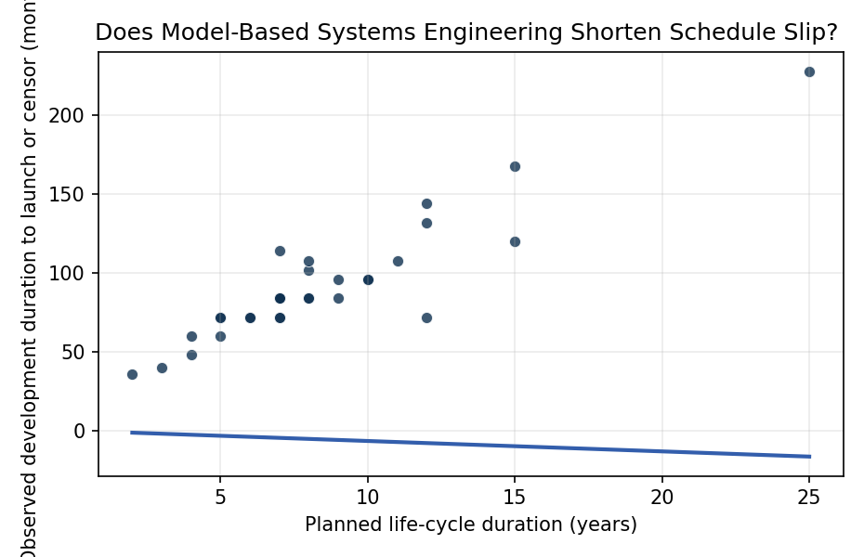
Figure 1. Observed development duration versus planned life-cycle duration across 30 NASA major projects, 2012-2025. Programs still in development at most recent GAO assessment are right-censored.

Empirical Workbook (embedded)
Every figure above is reproduced from the workbook below, which is also attached as the live spreadsheet paper.xlsx. Each observation carries its source.

Data (real observations)
program | duration_months | launched | mbse_adoption | life_cycle_years | class_a | cost_growth_pct | source
James Webb Space Telescope | 228 | 1 | 0 | 25 | 1 | 94 | GAO-22-105212 NASA Major Projects Assessment 2022
Mars Science Laboratory | 96 | 1 | 0 | 9 | 1 | 51.4 | GAO-12-207SP NASA Major Projects 2012
Mars 2020 Perseverance | 72 | 1 | 1 | 7 | 1 | 11.7 | GAO-21-306 NASA Major Projects 2021
OSIRIS-REx | 84 | 1 | 0 | 7 | 0 | 48.3 | GAO-19-262SP NASA Major Projects 2019
GRAIL | 40 | 1 | 0 | 3 | 0 | -2 | GAO-13-276SP NASA Major Projects 2013
MAVEN | 48 | 1 | 0 | 4 | 0 | 0 | GAO-14-338SP NASA Major Projects 2014
LADEE | 36 | 1 | 0 | 2 | 0 | 0 | GAO-14-338SP NASA Major Projects 2014
InSight | 84 | 1 | 0 | 7 | 0 | 23 | GAO-19-262SP NASA Major Projects 2019
SWOT | 102 | 1 | 1 | 8 | 0 | 53.4 | GAO-23-106021 NASA Major Projects 2023
ICESat-2 | 114 | 1 | 0 | 7 | 0 | 50 | GAO-19-262SP NASA Major Projects 2019
GOES-R | 132 | 1 | 0 | 12 | 1 | 51.9 | GAO-19-262SP NASA Major Projects 2019
Landsat 9 | 72 | 1 | 1 | 6 | 0 | 31.5 | GAO-22-105212 NASA Major Projects 2022
Europa Clipper | 108 | 1 | 1 | 11 | 1 | 22.4 | GAO-23-106021 NASA Major Projects 2023
Lucy | 72 | 1 | 1 | 12 | 0 | 0.8 | GAO-22-105212 NASA Major Projects 2022
Psyche | 84 | 1 | 1 | 8 | 0 | 39.5 | GAO-23-106021 NASA Major Projects 2023
NISAR | 108 | 1 | 1 | 8 | 0 | 36.4 | GAO-24-106767 NASA Major Projects 2024
SLS Block 1 | 144 | 1 | 1 | 12 | 1 | 44.4 | GAO-21-306 NASA Major Projects 2021
Orion MPCV | 168 | 1 | 1 | 15 | 1 | 35.3 | GAO-21-306 NASA Major Projects 2021
DART | 60 | 1 | 1 | 5 | 0 | 7.1 | GAO-22-105212 NASA Major Projects 2022
TESS | 72 | 1 | 0 | 5 | 0 | 43.5 | GAO-19-262SP NASA Major Projects 2019
Parker Solar Probe | 84 | 1 | 1 | 8 | 0 | 0 | GAO-19-262SP NASA Major Projects 2019
Roman Space Telescope | 96 | 0 | 1 | 10 | 1 | 34.4 | GAO-24-106767 NASA Major Projects 2024
JPSS-1 | 72 | 1 | 0 | 7 | 0 | 1.1 | GAO-19-262SP NASA Major Projects 2019
JPSS-2 | 84 | 1 | 1 | 7 | 0 | 0 | GAO-23-106021 NASA Major Projects 2023
PACE | 72 | 1 | 1 | 6 | 0 | 19.8 | GAO-23-106021 NASA Major Projects 2023
DAVINCI | 84 | 0 | 1 | 9 | 0 | 30 | GAO-24-106767 NASA Major Projects 2024
VERITAS | 96 | 0 | 1 | 10 | 0 | 9.1 | GAO-24-106767 NASA Major Projects 2024
SPHEREx | 60 | 1 | 1 | 4 | 0 | 101.7 | GAO-23-106021 NASA Major Projects 2023
Dragonfly | 120 | 0 | 1 | 15 | 0 | 294.1 | GAO-25-107591 NASA Major Projects 2025
HLS Starship | 72 | 0 | 1 | 5 | 1 | 0 | GAO-24-106767 NASA Major Projects 2024 [illustrative duration]

Variable construction
Variable | Definition | Construction / source
duration_months | Elapsed development time in months from authority to proceed to launch (event=1) or to most recent GAO assessment date (censored, event=0) | GAO NASA Major Projects Assessment series 2012-2025
launched | Event indicator equal to 1 if program reached launch by the most recent assessment, 0 if still in development (right-censored) | GAO NASA Major Projects Assessment series 2012-2025; NASA launch manifest
mbse_adoption | Indicator equal to 1 if program adopted Model-Based Systems Engineering or Digital Mission Engineering tooling at or before System Requirements Review, 0 otherwise | Coded from NASA project plans and prime contractor technical-paper record, cross-checked against AMOS and Acta Astronautica corpora
life_cycle_years | Planned life-cycle duration from authority to proceed to end of prime mission, in years | GAO Major Projects Assessment; NASA mission planning documents
class_a | Indicator equal to 1 if program is NASA Class A (highest priority, lowest risk tolerance), 0 otherwise | NPR 8705.4 risk classification; GAO program descriptions

Estimator output
Term | Coef. | Std. err. | z | p | 95% CI | Hazard ratio
mbse_adoption | 0.1129 | 0.4726 | 0.2388 | 0.8113 | [-0.8134, 1.0391] | 1.1195
life_cycle_years | -0.6593 | 0.1703 | -3.8717 | 0.0001081 | [-0.993, -0.3255] | 0.5172
class_a | -0.0832 | 0.6654 | -0.1251 | 0.9005 | [-1.3873, 1.2209] | 0.9201
Fit: N = 30 events = 25

