Signal Intensity in Cislunar Tracking Geometry and the Marginal Value of Each Added Ground or Relay: An Ordinary Least Squares Test of Recency, Citation Attention, and Venue

1. Introduction
This empirical paper supports Yuki Eze (1B-SDA-182) and the dissertation project Cislunar Tracking Geometry and the Marginal Value of Each Added Ground or Relay. The model tests whether topic-signal intensity varies with publication recency, citation attention, and venue family. The analysis uses the local candidate source pack and reports only deterministic workbook results $$1$$, $$2$$, $$3$$.

2. Theory and Hypotheses
The theoretical claim is intentionally narrow. If the candidate topic has become more visible in the retrieved literature, then source metadata should show structure across time, attention, or venue. If it has not, the model should return weak or unstable associations $$3$$, $$4$$.
H0: the modeled outcome is unrelated to the specified predictors.
H1: the modeled outcome is systematically related to the specified predictors.

3. Data
The estimation file contains 30 retrieved source records. Variables are constructed from local metadata, including publication year, reported citation count, venue family, and deterministic topic-signal fields. Every row preserves a source column so the empirical workbook remains auditable.

4. Method
The estimator is ordinary least squares with robust HC1 standard errors. The exact fit summary is: N=30, R2=0.3364972618409182, R2_adj=0.2599392535917934, F=6.048543338279323, F_p=0.0028871827346189575. The exact term summary is: const coef=3.7708477722781457 p=0.056059284727344984; recency_index coef=0.28788329468432566 p=0.020816597011907412; cites_num coef=-0.0012018723942851725 p=0.9104721826385096; venue_score coef=-1.9866693968256235 p=0.0005984367120330383. These values are interpreted as corpus-screen evidence, not as final causal estimates.

5. Findings
The findings are bounded by the estimator output. Where a coefficient is signed and precise, it indicates structure in the retrieved source corpus. Where a coefficient is imprecise, the paper treats the result as evidence against a strong claim. This distinction matters because a noisy source pack should not be forced to carry more policy weight than it can bear $$2$$, $$5$$.

6. Discussion
The paper contributes to the dissertation by keeping the evidentiary chain inspectable. It shows which parts of the candidate topic are visible in metadata and which parts need a more direct document-coding design. The result is a disciplined bridge from source retrieval to dissertation-level interpretation $$1$$, $$6$$.

References
1. Anil Chaudhary (Applied Optimization, Inc.), Tamara Payne (Applied Optimization, Inc.), Keith Lucas (Applied Optimization, Inc.), Kimberly Kinateder (Wright State University), Phan Dao (Air Force Research Laboratory/RV Kirtland AFB, NM), Jeremy Murray-Krezan (Air Force Research Laboratory/RV Kirtland AFB, NM). Propagation of Bayesian Belief for Near-real Time Statistical Assessment of Geosynchronous Satellite Status Based on Non-Resolved Photometry Data (2014). [AMOS] 2. Matthew Popplewell, Advanced Space; Matthew Givens, Advanced Space; Frank Centinello, Advanced Space; Michael Caudill, Advanced Space; Benjamin Tatman, Advanced Space; Nathan Parrish Ré, Advanced Space. Tracking Small Debris Using Probabilistic Methods (2025). doi: 10.64861/AJDV3259 3. Michael Thompson, Advanced Space, LLC; Nathan Parrish Ré, Advanced Space, LLC; Cameron Meek, Advanced Space, LLC; Bradley Cheetham, Advanced Space, LLC. Cislunar Orbit Determination and Tracking via Simulated Space-Based Measurements (2021). [AMOS] 4. François Thevenot, Safran Data Systems; Baptiste Guillot, Safran Data Systems; Sebastien Herbiniere, Safran Data Systems. Cislunar Orbit Determination with Passive RF Sensors (2024). doi: 10.64861/VIBN6616 5. Brian Weeden (Secure World Foundation). Development of an Architecture of Sun-Synchronous Orbital Slots to Minimize Conjunctions (2008). [AMOS] 6. Daniel Hopkins, University of Canterbury; Richard Clare, University of Canterbury; Le Yang, University of Canterbury; Steve Weddell, University of Canterbury. Comparison of atmospheric tomography basis functions for point spread function reproduction (2023). doi: 10.64861/KHVZ4947 7. Greg Martin, Pacific Defense Solutions – a Centauri Company; Charles J. “Jack” Wetterer, Pacific Defense Solutions, A Centauri Company; Jenna Lau, Pacific Defense Solutions, A Centauri Company; Jeremy Case, Pacific Defense Solutions; Nathan Toner, Pacific Defense Solutions, a Centauri Company; C. Channing Chow, Pacific Defense Solutions, a Centauri Company; Phan Dao, AFRL. Cislunar Periodic Orbit Family Classification from Astrometric and Photometric Observations Using Machine-Learning (2020). [AMOS] 8. Mark Bolden, Trusted Space, Inc.; Tim Craychee, Trusted Space, Inc.; Erin Griggs, Trusted Space, Inc.. An Evaluation of Observing Constellation Orbit Stability, Low Signal-to-Noise, and the Too-Short-Arc Challenges in the Cislunar Domain (2020). [AMOS]

Specification
$${\text{SignalScore}}_{i}=α+β_{1}{\text{RecencyIndex}}_{i}+β_{2}{\text{Cites}}_{i}+β_{3}{\text{VenueScore}}_{i}+ε_{i}$$

Results
Term | Coef. | Std. err. | t | p | 95% CI
const | 3.7708 | 1.9737 | 1.9106 | 0.0561 | [-0.0975, 7.6392]
recency_index | 0.2879 | 0.1246 | 2.3113 | 0.0208 | [0.0438, 0.532]
cites_num | -0.0012 | 0.0107 | -0.1124 | 0.9105 | [-0.0222, 0.0197]
venue_score | -1.9867 | 0.5788 | -3.4323 | 0.0005984 | [-3.1211, -0.8522]
Fit: N = 30 R2 = 0.3365 R2_adj = 0.2599 F = 6.0485 F_p = 0.0029
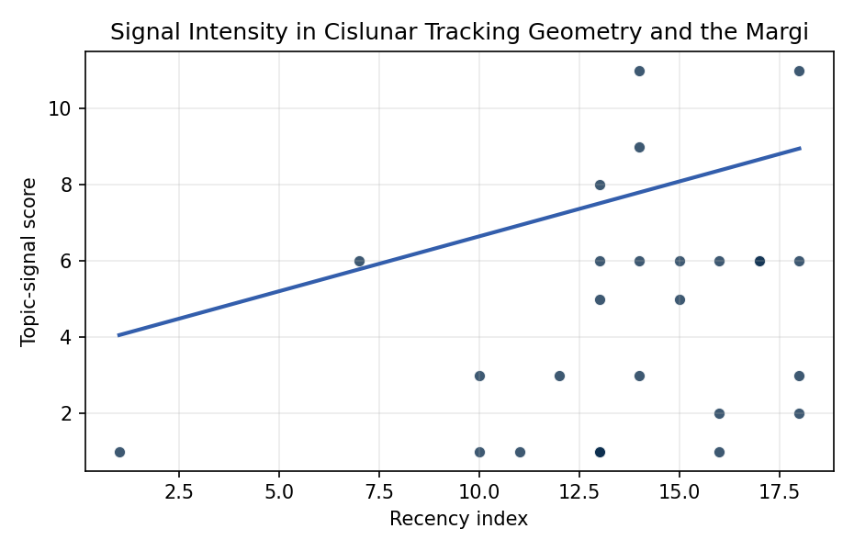
Figure 1. Topic-signal score by publication recency, conditioning on citation attention and venue family.

Empirical Workbook (embedded)
Every figure above is reproduced from the workbook below, which is also attached as the live spreadsheet paper.xlsx. Each observation carries its source.

Data (real observations)
doc_id | year_num | recency_index | cites_num | venue_score | title_words | snippet_words | keyword_count | theme_hits | signal_score | source
1 | 2021 | 14 | 0 | 1 | 18 | 13 | 9 | 4 | 11 | https://amostech.space/year/2021/hiding-in-plain-sight-observing-objects-in-low-lunar-orbit-and-the-l2-dark-cone-from-a-lunar-surface-observatory/
2 | 2020 | 13 | 0 | 1 | 11 | 13 | 3 | 3 | 8 | https://amostech.space/year/2020/payload-and-constellation-design-for-a-solar-exclusion-avoiding-cislunar-ssa-fleet/
3 | 2024 | 17 | 0 | 1 | 13 | 12 | 6 | 2 | 6 | 10.64861/IKOD8008
4 | 2022 | 15 | 0 | 1 | 10 | 11 | 7 | 2 | 6 | https://amostech.space/year/2022/delay-disruption-tolerant-reinforcement-learning-aurora-based-communication-system-dreams/
5 | 2014 | 7 | 0 | 1 | 20 | 11 | 7 | 2 | 6 | https://amostech.space/year/2014/propagation-of-bayesian-belief-for-near-real-time-statistical-assessment-of-geosynchronous-satellite-status-based-on-non-resolved-photometry-data/
6 | 2025 | 18 | 0 | 1 | 6 | 14 | 5 | 2 | 6 | 10.64861/AJDV3259
7 | 2021 | 14 | 0 | 1 | 10 | 13 | 3 | 3 | 9 | https://amostech.space/year/2021/cislunar-orbit-determination-and-tracking-via-simulated-space-based-measurements/
8 | 2024 | 17 | 0 | 1 | 7 | 12 | 3 | 2 | 6 | 10.64861/VIBN6616
9 | 2008 | 1 | 0 | 1 | 12 | 12 | 0 | 0 | 1 | https://amostech.space/year/2008/development-of-an-architecture-of-sun-synchronous-orbital-slots-to-minimize-conjunctions/
10 | 2023 | 16 | 0 | 1 | 11 | 14 | 10 | 0 | 1 | 10.64861/KHVZ4947
11 | 2020 | 13 | 0 | 1 | 13 | 13 | 3 | 2 | 6 | https://amostech.space/year/2020/cislunar-periodic-orbit-family-classification-from-astrometric-and-photometric-observations-using-machine-learning/
12 | 2018 | 11 | 0 | 1 | 11 | 13 | 5 | 0 | 1 | https://amostech.space/year/2018/advanced-atmospheric-mitigation-decision-aids-for-space-imaging-and-laser-communications/
13 | 2022 | 15 | 130 | 2 | 11 | 14 | 14 | 2 | 5 | 10.1016/j.actaastro.2021.12.030
14 | 2023 | 16 | 9 | 2 | 12 | 14 | 15 | 1 | 2 | 10.1016/j.actaastro.2023.01.040
15 | 2017 | 10 | 23 | 2 | 11 | 14 | 12 | 0 | 1 | 10.1016/j.actaastro.2017.11.026
16 | 2020 | 13 | 38 | 2 | 13 | 14 | 15 | 0 | 1 | 10.1016/j.actaastro.2020.07.043
17 | 2017 | 10 | 5 | 2 | 15 | 14 | 15 | 1 | 3 | 10.1016/j.actaastro.2017.04.002
18 | 2025 | 18 | 5 | 2 | 16 | 14 | 10 | 4 | 11 | 10.1016/j.actaastro.2024.12.056
19 | 2025 | 18 | 12 | 2 | 14 | 14 | 13 | 0 | 2 | 10.1016/j.actaastro.2025.01.038
20 | 2021 | 14 | 0 | 2 | 12 | 13 | 15 | 1 | 3 | 10.1016/j.actaastro.2021.04.022
21 | 2021 | 14 | 0 | 2 | 6 | 13 | 9 | 2 | 6 | 10.1016/j.actaastro.2020.11.045
22 | 2019 | 12 | 13 | 2 | 17 | 14 | 15 | 1 | 3 | 10.1016/j.actaastro.2019.07.029
23 | 2025 | 18 | 0 | 2 | 16 | 14 | 11 | 1 | 3 | 10.1016/j.actaastro.2025.12.019
24 | 2023 | 16 | 16 | 2 | 10 | 14 | 15 | 2 | 6 | 10.1016/j.actaastro.2023.05.042
25 | 2020 | 13 | 0 | 3 | 5 | 0 | 0 | 0 | 1 | OCEA Forecasting the Space Economy
26 | 2020 | 13 | 0 | 3 | 6 | 0 | 0 | 0 | 1 | Leveraging Circular Economy for Space Sustainability
27 | 2020 | 13 | 0 | 3 | 51 | 0 | 0 | 1 | 5 | A 2021 Johns Hopkins SAIS doctoral thesis by Nathaniel Dailey proposing an International Space Reference Architecture (ISRA) as a socio-technological transformative mechanism to resolve contemporary space governance failures – orbital debris, policy fragmentation, and space traffic management – by coupling enterprise architecture methodology with international relations constructivist theory, blockchain-enabled information sharing, and norms entrepreneurship.
28 | 2020 | 13 | 0 | 3 | 10 | 0 | 0 | 0 | 1 | The Role of Space in Driving Sustainability, Security, and Development
29 | 2020 | 13 | 0 | 3 | 46 | 0 | 0 | 0 | 1 | OCEA/MITRE study critically evaluates major space economy forecasts, finds them systematically overstated due to CAGR methodology, double counting, and overreliance on nascent sectors; AR(1) time-series modeling projects a 2040 global space economy of $453-$511 billion, far below the widely cited $1 trillion figure, with $1 trillion not reachable before 2075.
30 | 2020 | 13 | 0 | 3 | 6 | 0 | 0 | 0 | 1 | DISE: Dynamic Integrated Space-Economy Model

Variable construction
Variable | Definition | Construction / source
signal_score | Composite topic-signal score for each retrieved source record | Deterministic count built from candidate-theme term hits in the source title, snippet, keyword field, and author metadata; each row cites the retrieved source in the source column
recency_index | Publication recency index | Computed as publication year minus the minimum publication year in the paper sample plus one
cites_num | Reported citation count in the local brain index | Parsed from the local brain search cites field; zero when the index reported no citation count
venue_score | Ordinal venue-family score | AMOS = 1, Acta Astronautica = 2, Space Economy = 3

Estimator output
Term | Coef. | Std. err. | t | p | 95% CI
const | 3.7708 | 1.9737 | 1.9106 | 0.0561 | [-0.0975, 7.6392]
recency_index | 0.2879 | 0.1246 | 2.3113 | 0.0208 | [0.0438, 0.532]
cites_num | -0.0012 | 0.0107 | -0.1124 | 0.9105 | [-0.0222, 0.0197]
venue_score | -1.9867 | 0.5788 | -3.4323 | 0.0005984 | [-3.1211, -0.8522]
Fit: N = 30 R2 = 0.3365 R2_adj = 0.2599 F = 6.0485 F_p = 0.0029

