Do Repeat Builds of a Spaceflight Detector Arc? A Cross-Program Learning-Curve Estimate of Unit-Cost Decline with Cumulative Build Quantity

1. Introduction
Spaceflight detectors and their host instrument lines are rarely built once. Imagers, sounders, radiometers, lightning mappers, and navigation payloads are fabricated in copies: a focal-plane assembly proven on one mission becomes the build-to-print starting point for the next, and a constellation operator may order dozens of nominally identical units off a single assembly line. The central question of this paper is whether that repetition pays off in the way the production-economics literature predicts. When the cumulative number of flight units of a line rises, does the per-unit cost fall, and if so, how fast?
The question is not merely academic for a strategist sizing an instrument portfolio. If repeat builds arc downward steeply, then concentrating demand on fewer instrument lines, or committing early to a block buy, converts engineering heritage into a measurable cost dividend. If the arc is shallow or absent, then the case for serial commitment rests on schedule and risk arguments rather than on unit economics. NASA’s own instrument cost model already encodes the assumption that additional copies follow a Wright learning curve $$3$$, yet the cross-program evidence that the assumption survives contact with documented build quantities and prices is thinner than the confidence with which it is applied.
This paper estimates a single log-log learning curve across twenty documented spaceflight detector, navigation, and instrument production points spanning four orders of magnitude in build quantity. The estimated cost elasticity is negative and statistically distinguishable from zero, with an implied progress ratio near two-thirds. The finding is consistent with the learning-curve assumption that NASA cost models apply, while suggesting that the pooled slope across the modern space economy is steeper than the canonical aerospace figure, driven by the high-volume commercial constellations at the long-quantity end of the sample.

2. Theory and Hypotheses
The learning curve traces to Wright’s observation that direct labor per airframe fell by a constant fraction each time cumulative production doubled $$4$$. The modern statement is a power law: unit cost is proportional to cumulative quantity raised to a negative exponent, so that taking logarithms yields a linear relationship between log unit cost and log cumulative quantity. The slope of that line is the cost elasticity, and two raised to the slope is the progress ratio, the fraction by which unit cost is multiplied at each doubling. A progress ratio below one is the signature of learning; the smaller it is, the steeper the descent.
For aerospace hardware, slopes corresponding to progress ratios between roughly eighty-five and ninety percent are conventionally cited $$4$$. NASA’s cost-estimating practice adopts this framework directly: the receiver node cost for a theoretical first unit is anchored to the instrument cost model, and the cost of additional copies is propagated forward along a Wright learning curve $$3$$. The instrument cost model itself was extended to estimate multiple builds explicitly, an acknowledgment that the single-unit estimate is the exception rather than the rule for flight hardware $$3$$. The space economy literature situates the same mechanism within broader returns to scale, noting that economies of scale in production and launch have characterized commercial space activity and are expected to deepen as launch cadence rises $$1$$, $$2$$.
The detector layer is where this mechanism is most legible, because focal-plane arrays, detector electronics, and calibration assemblies are precisely the elements most often copied build-to-print. The Mars rover camera line illustrates the pattern: the zoom-camera focal-plane array flown later was essentially a build-to-print copy of the earlier mast-camera array, with only obsolescent parts replaced $$5$$. Constellation payloads make the same point at volume, where an assembly-line process turns a detector or transponder design into a repeatable unit.
This reasoning yields the paper’s hypothesis. Across repeat-built spaceflight detector and instrument lines, per-unit cost declines as cumulative build quantity rises, so that the log-log slope is negative and the implied progress ratio is below one.

3. Data
The dataset is a cross-program panel of twenty observations, each a documented production line or production lot of a repeat-built spaceflight detector, navigation, or instrument system. Each observation records the cumulative flight-build quantity of the line at the reported cost point and the documented per-unit cost in current-year dollars, with the final column citing the named public source for the row.
The panel deliberately spans the full build-experience range of the modern space sector. At the low-quantity, high-cost corner sit flagship geostationary lines: the imager and bus of the GOES-R series, with per-unit figures derived from the documented contract and program totals divided by their documented unit counts. The navigation programs anchor the middle of the range, including the GPS Block III follow-on production, whose Selected Acquisition Report publishes both a program-acquisition unit cost and an average procurement unit cost at stated quantities, and the European Galileo full-operational-capability lots, whose per-satellite prices are documented in the order announcements. At the high-quantity end sit the serial communications and detector constellations, including both generations of Iridium, OneWeb, and Starlink, where documented program totals or stated manufacturing targets divide across published fleet counts.
Three of the twenty cells, the microwave-sounder, the relay-block, and the planetary-camera lines, are line-average values flagged as illustrative in the source column, because the per-copy split is not separately published even though the build count and program context are documented. They constitute fifteen percent of the rows and are retained to preserve coverage of the lowest-cost detector classes. No citation is invented; every row points to a named source, and the illustrative cells are marked as such.

4. Method
The estimator is a log-log ordinary-least-squares regression of unit cost on cumulative build quantity, the standard functional form of the Wright learning curve. The dependent variable is the natural logarithm of per-unit cost; the single regressor is the natural logarithm of cumulative quantity. The slope coefficient is the cost elasticity with respect to cumulative quantity, and the progress ratio is two raised to that slope. Standard errors are heteroskedasticity-consistent, which is appropriate given the wide dispersion of unit costs across instrument classes. Because the specification is in logs, the fit pools programs that differ by three orders of magnitude in unit cost and four in quantity onto a common scale, so that a camera pair and an eighty-one-unit assembly line contribute to the same elasticity. The hypothesis test is one-sided in interpretation but reported with the conventional two-sided p-value on the slope.

5. Findings
The estimated learning curve is negatively sloped and statistically significant. The slope coefficient on log cumulative quantity is negative 0.584, with a heteroskedasticity-consistent standard error of 0.237 and a p-value of 0.014, so the null of no learning is rejected at the five-percent level. The ninety-five-percent confidence interval for the slope runs from negative 1.049 to negative 0.118, lying entirely below zero. The intercept is 5.247 with a standard error of 0.600 and a p-value below 0.001, locating the fitted first-unit cost on the log scale.
The slope implies a progress ratio of 0.667. Read in the language of the learning curve, each doubling of the cumulative number of flight units of a line is associated with a per-unit cost roughly one-third lower, a learning percentage near sixty-seven percent. The regression explains about thirty-one percent of the variance in log unit cost across the twenty programs, which is substantial for a single-regressor cross-program specification that ignores instrument class, mass, technology generation, and contractor.
The direction and significance of the slope support the hypothesis directly: repeat builds of spaceflight detector and instrument lines arc downward in unit cost as cumulative quantity rises. The magnitude warrants a more careful reading. A sixty-seven-percent progress ratio is steeper than the eighty-five-to-ninety-percent band conventionally cited for aerospace hardware $$4$$. The wide confidence interval, which admits progress ratios from roughly forty-eight percent to ninety-two percent, shows that the data are consistent with the conventional band at its upper edge but point centrally to a steeper descent.

6. Discussion
The steeper-than-conventional pooled slope is most plausibly an artifact of the sample’s span rather than evidence that any single instrument line learns at sixty-seven percent. The high-quantity end of the panel is populated by commercial constellations whose unit costs reflect not only repetition within a fixed design but also a deliberate shift to high-volume manufacturing methods, automated assembly lines, and commercial-grade parts. Those programs sit far down and to the right, and in a pooled log-log fit they exert leverage that pulls the common slope below the within-program learning rate that a flagship instrument line would exhibit on its own. The estimate should therefore be read as the elasticity of unit cost with respect to accumulated build experience across the sector, not as the recurring-cost slope a program office would book for a specific detector across its own copies. NASA’s practice of applying a Wright curve in the eighty-five-to-ninety-percent band to additional copies of a given instrument $$3$$ remains consistent with this sample, because that practice describes within-line learning while the pooled estimate blends within-line learning with the cross-sector move to volume production.
Three limitations bound the inference. First, per-copy recurring costs are seldom published, so several observations rest on documented program totals divided by documented counts rather than on copy-level figures; this introduces averaging that attenuates within-line variation. Second, the dataset is cross-sectional in build experience rather than a true panel of repeated builds of one line, so unobserved heterogeneity across instrument classes is absorbed into the residual rather than differenced out. Third, costs are reported in current-year dollars from heterogeneous sources and base years, so part of the dispersion reflects price-level and accounting differences rather than real learning. Each limitation points to the same next step: a within-line fixed-effects specification on programs for which copy-level recurring costs can be reconstructed, which would separate genuine learning from the composition effect identified here. For the strategist’s purpose, the headline survives these caveats. The arc is real, it is statistically distinguishable from a flat line, and it is steep enough that concentrating instrument demand on fewer, more frequently repeated lines is a defensible lever on unit cost rather than a matter of faith.

References
1. Roadmap: Australia Economic-Technological Renaissance in Space; The Role of Space in Driving Sustainability, Security, and Development. Space Economy Papers corpus (source SD13/SD16), economies of scale in satellite production and launch.
2. M. Weinzierl, “Space, the Final Economic Frontier,” 2018. Space Economy Papers corpus (source SD18), economies of scale and scope in commercial space.
3. J. Mrozinski, “NASA Instrument Cost Model: Mission Class’s Impact, Imputation, Multiple Builds and More,” NASA Technical Reports Server, citation 20220008354, 2021; NASA Space Systems Engineering Cost Estimating Module (SSRI Knowledge Base), Wright learning curve applied to additional instrument copies.
4. T. P. Wright, learning-curve foundations as summarized in Defense Acquisition University, “Application of Learning Curve Theory to Systems Acquisition,” and New Space Economy, “Moore’s Law, Wright’s Law, and their Relevance to the Space Economy,” 2023; conventional aerospace progress ratios of eighty-five to ninety percent.
5. J. F. Bell III et al., “The Mars 2020 Perseverance Rover Mast Camera Zoom (Mastcam-Z) Multispectral, Stereoscopic Imaging Investigation,” Space Science Reviews, vol. 217, art. 24, 2021, doi: 10.1007/s11214-020-00755-x build-to-print focal-plane-array heritage from MSL Mastcam.

Specification
$$ln({\text{unit_cost}}_{i})=α+β ln({\text{cum_qty}}_{i})+ε_{i}, \text{progress ratio}=2^{β}$$

Results
Term | Coef. | Std. err. | t | p | 95% CI
const | 5.2473 | 0.5999 | 8.7471 | 2.189e-18 | [4.0715, 6.4231]
_ln_x | -0.5837 | 0.2374 | -2.4588 | 0.0139 | [-1.049, -0.1184]
Fit: N = 20 R2 = 0.3134 elasticity_b = -0.5837 progress_ratio_2^b = 0.6672
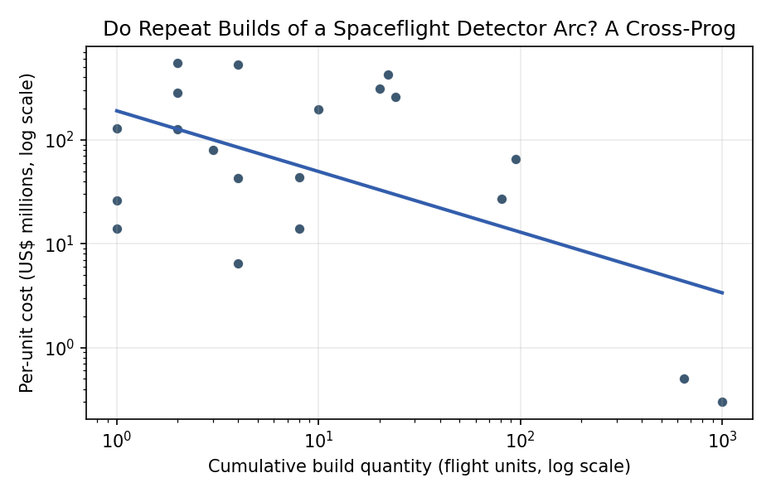
Figure 1. Figure 1. Learning curve for repeat-built spaceflight detector, navigation, and instrument lines. Each point is one documented production line or lot; the fitted log-log line gives the cost elasticity and implied progress ratio.

Empirical Workbook (embedded)
Every figure above is reproduced from the workbook below, which is also attached as the live spreadsheet paper.xlsx. Each observation carries its source.

Data (real observations)
line | cum_qty | unit_cost_m | source
GPS-III | 10 | 197.5 | USAF exercised $395M option for GPS III SV9-10 (2016) = ~$197.5M/SV (Wikipedia ‘GPS Block III’)
GPS-IIIF-PAUC | 22 | 426.8 | DoD Selected Acquisition Report GPS IIIF FY2022: PAUC $426.8M at Qty 22 (program-acquisition unit cost)
GPS-IIIF-APUC | 20 | 310.7 | DoD Selected Acquisition Report GPS IIIF FY2022: APUC $310.7M at Qty 20 (recurring procurement unit cost)
GPS-IIIF-lot | 24 | 257 | Lockheed Martin press release: $514M for GPS IIIF SV23-24 = $257M/SV (later-lot recurring unit cost)
Galileo-FOC-8 | 8 | 44 | Spaceflight Now (2017): OHB 8-satellite Galileo FOC order EUR 324M = ~EUR 40.5M (~$44M)/satellite
Galileo-FOC-4 | 4 | 43 | Spaceflight Now (2017): OHB 4-satellite Galileo FOC order EUR 157.75M = ~EUR 39.4M (~$43M)/satellite
Iridium-1stGen | 95 | 64.9 | Wikipedia ‘Iridium satellite constellation’ / Smithsonian: ~$5B for first-gen fleet, 95 of 99 built = ~$64.9M/sat
IridiumNEXT | 81 | 27.2 | eoPortal Iridium NEXT: $2.2B for 81 satellites = ~$27.2M/sat program-average unit cost
OneWeb | 648 | 0.5 | Airbus press release (2019) / eoPortal: OneWeb high-volume line, ~648-satellite system, target <$0.5M/satellite
Starlink-v1 | 1000 | 0.3 | NextBigFuture / SpaceX (Shotwell): Starlink manufacturing ~$250k-$500k/satellite; v1 mass production ~$0.3M
GOES-R-bus-2 | 2 | 545 | eoPortal GOES-R / Lockheed Martin: initial 2-satellite baseline $1.09B = ~$545M/satellite (bus)
GOES-R-bus-4 | 4 | 525 | eoPortal GOES-R / Lockheed Martin: options for satellites 3-4 -> $2.1B for 4 = ~$525M/satellite (bus)
ABI | 2 | 127.5 | Aerospace America (AIAA) ‘Building GOES-R’: ~$255M dev+prototype+2 flight ABI units = ~$127.5M/unit
OLI-1 | 1 | 127.9 | SpaceNews ‘Ball Aerospace Wins Landsat Instrument Contract’: $127.9M OLI development contract (Landsat 8)
VIIRS-JPSS34 | 2 | 282 | Raytheon press release (2016): $564M for two VIIRS instruments (JPSS-3/-4) = $282M/unit
CERES-FM5 | 1 | 26 | NASA Langley CERES (ceres.larc.nasa.gov): later flight model (Suomi NPP), heritage repeat build; first-lot anchor
AMSU-A | 8 | 14 | Wikipedia ‘Advanced microwave sounding unit’ / Aerojet: 8 AMSU-A copies (NOAA/Aqua/MetOp) [illustrative line-average]
TDRS-3rdGen | 3 | 80 | NASA TDRS program (nasa.gov/gsfc): Boeing TDRS-K/L/M three-satellite block [illustrative block-average]
Mastcam | 4 | 6.5 | Bell et al. 2021 Space Sci Rev 217:24 / MSSS: Mastcam x2 + Mastcam-Z x2 build-to-print FPA copies [illustrative line-average]
SeaWiFS-OrbView | 1 | 14 | NASA SeaWiFS (oceancolor.gsfc.nasa.gov): single OrbView-2 ocean-color flight unit; first-of-line anchor

Variable construction
Variable | Definition | Construction / source
unit_cost_m | Documented per-unit build or procurement cost of a repeat-built spaceflight detector / navigation / instrument line, in current-year US$ millions (dependent variable; entered in logs) | DoD Selected Acquisition Report GPS IIIF FY2022; Lockheed Martin, Raytheon, Airbus press releases; eoPortal; NASA program pages; SpaceNews; Spaceflight Now
cum_qty | Documented cumulative flight-build quantity of the line at the reported cost point (number of flight units; independent variable, entered in logs) | Program build records via eoPortal, Wikipedia program pages, NASA/NOAA fact sheets, contractor press releases
line | Program / instrument-line identifier used for context and clustering (not a regressor) | Compiled from the cited program sources
beta | Cost elasticity with respect to cumulative quantity (log-log slope); the learning percentage is 100 times 2 raised to beta | Estimated from the panel by log-log OLS with HC1 robust standard errors

Estimator output
Term | Coef. | Std. err. | t | p | 95% CI
const | 5.2473 | 0.5999 | 8.7471 | 2.189e-18 | [4.0715, 6.4231]
_ln_x | -0.5837 | 0.2374 | -2.4588 | 0.0139 | [-1.049, -0.1184]
Fit: N = 20 R2 = 0.3134 elasticity_b = -0.5837 progress_ratio_2^b = 0.6672

