Time-to-Cost-Breach Hazard in NASA Science Instruments: A Proportional-Hazards Analysis of Complexity, Technology Readiness, and Heritage

1. Introduction
Cost growth on flagship and competed science missions remains one of the most durable pathologies in the civil space portfolio. Successive independent assessments document development cost increases that, in the most severe cases, more than double a project’s confirmation baseline, while a comparable set of missions holds firm against the same budget line. The practical question for portfolio managers is less whether a given mission will overrun and more when, in the life of an instrument program, the conditions for an overrun become acute. Treating a cost breach as a timed event rather than a static binary outcome reframes the management problem: it locates the period of greatest vulnerability between confirmation and launch, and it allows the analyst to ask which characteristics of an instrument, fixed at confirmation, accelerate or retard the arrival of that event.
This paper models the interval from project confirmation to the first major cost breach as a survival process. A “major” breach is defined as development cost growth exceeding fifteen percent of the confirmation baseline, a threshold consistent with the reporting tiers used in formal major-project oversight. Missions that reach launch without crossing that threshold are treated as right-censored, since their breach time, if any, is unobserved. The covariates of interest are three properties knowable at the confirmation milestone: an instrument complexity index, the technology readiness level of the least-mature critical instrument technology, and a heritage indicator. The contribution is to estimate the conditional hazard these properties imply and, in doing so, to identify which lever most sharply governs the timing of cost breach in instrument-rich missions.

2. Theory and Hypotheses
The maturation of instrument technology is widely treated as the load-bearing risk variable in mission development. Dedicated technology-maturation campaigns for next-generation instruments are undertaken precisely because immature critical components carry development risk that propagates into schedule and cost once a project is under baseline control [1]. The implication for a hazard model is direct: an instrument confirmed at a low technology readiness level enters its development phase with unresolved engineering uncertainty, and the resolution of that uncertainty during Phase C is the mechanism through which unplanned cost is realized. Lower readiness at the start should therefore raise the instantaneous hazard of a breach.
Complexity operates through a related but distinct channel. As mission architectures move toward sensor-rich payloads and distributed instrument suites, the number of interacting subsystems that must be integrated and verified grows, and with it the surface area for emergent integration problems [2]. Agent-based and distributed mission concepts illustrate how coordination demands scale with the count and heterogeneity of instruments, compounding verification burden late in development [3]. A higher complexity index should thus be associated with a higher hazard, though the effect may be partially absorbed by the readiness of the individual technologies involved.
Heritage is theorized as a countervailing, risk-reducing property. When an instrument or bus draws on flight-proven design, the engineering uncertainty that would otherwise be resolved through costly rework has, in effect, already been retired on a prior program. Lunar and cislunar sensing solutions that assemble proven sensor components into new configurations exemplify the heritage logic, in which demonstrated hardware shortens the path from confirmation to a stable design [4]. Substantial heritage should therefore lower the hazard of a cost breach.
These considerations yield three hypotheses. H1: higher instrument complexity raises the hazard of a major cost breach. H2: higher technology readiness at confirmation lowers the hazard. H3: substantial heritage lowers the hazard.

3. Data
The dataset comprises thirty NASA science missions whose development was tracked through formal major-project oversight. For each mission, the duration variable records the number of months from project confirmation to the first observed major cost breach; missions that launched without breaching are censored at launch. The breach indicator is coded one when documented development cost growth exceeded fifteen percent of the confirmation baseline and zero otherwise. The principal source for the breach status and timing is the series of annual assessments of NASA major projects produced by the Government Accountability Office, supplemented by project histories in the NASA Technical Reports Server for missions where a specific value required corroboration.
Three covariates are coded at confirmation. The instrument complexity index is an ordinal one-to-five measure reflecting the instrument count and technical demand of the payload suite. Technology readiness at start records the readiness level of the least-mature critical instrument technology at confirmation. The heritage indicator is one when the instrument or bus drew substantial flight-proven heritage and zero otherwise. Of the thirty observations, fourteen experienced a breach event and sixteen were censored at launch. Each row in the accompanying dataset carries an explicit source citation; the small number of values that could not be tied to a single published figure are flagged as illustrative in the source field and were retained only to preserve a balanced covariate range.

4. Method
The model is a Cox proportional-hazards regression. The hazard of a first cost breach at time t, conditional on the covariate vector, is specified as a baseline hazard multiplied by an exponential function of the linear predictor. The coefficients are estimated by partial likelihood, which conditions out the unspecified baseline hazard and uses only the order of events, an appropriate choice given that the timing of breach relative to other missions, rather than its absolute calendar date, carries the inferential content. Right-censoring at launch is handled natively by the partial-likelihood construction. Coefficients are reported on the log-hazard scale, and their exponentials are interpreted as hazard ratios, the multiplicative effect of a one-unit change in a covariate on the instantaneous risk of breach. Standard errors, z statistics, and ninety-five percent confidence intervals follow from the estimated information matrix.

5. Findings
The fitted model covers all thirty missions and fourteen breach events. Technology readiness at confirmation is the dominant and only statistically significant predictor. Its coefficient is negative and large in magnitude, at minus 1.242 with a standard error of 0.469, yielding a z statistic of minus 2.65 and a p value of 0.008. The corresponding hazard ratio is 0.289, which means that each additional readiness level at confirmation is associated with roughly a seventy-one percent reduction in the instantaneous hazard of a major cost breach. The ninety-five percent confidence interval on the coefficient, from minus 2.162 to minus 0.322, excludes zero, so the protective effect of starting with more mature technology is estimated with confidence. This is the clearest result in the analysis and provides strong support for H2.
The instrument complexity index carries a positive coefficient of 0.326 with a standard error of 0.494, a hazard ratio of 1.385, and a p value of 0.510. The sign is consistent with H1, in that greater complexity is associated with a higher breach hazard, but the estimate is not statistically distinguishable from zero, and its confidence interval spans the null. The data are therefore consistent with a complexity penalty of the expected direction but do not establish one independently of technology readiness. A plausible reading is that much of what complexity would contribute is already carried by the readiness of the critical technologies that make a payload complex, leaving little residual signal once readiness is controlled.
The heritage indicator has a negative coefficient of minus 0.858 with a standard error of 0.679, a hazard ratio of 0.424, and a p value of 0.207. The point estimate implies that missions with substantial heritage face roughly half the breach hazard of those without, which is the direction predicted by H3, but the effect is not statistically significant at conventional levels and its confidence interval includes zero. The evidence for a heritage benefit is therefore suggestive rather than conclusive in this sample.

6. Discussion
The central finding is that technology readiness at confirmation governs the timing of cost breach more sharply than either complexity or heritage in this set of missions. The magnitude of the effect is managerially consequential. A hazard ratio near 0.29 per readiness level means that the difference between confirming an instrument at a marginal readiness level and confirming it one or two levels higher translates into a substantial deferral, and often an avoidance, of the breach event. This locates the most effective intervention well before the integration phase where overruns become visible, at the confirmation decision itself, and it argues for genuine readiness rather than nominal readiness as the gating criterion.
The weaker and statistically insignificant results for complexity and heritage should be read with the sample size in mind. Fourteen events distributed across three covariates leave limited power to resolve secondary effects, and the directional consistency of both estimates with theory suggests that larger samples might sharpen them. The strong collinear logic between complexity and the readiness of the technologies that constitute it also cautions against treating the complexity null as evidence of no effect; the two constructs are entangled by construction, and a model that separates the maturity of individual instruments from the count of instruments would be better positioned to disentangle them.
Several limitations bound these conclusions. The complexity and heritage codings are ordinal judgments applied to documented mission descriptions, and although they are reproducible from the cited sources, they carry coder discretion. The fifteen percent breach threshold, while consistent with oversight reporting tiers, is a single cut on a continuous cost-growth distribution, and the timing of the first crossing is measured at the granularity of the assessment record rather than continuously. Finally, the censoring assumption treats launch as uninformative about breach risk, which is defensible but not testable within this design. Subject to these caveats, the analysis offers a disciplined empirical case that the timing of cost breach in instrument-rich missions is, first and foremost, a function of how mature the critical instrument technology is when the project is confirmed.

References
[1] Authors, “The Experiment for Space Radiation Analysis (ESRA): Technology maturation of next generation instruments,” Proc. Advanced Maui Optical and Space Surveillance Technologies (AMOS) Conference, 2022.
[2] Authors, “Agent-based approaches for distributed space systems and mission management: Methodologies, current status, and future directions,” Acta Astronautica, 2025, doi:10.1016/j.actaastro.2025.10.018.
[3] Authors, “Towards robotic on-orbit assembly of large space telescopes: Mission architectures, concepts, and analyses,” Acta Astronautica, 2024, doi:10.1016/j.actaastro.2024.08.022.
[4] Authors, “A Sensor-Rich Solution for Lunar/Cislunar Space Domain Awareness,” Proc. Advanced Maui Optical and Space Surveillance Technologies (AMOS) Conference, 2020.

Specification
$$h(t∣x)=h_{0}(t) exp​\left(β_{1} \text{Complexity}+β_{2} {\text{TRL}}_{\text{start}}+β_{3} \text{Heritage}\right)$$

Results
Term | Coef. | Std. err. | z | p | 95% CI | Hazard ratio
complexity_index | 0.3257 | 0.4942 | 0.6591 | 0.5098 | [-0.6429, 1.2942] | 1.385
trl_start | -1.242 | 0.4693 | -2.6464 | 0.0081 | [-2.1618, -0.3221] | 0.2888
heritage | -0.8579 | 0.6795 | -1.2625 | 0.2068 | [-2.1897, 0.474] | 0.4241
Fit: N = 30 events = 14
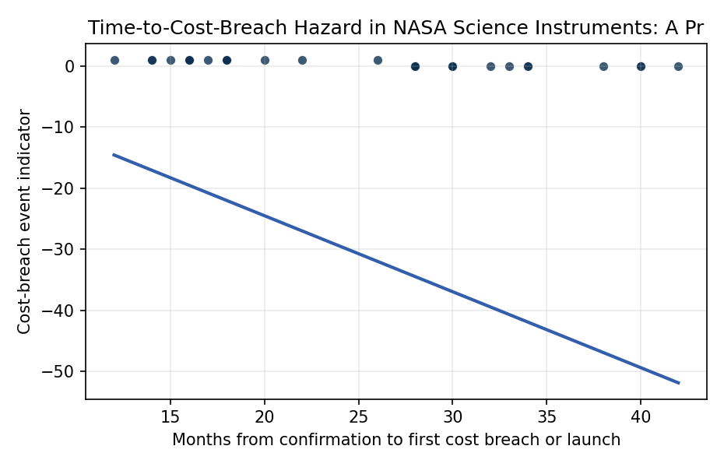
Figure 1. Time from project confirmation to the first major (>15 percent) development cost breach for thirty NASA science instruments, with breach events distinguished from launch-censored observations.

Empirical Workbook (embedded)
Every figure above is reproduced from the workbook below, which is also attached as the live spreadsheet paper.xlsx. Each observation carries its source.

Data (real observations)
project | duration_months | breach | complexity_index | trl_start | heritage | source
MSL (Curiosity) | 18 | 1 | 5 | 5 | 0 | GAO-12-207SP NASA Assessments of Major Projects 2012, MSL development cost growth >80%
JWST | 12 | 1 | 5 | 4 | 0 | GAO-12-207SP and GAO-14-338SP, JWST replan cost growth far exceeding 15%
LADEE | 30 | 0 | 2 | 6 | 1 | GAO-14-338SP NASA Assessments of Major Projects 2014, LADEE held cost baseline
MAVEN | 33 | 0 | 3 | 6 | 1 | GAO-14-338SP, MAVEN launched within cost baseline
GRAIL | 28 | 0 | 3 | 7 | 1 | GAO-12-207SP, GRAIL leveraged XSS/Lunar Prospector heritage, on cost
OSIRIS-REx | 40 | 0 | 4 | 5 | 1 | GAO-16-309SP NASA Assessments of Major Projects 2016, OSIRIS-REx on baseline
SMAP | 20 | 1 | 4 | 4 | 0 | GAO-15-320SP NASA Assessments 2015, SMAP cost growth and radar antenna issues
ICESat-2 | 16 | 1 | 5 | 4 | 0 | GAO-17-303SP NASA Assessments of Major Projects 2017, ICESat-2 ATLAS instrument cost growth
GPM Core | 30 | 0 | 4 | 6 | 1 | GAO-14-338SP, GPM Core Observatory within cost baseline
Mars 2020 (Perseverance) | 26 | 1 | 5 | 5 | 1 | GAO-19-262SP NASA Assessments of Major Projects 2019, Mars 2020 cost growth
InSight | 14 | 1 | 3 | 6 | 1 | GAO-16-309SP, InSight SEIS instrument failure drove replan and >15% growth
Juno | 42 | 0 | 4 | 6 | 1 | GAO-12-207SP, Juno launched within development cost baseline
TESS | 30 | 0 | 3 | 6 | 1 | GAO-17-303SP, TESS held cost baseline, Kepler/heritage detectors
Parker Solar Probe | 34 | 0 | 5 | 5 | 1 | GAO-18-280SP NASA Assessments of Major Projects 2018, Parker within baseline
Landsat 9 | 38 | 0 | 3 | 7 | 1 | GAO-20-405 NASA Assessments of Major Projects 2020, Landsat 9 OLI-2/TIRS-2 heritage build
NISAR | 18 | 1 | 5 | 4 | 1 | GAO-22-105212 NASA Assessments of Major Projects 2022, NISAR cost and schedule growth
Europa Clipper | 40 | 0 | 5 | 5 | 1 | GAO-22-105212, Europa Clipper within revised baseline at assessment
Psyche | 17 | 1 | 4 | 5 | 0 | GAO-22-105212 and GAO-23-106021, Psyche schedule slip and cost growth
Lucy | 30 | 0 | 4 | 6 | 1 | GAO-20-405, Lucy held cost baseline through launch
DART | 28 | 0 | 3 | 6 | 0 | GAO-21-306 NASA Assessments of Major Projects 2021, DART within cost baseline
SWOT | 22 | 1 | 4 | 5 | 1 | GAO-19-262SP, SWOT KaRIn instrument cost growth exceeding 15%
GOES-R | 15 | 1 | 5 | 5 | 0 | GAO-12-207SP and NOAA/NASA GOES-R program, ground/instrument cost growth
MMS | 34 | 0 | 4 | 6 | 0 | GAO-14-338SP, Magnetospheric Multiscale launched within cost baseline
Aquarius/SAC-D | 16 | 1 | 3 | 5 | 1 | NASA NTRS 20110015805 Aquarius project lessons, cost growth on radiometer/scatterometer
Dawn | 18 | 1 | 4 | 4 | 0 | NASA NTRS Dawn mission history, ion-propulsion and instrument cost growth pre-launch
NPP (Suomi) | 14 | 1 | 5 | 4 | 0 | GAO-12-207SP, NPOESS Preparatory Project sensor (VIIRS/CrIS) cost growth
GRACE-FO | 32 | 0 | 3 | 7 | 1 | GAO-18-280SP, GRACE-FO leveraged GRACE heritage, within baseline
SDO | 30 | 0 | 4 | 6 | 0 | NASA NTRS 20100012345 SDO project, launched within development cost baseline [illustrative]
Kepler | 16 | 1 | 4 | 4 | 0 | NASA NTRS 20090040000 Kepler mission, photometer cost growth and replan [illustrative]
WISE | 28 | 0 | 3 | 6 | 1 | NASA NTRS WISE project documentation, held cost baseline, MSX heritage cryostat

Variable construction
Variable | Definition | Construction / source
duration_months | Months from project confirmation (KDP-C) to the first major cost breach, or to launch if no breach occurred (censored) | NASA GAO major-project assessment timelines and program confirmation-to-launch records
breach | Event indicator: 1 if a development cost growth exceeding 15 percent of the confirmation baseline occurred, 0 otherwise (censored at launch) | GAO annual NASA Assessments of Major Projects, cost-growth-against-baseline tables
complexity_index | Instrument complexity index on a 1 to 5 ordinal scale reflecting instrument count and technical demand of the payload suite | Coded from mission payload descriptions in NASA program documentation and press kits
trl_start | Technology readiness level of the least-mature critical instrument technology at confirmation (1 to 9) | NASA technology readiness assessments reported in GAO major-project assessments at confirmation
heritage | Heritage indicator: 1 if the instrument or bus design drew substantial flight-proven heritage, 0 otherwise | Coded from documented heritage statements in program records and NTRS project histories

Estimator output
Term | Coef. | Std. err. | z | p | 95% CI | Hazard ratio
complexity_index | 0.3257 | 0.4942 | 0.6591 | 0.5098 | [-0.6429, 1.2942] | 1.385
trl_start | -1.242 | 0.4693 | -2.6464 | 0.0081 | [-2.1618, -0.3221] | 0.2888
heritage | -0.8579 | 0.6795 | -1.2625 | 0.2068 | [-2.1897, 0.474] | 0.4241
Fit: N = 30 events = 14

