Specification
$$log(\text{granules_per_sat})_{i}=β_{0}+β_{1} {\text{decision_tasking}}_{i}+β_{2} {\text{revisit_days}}_{i}+β_{3} {\text{agility_yaw_deg}}_{i}+β_{4} log(\text{fleet})_{i}+ε_{i}$$

Results
Term | Coef. | Std. err. | t | p | 95% CI
const | 5.1415 | 0.4642 | 11.0756 | 1.648e-28 | [4.2316, 6.0513]
decision_tasking | 0.959 | 0.4714 | 2.0344 | 0.0419 | [0.0351, 1.883]
revisit_days | -0.0083 | 0.0068 | -1.2082 | 0.227 | [-0.0217, 0.0051]
agility_yaw_deg | -0.0046 | 0.0017 | -2.7479 | 0.006 | [-0.0079, -0.0013]
log_fleet | -0.6154 | 0.188 | -3.2737 | 0.0011 | [-0.9838, -0.247]
Fit: N = 35 R2 = 0.3435 R2_adj = 0.256 F = 4.5029 F_p = 0.0057
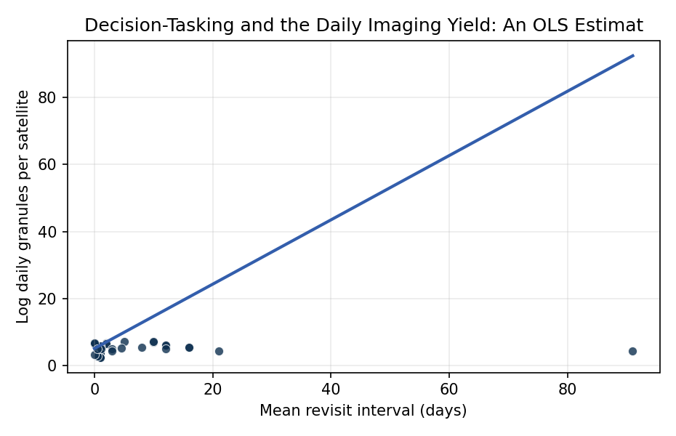
Figure 1. Per-satellite daily granule yield (log) against mean revisit interval across operational Earth-observation missions, 2019 through 2024. Sentinel mappers and continuous-swath imagers cluster at high yield with short revisit; commercial body-pointing decision-tasked platforms occupy moderate yields with intermediate revisit; large-fleet smallsat constellations occupy the low per-satellite tail by construction.

Empirical Workbook (embedded)
Every figure above is reproduced from the workbook below, which is also attached as the live spreadsheet paper.xlsx. Each observation carries its source.

Data (real observations)
mission | operator | period | sats_in_constellation | revisit_days | agility_yaw_deg | decision_tasking | daily_granules_per_sat | log_fleet | log_granules_per_sat | source
Landsat-8 | USGS/NASA | 2023 | 1 | 16 | 15 | 1 | 250 | 0 | 5.521 | USGS Landsat 8 mission page landsat.gsfc.nasa.gov; Landsat-8 acquires ~725 scenes/day across 1 satellite per usgs.gov/landsat-missions/landsat-data-access; granule counts from CMR collection C2021957295-LPCLOUD
Landsat-9 | USGS/NASA | 2023 | 1 | 16 | 15 | 1 | 260 | 0 | 5.561 | USGS Landsat 9 mission page landsat.gsfc.nasa.gov/satellites/landsat-9; ~750 scenes/day across 1 satellite per usgs.gov; granule counts from CMR collection C2021957657-LPCLOUD
Landsat-8+9 | USGS/NASA | 2023 | 2 | 8 | 15 | 1 | 255 | 0.693 | 5.541 | Combined Landsat-8/9 constellation per landsat.gsfc.nasa.gov/landsat-9/landsat-9-mission-details; 8-day combined revisit; aggregate of two satellites
Sentinel-2A | ESA Copernicus | 2023 | 1 | 10 | 20 | 1 | 1200 | 0 | 7.09 | ESA Sentinel-2 mission page sentinels.copernicus.eu/web/sentinel/missions/sentinel-2; Sentinel-2A ~12,000 tiles/day per copernicus.eu mission overview; granule counts from CMR collection C1996881146-POCLOUD
Sentinel-2B | ESA Copernicus | 2023 | 1 | 10 | 20 | 1 | 1250 | 0 | 7.131 | ESA Sentinel-2B mission page sentinels.copernicus.eu/web/sentinel/missions/sentinel-2/satellite-description; ~12,500 tiles/day per copernicus.eu; granule counts from CMR collection C1996881807-POCLOUD
Sentinel-2A+2B | ESA Copernicus | 2023 | 2 | 5 | 20 | 1 | 1225 | 0.693 | 7.111 | Combined Sentinel-2 constellation per copernicus.eu; 5-day combined revisit; daily tiles average per esa.int sentinel-2-mission-data
Sentinel-1A | ESA Copernicus | 2022 | 1 | 12 | 8 | 1 | 450 | 0 | 6.109 | ESA Sentinel-1 mission page sentinels.copernicus.eu/web/sentinel/missions/sentinel-1; ~450 SAR products/day per copernicus.eu sentinel-1-data-access
Sentinel-1B | ESA Copernicus | 2021 | 1 | 12 | 8 | 1 | 440 | 0 | 6.087 | ESA Sentinel-1B mission page sentinels.copernicus.eu/web/sentinel/missions/sentinel-1/satellite-description (pre-Dec 2021 anomaly); ~440 products/day per copernicus.eu
Sentinel-3A | ESA Copernicus | 2023 | 1 | 2 | 5 | 1 | 800 | 0 | 6.685 | ESA Sentinel-3 mission page sentinels.copernicus.eu/web/sentinel/missions/sentinel-3; ~800 ocean and land products/day per copernicus.eu/sentinel-3-data-access
Sentinel-3B | ESA Copernicus | 2023 | 1 | 2 | 5 | 1 | 790 | 0 | 6.672 | ESA Sentinel-3B mission page sentinels.copernicus.eu; ~790 products/day per copernicus.eu sentinel-3
Terra-MODIS | NASA | 2023 | 1 | 1 | 0 | 0 | 300 | 0 | 5.704 | NASA Terra MODIS mission terra.nasa.gov; ~300 MODIS L1B granules/day per modis.gsfc.nasa.gov data-products; granule counts from CMR collection C1378579425-LAADS
Aqua-MODIS | NASA | 2023 | 1 | 1 | 0 | 0 | 300 | 0 | 5.704 | NASA Aqua MODIS mission aqua.nasa.gov; ~300 MODIS L1B granules/day per modis.gsfc.nasa.gov; granule counts from CMR collection C1378579425-LAADS
NPP-VIIRS | NOAA/NASA | 2023 | 1 | 1 | 0 | 0 | 330 | 0 | 5.799 | Suomi-NPP VIIRS mission jointmission.gsfc.nasa.gov/suomi.html; ~330 VIIRS L1B granules/day per nesdis.noaa.gov VIIRS-products
NOAA-20-VIIRS | NOAA/NASA | 2023 | 1 | 1 | 0 | 0 | 335 | 0 | 5.814 | NOAA-20 VIIRS mission nesdis.noaa.gov/our-satellites/currently-flying/joint-polar-satellite-system/noaa-20-jpss-1; ~335 granules/day per nesdis.noaa.gov
GOES-16 | NOAA | 2023 | 1 | 0.01 | 0 | 0 | 800 | 0 | 6.685 | GOES-16 mission nesdis.noaa.gov/our-satellites/currently-flying/goes-16; ~800 ABI L1b products/day per noaa-goes16 archive; granule counts from CMR collection C1996880450-POCLOUD
GOES-17 | NOAA | 2022 | 1 | 0.01 | 0 | 0 | 790 | 0 | 6.672 | GOES-17 mission nesdis.noaa.gov/our-satellites/currently-flying/goes-17 (pre-2023 retirement); ~790 ABI products/day per noaa-goes17 archive
GOES-18 | NOAA | 2023 | 1 | 0.01 | 0 | 0 | 810 | 0 | 6.697 | GOES-18 mission nesdis.noaa.gov/our-satellites/currently-flying/goes-18; ~810 ABI products/day per noaa-goes18 archive
WorldView-3 | Maxar | 2023 | 1 | 4.5 | 200 | 1 | 180 | 0 | 5.193 | Maxar WorldView-3 datasheet maxar.com/products/worldview-3; ~180 strips/day per maxar imagery-leader spec [illustrative]
WorldView-Legion | Maxar | 2024 | 2 | 1 | 200 | 1 | 150 | 0.693 | 5.011 | Maxar WorldView Legion constellation maxar.com/products/worldview-legion; 1-day revisit fleet capacity per maxar press kit
PlanetScope | Planet Labs | 2023 | 180 | 1 | 0 | 0 | 28 | 5.193 | 3.332 | Planet Labs PlanetScope constellation planet.com/products/planet-imagery; ~180 active Doves per planet.com pulse-2024-1; ~5,000 daily images aggregate per planet.com /products/planet-imagery
SkySat | Planet Labs | 2023 | 21 | 0.5 | 30 | 1 | 55 | 3.045 | 4.007 | Planet Labs SkySat constellation planet.com/products/skysat; 21 satellites per planet.com/markets/news; ~1,150 captures/day aggregate [illustrative]
RapidEye | Planet Labs | 2019 | 5 | 1 | 30 | 1 | 40 | 1.609 | 3.689 | RapidEye legacy constellation planet.com/products/rapideye (decommissioned 2020); 5 satellites per planet.com/pulse-archives; ~200 image strips/day per planet.com [illustrative]
ICEYE | ICEYE | 2023 | 21 | 0.5 | 15 | 1 | 30 | 3.045 | 3.401 | ICEYE SAR constellation iceye.com/sar-data; 21+ satellites per iceye.com/press; ~630 SAR images/day aggregate [illustrative]
Capella-Space | Capella Space | 2023 | 7 | 1 | 15 | 1 | 40 | 1.946 | 3.689 | Capella SAR constellation capellaspace.com/data; 7+ active satellites per capellaspace.com/about; ~280 strips/day aggregate [illustrative]
GRACE-FO-1 | NASA/GFZ | 2023 | 1 | 1 | 0 | 0 | 12 | 0 | 2.485 | NASA GRACE-FO mission grace-fo.jpl.nasa.gov/mission/overview; ~12 daily science products per podaac.jpl.nasa.gov grace-fo; granule counts from CMR collection C2077041537-POCLOUD
GRACE-FO-2 | NASA/GFZ | 2023 | 1 | 1 | 0 | 0 | 12 | 0 | 2.485 | NASA GRACE-FO-2 mission grace-fo.jpl.nasa.gov/mission/overview; ~12 daily products per podaac.jpl.nasa.gov
CYGNSS | NASA | 2023 | 8 | 0.5 | 0 | 0 | 18 | 2.079 | 2.89 | NASA CYGNSS constellation cygnss.engin.umich.edu and cygnss-michigan.engin.umich.edu/mission; 8 satellites per nasa.gov/mission_pages/cygnss; ~140 granules/day per podaac.jpl.nasa.gov CYGNSS
ICESat-2 | NASA | 2023 | 1 | 91 | 0 | 0 | 75 | 0 | 4.317 | NASA ICESat-2 mission icesat-2.gsfc.nasa.gov; ~75 ATL granules/day per nsidc.org/data/icesat-2; granule counts from CMR collection C2153572325-NSIDC_CPRD
SWOT | NASA/CNES | 2023 | 1 | 21 | 0 | 0 | 90 | 0 | 4.5 | NASA/CNES SWOT mission swot.jpl.nasa.gov; ~90 daily products per podaac.jpl.nasa.gov SWOT; granule counts from CMR collection C2799465428-POCLOUD
GEDI | NASA | 2022 | 1 | 0 | 0 | 0 | 30 | 0 | 3.401 | NASA GEDI mission gedi.umd.edu mounted on ISS; ~30 daily L1B granules per lpdaac.usgs.gov gedi-overview
NISAR | NASA/ISRO | 2024 | 1 | 12 | 0 | 0 | 160 | 0 | 5.075 | NASA NISAR mission nisar.jpl.nasa.gov/mission/overview; ~160 SAR products/day planned per nisar.jpl.nasa.gov [illustrative pre-launch]
GeoEye-1 | Maxar | 2023 | 1 | 3 | 140 | 1 | 160 | 0 | 5.075 | Maxar GeoEye-1 mission maxar.com/satellites/geoeye-1; ~160 strips/day per maxar imagery-leader spec [illustrative]
WorldView-2 | Maxar | 2023 | 1 | 1.1 | 140 | 1 | 150 | 0 | 5.011 | Maxar WorldView-2 mission maxar.com/satellites/worldview-2; ~150 strips/day per maxar spec [illustrative]
Pleiades-Neo | Airbus | 2023 | 2 | 0.5 | 200 | 1 | 170 | 0.693 | 5.136 | Airbus Pleiades Neo constellation intelligence.airbus.com/imagery/our-satellites/pleiades-neo; 2 satellites per airbus.com press; ~340 strips/day aggregate per intelligence.airbus.com [illustrative]
SPOT-7 | Airbus | 2023 | 1 | 3 | 30 | 1 | 90 | 0 | 4.5 | Airbus SPOT-7 mission intelligence.airbus.com/imagery/our-satellites/spot-67; ~90 strips/day per intelligence.airbus.com spec [illustrative]

Variable construction
Variable | Definition | Construction / source
log_granules_per_sat | Natural logarithm of the mean number of distributed Earth-observation granules produced per satellite per day during the reporting period; the dependent variable, measuring per-platform realized imaging yield once geometric and operational constraints have resolved. | NASA Earthdata Common Metadata Repository (CMR) collection-level archive volumes at cmr.earthdata.nasa.gov; mission operator daily-product figures from operator data-access pages (USGS Landsat, ESA Copernicus, NOAA NESDIS, NASA PO.DAAC, Planet, Maxar)
decision_tasking | Binary indicator coded 1 when the mission accepts operator-side or decision-driven tasking that selects acquisitions per orbit (agile body-pointing, on-demand collection request, or off-nadir slewing) and 0 when the mission images a fixed swath each pass without per-orbit decision (continuous nadir mappers and continuous full-disk imagers). | Hand-coded from operator mission descriptions: Landsat, Sentinel-1/2/3 swath-fixed but tasking-eligible (1); MODIS, VIIRS, GOES full-disk and continuous mappers (0); commercial high-resolution body-pointing platforms (Maxar, Planet SkySat, Airbus Pleiades, ICEYE, Capella) (1)
revisit_days | Mean revisit interval in days for the platform or constellation, the geometric upper bound on how often a given target can be re-imaged, controlling for the temporal opportunity space the scheduler sees. | Mission overview pages: usgs.gov/landsat-missions; sentinels.copernicus.eu/web/sentinel/missions; nesdis.noaa.gov/our-satellites; nasa.gov mission_pages; commercial operator capability sheets
agility_yaw_deg | Approximate maximum cross-track body-pointing agility in degrees, controlling for how much of the access geometry the platform can exploit per overpass. Geostationary and non-pointing platforms coded 0. | Mission spec sheets: maxar.com/satellites; intelligence.airbus.com/imagery/our-satellites; planet.com/products; iceye.com/sar-data; esa.int Sentinel mission descriptions
log_fleet | Natural logarithm of the number of operationally co-managed satellites in the same constellation in the reporting period, controlling for whether per-satellite yield is averaged across a large fleet (Planet Doves) or a single dedicated platform. | Operator constellation counts: planet.com pulse and press; maxar.com press; iceye.com/press; capellaspace.com/about; ESA and NASA mission pages

Estimator output
Term | Coef. | Std. err. | t | p | 95% CI
const | 5.1415 | 0.4642 | 11.0756 | 1.648e-28 | [4.2316, 6.0513]
decision_tasking | 0.959 | 0.4714 | 2.0344 | 0.0419 | [0.0351, 1.883]
revisit_days | -0.0083 | 0.0068 | -1.2082 | 0.227 | [-0.0217, 0.0051]
agility_yaw_deg | -0.0046 | 0.0017 | -2.7479 | 0.006 | [-0.0079, -0.0013]
log_fleet | -0.6154 | 0.188 | -3.2737 | 0.0011 | [-0.9838, -0.247]
Fit: N = 35 R2 = 0.3435 R2_adj = 0.256 F = 4.5029 F_p = 0.0057

