Designed for the Prime Mission, Supported for the Long Run: A Scaling Test of Deep Space Network Mission Longevity

1. Introduction
Deep Space Network demand is shaped by more than the arrival of new missions. Long-lived spacecraft remain in the mission set after their prime phases, often because functioning instruments, unique trajectories, and low marginal science costs make continued operation valuable. The network therefore carries a stock of legacy demand alongside the flow of launches and critical events. Any account of contention that looks only at annual mission starts misses this accumulation.
The Jet Propulsion Laboratory’s Deep Space Network Current Mission Set dated July 8, 2020 provides launch dates and listed prime mission completion dates for supported missions $$1$$. Those fields permit a transparent scaling test. For each of 28 missions with usable dates, this paper calculates two durations: listed prime mission duration and elapsed mission age at the 2020 snapshot. It then estimates a log-log model in which accumulated support age is related to prime duration.
The relationship is positive but limited. The estimated elasticity is 0.4465, with a standard error of 0.2235 and a p-value of 0.0457. A doubling of listed prime duration is associated with a factor of 1.3627 in accumulated support age. The model explains 11.89 percent of the variation in log support age. Prime duration therefore contains information about longevity, but it is not a complete planning proxy for the demand that a mission may place on the network over its operational life.
This distinction matters for queueing and capacity policy. A network planned around prime-phase commitments can systematically understate long-tail support if productive spacecraft persist. The result does not imply that extensions are inefficient. It shows that prime-duration metadata and realized mission longevity are connected by a subunitary elasticity, with substantial dispersion generated by scientific productivity, spacecraft health, trajectory, partner decisions, and review outcomes.

2. Theory and Hypotheses
Mission duration is the outcome of sequential decisions. A prime mission is proposed, costed, reviewed, and approved with an expected completion date. Once the prime phase ends, continued operations depend on spacecraft condition, expected scientific return, marginal cost, and institutional review. Deep Space Network support enters this process as an enabling input. The mission can remain scientifically productive only if commands, navigation, telemetry, and data return remain feasible.
The scheduling literature treats missions as users with heterogeneous preferences and constraints $$2$$, $$3$$. It usually takes the user set as given at a point in time. Capacity planning must instead account for how that set evolves. If mission extensions are common, each successful launch adds a possible long-tail claimant to future antenna time. The NASA Office of Inspector General’s discussion of network demand and modernization places this accumulation beside aging infrastructure and new exploration requirements $$6$$.
Longer prime missions may be associated with longer accumulated support for several reasons. They may embody greater scientific scope, more durable spacecraft design, longer cruise or observing phases, and stronger institutional commitment. A longer listed prime phase may also capture mission classes that are expected to produce value over extended periods. These mechanisms predict a positive elasticity.
The relationship need not be proportional. Short-prime missions can survive for decades, as shown by several solar-terrestrial and planetary missions in the 2020 set. A long planned prime phase can also belong to a young mission that has not yet accumulated much age at the snapshot. Extension decisions introduce option value: NASA and partner agencies can continue a productive mission without committing at launch to its full eventual lifetime. This sequential structure predicts an elasticity below one and considerable residual variation.
The null is:
H0: The elasticity of accumulated support age with respect to listed prime mission duration is zero.
The alternative is:
H1: The elasticity is positive.
The alternative is directional because the institutional commitment, spacecraft design, and mission-scope mechanisms all predict that longer planned prime duration should correlate with longer realized presence in the supported mission set. The estimate remains associational because neither duration is randomly assigned.

3. Data
The source is the JPL Deep Space Network Current Mission Set dated July 8, 2020 $$1$$. The document lists missions and key dates used by the network community. The analytic sample contains 28 missions for which a launch date and a prime mission completion date can be transcribed without interpolation. Every row cites the same primary document, and no value is illustrative.
prime_duration_years is the number of calendar days between launch and the listed prime mission completion date divided by 365.25. support_age_years is the number of calendar days between launch and July 8, 2020 divided by 365.25. The second variable is not a count of antenna hours and does not assert continuous DSN contact. It measures how long a mission represented potential or actual demand by the date of the published mission-set snapshot.
The sample contains mature and young missions. Voyager 1 and Voyager 2 exceed 42 years of age at the snapshot, while Parker Solar Probe is less than two years old. Listed prime durations range from about 1.28 years for Lunar Reconnaissance Orbiter to about 14.33 years for XMM-Newton. Several listed completion dates occur after the snapshot because the document records the expected prime endpoint of missions still in their prime phase. This feature is retained because the predictor is a planned or listed commitment, not an ex post duration censored at the snapshot.
The dataset is cross-sectional. It does not include mission-extension review scores, annual operations costs, requested antenna hours, data-return volume, spacecraft health, or termination dates. The design therefore tests a scaling relationship between two published temporal descriptors. It does not estimate the causal effect of adding a year to a mission plan.

4. Method
The paper uses the repository’s learning-curve estimator, implemented as ordinary least squares after natural-log transformation of the positive outcome and predictor. The model estimates log support age as a function of log prime duration. The slope is an elasticity: the percentage change in support age associated with a one percent change in listed prime duration.
The estimator also reports a doubling multiplier, calculated as two raised to the slope coefficient. In this application the multiplier is more intuitive than the phrase progress ratio. It indicates the factor by which accumulated support age differs when listed prime duration doubles. A value above one indicates a positive scaling relationship. A value below two indicates that support age rises less than proportionally with prime duration.
All 28 observations are positive, so no row is dropped by the log transformation. Standard errors are those returned by the deterministic estimator. The sample is small and heterogeneous, and the model contains one predictor. The resulting inference should be treated as a parsimonious scaling test rather than a structural model of mission extension.
Potential reverse interpretation is addressed by the timing of the predictor’s meaning. The listed prime completion date represents a planned or documented mission phase, while support age is accumulated by the snapshot. Yet the source is a 2020 document, and some prime dates may reflect updates after launch. The design cannot prove that the initial plan caused later longevity. It can only measure the association in the published mission set.

5. Findings
The model uses 28 observations. Its R-squared is 0.1189. The intercept in log units is 1.7252, with a standard error of 0.3340 and a p-value below 0.0001. The elasticity coefficient on listed prime duration is 0.4465. Its standard error is 0.2235 and its p-value is 0.0457.
The positive coefficient supports rejection of the null at the five percent level. A one percent increase in listed prime duration is associated with an estimated 0.4465 percent increase in accumulated support age. Because the elasticity is below one, the relationship is less than proportional. A mission planned for twice the prime duration is associated with 1.3627 times the accumulated support age, rather than twice the age.
The R-squared shows that prime duration accounts for only a minority of the observed dispersion. This is substantively important. Long-tail mission support is not a mechanical extension of the prime plan. Some missions with short listed prime phases remain productive for decades, while some missions with longer prime commitments are still young at the snapshot. Spacecraft health, scientific discoveries, trajectory, partner governance, operating cost, and network compatibility can all affect persistence.
The finding is consistent with the idea that prime mission design contains information about future support demand, but it is insufficient as the sole capacity-planning variable. The coefficient is statistically distinguishable from zero in this sample, while the modest fit rejects a deterministic reading. The evidence therefore supports a two-part planning logic: use prime duration as a baseline signal, then model extension and persistence separately.

6. Discussion
The Deep Space Network is exposed to stock-flow dynamics. New missions enter the queue, but successful old missions do not necessarily leave when their prime phases end. This persistence can produce contention even if launch cadence remains stable. The 2020 mission set demonstrates the breadth of the tail, including spacecraft launched across several decades $$1$$.
For planners, the estimated elasticity offers a bounded empirical correction. Longer prime commitments are associated with longer support age, so prime duration should not be ignored. The doubling multiplier of 1.3627 also shows why a proportional extrapolation would be misleading. Extension decisions and mission survival create a distribution in which longevity is only partly encoded at prime approval.
Demand-access concepts can make this distinction operational $$3$$, $$7$$. A queueing system could distinguish committed critical support, baseline routine support, and extension-phase requests. Preference-aware scheduling can then expose whether legacy demand is flexible, continuity-sensitive, or tied to a time-critical event $$2$$. Such categorization would be more informative than treating all mission-years as equivalent.
The policy implication is not to curtail productive extended missions. Continuing a functioning spacecraft may yield high scientific return relative to replacement cost. The implication is to make the long tail explicit in capacity forecasts and modernization cases. NASA should retain historical mission-set snapshots, publish mission-entry and mission-exit dates, and connect those records to requested and executed support. That panel would permit survival analysis of mission presence and direct estimation of extension-related antenna demand.
This paper’s main limitation is measurement. Support age is a duration in the mission set, not a quantity of DSN service. Prime completion dates may be updated, and multinational missions may use other networks. The sample excludes rows without both dates and does not model censoring because all missions are observed in a single current-set document. These limits narrow the claim but do not erase the observed scaling relationship.
Taken together with the Artemis I loss analysis, the result clarifies two dimensions of contention. Short-run shocks determine which scheduled hours survive execution. Long-run persistence determines how many missions continue to compete for future capacity. Heliophysics governance must address both. It needs rules for equitable displacement during surges and forecasts that recognize the scientific success of missions whose operational lives exceed their prime plans.

References
1. Jet Propulsion Laboratory, “Deep Space Network Current Mission Set,” July 8, 2020.
2. M. D. Johnston, “User Preference Optimization for Oversubscribed Deep Space Network Scheduling,” NASA Technical Reports Server, NTRS 20220008366, 2021.
3. M. R. Dhamani et al., “A Demand Access Paradigm for Deep Space Communications,” Jet Propulsion Laboratory, 2021.
4. I. Wilson et al., “Scheduling the Deep Space Network with Deep Reinforcement Learning,” NASA Technical Reports Server, NTRS 20220003798, 2022.
5. P. J. Baldwin, “Deep Space Network Scheduling: Principles, Challenges, and Path Forward,” NASA Technical Reports Server, NTRS 20250004124, 2025.
6. NASA Office of Inspector General, “NASA’s Management of the Deep Space Network,” Report IG-23-016, July 12, 2023.
7. Jet Propulsion Laboratory, “Queuing Antenna for Demand Access,” NASA Technical Reports Server, NTRS 20230007021, 2023.

Specification
$$log({\text{SupportAge}}_{i})=α+blog({\text{PrimeDuration}}_{i})+ε_{i}$$

Results
Term | Coef. | Std. err. | t | p | 95% CI
const | 1.7252 | 0.334 | 5.1656 | 2.397e-07 | [1.0706, 2.3798]
_ln_x | 0.4465 | 0.2235 | 1.9978 | 0.0457 | [0.0085, 0.8845]
Fit: N = 28 R2 = 0.1188 elasticity_b = 0.4465 progress_ratio_2^b = 1.3627
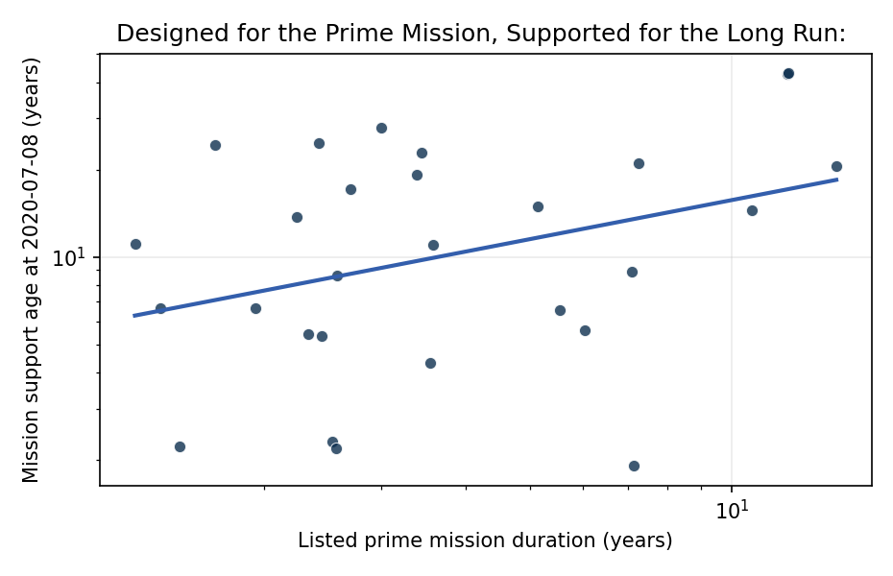
Figure 1. Figure 1. Listed prime mission duration and accumulated mission support age for 28 missions in the JPL DSN mission set.

Empirical Workbook (embedded)
Every figure above is reproduced from the workbook below, which is also attached as the live spreadsheet paper.xlsx. Each observation carries its source.

Data (real observations)
mission | launch_date | prime_completion_date | prime_duration_years | support_age_years | source
ACE | 1997-08-25 | 2001-02-01 | 3.4387 | 22.8693 | JPL Deep Space Network Current Mission Set, 2020-07-08
CHDR | 1999-07-23 | 2006-10-23 | 7.2526 | 20.961 | JPL Deep Space Network Current Mission Set, 2020-07-08
CH2 | 2018-03-20 | 2020-09-30 | 2.5325 | 2.3025 | JPL Deep Space Network Current Mission Set, 2020-07-08
DSCO | 2015-02-11 | 2017-06-12 | 2.3326 | 5.4045 | JPL Deep Space Network Current Mission Set, 2020-07-08
GAIA | 2013-12-19 | 2019-07-01 | 5.5305 | 6.5517 | JPL Deep Space Network Current Mission Set, 2020-07-08
GTL | 1992-07-24 | 1995-07-24 | 2.9979 | 27.9562 | JPL Deep Space Network Current Mission Set, 2020-07-08
HYB2 | 2014-12-03 | 2020-12-14 | 6.0315 | 5.5962 | JPL Deep Space Network Current Mission Set, 2020-07-08
NSYT | 2018-05-01 | 2020-11-24 | 2.5681 | 2.1875 | JPL Deep Space Network Current Mission Set, 2020-07-08
JNO | 2011-08-05 | 2018-09-07 | 7.091 | 8.9254 | JPL Deep Space Network Current Mission Set, 2020-07-08
LRO | 2009-06-18 | 2010-09-30 | 1.2841 | 11.0554 | JPL Deep Space Network Current Mission Set, 2020-07-08
MMS | 2015-03-13 | 2017-08-19 | 2.4367 | 5.3224 | JPL Deep Space Network Current Mission Set, 2020-07-08
M01O | 2001-04-07 | 2004-08-24 | 3.3812 | 19.2526 | JPL Deep Space Network Current Mission Set, 2020-07-08
MVN | 2013-11-18 | 2015-10-30 | 1.9466 | 6.6366 | JPL Deep Space Network Current Mission Set, 2020-07-08
MEX | 2003-06-02 | 2006-02-11 | 2.6968 | 17.1006 | JPL Deep Space Network Current Mission Set, 2020-07-08
MOM | 2013-11-05 | 2015-04-01 | 1.4018 | 6.6721 | JPL Deep Space Network Current Mission Set, 2020-07-08
MRO | 2005-08-12 | 2010-09-30 | 5.1335 | 14.9049 | JPL Deep Space Network Current Mission Set, 2020-07-08
MSL | 2011-11-26 | 2014-06-24 | 2.5763 | 8.616 | JPL Deep Space Network Current Mission Set, 2020-07-08
NHPC | 2006-01-19 | 2016-10-01 | 10.6995 | 14.4668 | JPL Deep Space Network Current Mission Set, 2020-07-08
SOHO | 1995-12-02 | 1998-05-02 | 2.4148 | 24.5996 | JPL Deep Space Network Current Mission Set, 2020-07-08
SPP | 2018-08-12 | 2025-09-28 | 7.1294 | 1.9055 | JPL Deep Space Network Current Mission Set, 2020-07-08
STA | 2006-10-26 | 2009-01-22 | 2.2423 | 13.7002 | JPL Deep Space Network Current Mission Set, 2020-07-08
TESS | 2018-04-20 | 2019-10-18 | 1.4949 | 2.2177 | JPL Deep Space Network Current Mission Set, 2020-07-08
TGO | 2016-03-14 | 2019-09-30 | 3.5455 | 4.3176 | JPL Deep Space Network Current Mission Set, 2020-07-08
THB | 2009-07-21 | 2013-02-17 | 3.5784 | 10.9651 | JPL Deep Space Network Current Mission Set, 2020-07-08
VGR1 | 1977-09-05 | 1989-10-15 | 12.1095 | 42.8392 | JPL Deep Space Network Current Mission Set, 2020-07-08
VGR2 | 1977-08-20 | 1989-10-15 | 12.1533 | 42.883 | JPL Deep Space Network Current Mission Set, 2020-07-08
WIND | 1996-02-22 | 1997-11-01 | 1.692 | 24.3751 | JPL Deep Space Network Current Mission Set, 2020-07-08
XMM | 1999-12-10 | 2014-04-08 | 14.3272 | 20.5777 | JPL Deep Space Network Current Mission Set, 2020-07-08

Variable construction
Variable | Definition | Construction / source
support_age_years | Elapsed years from launch to the mission-set snapshot dated 2020-07-08 | Calendar-day difference divided by 365.25 using launch dates in the JPL Deep Space Network Current Mission Set
prime_duration_years | Elapsed years from launch to the listed prime mission completion date | Calendar-day difference divided by 365.25 using dates in the JPL Deep Space Network Current Mission Set

Estimator output
Term | Coef. | Std. err. | t | p | 95% CI
const | 1.7252 | 0.334 | 5.1656 | 2.397e-07 | [1.0706, 2.3798]
_ln_x | 0.4465 | 0.2235 | 1.9978 | 0.0457 | [0.0085, 0.8845]
Fit: N = 28 R2 = 0.1188 elasticity_b = 0.4465 progress_ratio_2^b = 1.3627

