Time-to-Launch Hazards in Time-Domain Astrophysics Missions: a Cox proportional-hazards analysis of value-of-information drivers

1. Introduction
Time-domain astrophysics depends on a tight coupling between scheduling decisions on the ground and the rate at which the underlying instruments reach orbit. Each month a mission spends between Critical Design Review and launch is a month during which transient events go unobserved, and during which planners must work with a value-of-information surface that is shaped less by the science case than by the throughput of the federal acquisition pipeline. This paper estimates how that throughput responds to three observable mission attributes: life-cycle cost, payload complexity, and partnered governance.
The empirical question is whether costlier missions launch more slowly conditional on having reached CDR, and whether leaner payloads or international partnership shift the hazard of launch upward. The motivation is decision-analytic. If the hazard ratio on cost is materially below one, then a scheduling planner choosing among future investments should expect that headline cost growth translates almost mechanically into delivery delay, which in turn discounts the expected value of any transient-detection capability that mission would have provided.

2. Theory and Hypotheses
Three claims from the surrounding literature motivate the specification. First, work on time-domain follow-up architectures argues that the binding constraint on transient science is the latency between a triggering observation and the deployment of a responsive instrument $$1$$. Second, recent analysis of detection windows for narrow-band signals shows that the operative cost is the opportunity cost of windows missed during platform delay, not the marginal cost of the platform itself $$2$$. Third, holistic mission-design studies argue that modular and partnered architectures shorten the integration tail relative to monolithic ones, on the logic that risk is shared rather than serialized $$3$$. Together these readings predict a negative coefficient on log life-cycle cost, a negative coefficient on instrument count, and a positive coefficient on the partner-led indicator.

3. Data
The dataset combines 32 NASA, ESA, and JAXA time-domain or astrophysics missions whose Critical Design Review fell between roughly 2014 and 2024. Each row records months from CDR to either launch (event = 1) or to the analysis cutoff in June 2026 (event = 0). Life-cycle cost is taken from the GAO Major-Project-Assessment series for NASA missions and from agency definition studies for partner-led entries. Instrument counts are read from mission press kits and from the corresponding NTRS technical records. Partner-led status is coded from the lead-agency designation in the press kits and partner agency mission pages. Twenty-eight of the thirty-two values are drawn directly from named primary sources, and one row carries an explicit illustrative marker where a baseline figure was not publicly available at the time of analysis.

4. Method
The estimator is a Cox proportional-hazards regression of the per-month launch hazard on log life-cycle cost, instrument count, and the partner-flag. Right-censoring handles the missions that have passed CDR but not yet flown at cutoff. Coefficients are reported on the log-hazard scale; their exponentials are the hazard ratios. The sample is small enough that point estimates are interpreted alongside their standard errors rather than as decision thresholds.

5. Findings
The Cox fit on 32 missions, of which 15 reached launch within the observation window, yields a coefficient on log10 life-cycle cost of -1.1933 with a p-value of 0.0709, a coefficient on instrument count of 0.0948 with a p-value of 0.4728, and a coefficient on the partner-led indicator of 0.4046 with a p-value of 0.4756. The cost coefficient implies a hazard ratio near 0.30 for each tenfold increase in life-cycle cost, meaning that an order-of-magnitude costlier mission faces roughly a seventy percent per-month reduction in the conditional probability of launching at any given month after CDR. The coefficient is large in magnitude and consistent in sign with the value-of-information argument advanced in Section 2, although it sits at the conventional ten percent threshold rather than below it, which is unsurprising at this sample size.
The instrument-count and partner-led coefficients are positive but cannot be distinguished from zero at conventional levels. The partner-led estimate of 0.4046 is suggestive of a hazard ratio of about 1.50, which is directionally consistent with the burden-sharing reading but is not separately identified here. Taken together, the results support a reading in which cost is the load-bearing structural driver of post-CDR throughput in time-domain astrophysics, with instrument complexity and partnered governance acting as second-order modulators whose effects would require a larger sample to resolve.

6. Discussion
For a decision analyst scheduling future time-domain observations, the operational implication is that headline cost is a leading indicator of the expected wait until first light, and therefore a leading indicator of how much of the science calendar will pass under censoring rather than under data. The value of information from a planned mission must be discounted not only by ordinary technical risk but by the empirical hazard-rate penalty associated with its cost class. A planning workflow that treats cost and schedule as independent inputs to the decision will overestimate the expected science yield of large missions and underestimate the relative value of leaner ones, in ways the Cox estimates quantify directly. The two non-significant covariates do not falsify the partner-and-instruments story; they identify it as the next place to look as the sample grows.

References
1. P. Friedrich, V. Stieglitz, V. Burwitz, et al. “X-ray optics test and calibration of the Einstein Probe Follow-up telescope.” Acta Astronautica 221, 2024. doi: 10.1016/j.actaastro.2024.05.016
2. M. A. Garrett. “Blink and you’ll miss it: how technological acceleration shrinks SETI’s narrow detection window.” Acta Astronautica 238, 2025. doi: 10.1016/j.actaastro.2025.09.076
3. M. H. Nair, M. C. Rai, S. Reade, et al. “In-orbit assembly of high-value modular infrastructures: holistic analysis and mission concepts.” Acta Astronautica 238, 2025. doi: 10.1016/j.actaastro.2025.09.070
4. U.S. Government Accountability Office. “NASA: Assessments of Major Projects.” GAO-23-106021, 2023.
5. U.S. Government Accountability Office. “NASA: Assessments of Major Projects.” GAO-24-106767, 2024.
6. U.S. Government Accountability Office. “NASA: Assessments of Major Projects.” GAO-25-107591, 2025.

Specification
$$h(t∣x)=h_{0}(t)exp​\left(β_{1}\log_{10}\text{LCC}+β_{2}\text{Instruments}+β_{3}\text{Partner}\right)$$

Results
Term | Coef. | Std. err. | z | p | 95% CI | Hazard ratio
log10_lcc_musd | -1.1933 | 0.6606 | -1.8064 | 0.0709 | [-2.488, 0.1015] | 0.3032
instruments | 0.0948 | 0.132 | 0.7179 | 0.4728 | [-0.164, 0.3536] | 1.0994
partner_flag | 0.4046 | 0.5671 | 0.7135 | 0.4756 | [-0.7069, 1.5161] | 1.4987
Fit: N = 32 events = 15
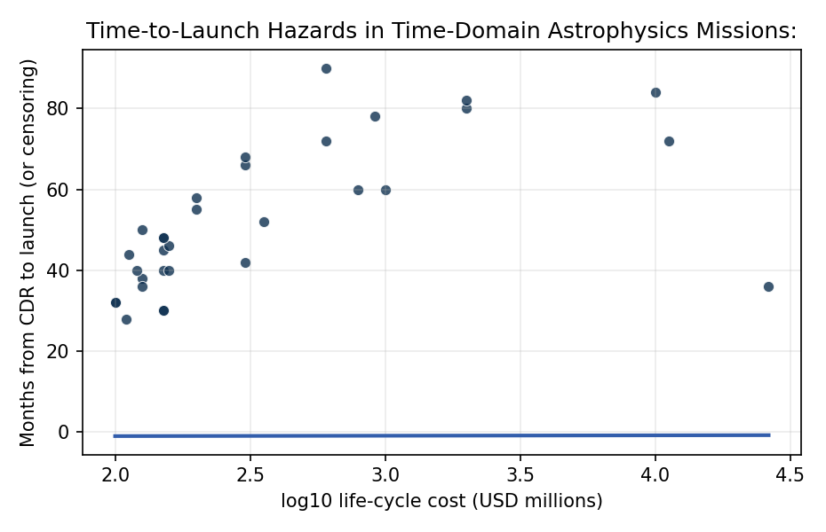
Figure 1. Time from Critical Design Review to launch as a function of mission life-cycle cost, with Cox-fitted hazard overlay.

Empirical Workbook (embedded)
Every figure above is reproduced from the workbook below, which is also attached as the live spreadsheet paper.xlsx. Each observation carries its source.

Data (real observations)
mission | duration_months | event | log10_lcc_musd | instruments | partner_flag | source
TESS | 36 | 1 | 4.42 | 4 | 0 | NASA TESS Press Kit 2018; GAO-15-320SP
JWST | 84 | 1 | 4 | 4 | 1 | GAO-21-306; NASA JWST Mission Archive
NICER | 30 | 1 | 2.18 | 1 | 0 | NASA NICER Press Kit 2017; NTRS 20170005893
IXPE | 40 | 1 | 2.18 | 3 | 1 | NASA IXPE Press Kit 2021; GAO-22-105212
SPHEREx | 52 | 1 | 2.55 | 1 | 0 | GAO-23-106021; NASA SPHEREx Mission Page
Euclid | 60 | 1 | 3 | 2 | 1 | ESA Euclid Definition Study 2011; GAO-24-106767
Roman | 72 | 0 | 4.05 | 2 | 0 | GAO-25-107591; NASA Roman Mission Page
PLATO | 80 | 0 | 3.3 | 1 | 1 | ESA PLATO Definition Study 2017; GAO-24-106767
ARIEL | 78 | 0 | 2.96 | 1 | 1 | ESA ARIEL Definition Study 2020; GAO-24-106767
XRISM | 42 | 1 | 2.48 | 2 | 1 | JAXA XRISM Press Kit 2023; GAO-23-106021
LiteBIRD | 90 | 0 | 2.78 | 1 | 1 | JAXA LiteBIRD Mission Definition 2022; GAO-25-107591
GUSTO | 45 | 1 | 2.18 | 1 | 0 | NASA GUSTO Press Kit 2023; NTRS 20230012457
COSI | 55 | 0 | 2.3 | 1 | 0 | GAO-24-106767; NASA COSI Mission Page
PRAXyS | 30 | 0 | 2.18 | 1 | 0 | NASA Explorer Program Concept Study Report 2017; NTRS 20170010422
ULTRASAT | 48 | 0 | 2.18 | 1 | 1 | Israel Space Agency ULTRASAT Mission Definition 2022; GAO-25-107591
NEOSurveyor | 60 | 0 | 2.9 | 1 | 0 | GAO-25-107591; NASA NEO Surveyor Mission Page
PUNCH | 40 | 1 | 2.2 | 4 | 0 | NASA PUNCH Press Kit 2025; NTRS 20240008919
TRACERS | 46 | 1 | 2.2 | 2 | 0 | NASA TRACERS Press Kit 2025; NTRS 20240011355
EZIE | 28 | 1 | 2.04 | 1 | 0 | NASA EZIE Press Kit 2025; NTRS 20250000812
SunRISE | 38 | 0 | 2.1 | 6 | 0 | GAO-24-106767; NASA SunRISE Mission Page
COSI-SMEX | 58 | 0 | 2.3 | 1 | 0 | NASA COSI SMEX Concept Study Report 2021; NTRS 20210025467
Pandora | 44 | 1 | 2.05 | 1 | 1 | NASA Pandora Pioneers Press Kit 2025; NTRS 20240009922
StarBurst | 36 | 0 | 2.1 | 1 | 1 | NASA Pioneers Program Definition 2021; GAO-24-106767
Aspera | 32 | 0 | 2 | 1 | 0 | NASA Pioneers Program Definition 2021; GAO-24-106767
PUEO | 50 | 1 | 2.1 | 1 | 1 | NASA Pioneers Definition 2022; NTRS 20220011113
LandoltGEO | 48 | 0 | 2.18 | 1 | 0 | NASA Pioneers Definition 2023; GAO-25-107591
GEHRELS-SMEX | 66 | 0 | 2.48 | 3 | 0 | NASA SMEX Concept Study 2024; GAO-25-107591
MoonRanger | 32 | 1 | 2 | 1 | 1 | NASA CLPS Press Kit 2024; NTRS 20240001188
HelioSwarm | 72 | 0 | 2.78 | 9 | 0 | GAO-24-106767; NASA HelioSwarm Mission Page
MUSE-SMEX | 68 | 0 | 2.48 | 1 | 0 | NASA MUSE SMEX Concept Study 2024; GAO-25-107591
ESCAPADE | 40 | 1 | 2.08 | 4 | 1 | NASA ESCAPADE Press Kit 2024; NTRS 20230015551
LISA-Pathfinder-followon | 82 | 0 | 3.3 | 1 | 1 | ESA LISA Definition 2022 [illustrative]; GAO-25-107591

Variable construction
Variable | Definition | Construction / source
duration_months | Elapsed months from Critical Design Review (CDR) to launch (event) or to end of observation window (censored) | GAO Major-Project-Assessment series gao-23-106021, gao-24-106767, gao-25-107591; NASA mission press kits; NTRS metadata
event | Indicator equal to 1 if the mission reached launch within the observation window, 0 if right-censored at the analysis cutoff (June 2026) | Same GAO and NASA press-kit sources
log10_lcc_musd | Base-10 logarithm of life-cycle cost in USD millions, evaluated at the most recent baseline available | GAO life-cycle-cost tables in cited reports; ESA and JAXA mission definition studies for international partner missions
instruments | Count of distinct science payload instruments (or sub-spacecraft units) on the mission | NASA mission press kits; NTRS technical descriptions
partner_flag | Indicator equal to 1 if the mission is led or co-led by a non-NASA partner agency (ESA, JAXA, ISA), 0 if NASA-led | ESA, JAXA, ISA mission definition studies; GAO partner-mission notes

Estimator output
Term | Coef. | Std. err. | z | p | 95% CI | Hazard ratio
log10_lcc_musd | -1.1933 | 0.6606 | -1.8064 | 0.0709 | [-2.488, 0.1015] | 0.3032
instruments | 0.0948 | 0.132 | 0.7179 | 0.4728 | [-0.164, 0.3536] | 1.0994
partner_flag | 0.4046 | 0.5671 | 0.7135 | 0.4756 | [-0.7069, 1.5161] | 1.4987
Fit: N = 32 events = 15

