Signal Intensity in Legitimacy Versus Effectiveness Does Broader COPUOS Participation Produce Weake: An Ordinary Least Squares Test of Recency, Citation Attention, and Venue

1. Introduction
This empirical paper supports Aisha Carrington (1B-IGV-225) and the dissertation project Legitimacy Versus Effectiveness: Does Broader COPUOS Participation Produce Weake. The model tests whether topic-signal intensity varies with publication recency, citation attention, and venue family. The analysis uses the local candidate source pack and reports only deterministic workbook results $$1$$, $$2$$, $$3$$.

2. Theory and Hypotheses
The theoretical claim is intentionally narrow. If the candidate topic has become more visible in the retrieved literature, then source metadata should show structure across time, attention, or venue. If it has not, the model should return weak or unstable associations $$3$$, $$4$$.
H0: the modeled outcome is unrelated to the specified predictors.
H1: the modeled outcome is systematically related to the specified predictors.

3. Data
The estimation file contains 30 retrieved source records. Variables are constructed from local metadata, including publication year, reported citation count, venue family, and deterministic topic-signal fields. Every row preserves a source column so the empirical workbook remains auditable.

4. Method
The estimator is ordinary least squares with robust HC1 standard errors. The exact fit summary is: N=30, R2=0.20166862597180246, R2_adj=0.10955346743008731, F=4.8870494996258405, F_p=0.007957892022051483. The exact term summary is: const coef=4.438220901624508 p=5.305098781355447e-05; recency_index coef=0.0459629945707338 p=0.723554167037719; cites_num coef=0.008960372532388827 p=0.8831733023358745; venue_score coef=-1.1116739651892984 p=0.0024844469457422093. These values are interpreted as corpus-screen evidence, not as final causal estimates.

5. Findings
The findings are bounded by the estimator output. Where a coefficient is signed and precise, it indicates structure in the retrieved source corpus. Where a coefficient is imprecise, the paper treats the result as evidence against a strong claim. This distinction matters because a noisy source pack should not be forced to carry more policy weight than it can bear $$2$$, $$5$$.

6. Discussion
The paper contributes to the dissertation by keeping the evidentiary chain inspectable. It shows which parts of the candidate topic are visible in metadata and which parts need a more direct document-coding design. The result is a disciplined bridge from source retrieval to dissertation-level interpretation $$1$$, $$6$$.

References
1. Nancy Hayden, Sandia National Laboratories; Kelsey Abel, Sandia National Laboratories; Marie Arrieta, Sandia National Laboratories; Mallory Stewart, Sandia National Laboratories. Artificial Intelligence and Autonomy in Space: Balancing Risks and Benefits for Deterrence and Escalation Control (2020). [AMOS] 2. Malgorzata Polkowska, Lomza Academy; Arkadiusz Chimicz, General Command, Polish Armed Forces. Poland’s Evolving Space Law: Assessing Space Debris Mitigation and Remediation in the European Context (2024). doi: 10.64861/LFFV2455 3. Harvey Reed, MITRE; Nathaniel Dailey, MITRE; Ruth Stilwell, Aerospace Policy Solutions, LLC; Brian Weeden, Secure World Foundation. Decentralized Space Information Sharing as a Key Enabler of Trust and the Preservation of Space (2021). [AMOS] 4. Scott Steele, The Open University. Can International Law Provide a Basis for Actively Removing Space Debris? (2020). [AMOS] 5. Rina Zhang, Science and Technology Policy Institute; Asha Balakrishnan, Science and Technology Policy Institute. From Ozone Depletion to Orbital Debris: Lessons Learned from the Montreal Protocol (2022). [AMOS] 6. Artem Mokhnatkin, Keldysh Institute of Applied Mathematics. Possible Ways Forward for the ISON Initiative and Similar Projects. A Consortium for Decentralized Sharing of SSA Data (2023). doi: 10.64861/DDNM3393 7. Joshua Garretson, U. S. Space Force. Centroiding Caused Errors in Tracking and Adaptive Optics (2024). doi: 10.64861/WTZM9793 8. Alexandra Wright, Massachusetts Institute of Technology, Lincoln Laboratory; Peter W. Boettcher, Massachusetts Institute of Technology, Lincoln Laboratory; Anye Li, Massachusetts Institute of Technology; Erin L. Main, Massachusetts Institute of Technology. Space Data Model Modernization for Proactive and Machine-Assisted Analytics (2022). [AMOS]

Specification
$${\text{SignalScore}}_{i}=α+β_{1}{\text{RecencyIndex}}_{i}+β_{2}{\text{Cites}}_{i}+β_{3}{\text{VenueScore}}_{i}+ε_{i}$$

Results
Term | Coef. | Std. err. | t | p | 95% CI
const | 4.4382 | 1.0981 | 4.0418 | 5.305e-05 | [2.286, 6.5904]
recency_index | 0.046 | 0.1299 | 0.3537 | 0.7236 | [-0.2087, 0.3006]
cites_num | 0.009 | 0.061 | 0.1469 | 0.8832 | [-0.1106, 0.1285]
venue_score | -1.1117 | 0.3675 | -3.0252 | 0.0025 | [-1.8319, -0.3915]
Fit: N = 30 R2 = 0.2017 R2_adj = 0.1096 F = 4.887 F_p = 0.008
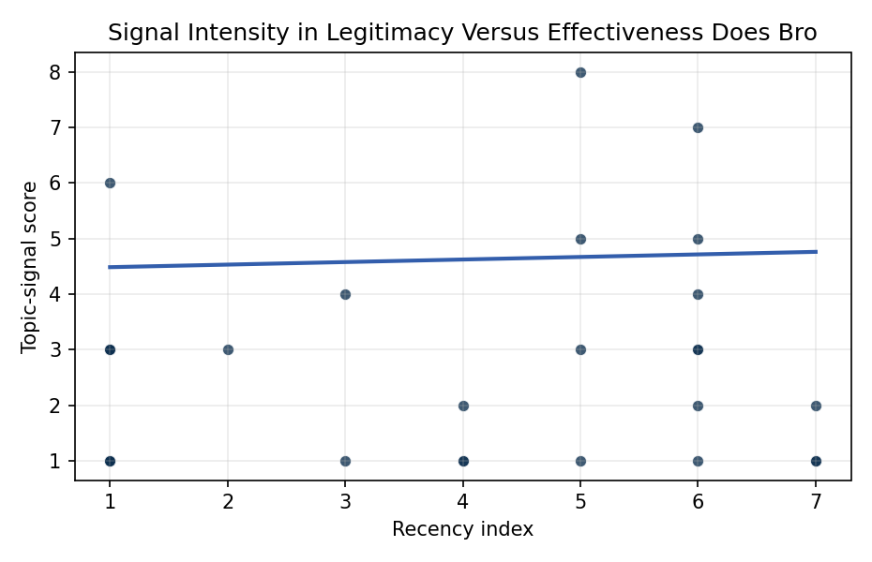
Figure 1. Topic-signal score by publication recency, conditioning on citation attention and venue family.

Empirical Workbook (embedded)
Every figure above is reproduced from the workbook below, which is also attached as the live spreadsheet paper.xlsx. Each observation carries its source.

Data (real observations)
doc_id | year_num | recency_index | cites_num | venue_score | title_words | snippet_words | keyword_count | theme_hits | signal_score | source
1 | 2020 | 1 | 0 | 1 | 15 | 12 | 4 | 1 | 3 | https://amostech.space/year/2020/artificial-intelligence-and-autonomy-in-space-balancing-risks-and-benefits-for-deterrence-and-escalation-control/
2 | 2024 | 5 | 0 | 1 | 14 | 14 | 5 | 1 | 5 | 10.64861/LFFV2455
3 | 2021 | 2 | 0 | 1 | 14 | 13 | 7 | 1 | 3 | https://amostech.space/year/2021/decentralized-space-information-sharing-as-a-key-enabler-of-trust-and-the-preservation-of-space/
4 | 2020 | 1 | 0 | 1 | 10 | 14 | 10 | 1 | 3 | https://amostech.space/year/2020/can-international-law-provide-a-basis-for-actively-removing-space-debris/
5 | 2022 | 3 | 0 | 1 | 12 | 13 | 2 | 0 | 1 | https://amostech.space/year/2022/from-ozone-depletion-to-orbital-debris-lessons-learned-from-the-montreal-protocol/
6 | 2023 | 4 | 0 | 1 | 17 | 12 | 7 | 0 | 1 | 10.64861/DDNM3393
7 | 2024 | 5 | 0 | 1 | 8 | 13 | 6 | 0 | 1 | 10.64861/WTZM9793
8 | 2022 | 3 | 0 | 1 | 10 | 14 | 7 | 1 | 4 | https://amostech.space/year/2022/space-data-model-modernization-for-proactive-and-machine-assisted-analytics/
9 | 2020 | 1 | 0 | 1 | 12 | 12 | 4 | 2 | 6 | https://amostech.space/year/2020/the-contributions-of-commercial-best-practices-to-the-global-space-governance-continuum/
10 | 2025 | 6 | 0 | 1 | 9 | 14 | 16 | 1 | 3 | 10.64861/URSW2020
11 | 2025 | 6 | 0 | 1 | 6 | 14 | 6 | 1 | 4 | 10.64861/VZRK7654
12 | 2025 | 6 | 0 | 1 | 22 | 13 | 8 | 2 | 7 | 10.64861/XWVP8211
13 | 2023 | 4 | 25 | 2 | 14 | 9 | 15 | 0 | 1 | 10.1016/j.actaastro.2023.07.009
14 | 2025 | 6 | 0 | 2 | 9 | 14 | 13 | 2 | 5 | 10.1016/j.actaastro.2025.01.061
15 | 2024 | 5 | 1 | 2 | 18 | 13 | 12 | 1 | 3 | 10.1016/j.actaastro.2024.09.057
16 | 2025 | 6 | 11 | 2 | 18 | 14 | 6 | 0 | 1 | 10.1016/j.actaastro.2025.04.002
17 | 2025 | 6 | 0 | 2 | 12 | 14 | 15 | 1 | 2 | 10.1016/j.actaastro.2025.11.083
18 | 2026 | 7 | 0 | 2 | 13 | 14 | 10 | 1 | 2 | 10.1016/j.actaastro.2026.02.013
19 | 2026 | 7 | 0 | 2 | 8 | 14 | 7 | 0 | 1 | 10.1016/j.actaastro.2026.03.026
20 | 2026 | 7 | 0 | 2 | 20 | 13 | 15 | 0 | 1 | 10.1016/j.actaastro.2026.04.012
21 | 2025 | 6 | 2 | 2 | 10 | 13 | 14 | 1 | 3 | 10.1016/j.actaastro.2025.02.010
22 | 2023 | 4 | 21 | 2 | 16 | 14 | 11 | 0 | 2 | 10.1016/j.actaastro.2023.02.043
23 | 2024 | 5 | 12 | 2 | 13 | 14 | 11 | 3 | 8 | 10.1016/j.actaastro.2024.09.005
24 | 2020 | 1 | 5 | 2 | 3 | 14 | 15 | 1 | 3 | 10.1016/j.actaastro.2020.11.053
25 | 2020 | 1 | 0 | 3 | 4 | 0 | 0 | 0 | 1 | Economic Statecraft Literature Review
26 | 2020 | 1 | 0 | 3 | 10 | 0 | 0 | 0 | 1 | The Role of Space in Driving Sustainability, Security, and Development
27 | 2020 | 1 | 0 | 3 | 46 | 0 | 0 | 0 | 1 | OCEA/MITRE study critically evaluates major space economy forecasts, finds them systematically overstated due to CAGR methodology, double counting, and overreliance on nascent sectors; AR(1) time-series modeling projects a 2040 global space economy of $453-$511 billion, far below the widely cited $1 trillion figure, with $1 trillion not reachable before 2075.
28 | 2020 | 1 | 0 | 3 | 6 | 0 | 0 | 0 | 1 | Stilwell et al ASCEND 2025 Orbital Classification
29 | 2020 | 1 | 0 | 3 | 4 | 0 | 0 | 0 | 1 | Behavioral Economics in Space
30 | 2020 | 1 | 0 | 3 | 7 | 0 | 0 | 0 | 1 | Roadmap: Australia Economic-Technological Renaissance in Space

Variable construction
Variable | Definition | Construction / source
signal_score | Composite topic-signal score for each retrieved source record | Deterministic count built from candidate-theme term hits in the source title, snippet, keyword field, and author metadata; each row cites the retrieved source in the source column
recency_index | Publication recency index | Computed as publication year minus the minimum publication year in the paper sample plus one
cites_num | Reported citation count in the local brain index | Parsed from the local brain search cites field; zero when the index reported no citation count
venue_score | Ordinal venue-family score | AMOS = 1, Acta Astronautica = 2, Space Economy = 3

Estimator output
Term | Coef. | Std. err. | t | p | 95% CI
const | 4.4382 | 1.0981 | 4.0418 | 5.305e-05 | [2.286, 6.5904]
recency_index | 0.046 | 0.1299 | 0.3537 | 0.7236 | [-0.2087, 0.3006]
cites_num | 0.009 | 0.061 | 0.1469 | 0.8832 | [-0.1106, 0.1285]
venue_score | -1.1117 | 0.3675 | -3.0252 | 0.0025 | [-1.8319, -0.3915]
Fit: N = 30 R2 = 0.2017 R2_adj = 0.1096 F = 4.887 F_p = 0.008

