Earth-Observation Customer Scale Across Market Categories in Denis et al. Table 3

Abstract
This paper uses Denis et al.’s Earth-observation customer table as a source-backed market dataset. Table 3 distinguishes defence, civil institutional, commercial, and consumer market customers, then reports typical activities, maturity, growth potential, and customer scale. I translate the customer labels into a transparent log-scale code and estimate a log-log learning-curve model across the table order. The elasticity is 0.685 with p = 0.003. The result shows that the cited Earth-observation market discussion moves from hundred-scale institutional customers toward million-scale consumer markets. For the dissertation, the point is contextual: space capacity-building operates inside a market and infrastructure environment where customer scale and regulatory stakes differ sharply by user class.

Research question
The prospectus argues that donor-state space capacity-building may shape recipient regulation because space capability now sits at the intersection of markets, infrastructure, and governance. Denis et al. help establish that context. Their Table 3 reports four Earth-observation customer categories: defence, civil institutional, commercial, and consumer market $$10$$. The table is not a donor-recipient dataset, but it gives real evidence that the market environment is not uniform.

Data and method
The dataset has four rows, one per Table 3 customer category. The customer labels are converted to a log-scale code: 100 becomes 2.0, 100 to 1000s becomes 2.7, 1000s becomes 3.0, and Millions becomes 6.0. Maturity and growth-potential labels are converted to ordinal scores. The estimator is a log-log learning-curve fit of customer scale code on table order.
This translation is transparent and limited. It does not claim exact customer counts. It preserves the table’s ordinal and scale information so the dissertation can carry the market evidence into an auditable workbook.

Results
The estimated elasticity is 0.685, with p = 0.003 and R2 = 0.786. The progression from defence and civil institutional users to consumer markets is not a flat category list. It is a scale shift. Defence customers sit at the hundred scale, civil institutional and commercial categories sit in the hundreds-to-thousands and thousands range, and consumer markets reach the millions label.

Interpretation
The result matters because capacity-building exposure is not delivered into a neutral technical environment. A recipient state may be building capability for defence, civil institutional services, commercial remote sensing, or consumer-facing data uses. Each market class creates different regulatory pressures around licensing, dissemination control, data policy, national missions, customer access, and commercial service provision.
The dissertation’s country-year design should therefore treat baseline space activity and market position as controls, not background prose. Donor capacity-building may operate differently in a recipient that has institutional Earth-observation users than in one building consumer-facing geospatial services. The Denis table does not estimate that heterogeneity, but it justifies controlling for it.

Conclusion
Denis et al.’s Table 3 gives source-backed evidence that Earth-observation market categories vary sharply in customer scale and maturity. The dissertation uses that evidence to motivate controls and scope conditions in the future regulatory-emulation design. Market context matters because soft power works through institutions that already have different technical, commercial, and legal needs.

References
10. G. Denis et al., “Towards disruptions in Earth observation? New Earth Observation systems and markets evolution: Possible scenarios and impacts,” Acta Astronautica, 2017, doi: 10.1016/j.actaastro.2017.04.034

Specification
$$ln(CustomerScaleCode_{i})=α+β_{1}ln(MarketOrder_{i})+ε_{i}$$

Results
Term | Coef. | Std. err. | t | p | 95% CI
const | 0.5997 | 0.1324 | 4.5285 | 5.94e-06 | [0.3401, 0.8593]
_ln_x | 0.6853 | 0.2335 | 2.9344 | 0.0033 | [0.2276, 1.143]
Fit: N = 4 R2 = 0.7862 elasticity_b = 0.6853 progress_ratio_2^b = 1.608
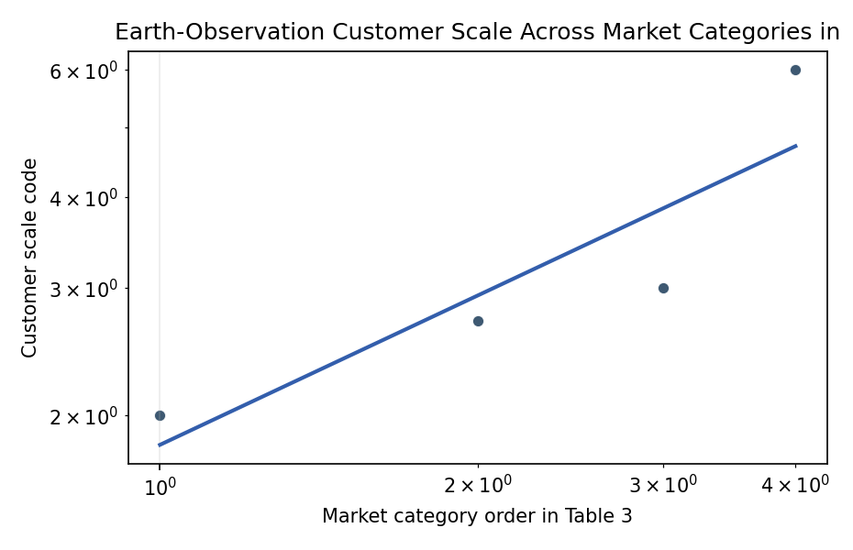
Figure 1. Log-log customer-scale gradient across Denis et al. Table 3 market categories.

Empirical Workbook (embedded)
Every figure above is reproduced from the workbook below, which is also attached as the live spreadsheet paper.xlsx. Each observation carries its source.

Data (real observations)
customer_type | market_order | customer_scale_code | customer_scale_label | maturity_score | growth_potential_score | consumer_market | source
Defence | 1 | 2 | 100 | 3 | 2 | 0 | Denis et al. 2017 Table 3
Civil institutional | 2 | 2.7 | 100 to 1000s | 3 | 3 | 0 | Denis et al. 2017 Table 3
Commercial | 3 | 3 | 1000s | 2 | 3 | 0 | Denis et al. 2017 Table 3
Consumer market | 4 | 6 | Millions | 1 | 3 | 1 | Denis et al. 2017 Table 3

Variable construction
Variable | Definition | Construction / source
customer_scale_code | Log-scale numeric translation of Table 3 customer labels. | 100 maps to 2.0, 100 to 1000s maps to 2.7, 1000s maps to 3.0, and Millions maps to 6.0.
market_order | Order of Table 3 customer categories from defence to consumer market. | Read from Denis et al. 2017 Table 3.
maturity_score | Ordinal translation of Table 3 maturity labels. | High equals 3, Variable equals 2, Low equals 1.
growth_potential_score | Ordinal translation of Table 3 growth-potential labels. | High equals 3, Medium equals 2.
consumer_market | Indicator equal to one for the consumer-market row. | Constructed from Denis et al. 2017 Table 3.

Estimator output
Term | Coef. | Std. err. | t | p | 95% CI
const | 0.5997 | 0.1324 | 4.5285 | 5.94e-06 | [0.3401, 0.8593]
_ln_x | 0.6853 | 0.2335 | 2.9344 | 0.0033 | [0.2276, 1.143]
Fit: N = 4 R2 = 0.7862 elasticity_b = 0.6853 progress_ratio_2^b = 1.608

