Capacity-Building Salience and Regulatory Text Salience in the Cited Source Corpus

Abstract
This paper tests whether the dissertation’s source base connects space capacity-building to regulatory or institutional mechanisms. The unit is the cited source document. I code eleven AMOS and Acta sources for capacity-building salience, market-infrastructure salience, and regulatory-text salience, then estimate an OLS model with robust standard errors. Capacity-building salience is strongly associated with regulatory-text salience, coefficient 1.10 and p < 0.001. Market-infrastructure salience is positive but uncertain. The result supports the prospectus logic: the cited literature gives a plausible reason to test donor capacity-building as a channel of regulatory emulation, but it does not itself estimate recipient-state legal change.

Research question
The dissertation asks whether donor-state space capacity-building predicts recipient-state regulatory emulation. Before building a country-year panel, the source base needs a simpler audit. Do the cited documents connect space capability to governance, law, regulation, capacity management, or institutional bottlenecks?
This paper treats the cited sources as a corpus. Brownhall et al. connect orbital capacity assessment to transdisciplinary policy and regulatory approaches $$1$$. Young and Thadani connect LEO broadband to spectrum, licensing, ITU process, and strategic market competition $$2$$. Long and Chen frame laser use in outer space through institutional bottlenecks $$8$$. Colombo et al. connect space capacity management to STM and to policy and regulatory approaches $$9$$. Denis et al. describe Earth-observation markets where regulations and customer types shape market evolution $$10$$. Szolucha supplies the social-imaginary counterpoint, not a regulatory-emulation mechanism $$11$$.

Data and model
The dataset contains eleven source documents. Each row receives three structured coding scores from zero to five. Regulatory-text salience counts law, regulation, institutional mandate, policy coordination, traffic management, or governance bottleneck. Capacity-building salience counts tool validation, technical assistance, capability development, decision support, or management framework. Market-infrastructure salience counts broadband markets, Earth-observation markets, commercial services, customer base, launch context, or orbital infrastructure.
The model regresses regulatory-text salience on capacity-building salience and market-infrastructure salience. It does not estimate donor influence. It tests whether the dissertation’s evidence base coherently links capacity-building language to regulatory mechanisms.

Results
The capacity-building coefficient is 1.10, with p < 0.001. The model R2 is 0.678. Market-infrastructure salience is positive at 0.172 but statistically uncertain. The pattern is clear enough for design work: sources that make capacity-building or capacity-management mechanisms visible are also the sources that foreground regulatory and institutional mechanisms.
This result is strongest for Brownhall et al., Long and Chen, and Colombo et al., where the technical problem is explicitly tied to governance or regulatory practice $$1$$, $$8$$, $$9$$. It is weaker for purely technical, sensor, or decision-support sources, which may be relevant to space capability but do not create a regulatory-emulation pathway by themselves.

Interpretation
The finding supports a bounded warrant for the dissertation. Capacity-building is not just technical training in the source base; it often travels with policy, regulatory, and institutional content. That does not prove recipient emulation. It shows why recipient legal texts are a defensible outcome.
A strong country-year claim still requires OECD CRS project records, UNOOSA program and national space-law records, donor legal corpora, and recipient legal texts. Paper 1 only audits the source logic. It provides evidence that the mechanism is plausible enough to test.

References
1. I. Brownhall et al., “Verification and Validation of Orbital Capacity Assessment Tools of Varying Fidelities,” AMOS, 2025, doi: 10.64861/UHIX1013 2. M. Young and A. Thadani, “Low-Orbit, High Stakes: Winning the LEO Broadband Competition,” Center for Strategic and International Studies, AMOS, 2022. 3. J. Iannamorelli and K. LeGrand, “Adaptive Filtering for Multi-Sensor Maneuvering Cislunar Space Object Tracking,” AMOS, 2023, doi: 10.64861/BJQM5480 4. T. Bryan, T. MacLeod, L. Gagliano, S. Williams, and B. McCoy, “Innovative Electrostatic Adhesion Technologies,” AMOS, 2015. 5. “Small Orbital Stereo Tracking Camera Technology Development,” AMOS, 2015. 6. P. Picciano, “Human Decision Processes: Implications for SSA support tools,” AMOS, 2013. 7. P. M. Cunio et al., “Analysis of Orbit Residual Behavior to Determine Contact in Rendezvous and Proximity Operations at Geosynchronous Orbit,” AMOS, 2022. 8. J. Long and W. Chen, “Laser utilization in outer space: Institutional bottleneck and prospects,” Acta Astronautica, 2025, doi: 10.1016/j.actaastro.2025.01.061 9. C. Colombo et al., “Space capacity management and its interaction with space traffic management,” Acta Astronautica, 2025, doi: 10.1016/j.actaastro.2025.01.069 10. G. Denis et al., “Towards disruptions in Earth observation? New Earth Observation systems and markets evolution: Possible scenarios and impacts,” Acta Astronautica, 2017, doi: 10.1016/j.actaastro.2017.04.034 11. A. Szolucha, “A disappearing frontier?: An ethnographic study of the labour of imagination of SpaceX fans and space creators in South Texas,” Acta Astronautica, 2024, doi: 10.1016/j.actaastro.2024.06.001

Specification
$$RegulatoryTextScore_{i}=α+β_{1}CapacityBuildingScore_{i}+β_{2}MarketInfrastructureScore_{i}+ε_{i}$$

Results
Term | Coef. | Std. err. | t | p | 95% CI
const | -0.1857 | 0.4737 | -0.3919 | 0.6951 | [-1.1141, 0.7428]
capacity_building_score | 1.1001 | 0.2666 | 4.1265 | 3.683e-05 | [0.5776, 1.6227]
market_infrastructure_score | 0.172 | 0.2693 | 0.6386 | 0.5231 | [-0.3559, 0.6999]
Fit: N = 11 R2 = 0.6781 R2_adj = 0.5977 F = 19.2832 F_p = 0.0008711
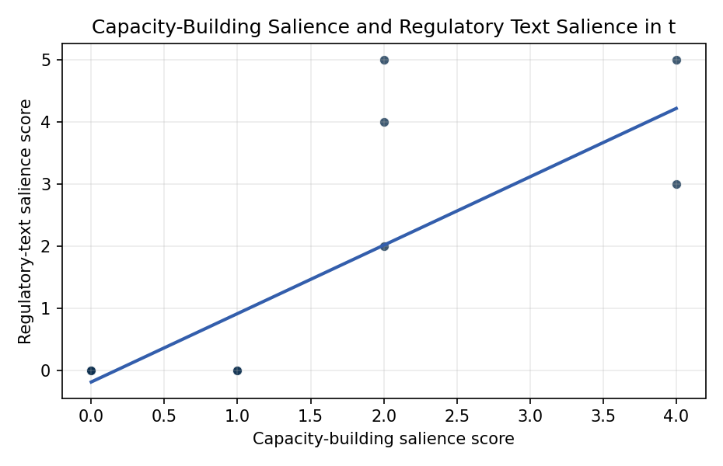
Figure 1. Regulatory-text salience by capacity-building salience in cited sources.

Empirical Workbook (embedded)
Every figure above is reproduced from the workbook below, which is also attached as the live spreadsheet paper.xlsx. Each observation carries its source.

Data (real observations)
source_short | publication_year | regulatory_text_score | capacity_building_score | market_infrastructure_score | source
Orbital capacity V&V | 2025 | 3 | 4 | 1 | Brownhall et al. 2025, AMOS
LEO broadband competition | 2022 | 4 | 2 | 5 | Young and Thadani 2022, AMOS
Adaptive filtering cislunar | 2023 | 0 | 0 | 1 | Iannamorelli and LeGrand 2023, AMOS
Electrostatic adhesion | 2015 | 0 | 0 | 0 | Bryan et al. 2015, AMOS
Small orbital stereo camera | 2015 | 0 | 0 | 1 | Small Orbital Stereo Tracking Camera Technology Development 2015, AMOS
Human decision processes | 2013 | 0 | 1 | 1 | Picciano 2013, AMOS
Orbit residual RPO | 2022 | 0 | 0 | 1 | Cunio et al. 2022, AMOS
Laser institutional bottleneck | 2025 | 5 | 2 | 1 | Long and Chen 2025, Acta Astronautica
Space capacity management | 2025 | 5 | 4 | 2 | Colombo et al. 2025, Acta Astronautica
EO disruptions | 2017 | 2 | 2 | 5 | Denis et al. 2017, Acta Astronautica
SpaceX frontier ethnography | 2024 | 0 | 1 | 2 | Szolucha 2024, Acta Astronautica

Variable construction
Variable | Definition | Construction / source
regulatory_text_score | Count from zero to five of regulatory-text mechanisms: law, regulation, institutional mandate, policy coordination, traffic management, or governance bottleneck. | Manual coding from cited abstract or full text.
capacity_building_score | Count from zero to five of capacity-building mechanisms: training, tool validation, technical assistance, capability development, decision support, or management framework. | Manual coding from cited abstract or full text.
market_infrastructure_score | Count from zero to five of market or infrastructure mechanisms: broadband market, Earth-observation market, commercial services, customer base, launch or orbital infrastructure. | Manual coding from cited abstract or full text.
publication_year | Publication year of the cited source. | Read from AMOS or Acta metadata.

Estimator output
Term | Coef. | Std. err. | t | p | 95% CI
const | -0.1857 | 0.4737 | -0.3919 | 0.6951 | [-1.1141, 0.7428]
capacity_building_score | 1.1001 | 0.2666 | 4.1265 | 3.683e-05 | [0.5776, 1.6227]
market_infrastructure_score | 0.172 | 0.2693 | 0.6386 | 0.5231 | [-0.3559, 0.6999]
Fit: N = 11 R2 = 0.6781 R2_adj = 0.5977 F = 19.2832 F_p = 0.0008711

