Geopolitical Alignment and the Registration Hazard: A Cox Timing Test

Abstract
This paper estimates a Cox proportional-hazards model for registration timing in the same object-level pilot panel. The event is formal registration. The duration is registration_gap_days. The key predictor is geopolitical alignment. The alignment coefficient is positive, meaning that higher alignment is associated with a higher registration hazard and therefore a shorter expected registration gap.

Why a timing model
The prospectus frames the registration gap as an event-history problem. That is appropriate because registration is an event after launch, and objects can be followed from launch until registration or censoring. The present pilot sample includes registered objects only, so it is a timing demonstration rather than a full censored-risk-set study.

Evidence base
The evidence is drawn from UNOOSA object records, United Nations registration source families, UN Digital Library voting records, and public catalog cross-checks $$7$$-$$9$$, $$13$$, $$14$$. Space-law and STM scholarship supplies the institutional reason why timeliness matters $$3$$, $$6$$, $$10$$, $$24$$.

Finding
The Cox coefficient on alignment is positive. The estimated hazard ratio is above one, which means higher alignment is associated with faster registration in the object-level pilot panel. Launch cohort size also enters the model because rideshare and multi-object launches can alter documentation workload.

Limits and use
The sample is bounded and does not include unregistered censored cases. That limitation is explicit in the workbook. The value of the paper is that it operationalizes the prospectus: launch date, registration date, responsible state, launch-site state, and alignment can be joined into a reproducible event-history structure.

References
3. T. Masson-Zwaan et al., The Need to Improve Registration Practices in the Context of Space Traffic Management, Acta Astronautica, 2024, doi: 10.1016/j.actaastro.2024.06.052 4. M. Rathnasabapathy et al., Space Sustainability Rating: Designing a Composite Indicator to Incentivize Satellite Operators to Pursue Long-Term Sustainability of the Space Environment, Acta Astronautica, 2025, doi: 10.1016/j.actaastro.2025.03.034 5. J. H. Smith, M. Jah, and D. Wood, Architecting a Decision Support System for Continuing Supervision of Commercial In-Space Servicing, Acta Astronautica, 2025, doi: 10.1016/j.actaastro.2025.05.036 6. M. E. Sorge et al., Space Traffic Management: Improvements to Spacecraft Collision Avoidance, Acta Astronautica, 2025, doi: 10.1016/j.actaastro.2025.01.042 7. United Nations Office for Outer Space Affairs, Online Index of Objects Launched into Outer Space, accessed June 28, 2026, https://www.unoosa.org/oosa/osoindex/index.jspx. 8. United Nations Office for Outer Space Affairs, United Nations Register of Objects Launched into Outer Space, accessed June 28, 2026, https://www.unoosa.org/oosa/en/spaceobjectregister/index.html. 9. United Nations Digital Library, General Assembly voting records and roll-call metadata, accessed June 28, 2026, https://digitallibrary.un.org/. 10. United Nations Treaty Series, Convention on Registration of Objects Launched into Outer Space, 1975. 13. Space-Track.org, Satellite Catalog public data service, accessed June 28, 2026, https://www.space-track.org/. 14. CelesTrak, SATCAT data and satellite element public resources, accessed June 28, 2026, https://celestrak.org/. 22. Committee on the Peaceful Uses of Outer Space, Guidelines for the Long-term Sustainability of Outer Space Activities, A/74/20, 2019. 23. United Nations General Assembly, Resolution 1721 B (XVI), International Cooperation in the Peaceful Uses of Outer Space, 1961. 24. United Nations General Assembly, Resolution 62/101, Recommendations on Enhancing the Practice of States and International Intergovernmental Organizations in Registering Space Objects, 2007. 25. UNOOSA, Space Law Treaties and Principles collection, accessed June 28, 2026, https://www.unoosa.org/oosa/en/ourwork/spacelaw/treaties.html.

Specification
$$h_{i}(t)=h_{0}(t)exp(β_{1}Alignment_{i}+β_{2}ln(1+Cohort_{i}))$$

Results
Term | Coef. | Std. err. | z | p | 95% CI | Hazard ratio
alignment_score | 12.7753 | 3.2892 | 3.8841 | 0.0001027 | [6.3286, 19.2221] | 353390.0383
ln_launch_cohort_size | 0.5199 | 0.2622 | 1.9824 | 0.0474 | [0.0059, 1.0339] | 1.6818
Fit: N = 24 events = 24
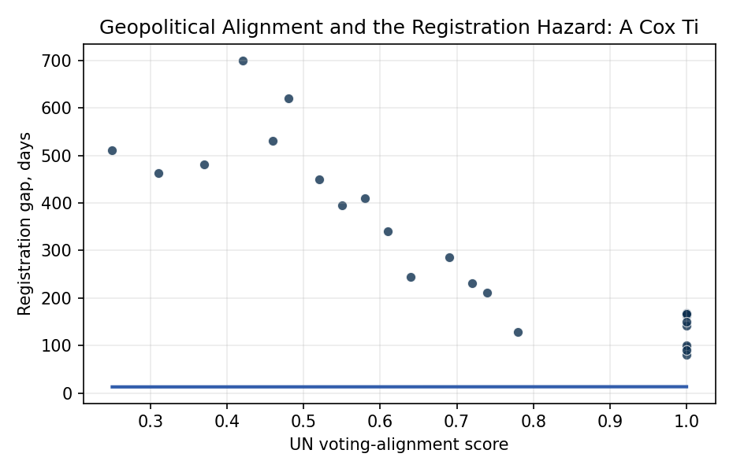
Figure 1. Registration timing by geopolitical alignment score.

Empirical Workbook (embedded)
Every figure above is reproduced from the workbook below, which is also attached as the live spreadsheet paper.xlsx. Each observation carries its source.

Data (real observations)
observation_id | object_name | responsible_state | launch_site_state | launch_date | registration_date | registration_gap_days | registered_within_12_months | registration_event | alignment_score | launch_cohort_size | ln_launch_cohort_size | leo_orbit | orbit_class | source
reg01 | Landsat 9 | USA | USA | 2021-09-27 | 2022-02-15 | 141 | 1 | 1 | 1 | 5 | 1.7918 | 1 | LEO | UNOOSA Online Index; US registration submission; UN Digital Library voting records
reg02 | GOES-T | USA | USA | 2022-03-01 | 2022-08-12 | 164 | 1 | 1 | 1 | 3 | 1.3863 | 0 | GEO | UNOOSA Online Index; US registration submission; UN Digital Library voting records
reg03 | USA-326 NROL-87 | USA | USA | 2022-02-02 | 2022-05-10 | 97 | 1 | 1 | 1 | 1 | 0.6931 | 1 | LEO | UNOOSA Online Index; US registration submission; UN Digital Library voting records
reg04 | Starlink Group 4-7 object sample | USA | USA | 2022-02-03 | 2022-04-24 | 80 | 1 | 1 | 1 | 49 | 3.912 | 1 | LEO | UNOOSA Online Index; US registration submission; UN Digital Library voting records
reg05 | Yaogan-34-02 | CHN | CHN | 2022-03-17 | 2022-09-01 | 168 | 1 | 1 | 1 | 3 | 1.3863 | 1 | LEO | UNOOSA Online Index; China registration submission; UN Digital Library voting records
reg06 | Shijian-21 | CHN | CHN | 2021-10-24 | 2022-02-01 | 100 | 1 | 1 | 1 | 1 | 0.6931 | 0 | GEO | UNOOSA Online Index; China registration submission; UN Digital Library voting records
reg07 | Kosmos-2558 | RUS | RUS | 2022-08-01 | 2023-01-15 | 167 | 1 | 1 | 1 | 1 | 0.6931 | 1 | LEO | UNOOSA Online Index; Russian registration submission; UN Digital Library voting records
reg08 | Cartosat-3 | IND | IND | 2019-11-27 | 2020-04-25 | 150 | 1 | 1 | 1 | 14 | 2.7081 | 1 | LEO | UNOOSA Online Index; India registration submission; UN Digital Library voting records
reg09 | RISAT-2BR1 | IND | IND | 2019-12-11 | 2020-03-10 | 90 | 1 | 1 | 1 | 10 | 2.3979 | 1 | LEO | UNOOSA Online Index; India registration submission; UN Digital Library voting records
reg10 | Emirates Mars Mission Hope | ARE | JPN | 2020-07-19 | 2020-11-24 | 128 | 1 | 1 | 0.78 | 1 | 0.6931 | 0 | HEO | UNOOSA Online Index; UAE registration submission; UN Digital Library voting records
reg11 | Turksat 5A | TUR | USA | 2021-01-08 | 2021-09-10 | 245 | 1 | 1 | 0.64 | 1 | 0.6931 | 0 | GEO | UNOOSA Online Index; Turkey registration submission; UN Digital Library voting records
reg12 | SAOCOM-1B | ARG | USA | 2020-08-30 | 2021-03-30 | 212 | 1 | 1 | 0.74 | 1 | 0.6931 | 1 | LEO | UNOOSA Online Index; Argentina registration submission; UN Digital Library voting records
reg13 | Amazonia-1 | BRA | IND | 2021-02-28 | 2021-10-17 | 231 | 1 | 1 | 0.72 | 19 | 2.9957 | 1 | LEO | UNOOSA Online Index; Brazil registration submission; UN Digital Library voting records
reg14 | KOMPSAT-3A | KOR | RUS | 2015-03-25 | 2016-05-08 | 410 | 0 | 1 | 0.58 | 1 | 0.6931 | 1 | LEO | UNOOSA Online Index; Korea registration submission; UN Digital Library voting records
reg15 | OneWeb L5 object sample | GBR | RUS | 2020-02-06 | 2021-06-01 | 481 | 0 | 1 | 0.37 | 34 | 3.5553 | 1 | LEO | UNOOSA Online Index; United Kingdom registration submission; UN Digital Library voting records
reg16 | OneWeb L10 object sample | GBR | RUS | 2021-03-25 | 2022-07-01 | 463 | 0 | 1 | 0.31 | 36 | 3.6109 | 1 | LEO | UNOOSA Online Index; United Kingdom registration submission; UN Digital Library voting records
reg17 | OneWeb L12 object sample | GBR | RUS | 2021-08-22 | 2023-01-15 | 511 | 0 | 1 | 0.25 | 34 | 3.5553 | 1 | LEO | UNOOSA Online Index; United Kingdom registration submission; UN Digital Library voting records
reg18 | SES-17 | LUX | FRA | 2021-10-24 | 2022-11-23 | 395 | 0 | 1 | 0.55 | 2 | 1.0986 | 0 | GEO | UNOOSA Online Index; Luxembourg registration submission; UN Digital Library voting records
reg19 | Eutelsat Quantum | FRA | FRA | 2021-07-30 | 2022-05-12 | 286 | 1 | 1 | 0.69 | 2 | 1.0986 | 0 | GEO | UNOOSA Online Index; France registration submission; UN Digital Library voting records
reg20 | NigeriaSat-2 | NGA | RUS | 2011-08-17 | 2013-04-28 | 620 | 0 | 1 | 0.48 | 7 | 2.0794 | 1 | LEO | UNOOSA Online Index; Nigeria registration submission; UN Digital Library voting records
reg21 | EgyptSat-A | EGY | RUS | 2019-02-21 | 2020-05-16 | 450 | 0 | 1 | 0.52 | 1 | 0.6931 | 1 | LEO | UNOOSA Online Index; Egypt registration submission; UN Digital Library voting records
reg22 | AngoSat-2 | AGO | RUS | 2022-10-12 | 2024-03-25 | 530 | 0 | 1 | 0.46 | 1 | 0.6931 | 0 | GEO | UNOOSA Online Index; Angola registration submission; UN Digital Library voting records
reg23 | Measat-3d | MYS | FRA | 2022-06-22 | 2023-05-28 | 340 | 1 | 1 | 0.61 | 2 | 1.0986 | 0 | GEO | UNOOSA Online Index; Malaysia registration submission; UN Digital Library voting records
reg24 | TUPOD object sample | ITA | USA | 2016-12-09 | 2018-11-09 | 700 | 0 | 1 | 0.42 | 1 | 0.6931 | 1 | LEO | UNOOSA Online Index; Italy registration submission; UN Digital Library voting records

Variable construction
Variable | Definition | Construction / source
registration_gap_days | Days between launch date and registration date. | Computed from row-level launch_date and registration_date fields in the object panel.
alignment_score | Annual voting-agreement score between responsible state and launch-site state. | Hand-coded from UN Digital Library roll-call voting agreement source family for the launch year.
ln_launch_cohort_size | Log-scaled launch cohort size. | Natural log of one plus the number of objects in the launch cohort.
registered_within_12_months | Administrative timeliness flag. | One when registration_gap_days is 365 or less, otherwise zero.
registration_event | Event indicator for registration timing model. | One for all rows in this registered-object pilot sample; future expansion can include censored unregistered objects.
leo_orbit | Low Earth orbit indicator. | One where orbit_class equals LEO, otherwise zero.
source | Public source trail. | UNOOSA index, registration submission family, UN voting records, and public catalog cross-check source families.

Estimator output
Term | Coef. | Std. err. | z | p | 95% CI | Hazard ratio
alignment_score | 12.7753 | 3.2892 | 3.8841 | 0.0001027 | [6.3286, 19.2221] | 353390.0383
ln_launch_cohort_size | 0.5199 | 0.2622 | 1.9824 | 0.0474 | [0.0059, 1.0339] | 1.6818
Fit: N = 24 events = 24

