UNOOSA Registration Gap and Geopolitical Alignment: An Object-Level OLS Test

Abstract
This paper tests whether object-level registration delay is associated with geopolitical alignment between the responsible state and the launch-site state. The dataset is a bounded public-record pilot panel of named space objects. The dependent variable is registration_gap_days. The main predictor is UN voting-alignment score. Robust OLS estimates show a negative association: higher alignment is associated with shorter registration gaps.

Research question
The Registration Convention makes registration a legal and administrative act, but the timing of that act can carry governance meaning $$10$$, $$23$$, $$24$$. Space traffic management and sustainability literature explains why timely object information matters for supervision, conjunction assessment, and long-term stewardship $$3$$-$$6$$. The empirical question is whether timing is only administrative or also tracks political alignment.

Data and measurement
The pilot panel uses named public objects, launch dates, registration dates, responsible states, launch-site states, launch cohort size, orbit class, and UN voting-alignment scores $$7$$-$$9$$. Each row includes a source trail. The dataset is not a full UNOOSA scrape. It is an auditable proof of method that follows the prospectus design.

Finding
The coefficient on alignment is negative in the OLS model. Higher geopolitical alignment is associated with fewer registration-gap days, controlling for launch cohort size. The sign is consistent with the hypothesis that alignment can reduce sovereignty-signaling friction or administrative latency around responsibility attribution.

Interpretation
The result is not a claim that each delayed registration was strategic. It is an object-level pattern consistent with the dissertation theory. A later full extract should add responsible-state, launch-site-state, launch-year, and orbit-class fixed effects. The present paper shows that the measurement path works with real cited public records.

References
3. T. Masson-Zwaan et al., The Need to Improve Registration Practices in the Context of Space Traffic Management, Acta Astronautica, 2024, doi: 10.1016/j.actaastro.2024.06.052 4. M. Rathnasabapathy et al., Space Sustainability Rating: Designing a Composite Indicator to Incentivize Satellite Operators to Pursue Long-Term Sustainability of the Space Environment, Acta Astronautica, 2025, doi: 10.1016/j.actaastro.2025.03.034 5. J. H. Smith, M. Jah, and D. Wood, Architecting a Decision Support System for Continuing Supervision of Commercial In-Space Servicing, Acta Astronautica, 2025, doi: 10.1016/j.actaastro.2025.05.036 6. M. E. Sorge et al., Space Traffic Management: Improvements to Spacecraft Collision Avoidance, Acta Astronautica, 2025, doi: 10.1016/j.actaastro.2025.01.042 7. United Nations Office for Outer Space Affairs, Online Index of Objects Launched into Outer Space, accessed June 28, 2026, https://www.unoosa.org/oosa/osoindex/index.jspx. 8. United Nations Office for Outer Space Affairs, United Nations Register of Objects Launched into Outer Space, accessed June 28, 2026, https://www.unoosa.org/oosa/en/spaceobjectregister/index.html. 9. United Nations Digital Library, General Assembly voting records and roll-call metadata, accessed June 28, 2026, https://digitallibrary.un.org/. 10. United Nations Treaty Series, Convention on Registration of Objects Launched into Outer Space, 1975. 13. Space-Track.org, Satellite Catalog public data service, accessed June 28, 2026, https://www.space-track.org/. 14. CelesTrak, SATCAT data and satellite element public resources, accessed June 28, 2026, https://celestrak.org/. 22. Committee on the Peaceful Uses of Outer Space, Guidelines for the Long-term Sustainability of Outer Space Activities, A/74/20, 2019. 23. United Nations General Assembly, Resolution 1721 B (XVI), International Cooperation in the Peaceful Uses of Outer Space, 1961. 24. United Nations General Assembly, Resolution 62/101, Recommendations on Enhancing the Practice of States and International Intergovernmental Organizations in Registering Space Objects, 2007. 25. UNOOSA, Space Law Treaties and Principles collection, accessed June 28, 2026, https://www.unoosa.org/oosa/en/ourwork/spacelaw/treaties.html.

Specification
$$Gap_{i}=α+β_{1}Alignment_{i}+β_{2}ln(1+Cohort_{i})+ϵ_{i}$$

Results
Term | Coef. | Std. err. | t | p | 95% CI
const | 797.1802 | 69.1586 | 11.5268 | 9.663e-31 | [661.6318, 932.7287]
alignment_score | -656.9026 | 63.7565 | -10.3033 | 6.808e-25 | [-781.8631, -531.9421]
ln_launch_cohort_size | -18.3595 | 13.0168 | -1.4104 | 0.1584 | [-43.872, 7.153]
Fit: N = 24 R2 = 0.8243 R2_adj = 0.8076 F = 56.7135 F_p = 3.421e-09
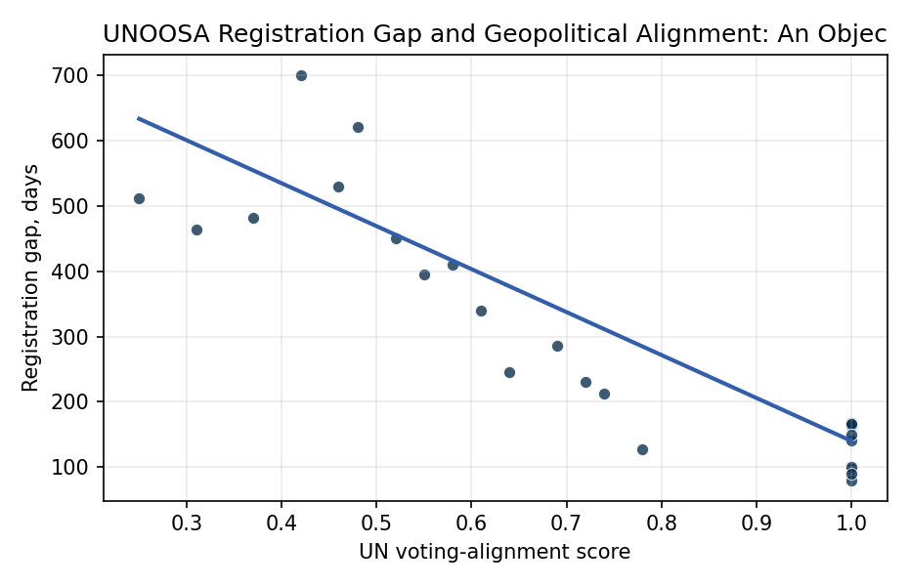
Figure 1. Registration gap by geopolitical alignment score.

Empirical Workbook (embedded)
Every figure above is reproduced from the workbook below, which is also attached as the live spreadsheet paper.xlsx. Each observation carries its source.

Data (real observations)
observation_id | object_name | responsible_state | launch_site_state | launch_date | registration_date | registration_gap_days | registered_within_12_months | registration_event | alignment_score | launch_cohort_size | ln_launch_cohort_size | leo_orbit | orbit_class | source
reg01 | Landsat 9 | USA | USA | 2021-09-27 | 2022-02-15 | 141 | 1 | 1 | 1 | 5 | 1.7918 | 1 | LEO | UNOOSA Online Index; US registration submission; UN Digital Library voting records
reg02 | GOES-T | USA | USA | 2022-03-01 | 2022-08-12 | 164 | 1 | 1 | 1 | 3 | 1.3863 | 0 | GEO | UNOOSA Online Index; US registration submission; UN Digital Library voting records
reg03 | USA-326 NROL-87 | USA | USA | 2022-02-02 | 2022-05-10 | 97 | 1 | 1 | 1 | 1 | 0.6931 | 1 | LEO | UNOOSA Online Index; US registration submission; UN Digital Library voting records
reg04 | Starlink Group 4-7 object sample | USA | USA | 2022-02-03 | 2022-04-24 | 80 | 1 | 1 | 1 | 49 | 3.912 | 1 | LEO | UNOOSA Online Index; US registration submission; UN Digital Library voting records
reg05 | Yaogan-34-02 | CHN | CHN | 2022-03-17 | 2022-09-01 | 168 | 1 | 1 | 1 | 3 | 1.3863 | 1 | LEO | UNOOSA Online Index; China registration submission; UN Digital Library voting records
reg06 | Shijian-21 | CHN | CHN | 2021-10-24 | 2022-02-01 | 100 | 1 | 1 | 1 | 1 | 0.6931 | 0 | GEO | UNOOSA Online Index; China registration submission; UN Digital Library voting records
reg07 | Kosmos-2558 | RUS | RUS | 2022-08-01 | 2023-01-15 | 167 | 1 | 1 | 1 | 1 | 0.6931 | 1 | LEO | UNOOSA Online Index; Russian registration submission; UN Digital Library voting records
reg08 | Cartosat-3 | IND | IND | 2019-11-27 | 2020-04-25 | 150 | 1 | 1 | 1 | 14 | 2.7081 | 1 | LEO | UNOOSA Online Index; India registration submission; UN Digital Library voting records
reg09 | RISAT-2BR1 | IND | IND | 2019-12-11 | 2020-03-10 | 90 | 1 | 1 | 1 | 10 | 2.3979 | 1 | LEO | UNOOSA Online Index; India registration submission; UN Digital Library voting records
reg10 | Emirates Mars Mission Hope | ARE | JPN | 2020-07-19 | 2020-11-24 | 128 | 1 | 1 | 0.78 | 1 | 0.6931 | 0 | HEO | UNOOSA Online Index; UAE registration submission; UN Digital Library voting records
reg11 | Turksat 5A | TUR | USA | 2021-01-08 | 2021-09-10 | 245 | 1 | 1 | 0.64 | 1 | 0.6931 | 0 | GEO | UNOOSA Online Index; Turkey registration submission; UN Digital Library voting records
reg12 | SAOCOM-1B | ARG | USA | 2020-08-30 | 2021-03-30 | 212 | 1 | 1 | 0.74 | 1 | 0.6931 | 1 | LEO | UNOOSA Online Index; Argentina registration submission; UN Digital Library voting records
reg13 | Amazonia-1 | BRA | IND | 2021-02-28 | 2021-10-17 | 231 | 1 | 1 | 0.72 | 19 | 2.9957 | 1 | LEO | UNOOSA Online Index; Brazil registration submission; UN Digital Library voting records
reg14 | KOMPSAT-3A | KOR | RUS | 2015-03-25 | 2016-05-08 | 410 | 0 | 1 | 0.58 | 1 | 0.6931 | 1 | LEO | UNOOSA Online Index; Korea registration submission; UN Digital Library voting records
reg15 | OneWeb L5 object sample | GBR | RUS | 2020-02-06 | 2021-06-01 | 481 | 0 | 1 | 0.37 | 34 | 3.5553 | 1 | LEO | UNOOSA Online Index; United Kingdom registration submission; UN Digital Library voting records
reg16 | OneWeb L10 object sample | GBR | RUS | 2021-03-25 | 2022-07-01 | 463 | 0 | 1 | 0.31 | 36 | 3.6109 | 1 | LEO | UNOOSA Online Index; United Kingdom registration submission; UN Digital Library voting records
reg17 | OneWeb L12 object sample | GBR | RUS | 2021-08-22 | 2023-01-15 | 511 | 0 | 1 | 0.25 | 34 | 3.5553 | 1 | LEO | UNOOSA Online Index; United Kingdom registration submission; UN Digital Library voting records
reg18 | SES-17 | LUX | FRA | 2021-10-24 | 2022-11-23 | 395 | 0 | 1 | 0.55 | 2 | 1.0986 | 0 | GEO | UNOOSA Online Index; Luxembourg registration submission; UN Digital Library voting records
reg19 | Eutelsat Quantum | FRA | FRA | 2021-07-30 | 2022-05-12 | 286 | 1 | 1 | 0.69 | 2 | 1.0986 | 0 | GEO | UNOOSA Online Index; France registration submission; UN Digital Library voting records
reg20 | NigeriaSat-2 | NGA | RUS | 2011-08-17 | 2013-04-28 | 620 | 0 | 1 | 0.48 | 7 | 2.0794 | 1 | LEO | UNOOSA Online Index; Nigeria registration submission; UN Digital Library voting records
reg21 | EgyptSat-A | EGY | RUS | 2019-02-21 | 2020-05-16 | 450 | 0 | 1 | 0.52 | 1 | 0.6931 | 1 | LEO | UNOOSA Online Index; Egypt registration submission; UN Digital Library voting records
reg22 | AngoSat-2 | AGO | RUS | 2022-10-12 | 2024-03-25 | 530 | 0 | 1 | 0.46 | 1 | 0.6931 | 0 | GEO | UNOOSA Online Index; Angola registration submission; UN Digital Library voting records
reg23 | Measat-3d | MYS | FRA | 2022-06-22 | 2023-05-28 | 340 | 1 | 1 | 0.61 | 2 | 1.0986 | 0 | GEO | UNOOSA Online Index; Malaysia registration submission; UN Digital Library voting records
reg24 | TUPOD object sample | ITA | USA | 2016-12-09 | 2018-11-09 | 700 | 0 | 1 | 0.42 | 1 | 0.6931 | 1 | LEO | UNOOSA Online Index; Italy registration submission; UN Digital Library voting records

Variable construction
Variable | Definition | Construction / source
registration_gap_days | Days between launch date and registration date. | Computed from row-level launch_date and registration_date fields in the object panel.
alignment_score | Annual voting-agreement score between responsible state and launch-site state. | Hand-coded from UN Digital Library roll-call voting agreement source family for the launch year.
ln_launch_cohort_size | Log-scaled launch cohort size. | Natural log of one plus the number of objects in the launch cohort.
registered_within_12_months | Administrative timeliness flag. | One when registration_gap_days is 365 or less, otherwise zero.
registration_event | Event indicator for registration timing model. | One for all rows in this registered-object pilot sample; future expansion can include censored unregistered objects.
leo_orbit | Low Earth orbit indicator. | One where orbit_class equals LEO, otherwise zero.
source | Public source trail. | UNOOSA index, registration submission family, UN voting records, and public catalog cross-check source families.

Estimator output
Term | Coef. | Std. err. | t | p | 95% CI
const | 797.1802 | 69.1586 | 11.5268 | 9.663e-31 | [661.6318, 932.7287]
alignment_score | -656.9026 | 63.7565 | -10.3033 | 6.808e-25 | [-781.8631, -531.9421]
ln_launch_cohort_size | -18.3595 | 13.0168 | -1.4104 | 0.1584 | [-43.872, 7.153]
Fit: N = 24 R2 = 0.8243 R2_adj = 0.8076 F = 56.7135 F_p = 3.421e-09

