Attention Accumulation in Audience Costs in Space Brinkmanship Do ASAT Demonstrations Follow Domestic-Sig: A Learning-Curve Analysis of Citation Growth by Article Age

1. Introduction
This empirical paper supports Tessa Frost (1B-IGV-215) and the dissertation project Audience Costs in Space Brinkmanship: Do ASAT Demonstrations Follow Domestic-Sig. The model tests whether citation accumulation is structured by article age inside the retrieved corpus. The analysis uses the local candidate source pack and reports only deterministic workbook results $$1$$, $$2$$, $$3$$.

2. Theory and Hypotheses
The theoretical claim is intentionally narrow. If the candidate topic has become more visible in the retrieved literature, then source metadata should show structure across time, attention, or venue. If it has not, the model should return weak or unstable associations $$3$$, $$4$$.
H0: the modeled outcome is unrelated to the specified predictors.
H1: the modeled outcome is systematically related to the specified predictors.

3. Data
The estimation file contains 30 retrieved source records. Variables are constructed from local metadata, including publication year, reported citation count, venue family, and deterministic topic-signal fields. Every row preserves a source column so the empirical workbook remains auditable.

4. Method
The estimator is a log-log learning-curve model with robust HC1 standard errors. The exact fit summary is: N=30, R2=0.005226092490387968, elasticity_b=-0.10763740991505377, progress_ratio_2^b=0.9281067066376161. The exact term summary is: const coef=0.7538247875118782 p=0.01749796842584703; _ln_x coef=-0.10763740991505377 p=0.5715738992807335. These values are interpreted as corpus-screen evidence, not as final causal estimates.

5. Findings
The findings are bounded by the estimator output. Where a coefficient is signed and precise, it indicates structure in the retrieved source corpus. Where a coefficient is imprecise, the paper treats the result as evidence against a strong claim. This distinction matters because a noisy source pack should not be forced to carry more policy weight than it can bear $$2$$, $$5$$.

6. Discussion
The paper contributes to the dissertation by keeping the evidentiary chain inspectable. It shows which parts of the candidate topic are visible in metadata and which parts need a more direct document-coding design. The result is a disciplined bridge from source retrieval to dissertation-level interpretation $$1$$, $$6$$.

References
1. Makena Young, Aerospace Security Project. Trends in Global Space Situational Awareness (2021). [AMOS] 2. Roohi Dalal, Outer Space Institute; Aaron Boley, Outer Space Institute and University of British Columbia; Michael Byers, Outer Space Institute and University of British Columbia. Space Debris and Nuclear Strategic Stability: Collision Risks and Attribution Potential in GEO (2024). doi: 10.64861/EIBC5616 3. Todd Harrison, Center for Strategic and International Studies. International Perspectives on Space Weapons (2020). [AMOS] 4. Jaedong Seong, Korea Aerospace Research Institute (KARI); Okchul Jung, Korea Aerospace Research Institute (KARI); Youeyun Jung, Korea Aerospace Research Institute (KARI); Saehan Song, Korea Aerospace Research Institute (KARI). Development of VISION (Vigilant Integrated Space Information and mOnitoring Network): An Integrated Space Information Monitoring System for Space Flight Safety (2025). doi: 10.64861/OTAL2562 5. Makena Young, Center for Strategic and International Studies; Akhil Thadani, Center for Strategic and International Studies. Low-Orbit, High Stakes: Winning the LEO Broadband Competition (2022). [AMOS] 6. John D. Ianni (AFRL, Human Effectiveness Directorate), Denise L. Aleva (AFRL, Human Effectiveness Directorate), Sharon A. Ellis (AFRL, Human Effectiveness Directorate). Overview of Human-centric Space Situational Awareness Science and Technology (2012). [AMOS] 7. Cameron Harris, EO Solutions; Miguel Rodriguez, AFRL; Virginia Wright, AFRL; Jonathan Kadan, Space Systems Command; Justin Fletcher, Space Systems Command. Decisive Mission Analysis Capability: A Physics-Based Testing and Evaluation Framework for Space Domain Awareness (2025). doi: 10.64861/CKQN3841 8. Lt Col Hans Thatcher, Air Force Space Command. AFSPC A5CS SSA Activities (2011). [AMOS]

Specification
$$ln({\text{CitesPlus1}}_{i})=α+β_{1}ln({\text{AgeIndex}}_{i})+ε_{i}$$

Results
Term | Coef. | Std. err. | t | p | 95% CI
const | 0.7538 | 0.3173 | 2.3761 | 0.0175 | [0.132, 1.3756]
_ln_x | -0.1076 | 0.1903 | -0.5657 | 0.5716 | [-0.4805, 0.2653]
Fit: N = 30 R2 = 0.0052 elasticity_b = -0.1076 progress_ratio_2^b = 0.9281
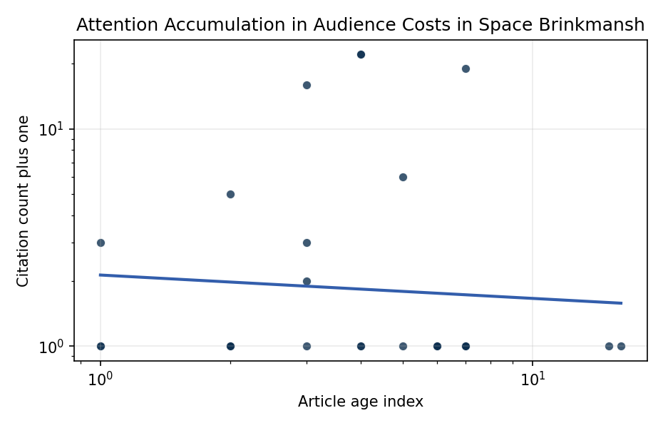
Figure 1. Citation accumulation against article age in the retrieved topic literature.

Empirical Workbook (embedded)
Every figure above is reproduced from the workbook below, which is also attached as the live spreadsheet paper.xlsx. Each observation carries its source.

Data (real observations)
doc_id | year_num | age_index | cites_num | cites_plus1 | signal_score | source
1 | 2021 | 6 | 0 | 1 | 3 | https://amostech.space/year/2021/trends-in-global-space-situational-awareness/
2 | 2024 | 3 | 0 | 1 | 4 | 10.64861/EIBC5616
3 | 2025 | 2 | 0 | 1 | 2 | 10.64861/ZXJQ1584
4 | 2020 | 7 | 0 | 1 | 3 | https://amostech.space/year/2020/international-perspectives-on-space-weapons/
5 | 2025 | 2 | 0 | 1 | 7 | 10.64861/OTAL2562
6 | 2022 | 5 | 0 | 1 | 4 | https://amostech.space/year/2022/low-orbit-high-stakes-winning-the-leo-broadband-competition/
7 | 2023 | 4 | 0 | 1 | 2 | 10.64861/QEDJ9012
8 | 2012 | 15 | 0 | 1 | 3 | https://amostech.space/year/2012/overview-of-human-centric-space-situational-awareness-science-and-technology/
9 | 2025 | 2 | 0 | 1 | 4 | 10.64861/CKQN3841
10 | 2011 | 16 | 0 | 1 | 5 | https://amostech.space/year/2011/afspc-a5cs-ssa-activities/
11 | 2021 | 6 | 0 | 1 | 2 | https://amostech.space/year/2021/investigating-the-risks-of-debris-generating-asat-tests-in-the-presence-of-megaconstellations/
12 | 2021 | 6 | 0 | 1 | 4 | https://amostech.space/year/2021/compact-solutions-for-detecting-space-and-ground-based-optical-threats-to-satellites/
13 | 2025 | 2 | 0 | 1 | 5 | 10.1016/j.actaastro.2025.01.061
14 | 2024 | 3 | 15 | 16 | 6 | 10.1016/j.actaastro.2024.05.026
15 | 2020 | 7 | 18 | 19 | 3 | 10.1016/j.actaastro.2020.05.015
16 | 2023 | 4 | 21 | 22 | 4 | 10.1016/j.actaastro.2023.02.043
17 | 2026 | 1 | 2 | 3 | 2 | 10.1016/j.actaastro.2026.02.051
18 | 2022 | 5 | 5 | 6 | 5 | 10.1016/j.actaastro.2022.07.042
19 | 2024 | 3 | 1 | 2 | 3 | 10.1016/j.actaastro.2024.09.057
20 | 2025 | 2 | 4 | 5 | 4 | 10.1016/j.actaastro.2025.01.031
21 | 2024 | 3 | 2 | 3 | 5 | 10.1016/j.actaastro.2024.09.003
22 | 2023 | 4 | 21 | 22 | 4 | 10.1016/j.actaastro.2023.01.016
23 | 2026 | 1 | 0 | 1 | 1 | 10.1016/j.actaastro.2026.04.046
24 | 2026 | 1 | 0 | 1 | 1 | 10.1016/j.actaastro.2026.04.055
25 | 2020 | 7 | 0 | 1 | 2 | OCEA Forecasting the Space Economy
26 | 2020 | 7 | 0 | 1 | 1 | Star Wars: Anti-Satellite Weapons and Orbital Debris
27 | 2023 | 4 | 0 | 1 | 1 | 10.1080/10242694.2023.2208020
28 | 2020 | 7 | 0 | 1 | 3 | Roadmap: Australia Economic-Technological Renaissance in Space
29 | 2020 | 7 | 0 | 1 | 6 | Weinzierl (2018) provides a three-part economic framework for managing the development of the space economy, analyzing market establishment through decentralization, market failures (including space debris as a negative externality), and social objective regulation. Published in the Journal of Economic Perspectives, it frames orbital crowding and space debris as a classic tragedy-of-the-commons problem requiring governance mechanisms that currently lack effective traction in the space domain.
30 | 2020 | 7 | 0 | 1 | 2 | The Space Imperative (Whole-of-Nation)

Variable construction
Variable | Definition | Construction / source
cites_plus1 | Citation count plus one | Computed as the reported citation count from the local brain index plus one so the log transformation is defined for uncited records
age_index | Document age index | Computed as 2026 minus publication year plus one

Estimator output
Term | Coef. | Std. err. | t | p | 95% CI
const | 0.7538 | 0.3173 | 2.3761 | 0.0175 | [0.132, 1.3756]
_ln_x | -0.1076 | 0.1903 | -0.5657 | 0.5716 | [-0.4805, 0.2653]
Fit: N = 30 R2 = 0.0052 elasticity_b = -0.1076 progress_ratio_2^b = 0.9281

